PROJECT FILE
INFORMATICS PRACTICES (CLASS XII)
SESSION: [Year, e.g., 2023-2024]

SUPERMARKET BILLING SYSTEM
(Automated Billing, Inventory Deduction and Receipt Generation using Python File Handling)
Submitted By:
[Your Name]
Class: XII – [Section]
Roll No: [Your Roll Number]
Submitted To:
[Teacher's Name]
Department of Computer Science
[Your School Name]

CERTIFICATE
This is to certify that [Your Name] of Class XII has successfully completed the Informatics Practices project titled "Supermarket Billing System" under the guidance of [Teacher's Name] during the academic year [Year].
This project is a bonafide record of work done by the candidate independently and fulfills the requirements of the Central Board of Secondary Education (CBSE) for the AISSCE Examination.
Teacher In-Charge: __________________
Signature: __________________
External Examiner: __________________
Signature: __________________
School Seal:

ACKNOWLEDGEMENT
I would like to express my sincere thanks to my Informatics Practices teacher [Teacher's Name] and our Principal [Principal's Name] for giving me the opportunity to work on this project titled "Supermarket Billing System".
While working on this project I learnt how data can be permanently stored in files using Python — using CSV files for tabular data and text files for printed receipts. I would also like to thank my parents and friends who supported and encouraged me throughout the completion of this project.
Name: [Your Name]
Class: XII

TABLE OF CONTENTS
- Introduction
- Objectives of the Project
- Proposed System
- System Requirements (Hardware & Software)
- Theory: File Handling in Python
- File Structure (Data Description)
- Functions Used (Quick Reference)
- Source Code
- Output Screens and Observations
- Conclusion and Future Scope
- Troubleshooting / Common Errors
- Bibliography

1. INTRODUCTION
A supermarket handles hundreds of customers every day. Every customer buys several items, and for each item the shopkeeper must know its price, calculate the total amount, add tax, print a bill and reduce the sold quantity from the stock. If this is done manually, it takes a lot of time and mistakes are very common — wrong prices, wrong totals, and stock registers that never match the actual stock.
The Supermarket Billing System is a software application that automates all of these tasks. It is a menu-driven Python program that:
- Stores the complete item catalogue in a CSV file (inventory.csv).
- Allows the cashier to prepare a bill by entering item codes and quantities.
- Automatically checks the available stock and prevents selling more than what is available.
- Calculates the subtotal, applies a discount, adds GST, applies round-off and prints the final amount.
- Automatically deducts the sold quantity from the inventory file.
- Generates a proper receipt and saves it as a text file inside a receipts folder.
- Records every sale in a sales log CSV file for later reporting.
- Produces a sales report by reading back the log file.
The entire project is built using Python File Handling — no database is used. This makes it a perfect demonstration of how CSV files, text files, file modes, and file methods are used in real applications.
2. OBJECTIVES
The main objectives of this project are:
- To understand the difference between text files, CSV files and binary files.
- To learn and apply different file modes — r, w, a, r+ — in a real application.
- To use the csv module (csv.reader, csv.writer, csv.DictReader, csv.DictWriter) for storing tabular data.
- To use text file writing to generate a formatted, printable receipt.
- To use the os module for checking file existence, creating folders and listing files.
- To implement permanent data storage — data survives even after the program is closed.
- To design a complete, menu-driven, real-world application that performs billing, stock management and reporting.
3. PROPOSED SYSTEM
The proposed system is a menu-driven program divided into three modules:
3.1 Billing Module
- Prepare a new bill by entering item codes and quantities.
- Validate each item code against the inventory.
- Check available stock before accepting the quantity.
- Calculate subtotal, discount, GST, round-off and grand total.
- Accept the payment mode (Cash / Card / UPI).
- Generate a formatted receipt and save it as a text file.
- Deduct the sold quantity from the inventory file.
- Append the sale to the sales log.
3.2 Inventory Module
- View the complete inventory in a tabular format.
- Add a new item to the catalogue.
- Restock an existing item.
- Search an item by code or by name.
- Generate a low-stock report.
3.3 Report Module
- Generate a sales report (total bills, total revenue, average bill, highest and lowest bill, payment mode analysis).
- Display the raw contents of the sales log file to demonstrate file reading.
4. SYSTEM REQUIREMENTS
Hardware Requirements:
- Processor: Intel Core i3 or above
- RAM: 4 GB or above
- Hard Disk: 100 GB or above
Software Requirements:
- Operating System: Windows 7/8/10/11 or Linux
- Python 3.x (IDLE / PyCharm / VS Code)
- Any text editor (Notepad / Notepad++) to view the CSV and receipt files
- MS Word (for documentation)
Note: No external library needs to be installed. csv, os and datetime are all built-in Python modules. No MySQL is required.
5. THEORY: FILE HANDLING IN PYTHON
5.1 What is a File?
A file is a named location on secondary storage (hard disk) used to store data permanently. When a program ends, data stored in variables is lost. But data stored in a file remains available even after the program is closed. This is called persistent storage.
5.2 Types of Files
Type | Contents | Example
Text File | Data stored as human-readable characters (ASCII/Unicode) | .txt, .csv
Binary File | Data stored in binary form (0s and 1s), not readable in a text editor | .dat, .pkl, images
This project uses text files (both .csv and .txt).
5.3 File Modes Used in This Project
Mode | Meaning | Used In This Project For
"r" | Read only. File must exist. | Reading inventory.csv and sales_log.csv
"w" | Write only. Erases existing contents. Creates file if it does not exist. | Rewriting inventory.csv after stock deduction
"a" | Append. Adds to the end without erasing. | Adding a new row to sales_log.csv
"r+" | Read and write | Not used (kept simple for clarity)
5.4 Text File Methods Used
Method | Description
open(filename, mode) | Opens a file and returns a file object
close() | Closes the file and frees the memory
read() | Reads the entire file as one string
readline() | Reads one line at a time
readlines() | Reads all lines and returns a list of strings
write(string) | Writes a single string to the file
writelines(list) | Writes a list of strings to the file
seek(pos) | Moves the file pointer to a given position
tell() | Returns the current position of the file pointer
5.5 The csv Module
CSV stands for Comma Separated Values. It is the simplest way to store a table in a text file — each line is a row and commas separate the columns.
Function | Description
csv.reader(file) | Reads the file and returns each row as a list
csv.writer(file) | Writes lists as comma-separated rows
csv.DictReader(file) | Reads each row as a dictionary using the header row as keys
csv.DictWriter(file, fieldnames) | Writes dictionaries as rows, using the given field names
Advantage of DictReader: We can access values by column name, e.g. row["ItemName"], instead of remembering the position row[1]. This makes the code much more readable and less error-prone.
Important: While opening a CSV file for writing, we must use newline="" to prevent blank lines from appearing between rows on Windows.
5.6 The os Module
Function | Description
os.path.exists(path) | Returns True if the file or folder exists
os.makedirs(path) | Creates a new folder
os.listdir(path) | Returns a list of all files in a folder
os.path.join(a, b) | Joins folder and file names correctly for the operating system
5.7 Why This Project Uses CSV Instead of Pickle
pickle stores data in binary form, which is faster but not human-readable. Since a supermarket owner may want to open the stock file in Excel or Notepad, CSV is a better choice here. It is readable, editable and universally supported.
6. FILE STRUCTURE (DATA DESCRIPTION)
The program automatically creates the following files on its first run:
File / Folder | Type | Purpose
inventory.csv | CSV (text) | Stores the complete item catalogue and current stock
sales_log.csv | CSV (text) | Stores one row per bill generated
bill_counter.txt | Plain text | Stores the last bill number (so bill numbers never repeat)
receipts/ | Folder | Contains one .txt receipt file per bill
receipts/receipt_1001.txt | Plain text | The printed receipt of bill number 1001
6.1 Structure of inventory.csv
Column | Type | Description
ItemCode | Text | Unique code of the item (e.g. P001)
ItemName | Text | Name of the product
Category | Text | Grocery / Dairy / Beverages / Snacks …
Price | Number | Price of one unit in rupees
Stock | Integer | Number of units currently available
Sample contents:
text
ItemCode,ItemName,Category,Price,Stock
P001,Basmati Rice 5kg,Grocery,550.0,40
P002,Sunflower Oil 1L,Grocery,140.0,60
P003,Wheat Flour 10kg,Grocery,420.0,35
P007,Milk 1L,Dairy,60.0,100
P015,Biscuits 500g,Snacks,90.0,90
The program ships with 20 default items across 8 categories.
6.2 Structure of sales_log.csv
Column | Description
BillNo | Bill number (auto-incremented)
Date | Date of the bill (DD-MM-YYYY)
Customer | Customer name or "Walk-in Customer"
Items | Number of distinct items in the bill
Qty | Total quantity of all items
Subtotal | Amount before discount and tax
Discount | Discount given
GST | Tax amount
Total | Final amount paid
PaymentMode | Cash / Card / UPI
6.3 Structure of bill_counter.txt
A single-line text file containing only a number:
text
1000
The program reads this number, adds 1 to it, uses the result as the new bill number, and writes it back. This is a simple and effective use of text file read + write.
6.4 Structure of a Receipt File
A formatted 60-character-wide text file, ready for printing:
text
============================================================
SUNRISE SUPERMARKET
12, MG Road, Bengaluru - 560001
Ph: 080-2222-3333
GSTIN: 29ABCDE1234F1Z5
============================================================
TAX INVOICE / CASH MEMO
============================================================
Bill No. : 1001
Date : 15-07-2025 Time: 18:42:07
Customer : Rohan Sharma
Payment : UPI
------------------------------------------------------------
Item Rate Qty Amount
------------------------------------------------------------
Basmati Rice 5kg 550.00 2 1100.00
Sunflower Oil 1L 140.00 3 420.00
Milk 1L 60.00 5 300.00
Biscuits 500g 90.00 4 360.00
------------------------------------------------------------
Subtotal 2180.00
GST @ 5% 109.00
Round Off 0.00
============================================================
GRAND TOTAL (Rs.) 2289.00
============================================================
Items sold are not returnable after 7 days.
Thank you for shopping with us!
Visit Again!
============================================================
7. FUNCTIONS USED (QUICK REFERENCE)
7.1 File Handling Functions
Function | Purpose
create_files() | Creates all required files and the receipts folder on first run
load_inventory() | Reads inventory.csv into a list of dictionaries
save_inventory(items) | Rewrites inventory.csv with updated stock
get_next_bill_no() | Reads and updates bill_counter.txt
write_receipt(...) | Writes a formatted text receipt
view_raw_log() | Demonstrates readlines() on the sales log
7.2 Billing Functions
Function | Purpose
new_bill() | The main billing routine — collects items, calculates, confirms, deducts stock and saves everything
view_receipts() | Lists all saved receipts and displays the selected one
7.3 Inventory Functions
Function | Purpose
show_inventory() | Displays the catalogue in a table
add_item() | Adds a new item to the catalogue
restock_item() | Increases the stock of an existing item
search_item() | Searches by item code or by a part of the item name
low_stock_report() | Lists all items whose stock is below a given limit
7.4 Report Functions
Function | Purpose
sales_report() | Reads the sales log and produces a summary
view_raw_log() | Displays the first 10 lines of the raw CSV file
8. SOURCE CODE
Below is the complete Python code. It creates all the required files automatically, so no manual setup is needed.
python
# ==========================================================
# SUPERMARKET BILLING SYSTEM
# Class 12 Informatics Practices Project
# Tools Used: Python 3 (File Handling - CSV and Text Files)
# ==========================================================

import csv
import os
import datetime

# ---------------------- GLOBAL SETTINGS ----------------------

INVENTORY_FILE = "inventory.csv"
SALES_FILE = "sales_log.csv"
COUNTER_FILE = "bill_counter.txt"
RECEIPT_DIR = "receipts"

GST_RATE = 0.05 # 5% GST
DISCOUNT_LIMIT = 5000.00 # discount applies if subtotal >= this amount
DISCOUNT_RATE = 0.05 # 5% discount

SHOP_NAME = "SUNRISE SUPERMARKET"
SHOP_ADDR = "12, MG Road, Bengaluru - 560001"
SHOP_PHONE = "Ph: 080-2222-3333"
SHOP_GSTIN = "GSTIN: 29ABCDE1234F1Z5"

# Default catalogue written to inventory.csv on first run
DEFAULT_ITEMS = [
["P001", "Basmati Rice 5kg", "Grocery", 550.00, 40],
["P002", "Sunflower Oil 1L", "Grocery", 140.00, 60],
["P003", "Wheat Flour 10kg", "Grocery", 420.00, 35],
["P004", "Sugar 1kg", "Grocery", 45.00, 80],
["P005", "Tea Powder 500g", "Beverages", 260.00, 50],
["P006", "Coffee 200g", "Beverages", 310.00, 25],
["P007", "Milk 1L", "Dairy", 60.00, 100],
["P008", "Butter 500g", "Dairy", 275.00, 30],
["P009", "Cheese 200g", "Dairy", 180.00, 20],
["P010", "Detergent 2kg", "Household", 240.00, 45],
["P011", "Dish Wash Liquid", "Household", 120.00, 55],
["P012", "Shampoo 340ml", "Personal Care", 350.00, 28],
["P013", "Toothpaste 200g", "Personal Care", 110.00, 65],
["P014", "Soap Pack of 4", "Personal Care", 160.00, 70],
["P015", "Biscuits 500g", "Snacks", 90.00, 90],
["P016", "Chocolate Box", "Snacks", 450.00, 15],
["P017", "Potato Chips 200g", "Snacks", 60.00, 120],
["P018", "Notebook 200 pages", "Stationery", 70.00, 40],
["P019", "Ball Pen Pack of 5", "Stationery", 50.00, 100],
["P020", "LED Bulb 9W", "Electricals", 130.00, 22],
]

# ==================== 1. FILE SETUP ====================

def create_files():
"""Create all required data files and folders if they do not exist."""
if not os.path.exists(INVENTORY_FILE):
with open(INVENTORY_FILE, "w", newline="") as f:
w = csv.writer(f)
w.writerow(["ItemCode", "ItemName", "Category", "Price", "Stock"])
w.writerows(DEFAULT_ITEMS)
print(" [OK] Inventory file created with", len(DEFAULT_ITEMS), "default items.")

if not os.path.exists(SALES_FILE):
with open(SALES_FILE, "w", newline="") as f:
w = csv.writer(f)
w.writerow(["BillNo", "Date", "Customer", "Items", "Qty",
"Subtotal", "Discount", "GST", "Total", "PaymentMode"])
print(" [OK] Sales log file created.")

if not os.path.exists(COUNTER_FILE):
with open(COUNTER_FILE, "w") as f:
f.write("1000")
print(" [OK] Bill counter file created.")

if not os.path.exists(RECEIPT_DIR):
os.makedirs(RECEIPT_DIR)
print(" [OK] Receipts folder created.")

# ==================== 2. INVENTORY FILE OPERATIONS ====================

def load_inventory():
"""Read inventory.csv and return a list of dictionaries."""
items = []
with open(INVENTORY_FILE, "r", newline="") as f:
reader = csv.DictReader(f)
for row in reader:
items.append(row)
return items

def save_inventory(items):
"""Rewrite the entire inventory.csv with the given list of dictionaries."""
with open(INVENTORY_FILE, "w", newline="") as f:
writer = csv.DictWriter(
f, fieldnames=["ItemCode", "ItemName", "Category", "Price", "Stock"])
writer.writeheader()
writer.writerows(items)

def get_next_bill_no():
"""Read the counter text file, increment it and write it back."""
with open(COUNTER_FILE, "r") as f:
data = f.read().strip()
try:
last = int(data)
except ValueError:
last = 1000
new_no = last + 1
with open(COUNTER_FILE, "w") as f:
f.write(str(new_no))
return new_no

# ==================== 3. DISPLAY HELPERS ====================

def show_inventory(items=None, title="CURRENT INVENTORY"):
"""Display the inventory (or a subset) as a neat table."""
if items is None:
items = load_inventory()

if not items:
print("\n [!] Inventory is empty.")
return

print("\n" + "-" * 78)
print(" " + title)
print("-" * 78)
print(" {:<8}{:<28}{:<16}{:>9}{:>9}".format(
"Code", "Item Name", "Category", "Price", "Stock"))
print("-" * 78)
for it in items:
print(" {:<8}{:<28}{:<16}{:>9.2f}{:>9}".format(
it["ItemCode"], it["ItemName"][:27], it["Category"][:15],
float(it["Price"]), int(it["Stock"])))
print("-" * 78)
print(" Total items shown:", len(items))

# ==================== 4. INVENTORY MENU FUNCTIONS ====================

def add_item():
items = load_inventory()
code = input(" Enter new Item Code: ").strip().upper()

if code == "":
print(" [!] Item code cannot be blank.")
return

for it in items:
if it["ItemCode"] == code:
print(" [!] This code already exists for:", it["ItemName"])
return

name = input(" Enter Item Name : ").strip()
category = input(" Enter Category : ").strip()

try:
price = float(input(" Enter Price (Rs.) : "))
stock = int(input(" Enter Opening Stock : "))
except ValueError:
print(" [!] Price must be a number and Stock must be a whole number.")
return

if price <= 0 or stock < 0:
print(" [!] Price must be positive and Stock cannot be negative.")
return

items.append({
"ItemCode": code,
"ItemName": name,
"Category": category,
"Price": "%.2f" % price,
"Stock": str(stock)
})
save_inventory(items)
print(" [OK] Item '" + name + "' added successfully.")

def restock_item():
items = load_inventory()
code = input(" Enter Item Code to restock: ").strip().upper()

for it in items:
if it["ItemCode"] == code:
print(" Current stock of", it["ItemName"], "=", it["Stock"])
try:
qty = int(input(" Enter quantity to ADD: "))
except ValueError:
print(" [!] Quantity must be a whole number.")
return
if qty <= 0:
print(" [!] Quantity must be greater than zero.")
return
it["Stock"] = str(int(it["Stock"]) + qty)
save_inventory(items)
print(" [OK] Stock updated. New stock =", it["Stock"])
return

print(" [!] Item code not found.")

def search_item():
items = load_inventory()
key = input(" Enter Item Code or part of Item Name: ").strip().lower()

if key == "":
print(" [!] Nothing entered.")
return

found = []
for it in items:
if key == it["ItemCode"].lower() or key in it["ItemName"].lower():
found.append(it)

if found:
show_inventory(found, "SEARCH RESULTS")
else:
print(" [!] No matching item found.")

def low_stock_report():
items = load_inventory()
try:
limit = int(input(" Show items with stock less than or equal to: "))
except ValueError:
print(" [!] Please enter a whole number.")
return

low = []
for it in items:
if int(it["Stock"]) <= limit:
low.append(it)

if low:
show_inventory(low, "LOW STOCK REPORT (stock <= " + str(limit) + ")")
print(" NOTE: Please reorder these items.")
else:
print(" [OK] No item has stock below or equal to", limit)

# ==================== 5. RECEIPT GENERATION (TEXT FILE WRITE) ====================

def write_receipt(bill_no, date_str, time_str, customer, mode, bill_lines,
subtotal, discount, taxable, gst, round_off, grand):
"""Write a formatted receipt to a text file and return its file name."""
filename = os.path.join(RECEIPT_DIR, "receipt_" + str(bill_no) + ".txt")
W = 60

disc_str = "-" + format(discount, ".2f")

with open(filename, "w") as f:
f.write("=" * W + "\n")
f.write(SHOP_NAME.center(W) + "\n")
f.write(SHOP_ADDR.center(W) + "\n")
f.write(SHOP_PHONE.center(W) + "\n")
f.write(SHOP_GSTIN.center(W) + "\n")
f.write("=" * W + "\n")
f.write("TAX INVOICE / CASH MEMO".center(W) + "\n")
f.write("=" * W + "\n")
f.write("Bill No. : " + str(bill_no) + "\n")
f.write("Date : " + date_str + " Time: " + time_str + "\n")
f.write("Customer : " + customer + "\n")
f.write("Payment : " + mode + "\n")
f.write("-" * W + "\n")
f.write("{:<26}{:>8}{:>5}{:>11}\n".format("Item", "Rate", "Qty", "Amount"))
f.write("-" * W + "\n")

for code, name, price, qty, amount in bill_lines:
f.write("{:<26}{:>8.2f}{:>5}{:>11.2f}\n".format(
name[:25], price, qty, amount))

f.write("-" * W + "\n")
f.write("{:<39}{:>11.2f}\n".format("Subtotal", subtotal))
if discount > 0:
f.write("{:<39}{:>11}\n".format("Discount", disc_str))
f.write("{:<39}{:>11.2f}\n".format("Taxable Amount", taxable))
f.write("{:<39}{:>11.2f}\n".format("GST @ 5%", gst))
f.write("{:<39}{:>11.2f}\n".format("Round Off", round_off))
f.write("=" * W + "\n")
f.write("{:<39}{:>11.2f}\n".format("GRAND TOTAL (Rs.)", grand))
f.write("=" * W + "\n")
f.write("Items sold are not returnable after 7 days.".center(W) + "\n")
f.write("Thank you for shopping with us!".center(W) + "\n")
f.write("Visit Again!".center(W) + "\n")
f.write("=" * W + "\n")

return filename

# ==================== 6. BILLING (MAIN FUNCTION) ====================

def new_bill():
items = load_inventory()
if not items:
print("\n [!] Inventory is empty. Please add items first.")
return

stock_map = {}
for it in items:
stock_map[it["ItemCode"]] = it

cart = {} # ItemCode -> quantity

print("\n" + "=" * 78)
print(" NEW BILL - BILLING COUNTER")
print("=" * 78)
print(" Enter an Item Code and press Enter.")
print(" Type 'LIST' to view the inventory, or 'DONE' to finish the bill.\n")

# ---------- STEP 1: Collect items ----------
while True:
code = input(" Item Code : ").strip().upper()

if code == "DONE":
if not cart:
print(" [!] No items added yet. Please add at least one item.")
continue
break

if code == "LIST":
show_inventory(items)
continue

if code == "":
continue

if code not in stock_map:
print(" [!] Invalid item code. Please try again.")
continue

item = stock_map[code]
already = cart.get(code, 0)
available = int(item["Stock"]) - already

if available <= 0:
print(" [!] '" + item["ItemName"] + "' is out of stock.")
continue

qty_text = input(" " + item["ItemName"] + " @ Rs."
+ format(float(item["Price"]), ".2f")
+ " (available " + str(available) + ") Qty : ").strip()

try:
qty = int(qty_text)
except ValueError:
print(" [!] Quantity must be a whole number.")
continue

if qty <= 0:
print(" [!] Quantity must be greater than zero.")
continue

if qty > available:
print(" [!] Only " + str(available) + " unit(s) available.")
continue

cart[code] = already + qty
print(" [OK] " + item["ItemName"] + " x " + str(qty) + " added.\n")

# ---------- STEP 2: Calculate the bill ----------
bill_lines = []
subtotal = 0.0
total_qty = 0

for code in cart:
item = stock_map[code]
qty = cart[code]
price = float(item["Price"])
amount = price * qty
subtotal += amount
total_qty += qty
bill_lines.append([code, item["ItemName"], price, qty, amount])

discount = 0.0
if subtotal >= DISCOUNT_LIMIT:
discount = round(subtotal * DISCOUNT_RATE, 2)

taxable = subtotal - discount
gst = round(taxable * GST_RATE, 2)
grand = taxable + gst
grand_rounded = round(grand)
round_off = round(grand_rounded - grand, 2)

# ---------- STEP 3: Display bill summary ----------
print("\n" + "=" * 78)
print(" BILL SUMMARY")
print("=" * 78)
print(" {:<8}{:<28}{:>10}{:>6}{:>14}".format(
"Code", "Item", "Rate", "Qty", "Amount"))
print("-" * 78)
for code, name, price, qty, amount in bill_lines:
print(" {:<8}{:<28}{:>10.2f}{:>6}{:>14.2f}".format(
code, name[:27], price, qty, amount))
print("-" * 78)
print(" {:<52}{:>14.2f}".format("Subtotal", subtotal))
if discount > 0:
print(" {:<52}{:>14}".format("Discount @ 5% (subtotal >= Rs.5000)",
"-" + format(discount, ".2f")))
print(" {:<52}{:>14.2f}".format("Taxable Amount", taxable))
print(" {:<52}{:>14.2f}".format("GST @ 5%", gst))
print(" {:<52}{:>14.2f}".format("Round Off", round_off))
print(" {:<52}{:>14.2f}".format("GRAND TOTAL", grand_rounded))
print("=" * 78)

# ---------- STEP 4: Payment mode and customer ----------
print(" Payment Modes: 1 - Cash 2 - Card 3 - UPI")
mode_choice = input(" Select payment mode (1/2/3): ").strip()
mode = {"1": "Cash", "2": "Card", "3": "UPI"}.get(mode_choice, "Cash")
print(" Payment mode selected :", mode)

customer = input(" Customer Name (press Enter to skip): ").strip()
if customer == "":
customer = "Walk-in Customer"

confirm = input("\n Confirm the bill? (y/n): ").strip().lower()
if confirm != "y":
print(" [!] Bill CANCELLED. Stock has NOT been deducted.")
return

# ---------- STEP 5: Generate bill number ----------
bill_no = get_next_bill_no()
now = datetime.datetime.now()
date_str = now.strftime("%d-%m-%Y")
time_str = now.strftime("%H:%M:%S")

# ---------- STEP 6: Deduct stock and save inventory ----------
for code in cart:
stock_map[code]["Stock"] = str(int(stock_map[code]["Stock"]) - cart[code])
save_inventory(items)
print(" [OK] Inventory updated (stock deducted).")

# ---------- STEP 7: Write the receipt text file ----------
receipt_file = write_receipt(bill_no, date_str, time_str, customer, mode,
bill_lines, subtotal, discount, taxable,
gst, round_off, grand_rounded)
print(" [OK] Receipt saved as :", receipt_file)

# ---------- STEP 8: Append the sale to the sales log ----------
with open(SALES_FILE, "a", newline="") as f:
w = csv.writer(f)
w.writerow([bill_no, date_str, customer, len(bill_lines), total_qty,
"%.2f" % subtotal, "%.2f" % discount, "%.2f" % gst,
"%.2f" % grand_rounded, mode])
print(" [OK] Sale recorded in the sales log.")

print("\n ***** BILL NO. " + str(bill_no) + " GENERATED SUCCESSFULLY *****")

# ==================== 7. VIEW SAVED RECEIPTS (TEXT FILE READ) ====================

def view_receipts():
if not os.path.exists(RECEIPT_DIR):
print(" [!] Receipts folder not found.")
return

files = sorted(os.listdir(RECEIPT_DIR))
txt_files = []
for fn in files:
if fn.lower().endswith(".txt"):
txt_files.append(fn)

if not txt_files:
print(" [!] No receipts have been generated yet.")
return

print("\n Receipts available:", len(txt_files))
for i in range(len(txt_files)):
print(" " + str(i + 1) + ". " + txt_files[i])

try:
ch = int(input(" Enter receipt number to view (0 to cancel): "))
except ValueError:
print(" [!] Please enter a number.")
return

if ch == 0:
return
if ch < 1 or ch > len(txt_files):
print(" [!] Invalid choice.")
return

path = os.path.join(RECEIPT_DIR, txt_files[ch - 1])
print("\n" + "=" * 62)
with open(path, "r") as f:
print(f.read())
print("=" * 62)

# ==================== 8. SALES REPORT (CSV FILE READ) ====================

def sales_report():
if not os.path.exists(SALES_FILE):
print(" [!] Sales log not found.")
return

rows = []
with open(SALES_FILE, "r", newline="") as f:
reader = csv.DictReader(f)
for row in reader:
rows.append(row)

if not rows:
print(" [!] No sales have been recorded yet.")
return

total_bills = len(rows)
total_revenue = 0.0
total_items = 0

for r in rows:
total_revenue += float(r["Total"])
total_items += int(r["Qty"])

avg_bill = total_revenue / total_bills

highest = rows[0]
lowest = rows[0]
for r in rows:
if float(r["Total"]) > float(highest["Total"]):
highest = r
if float(r["Total"]) < float(lowest["Total"]):
lowest = r

mode_count = {}
for r in rows:
m = r["PaymentMode"]
if m in mode_count:
mode_count[m] = mode_count[m] + 1
else:
mode_count[m] = 1

print("\n" + "=" * 62)
print(" SALES REPORT")
print("=" * 62)
print(" Total number of bills :", total_bills)
print(" Total items sold :", total_items)
print(" Total revenue collected : Rs. {:,.2f}".format(total_revenue))
print(" Average bill value : Rs. {:,.2f}".format(avg_bill))
print(" Highest bill : No. {} ({}) - Rs. {:,.2f}".format(
highest["BillNo"], highest["Customer"], float(highest["Total"])))
print(" Lowest bill : No. {} ({}) - Rs. {:,.2f}".format(
lowest["BillNo"], lowest["Customer"], float(lowest["Total"])))
print("-" * 62)
print(" Bills by payment mode :")
for mode in mode_count:
print(" {:<10} : {} bill(s)".format(mode, mode_count[mode]))
print("-" * 62)
print(" LAST 5 BILLS")
print("-" * 62)
print(" {:<8}{:<12}{:<22}{:>12}".format(
"BillNo", "Date", "Customer", "Total"))
print("-" * 62)
for r in rows[-5:]:
print(" {:<8}{:<12}{:<22}{:>12.2f}".format(
r["BillNo"], r["Date"], r["Customer"][:21], float(r["Total"])))
print("=" * 62)

def view_raw_log():
"""Demonstrates readlines() on a text file."""
if not os.path.exists(SALES_FILE):
print(" [!] Sales log not found.")
return

print("\n ----- FIRST 10 LINES OF " + SALES_FILE + " -----")
f = open(SALES_FILE, "r")
try:
lines = f.readlines()
finally:
f.close()

for i in range(len(lines[:10])):
print(" {:>2}: {}".format(i + 1, lines[i].rstrip()))

print(" ----- Total lines in file: " + str(len(lines)) + " -----")

# ==================== 9. MAIN MENU ====================

def main():
print("=" * 78)
print(" SUPERMARKET BILLING SYSTEM - FILE HANDLING PROJECT")
print("=" * 78)
print("\n Checking data files...")
create_files()
print(" Setup complete.\n")

while True:
print("\n" + "=" * 78)
print(" MAIN MENU")
print("=" * 78)
print(" ---------- BILLING ----------")
print(" 1. New Bill (Generate Receipt)")
print(" 2. View a Saved Receipt")
print(" ---------- INVENTORY ----------")
print(" 3. View Inventory")
print(" 4. Add New Item")
print(" 5. Restock an Item")
print(" 6. Search an Item")
print(" 7. Low Stock Report")
print(" ---------- REPORTS ----------")
print(" 8. Sales Report")
print(" 9. View Raw Sales Log")
print(" ---------- EXIT ----------")
print(" 10. Exit")
print("=" * 78)

choice = input(" Enter your choice (1-10): ").strip()

if choice == "1":
new_bill()
elif choice == "2":
view_receipts()
elif choice == "3":
show_inventory()
elif choice == "4":
add_item()
elif choice == "5":
restock_item()
elif choice == "6":
search_item()
elif choice == "7":
low_stock_report()
elif choice == "8":
sales_report()
elif choice == "9":
view_raw_log()
elif choice == "10":
print("\n Thank you for using the Supermarket Billing System. Goodbye!")
break
else:
print(" [!] Invalid choice. Please enter a number from 1 to 10.")

# ---------------------- PROGRAM STARTS HERE ----------------------
if __name__ == "__main__":
main()

9. OUTPUT SCREENS AND OBSERVATIONS
9.1 Program Start and File Setup (Automatic)
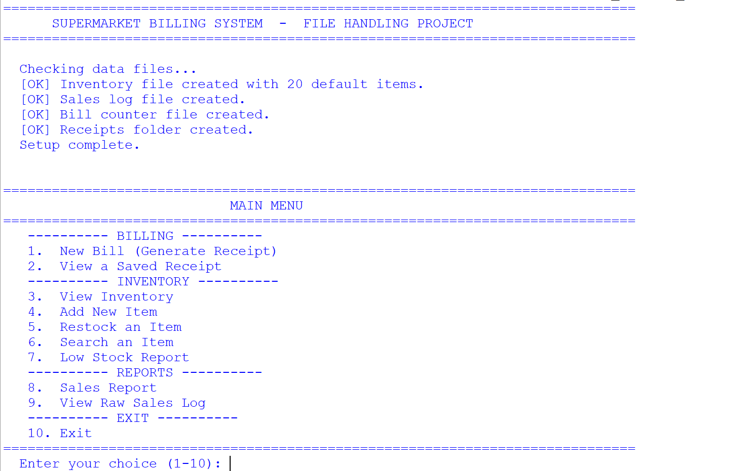Observation:
- On the very first run, the program created ______ new files/folders automatically.
- The message displayed was: ____________________________________.
- On the second run, no file-creation messages appeared because os.path.exists() returned True for all files. This proves that the files are stored permanently on the disk.

9.2 View Inventory (Option 3)
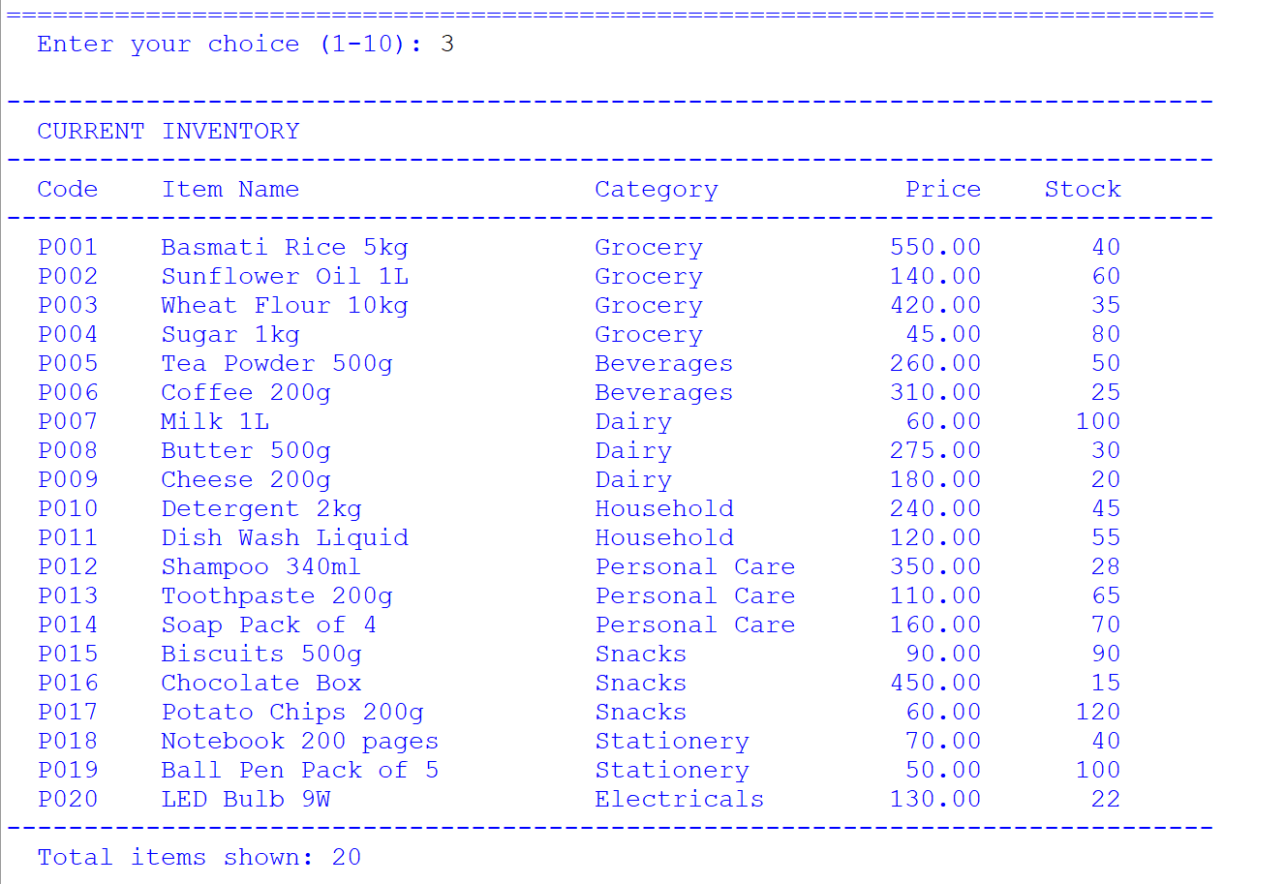Observation:
- The catalogue contains ______ items in total.
- The item with the highest price is ______________ priced at Rs. ______.
- The item with the lowest stock is ______________ with only ______ unit(s) left.

9.3 New Bill — Billing Counter (Option 1)
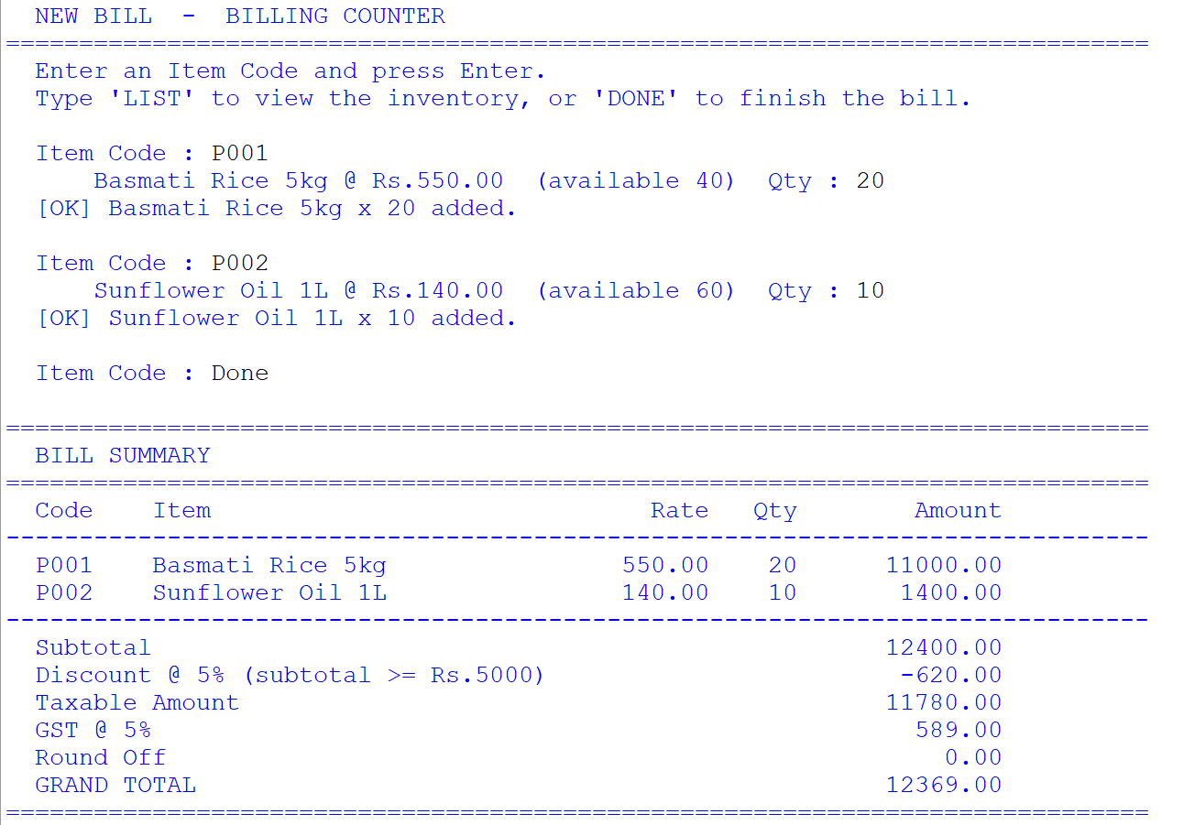
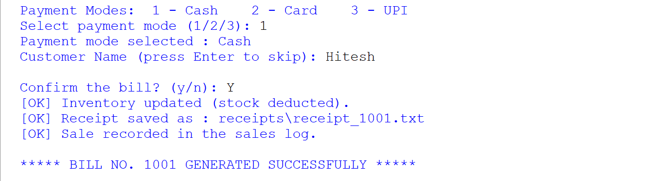
Observation:
- The bill contained ______ distinct items and ______ units in total.
- The subtotal was Rs. ______________.
- The discount applied was Rs. ______________ (this means the subtotal was ≥ Rs. 5000).
- The GST charged at 5% was Rs. ______________.
- The round-off amount was Rs. ______________.
- The grand total of the bill was Rs. ______________.
- The bill was confirmed with payment mode ______________.
Important Observation: When I tried to enter a quantity greater than the available stock, the program displayed an error message and did not accept the entry. This shows that stock validation is working correctly.

9.4 Receipt Generated (Text File)
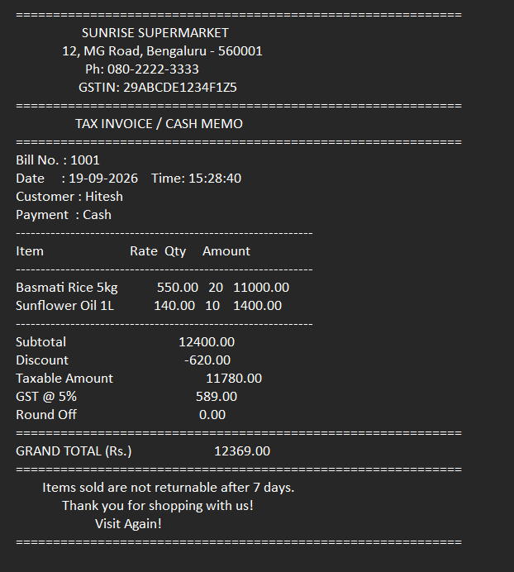
Observation:
- The receipt was saved as receipt_______.txt inside the receipts folder.
- The receipt is a plain text file that can be opened in Notepad and printed.
- The shop name and address are centred in the receipt, which was achieved using the str.center() method.
- The item columns were aligned using str.format() with {:<26} (left-aligned) and {:>11.2f} (right-aligned) format specifications.
- Opening the file in Notepad showed the receipt exactly as it would appear when printed.

9.5 Inventory Deduction (Proof that Stock was Reduced)
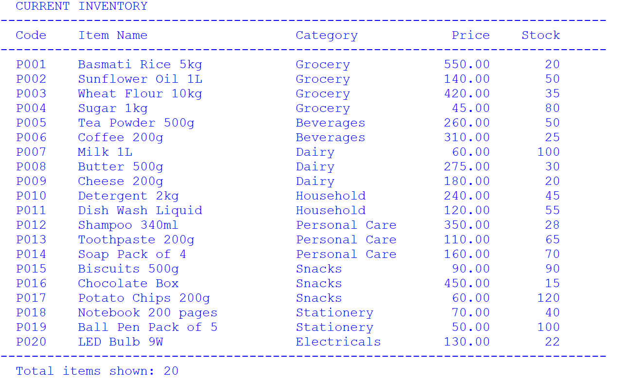
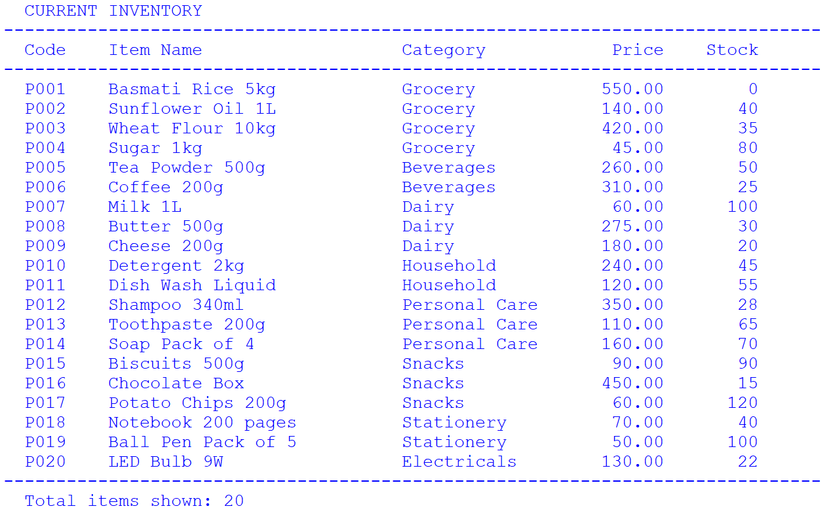
Observation:
Item Code | Item Name | Stock Before | Qty Sold | Stock After
______ | ______________ | ______ | ______ | ______
______ | ______________ | ______ | ______ | ______
______ | ______________ | ______ | ______ | ______
- This confirms that the program automatically deducted the sold quantity from inventory.csv by rewriting the file in "w" mode.
- The stock values were not lost when the program was closed and reopened — this is the main benefit of file handling over variables.

9.6 View a Saved Receipt (Option 2)
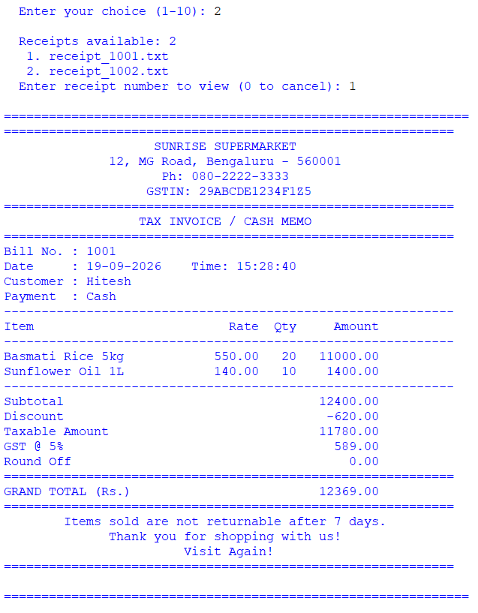
Observation:
- A total of ______ receipt file(s) were listed by os.listdir().
- The receipt was read back using open(path, "r") and f.read().
- This proves that the receipt text file was stored correctly and can be retrieved at any time.

9.7 Low Stock Report (Option 7)
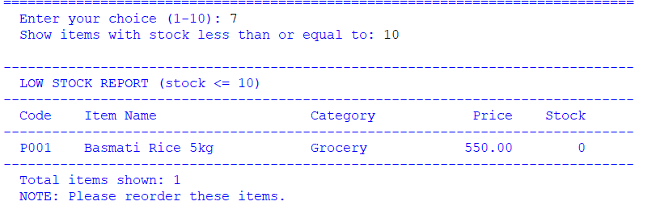Observation:
- With the limit set to ______, the program found ______ item(s) that need to be reordered.
- These items should be restocked immediately to avoid running out of stock.

9.8 Sales Report (Option 8)
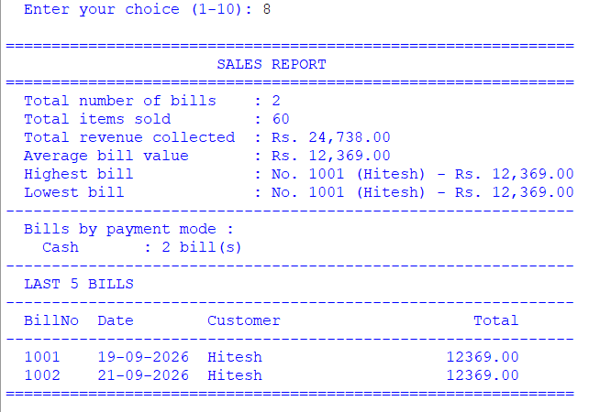Observation:
- Total number of bills generated: ______
- Total items sold: ______
- Total revenue collected: Rs. ______________
- Average bill value: Rs. ______________
- The highest bill was Bill No. ______ for Rs. ______________
- The lowest bill was Bill No. ______ for Rs. ______________
- The most preferred payment mode was ______________ with ______ bill(s).
- Conclusion: The sales report is generated by simply reading back the sales_log.csv file. This shows how a file can act as a permanent record of all transactions.

9.9 Raw Sales Log (Option 9)
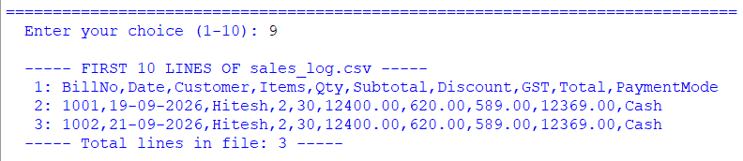Observation:
- The readlines() method returned a list of all lines in the file.
- The file contained ______ lines in total (including the header row).
- Each line is a string ending with \n, which is why rstrip() was used while printing.
- The CSV file can also be opened directly in MS Excel as a proper table, which proves the advantage of using CSV format.

10. CONCLUSION AND FUTURE SCOPE
Conclusion
In this project I successfully developed a complete Supermarket Billing System using only Python File Handling — without using any database. Through this project I learnt and applied:
- Different file modes — "r" for reading the inventory and sales log, "w" for rewriting the inventory after stock deduction, "a" for appending a new sale to the sales log, and "w" again for creating the receipt file.
- The csv module — csv.DictReader and csv.DictWriter made it easy to work with tabular data by column name, while csv.writer was used for the sales log.
- Text file writing — the receipt was generated as a formatted, printable .txt file using write() and string formatting.
- The os module — used to check whether files exist, create the receipts folder with os.makedirs(), list receipt files with os.listdir(), and build paths with os.path.join().
- Permanent storage — the biggest lesson was that data stored in files survives even after the program is closed, unlike data stored in variables.
The system performs automated billing, prevents over-selling by validating stock, deducts stock automatically, generates a professional receipt, and produces a detailed sales report — all using nothing but file handling.
Future Scope
- Barcode Scanner Integration — the item code could be read directly from a barcode scanner instead of being typed.
- Graphical User Interface — the program could be converted into a window-based application using Tkinter.
Error Message | Reason | Solution
FileNotFoundError: inventory.csv | The file was deleted or moved | Run the program again — create_files() recreates it automatically
PermissionError: [Errno 13] | The CSV file is currently open in Excel or Notepad | Close the file and run the program again
ValueError: could not convert string to float | A non-numeric value was typed where a number was expected | Enter only numbers for price and stock. The program already handles this with try-except
KeyError: 'ItemName' | The header row of the CSV is missing or misspelled | Delete inventory.csv and run the program again to recreate it with the correct header
Blank lines appearing between rows in the CSV | newline="" was not used while opening the file | The code already uses newline="" — do not remove it
ModuleNotFoundError: No module named 'csv' | Extremely rare; a corrupted Python installation | Reinstall Python 3 — csv and os are built-in
The receipt looks misaligned | The item name was longer than 25 characters and got truncated | This is intentional — the code slices names with name[:25] to keep the receipt neat
Stock becomes negative | Should not happen because the code checks qty > available | If it does, open inventory.csv and correct the stock manually, then save
os.makedirs error if the folder already exists | os.makedirs() fails if the folder exists | The code already checks with os.path.exists() before calling it
- Customer Loyalty Points — a separate file could store customer phone numbers and their accumulated points.
- Bill Printing — the receipt text file could be sent directly to a thermal printer.
- GST Reports — monthly GST reports could be generated for filing returns.
- Expiry Date Tracking — an extra column in the inventory could track expiry dates and alert the owner.
- Use of pickle — for faster storage, binary files could be used instead of CSV.

11. TROUBLESHOOTING / COMMON ERRORS
Important note on file paths: All files are created in the same folder where the Python script is saved. If you run the script from a different folder, the files will be created there. Always run the script from its own folder to keep everything together.

12. BIBLIOGRAPHY
- Websites:
  - Python Official Documentation — File I/O (docs.python.org/3/tutorial/inputoutput.html)
  - Python csv Module Documentation (docs.python.org/3/library/csv.html)
  - Python os Module Documentation (docs.python.org/3/library/os.html)
  - W3Schools (www.w3schools.com)
  - GeeksforGeeks (www.geeksforgeeks.org)
  - Stack Overflow (www.stackoverflow.com)
- Study Material:
  - NCERT Informatics Practices Textbook for Class XII
  - Sumita Arora, Informatics Practices with Python, Dhanpat Rai & Co.
- Software Documentation:
  - Python 3 IDLE Help Manual

