PROJECT FILE
INFORMATICS PRACTICES (CLASS XII)
SESSION: [Year, e.g., 2023-2024]

STUDENT REPORT CARD SYSTEM
(Automatic Grade & Percentage Calculation with Academic Records Management)
Submitted By:
[Your Name]
Class: XII – [Section]
Roll No: [Your Roll Number]
Submitted To:
[Teacher's Name]
Department of Computer Science
[Your School Name]

CERTIFICATE
This is to certify that [Your Name] of Class XII has successfully completed the Informatics Practices project titled "Student Report Card System" under the guidance of [Teacher's Name] during the academic year [Year].
This project is a bonafide record of work done by the candidate independently and fulfills the requirements of the Central Board of Secondary Education (CBSE) for the AISSCE Examination.
Teacher In-Charge: __________________
Signature: __________________
External Examiner: __________________
Signature: __________________
School Seal:

ACKNOWLEDGEMENT
I would like to express my sincere thanks to my Informatics Practices teacher [Teacher's Name] and our Principal [Principal's Name] for giving me the opportunity to work on this project titled "Student Report Card System".
While working on this project I learnt how a real school's examination record system works — how student details, subject details and marks are stored in linked tables, how percentages and grades are calculated automatically using SQL aggregate functions and Python logic, how ranks are computed by sorting the whole class, and how a professional-looking report card is printed. I would also like to thank my parents and friends who supported and encouraged me throughout the completion of this project.
Name: [Your Name]
Class: XII

TABLE OF CONTENTS
- Introduction
- Objectives of the Project
- Proposed System
- System Requirements (Hardware & Software)
- System Design (Table Structures)
- Grade and Result Logic
- Python Libraries and SQL Functions Used
- Source Code
- Output Screens and Observations
- Conclusion and Future Scope
- Troubleshooting
- Bibliography

1. INTRODUCTION
Every school maintains academic records of its students — marks in each subject, grades, percentages and rank in class. In the traditional system, teachers maintain these records in registers or Excel sheets, and calculating totals, percentages, grades and ranks for each student is a slow, error-prone manual task. A single arithmetic slip can change a student's grade.
The Student Report Card System is a software application that automates this entire process. It is a menu-driven Python program backed by a MySQL relational database. It allows the examination cell to:
- Maintain a permanent register of students (admission number, name, class, section, gender, date of birth, guardian, phone).
- Maintain a list of subjects with their maximum marks.
- Enter or update subject-wise marks for each student for each exam (Term1, Final).
- Automatically calculate the total, percentage and grade for each student.
- Automatically decide PASS or FAIL based on the per-subject passing criterion (33%).
- Automatically compute the class rank of every student.
- Print a professional Report Card for any student.
- Display the rank list of a class.
- Show subject-wise class averages, topper in each subject, pass/fail summary and grade distribution.
The database stores all data permanently, so records survive even after the program is closed and reopened — the biggest advantage of a database-driven system.
2. OBJECTIVES
The main objectives of this project are:
- To understand how Python and MySQL are connected using the mysql.connector library.
- To design a relational database with four linked tables (Students, Subjects, Marks, ReportCards) using primary keys, composite primary keys and foreign keys.
- To perform all four CRUD operations — Create, Read, Update and Delete — using SQL statements executed from Python.
- To implement automatic grade and percentage calculation using the standard CBSE grading scheme.
- To implement the PASS/FAIL logic based on a per-subject minimum of 33%.
- To compute the class rank of every student by sorting the whole class.
- To use SQL aggregate functions (COUNT, AVG, MAX, MIN) with GROUP BY and JOIN to generate analytics.
- To automatically initialise the schema and default data using CREATE DATABASE IF NOT EXISTS and CREATE TABLE IF NOT EXISTS, so the user never has to type SQL commands manually.
3. PROPOSED SYSTEM
The system is a menu-driven program divided into five modules:
3.1 Student Management Module
- Add a new student to the register.
- View all students (optionally filtered by class and section).
- Search a student by admission number or by name.
- Update a student's phone number.
- Delete a student (with automatic cleanup of related marks and report cards).
3.2 Subject Management Module
- View all subjects with their maximum marks.
- Add a new subject.
3.3 Marks Entry Module
- Enter marks for a student subject-by-subject for a chosen exam.
- If marks already exist for a subject, the current value is shown and the user can update it, or press Enter to keep it unchanged.
- Validate that marks lie between 0 and the subject's maximum.
3.4 Report Card Module
- Generate a report card for a single student (calculates total, percentage, grade, result; saves to ReportCards).
- View a previously saved report card.
- View the report cards of an entire class for a chosen exam in a compact table.
3.5 Analytics Module
- Class rank list (with automatic ClassRank update in the database).
- Subject-wise class averages, highest and lowest.
- Topper in each subject.
- Pass/Fail summary.
- Grade distribution.
4. SYSTEM REQUIREMENTS
Hardware Requirements:
- Processor: Intel Core i3 or above
- RAM: 4 GB or above
- Hard Disk: 100 GB or above
Software Requirements:
- Operating System: Windows 7/8/10/11 or Linux
- Python 3.x (IDLE / PyCharm)
- MySQL Server 5.7 or above (or XAMPP's MariaDB)
- Python-MySQL Connector (mysql-connector-python)
5. SYSTEM DESIGN (TABLE STRUCTURES)
The database is named SchoolDB. The database and tables are created automatically by the Python script on first execution.
Table 1: Students
Column | Data Type | Constraint | Description
AdmNo | INT | PRIMARY KEY | Unique admission number
Name | VARCHAR(80) | NOT NULL | Full name of the student
Class | VARCHAR(10) | NOT NULL | e.g. XII
Section | VARCHAR(5) | NOT NULL | e.g. A, B
Gender | VARCHAR(2) | NULL | M / F / O
DOB | DATE | NULL | Date of birth
Guardian | VARCHAR(80) | NULL | Parent / guardian name
Phone | VARCHAR(15) | NULL | Contact number
Table 2: Subjects
Column | Data Type | Constraint | Description
SubCode | VARCHAR(10) | PRIMARY KEY | Subject code (e.g. ENG, MATH)
SubName | VARCHAR(60) | NOT NULL | Full subject name
MaxMarks | INT | NOT NULL | Maximum marks for the subject
Table 3: Marks
Column | Data Type | Constraint | Description
AdmNo | INT | COMPOSITE PK, FK → Students | Student's admission number
SubCode | VARCHAR(10) | COMPOSITE PK, FK → Subjects | Subject code
ExamType | VARCHAR(20) | COMPOSITE PK | Term1 / Final
MarksObtained | INT | NULL | Marks scored
The composite primary key (AdmNo, SubCode, ExamType) ensures that a student can have only one mark entry per subject per exam — the database enforces this automatically.
Table 4: ReportCards
Column | Data Type | Constraint | Description
AdmNo | INT | COMPOSITE PK, FK → Students | Student's admission number
ExamType | VARCHAR(20) | COMPOSITE PK | Term1 / Final
TotalMarks | INT | NULL | Sum of marks across subjects
MaxTotal | INT | NULL | Sum of maximum marks
Percentage | DECIMAL(5,2) | NULL | TotalMarks / MaxTotal × 100
Grade | VARCHAR(4) | NULL | A1, A2, B1, … E
Result | VARCHAR(6) | NULL | PASS / FAIL
ClassRank | INT | NULL | Rank within class-section for the exam
Note: The column has been named ClassRank instead of Rank, because RANK is a reserved word in MySQL 8.0+ (used by window functions).
Relationship Diagram (in words):
text
Students (1) ─── (many) Marks ─── (many) (1) Subjects
Students (1) ─── (many) ReportCards
Default Data Inserted on First Run
- 10 default students (AdmNo 1001 to 1010) in Classes XII-A and XII-B.
- 6 default subjects: ENG, MATH, PHY, CHEM, CS, IP — each with maximum marks of 100.
- 120 default marks (10 students × 2 exams × 6 subjects) generated by random.seed(7) so they are reproducible.
- 20 pre-generated report cards (10 students × 2 exams) so the system is immediately usable.
6. GRADE AND RESULT LOGIC
6.1 Grade Bands (based on overall percentage)
Percentage | Grade | Remarks
91 – 100 | A1 | Outstanding
81 – 90 | A2 | Excellent
71 – 80 | B1 | Very Good
61 – 70 | B2 | Good
51 – 60 | C1 | Satisfactory
41 – 50 | C2 | Average
33 – 40 | D | Pass
Below 33 | E | Needs Improvement
6.2 Pass / Fail Rule
A student is declared PASS only if the marks obtained in every subject are at least 33% of that subject's maximum marks.
- If any single subject has marks below 33%, the student is declared FAIL for that exam.
- Even if the overall percentage is above 33%, a single low subject makes the overall result FAIL.
6.3 Class Rank Rule
- Students of the same Class and Section are ranked together.
- Ranking is by percentage descending; ties are broken by total marks descending.
- Ranks are stored in the ClassRank column of ReportCards whenever the rank list is recomputed.
6.4 Percentage Calculation
text
Percentage = (Total Marks Obtained / Total Maximum Marks) × 100
7. PYTHON LIBRARIES AND SQL FUNCTIONS USED
7.1 Python Libraries
- mysql.connector — establishes the connection between Python and MySQL, executes SQL statements, fetches results, and commits changes.
- datetime — records the current date (for the report card) and stores dates of birth.
- random — used once during initial setup to generate reproducible sample marks.
7.2 MySQL Connector Methods
Method | Purpose
mysql.connector.connect(...) | Opens a connection
con.cursor() | Creates a cursor
cur.execute(sql, params) | Runs a single SQL statement
cur.executemany(sql, list) | Runs the same SQL for many rows
cur.fetchone() / cur.fetchall() | Fetch one / all result rows
cur.rowcount | Rows affected by the last statement
con.commit() / con.rollback() | Save / undo changes
cur.close() / con.close() | Release resources
7.3 SQL Statements Used
Statement | Purpose
CREATE DATABASE IF NOT EXISTS | Auto-create the database
CREATE TABLE IF NOT EXISTS | Auto-create the four tables
INSERT INTO | Add students, subjects, marks, report cards
UPDATE ... SET | Modify a phone number, a mark, or a report card
DELETE FROM | Remove students / marks / report cards
SELECT ... WHERE / LIKE | Search by admission no. or name
JOIN | Combine students + marks + subjects
GROUP BY + AVG/MAX/MIN/COUNT | Analytics
INSERT ... ON DUPLICATE KEY UPDATE | Insert-or-update report cards and marks
ORDER BY ... DESC | Rank lists and toppers
8. SOURCE CODE
Below is the complete Python code. It creates the database, tables and default data automatically, so no prior SQL setup is required.
python
# ==========================================================
# STUDENT REPORT CARD SYSTEM
# Class 12 Informatics Practices Project
# Tools Used: Python 3 + MySQL (mysql-connector-python)
# ==========================================================

import mysql.connector
import datetime
import random

# ------------------------- CONFIGURATION (EDIT THESE) -------------------------
DB_HOST = "localhost"
DB_USER = "root" # <-- Change to your MySQL username
DB_PASSWORD = "" # <-- Change to your MySQL password (empty for XAMPP)
DB_NAME = "SchoolDB"

SCHOOL_NAME = "ST. XAVIER'S SENIOR SECONDARY SCHOOL"
SCHOOL_ADDR = "12, Park Street, Kolkata - 700016"
ADMIN_PASSWORD = "school123"

PASS_MARKS_PCT = 33 # passing per subject

GRADE_BANDS = [
(91, "A1", "Outstanding"),
(81, "A2", "Excellent"),
(71, "B1", "Very Good"),
(61, "B2", "Good"),
(51, "C1", "Satisfactory"),
(41, "C2", "Average"),
(33, "D", "Pass"),
(0, "E", "Needs Improvement"),
]

# 8 columns each: AdmNo, Name, Class, Section, Gender, DOB, Guardian, Phone
DEFAULT_STUDENTS = [
(1001, "Aarav Sharma", "XII", "A", "M", datetime.date(2007, 4, 12), "Ramesh Sharma", "9876543210"),
(1002, "Diya Patel", "XII", "A", "F", datetime.date(2007, 8, 25), "Nilesh Patel", "9823456781"),
(1003, "Vihaan Reddy", "XII", "A", "M", datetime.date(2006, 12, 3), "Suresh Reddy", "9812345672"),
(1004, "Ananya Iyer", "XII", "A", "F", datetime.date(2007, 2, 18), "Ganesh Iyer", "9845612378"),
(1005, "Kabir Singh", "XII", "A", "M", datetime.date(2007, 6, 30), "Harpreet Singh", "9876123450"),
(1006, "Ishita Banerjee", "XII", "A", "F", datetime.date(2007, 9, 5), "Amit Banerjee", "9834567120"),
(1007, "Arjun Nair", "XII", "B", "M", datetime.date(2007, 3, 22), "Suresh Nair", "9845123670"),
(1008, "Saanvi Joshi", "XII", "B", "F", datetime.date(2007, 11, 9), "Mahesh Joshi", "9823456710"),
(1009, "Reyansh Gupta", "XII", "B", "M", datetime.date(2007, 5, 14), "Anil Gupta", "9812673450"),
(1010, "Anika Verma", "XII", "B", "F", datetime.date(2007, 7, 1), "Sanjay Verma", "9876501234"),
]

# 3 columns each: SubCode, SubName, MaxMarks
DEFAULT_SUBJECTS = [
("ENG", "English Core", 100),
("MATH", "Mathematics", 100),
("PHY", "Physics", 100),
("CHEM", "Chemistry", 100),
("CS", "Computer Science", 100),
("IP", "Informatics Practices", 100),
]

EXAM_TYPES = ["Term1", "Final"]

# ==================== 1. HELPER FUNCTIONS ====================

def get_grade(pct):
"""Return (grade_code, remark) for a given percentage."""
for band_min, code, remark in GRADE_BANDS:
if pct >= band_min:
return code, remark
return "E", "Needs Improvement"

def connect_db():
try:
con = mysql.connector.connect(
host=DB_HOST, user=DB_USER, password=DB_PASSWORD,
database=DB_NAME)
return con
except mysql.connector.Error as err:
print("Database Connection Error:", err)
return None

def ask_int(prompt, lo=None, hi=None):
"""Robust integer input with optional range check."""
try:
v = int(input(prompt).strip())
except ValueError:
print(" [!] Please enter a whole number.")
return None
if lo is not None and v < lo:
print(" [!] Value must be at least " + str(lo))
return None
if hi is not None and v > hi:
print(" [!] Value must be at most " + str(hi))
return None
return v

# ==================== 2. DATABASE INITIALISATION ====================

def _compute_report_data(cur, adm_no, exam_type):
"""Compute report data for one student. Returns a dict or None."""
cur.execute("SELECT AdmNo, Name, Class, Section, Guardian "
"FROM Students WHERE AdmNo = %s", (adm_no,))
stu = cur.fetchone()
if not stu:
return None

cur.execute("SELECT SubCode, SubName, MaxMarks FROM Subjects ORDER BY SubCode")
subjects = cur.fetchall()
if not subjects:
return None

cur.execute("SELECT SubCode, MarksObtained FROM Marks "
"WHERE AdmNo = %s AND ExamType = %s", (adm_no, exam_type))
marks_map = {}
for r in cur.fetchall():
marks_map[r[0]] = r[1]

rows = []
total = 0
max_total = 0
all_pass = True

for sub, sname, mx in subjects:
if sub not in marks_map:
rows.append((sub, sname, mx, None, None, "-"))
continue
m = marks_map[sub]
total += m
max_total += mx
pct = round(m * 100.0 / mx, 2)
code, _ = get_grade(pct)
if pct < PASS_MARKS_PCT:
all_pass = False
rows.append((sub, sname, mx, m, pct, code))

if max_total == 0:
return None

overall_pct = round(total * 100.0 / max_total, 2)
grade, remarks = get_grade(overall_pct)
result = "PASS" if all_pass else "FAIL"

return {
"student": stu,
"subjects": rows,
"total": total,
"max_total": max_total,
"pct": overall_pct,
"grade": grade,
"remarks": remarks,
"result": result,
}

def _save_report_card(cur, adm_no, exam_type, data):
"""Insert or update the report card row."""
cur.execute("""
INSERT INTO ReportCards
(AdmNo, ExamType, TotalMarks, MaxTotal, Percentage, Grade, Result, ClassRank)
VALUES (%s, %s, %s, %s, %s, %s, %s, NULL)
ON DUPLICATE KEY UPDATE
TotalMarks = VALUES(TotalMarks),
MaxTotal = VALUES(MaxTotal),
Percentage = VALUES(Percentage),
Grade = VALUES(Grade),
Result = VALUES(Result)
""", (adm_no, exam_type, data["total"], data["max_total"],
data["pct"], data["grade"], data["result"]))

def _recalculate_ranks(cur):
"""Recompute ClassRank for every class-section and exam."""
cur.execute("SELECT DISTINCT Class, Section FROM Students")
sections = cur.fetchall()
for cls, sec in sections:
for exam in EXAM_TYPES:
cur.execute("""
SELECT r.AdmNo
FROM ReportCards r
JOIN Students s ON r.AdmNo = s.AdmNo
WHERE s.Class = %s AND s.Section = %s AND r.ExamType = %s
ORDER BY r.Percentage DESC, r.TotalMarks DESC
""", (cls, sec, exam))
rows = cur.fetchall()
for i, r in enumerate(rows, 1):
cur.execute("UPDATE ReportCards SET ClassRank = %s "
"WHERE AdmNo = %s AND ExamType = %s",
(i, r[0], exam))

def initialize_database():
"""Create database, tables and default data if they do not exist."""
try:
con = mysql.connector.connect(host=DB_HOST, user=DB_USER, password=DB_PASSWORD)
cur = con.cursor()
cur.execute("CREATE DATABASE IF NOT EXISTS " + DB_NAME)
cur.execute("USE " + DB_NAME)

cur.execute("""
CREATE TABLE IF NOT EXISTS Students (
AdmNo INT PRIMARY KEY,
Name VARCHAR(80) NOT NULL,
Class VARCHAR(10) NOT NULL,
Section VARCHAR(5) NOT NULL,
Gender VARCHAR(2),
DOB DATE,
Guardian VARCHAR(80),
Phone VARCHAR(15)
)
""")

cur.execute("""
CREATE TABLE IF NOT EXISTS Subjects (
SubCode VARCHAR(10) PRIMARY KEY,
SubName VARCHAR(60) NOT NULL,
MaxMarks INT NOT NULL
)
""")

cur.execute("""
CREATE TABLE IF NOT EXISTS Marks (
AdmNo INT,
SubCode VARCHAR(10),
ExamType VARCHAR(20),
MarksObtained INT,
PRIMARY KEY (AdmNo, SubCode, ExamType),
FOREIGN KEY (AdmNo) REFERENCES Students(AdmNo),
FOREIGN KEY (SubCode) REFERENCES Subjects(SubCode)
)
""")

cur.execute("""
CREATE TABLE IF NOT EXISTS ReportCards (
AdmNo INT,
ExamType VARCHAR(20),
TotalMarks INT,
MaxTotal INT,
Percentage DECIMAL(5,2),
Grade VARCHAR(4),
Result VARCHAR(6),
ClassRank INT,
PRIMARY KEY (AdmNo, ExamType),
FOREIGN KEY (AdmNo) REFERENCES Students(AdmNo)
)
""")

# --- Insert default students (8 values per tuple) ---
cur.execute("SELECT COUNT(*) FROM Students")
if cur.fetchone()[0] == 0:
cur.executemany(
"INSERT INTO Students VALUES "
"(%s, %s, %s, %s, %s, %s, %s, %s)",
DEFAULT_STUDENTS)
print(" [OK] " + str(len(DEFAULT_STUDENTS)) + " default students inserted.")

# --- Insert default subjects (3 values per tuple) ---
cur.execute("SELECT COUNT(*) FROM Subjects")
if cur.fetchone()[0] == 0:
cur.executemany(
"INSERT INTO Subjects VALUES (%s, %s, %s)",
DEFAULT_SUBJECTS)
print(" [OK] " + str(len(DEFAULT_SUBJECTS)) + " default subjects inserted.")

# --- Insert default marks (4 values per tuple) ---
cur.execute("SELECT COUNT(*) FROM Marks")
if cur.fetchone()[0] == 0:
random.seed(7)
marks_rows = []
for st in DEFAULT_STUDENTS:
adm = st[0]
for exam in EXAM_TYPES:
for sub, sname, mx in DEFAULT_SUBJECTS:
m = random.randint(42, 98)
marks_rows.append((adm, sub, exam, m))
cur.executemany(
"INSERT INTO Marks VALUES (%s, %s, %s, %s)",
marks_rows)
print(" [OK] " + str(len(marks_rows)) + " default marks inserted.")

# --- Pre-generate report cards (so the system is ready to use) ---
cur.execute("SELECT COUNT(*) FROM ReportCards")
if cur.fetchone()[0] == 0:
count = 0
for st in DEFAULT_STUDENTS:
for exam in EXAM_TYPES:
data = _compute_report_data(cur, st[0], exam)
if data:
_save_report_card(cur, st[0], exam, data)
count += 1
_recalculate_ranks(cur)
print(" [OK] " + str(count) + " report cards pre-generated.")

con.commit()
print(" [OK] Database '" + DB_NAME + "' and all tables are ready.")
cur.close()
con.close()

except mysql.connector.Error as err:
print("Database Initialisation Error:", err)
print("Please check DB_USER and DB_PASSWORD in the CONFIGURATION section.")
exit(1)

# ==================== 3. STUDENT MANAGEMENT ====================

def add_student():
con = connect_db()
if not con:
return
cur = con.cursor()
adm = ask_int(" Enter Admission Number: ", 1)
if adm is None:
cur.close(); con.close(); return

cur.execute("SELECT AdmNo FROM Students WHERE AdmNo = %s", (adm,))
if cur.fetchone():
print(" [!] Admission number already exists.")
cur.close(); con.close(); return

name = input(" Enter Name : ").strip()
if name == "":
print(" [!] Name cannot be blank.")
cur.close(); con.close(); return
cls = input(" Enter Class (e.g. XII): ").strip().upper()
sec = input(" Enter Section (A/B) : ").strip().upper()
gen = input(" Enter Gender (M/F/O) : ").strip().upper()
if gen not in ("M", "F", "O"):
gen = "O"
dob_txt = input(" Enter DOB (DD-MM-YYYY) or Enter to skip: ").strip()
dob = None
if dob_txt:
try:
dob = datetime.datetime.strptime(dob_txt, "%d-%m-%Y").date()
except ValueError:
print(" [!] Invalid date format. DOB left blank.")
guardian = input(" Enter Guardian Name : ").strip()
phone = input(" Enter Phone Number : ").strip()

try:
cur.execute("INSERT INTO Students VALUES (%s, %s, %s, %s, %s, %s, %s, %s)",
(adm, name, cls, sec, gen, dob, guardian, phone))
con.commit()
print(" [OK] Student '" + name + "' added with Admission No. " + str(adm) + ".")
except mysql.connector.Error as err:
print(" [!] Could not add student:", err)
finally:
cur.close(); con.close()

def view_students():
con = connect_db()
if not con:
return
cur = con.cursor()
cls = input(" Filter by Class (Enter for all): ").strip().upper()

if cls:
cur.execute("SELECT * FROM Students WHERE Class = %s ORDER BY AdmNo", (cls,))
else:
cur.execute("SELECT * FROM Students ORDER BY AdmNo")
rows = cur.fetchall()

if not rows:
print(" [!] No students found.")
else:
print("\n " + "-" * 96)
print(" {:<8}{:<24}{:<6}{:<4}{:<4}{:<13}{:<22}{:<14}".format(
"AdmNo", "Name", "Class", "Sec", "Gen", "DOB", "Guardian", "Phone"))
print(" " + "-" * 96)
for r in rows:
dob = r[5].strftime("%d-%m-%Y") if r[5] else "-"
print(" {:<8}{:<24}{:<6}{:<4}{:<4}{:<13}{:<22}{:<14}".format(
r[0], r[1][:23], r[2], r[3], r[4] or "-", dob,
(r[6] or "-")[:21], r[7] or "-"))
print(" " + "-" * 96)
print(" Total students:", len(rows))
cur.close(); con.close()

def search_student():
con = connect_db()
if not con:
return
cur = con.cursor()
print(" 1. By Admission Number")
print(" 2. By Name (contains)")
ch = input(" Enter choice (1/2): ").strip()

if ch == "1":
adm = ask_int(" Enter Admission Number: ")
if adm is None:
cur.close(); con.close(); return
cur.execute("SELECT * FROM Students WHERE AdmNo = %s", (adm,))
elif ch == "2":
key = input(" Enter part of the name: ").strip()
cur.execute("SELECT * FROM Students WHERE Name LIKE %s ORDER BY Name",
("%" + key + "%",))
else:
print(" [!] Invalid choice.")
cur.close(); con.close(); return

rows = cur.fetchall()
if not rows:
print(" [!] No matching student.")
else:
print("\n " + "-" * 96)
print(" {:<8}{:<24}{:<6}{:<4}{:<4}{:<13}{:<22}{:<14}".format(
"AdmNo", "Name", "Class", "Sec", "Gen", "DOB", "Guardian", "Phone"))
print(" " + "-" * 96)
for r in rows:
dob = r[5].strftime("%d-%m-%Y") if r[5] else "-"
print(" {:<8}{:<24}{:<6}{:<4}{:<4}{:<13}{:<22}{:<14}".format(
r[0], r[1][:23], r[2], r[3], r[4] or "-", dob,
(r[6] or "-")[:21], r[7] or "-"))
cur.close(); con.close()

def update_student_phone():
con = connect_db()
if not con:
return
cur = con.cursor()
adm = ask_int(" Enter Admission Number: ")
if adm is None:
cur.close(); con.close(); return
cur.execute("SELECT Name, Phone FROM Students WHERE AdmNo = %s", (adm,))
r = cur.fetchone()
if not r:
print(" [!] Student not found.")
cur.close(); con.close(); return
print(" Student: " + r[0] + " | Current Phone: " + (r[1] or "-"))
new_phone = input(" Enter new Phone Number: ").strip()
if new_phone == "":
print(" [!] No change.")
cur.close(); con.close(); return
cur.execute("UPDATE Students SET Phone = %s WHERE AdmNo = %s", (new_phone, adm))
con.commit()
print(" [OK] Phone updated.")
cur.close(); con.close()

def delete_student():
con = connect_db()
if not con:
return
cur = con.cursor()
adm = ask_int(" Enter Admission Number to delete: ")
if adm is None:
cur.close(); con.close(); return
cur.execute("SELECT Name FROM Students WHERE AdmNo = %s", (adm,))
r = cur.fetchone()
if not r:
print(" [!] Student not found.")
cur.close(); con.close(); return
confirm = input(" Delete '" + r[0] + "' and all marks and report cards? (y/n): ").strip().lower()
if confirm != "y":
print(" [!] Deletion cancelled.")
cur.close(); con.close(); return

try:
cur.execute("DELETE FROM Marks WHERE AdmNo = %s", (adm,))
cur.execute("DELETE FROM ReportCards WHERE AdmNo = %s", (adm,))
cur.execute("DELETE FROM Students WHERE AdmNo = %s", (adm,))
con.commit()
print(" [OK] Student and related records deleted.")
except mysql.connector.Error as err:
con.rollback()
print(" [!] Error:", err)
finally:
cur.close(); con.close()

# ==================== 4. SUBJECT MANAGEMENT ====================

def view_subjects():
con = connect_db()
if not con:
return
cur = con.cursor()
cur.execute("SELECT SubCode, SubName, MaxMarks FROM Subjects ORDER BY SubCode")
rows = cur.fetchall()
print("\n " + "-" * 60)
print(" {:<10}{:<40}{:>10}".format("Code", "Subject Name", "Max Marks"))
print(" " + "-" * 60)
for r in rows:
print(" {:<10}{:<40}{:>10}".format(r[0], r[1], r[2]))
print(" " + "-" * 60)
print(" Total subjects:", len(rows))
cur.close(); con.close()

def add_subject():
con = connect_db()
if not con:
return
cur = con.cursor()
code = input(" Enter Subject Code (e.g. BIO): ").strip().upper()
if code == "":
print(" [!] Code cannot be blank.")
cur.close(); con.close(); return
cur.execute("SELECT SubCode FROM Subjects WHERE SubCode = %s", (code,))
if cur.fetchone():
print(" [!] Subject code already exists.")
cur.close(); con.close(); return
name = input(" Enter Subject Name : ").strip()
mx = ask_int(" Enter Maximum Marks : ", 1)
if mx is None:
cur.close(); con.close(); return
try:
cur.execute("INSERT INTO Subjects VALUES (%s, %s, %s)", (code, name, mx))
con.commit()
print(" [OK] Subject '" + name + "' added.")
print(" NOTE: Please enter marks for all students in this subject")
print(" and re-generate the report cards.")
except mysql.connector.Error as err:
print(" [!] Error:", err)
finally:
cur.close(); con.close()

# ==================== 5. MARKS ENTRY ====================

def enter_marks():
con = connect_db()
if not con:
return
cur = con.cursor()
adm = ask_int(" Enter Admission Number: ")
if adm is None:
cur.close(); con.close(); return
cur.execute("SELECT Name, Class, Section FROM Students WHERE AdmNo = %s", (adm,))
st = cur.fetchone()
if not st:
print(" [!] Student not found.")
cur.close(); con.close(); return
print(" Student: " + st[0] + " (Class " + st[1] + "-" + st[2] + ")")

exam = input(" Enter Exam Type (Term1 / Final): ").strip()
if exam not in EXAM_TYPES:
print(" [!] Valid exam types are: " + ", ".join(EXAM_TYPES))
cur.close(); con.close(); return

cur.execute("SELECT SubCode, SubName, MaxMarks FROM Subjects ORDER BY SubCode")
subjects = cur.fetchall()

print("\n Enter marks for each subject.")
print(" Press Enter to keep the existing value (or skip if none).\n")

for sub, sname, mx in subjects:
cur.execute("SELECT MarksObtained FROM Marks "
"WHERE AdmNo = %s AND SubCode = %s AND ExamType = %s",
(adm, sub, exam))
r = cur.fetchone()
existing = r[0] if r else None

prompt = " {:<6}{:<28}(Max {:>3})".format(sub, sname[:27], mx)
if existing is not None:
prompt += " [current: {}]".format(existing)
prompt += ": "
txt = input(prompt).strip()
if txt == "":
continue
try:
m = int(txt)
except ValueError:
print(" [!] Invalid number, skipping.")
continue
if m < 0 or m > mx:
print(" [!] Marks must be between 0 and {}.".format(mx))
continue

if existing is None:
cur.execute("INSERT INTO Marks VALUES (%s, %s, %s, %s)",
(adm, sub, exam, m))
else:
cur.execute("UPDATE Marks SET MarksObtained = %s "
"WHERE AdmNo = %s AND SubCode = %s AND ExamType = %s",
(m, adm, sub, exam))

con.commit()
print("\n [OK] Marks saved for Admission No. " + str(adm) + " (" + exam + ").")
print(" NOTE: Please re-generate the report card for this student.")
cur.close(); con.close()

def view_marks():
con = connect_db()
if not con:
return
cur = con.cursor()
adm = ask_int(" Enter Admission Number: ")
if adm is None:
cur.close(); con.close(); return

cur.execute("SELECT Name FROM Students WHERE AdmNo = %s", (adm,))
r = cur.fetchone()
if not r:
print(" [!] Student not found.")
cur.close(); con.close(); return
print(" Student: " + r[0])

cur.execute("""
SELECT m.ExamType, m.SubCode, s.SubName, m.MarksObtained, s.MaxMarks
FROM Marks m JOIN Subjects s ON m.SubCode = s.SubCode
WHERE m.AdmNo = %s
ORDER BY m.ExamType, m.SubCode
""", (adm,))
rows = cur.fetchall()
if not rows:
print(" [!] No marks recorded for this student.")
else:
current_exam = None
for exam, code, sname, m, mx in rows:
if exam != current_exam:
print("\n " + exam.upper())
print(" " + "-" * 60)
print(" {:<8}{:<40}{:>10}".format("Code", "Subject", "Marks"))
print(" " + "-" * 60)
current_exam = exam
print(" {:<8}{:<40}{:>10}".format(code, sname[:38], "{}/{}".format(m, mx)))
cur.close(); con.close()

# ==================== 6. REPORT CARD ====================

def print_report_card(data, exam_type):
stu = data["student"]
rank_txt = str(data["rank"]) if data.get("rank") else "-"

print("\n" + "=" * 68)
print(SCHOOL_NAME.center(68))
print(SCHOOL_ADDR.center(68))
print(("REPORT CARD - " + exam_type.upper()).center(68))
print("=" * 68)
print(" Adm. No. : {:<22} Class : {}".format(stu[0], stu[2]))
print(" Name : {:<22} Section : {}".format(stu[1][:21], stu[3]))
print(" Guardian : {:<22} Date : {}".format(
(stu[4] or "-")[:21], datetime.date.today().strftime("%d-%m-%Y")))
print("-" * 68)
print(" {:<28}{:>6}{:>12}{:>10}{:>10}".format(
"Subject", "Max", "Obtained", "%", "Grade"))
print("-" * 68)
for sub, sname, mx, m, pct, gr in data["subjects"]:
if m is None:
print(" {:<28}{:>6}{:>12}{:>10}{:>10}".format(
sname[:27], mx, "Not Entered", "-", "-"))
else:
print(" {:<28}{:>6}{:>12}{:>10.2f}{:>10}".format(
sname[:27], mx, m, pct, gr))
print("-" * 68)
print(" {:<28}{:>6}{:>12}{:>10.2f}{:>10}".format(
"TOTAL", data["max_total"], data["total"], data["pct"], data["grade"]))
print("=" * 68)
print(" Result : " + data["result"])
print(" Remarks : " + data["remarks"])
print(" Class Rank : " + rank_txt)
print("=" * 68)

def generate_report_card():
con = connect_db()
if not con:
return
cur = con.cursor()
adm = ask_int(" Enter Admission Number: ")
if adm is None:
cur.close(); con.close(); return
exam = input(" Enter Exam Type (Term1 / Final): ").strip()
if exam not in EXAM_TYPES:
print(" [!] Valid exam types are: " + ", ".join(EXAM_TYPES))
cur.close(); con.close(); return

data = _compute_report_data(cur, adm, exam)
if not data:
print(" [!] Cannot generate report card.")
print(" Check the admission number, exam type, and whether all subjects have marks.")
cur.close(); con.close(); return

try:
_save_report_card(cur, adm, exam, data)
_recalculate_ranks(cur)
con.commit()

# Re-fetch the rank
cur.execute("SELECT ClassRank FROM ReportCards WHERE AdmNo=%s AND ExamType=%s",
(adm, exam))
rk = cur.fetchone()
data["rank"] = rk[0] if rk else None

print_report_card(data, exam)
print(" [OK] Report card saved/updated in the database.")
except mysql.connector.Error as err:
con.rollback()
print(" [!] Error:", err)
finally:
cur.close(); con.close()

def view_report_card():
con = connect_db()
if not con:
return
cur = con.cursor()
adm = ask_int(" Enter Admission Number: ")
if adm is None:
cur.close(); con.close(); return
exam = input(" Enter Exam Type (Term1 / Final): ").strip()

cur.execute("""
SELECT r.AdmNo, s.Name, s.Class, s.Section, s.Guardian,
r.TotalMarks, r.MaxTotal, r.Percentage, r.Grade, r.Result, r.ClassRank
FROM ReportCards r JOIN Students s ON r.AdmNo = s.AdmNo
WHERE r.AdmNo = %s AND r.ExamType = %s
""", (adm, exam))
r = cur.fetchone()
if not r:
print(" [!] No saved report card. Use 'Generate Report Card' first.")
cur.close(); con.close(); return

cur.execute("""
SELECT sub.SubCode, sub.SubName, sub.MaxMarks, m.MarksObtained
FROM Subjects sub
LEFT JOIN Marks m ON m.SubCode = sub.SubCode
AND m.AdmNo = %s AND m.ExamType = %s
ORDER BY sub.SubCode
""", (adm, exam))
subjects = cur.fetchall()

rows = []
for sub, sname, mx, m in subjects:
if m is None:
rows.append((sub, sname, mx, None, None, "-"))
else:
pct = round(m * 100.0 / mx, 2)
gr, _ = get_grade(pct)
rows.append((sub, sname, mx, m, pct, gr))

data = {
"student": (r[0], r[1], r[2], r[3], r[4]),
"subjects": rows,
"total": r[5],
"max_total": r[6],
"pct": float(r[7]),
"grade": r[8],
"remarks": get_grade(float(r[7]))[1],
"result": r[9],
"rank": r[10],
}
print_report_card(data, exam)
cur.close(); con.close()

def view_class_report_cards():
con = connect_db()
if not con:
return
cur = con.cursor()
cls = input(" Enter Class (e.g. XII): ").strip().upper()
sec = input(" Enter Section (A/B, Enter for all): ").strip().upper()
exam = input(" Enter Exam Type (Term1 / Final): ").strip()

if sec:
cur.execute("""
SELECT r.AdmNo, s.Name, r.TotalMarks, r.MaxTotal, r.Percentage,
r.Grade, r.Result, r.ClassRank
FROM ReportCards r JOIN Students s ON r.AdmNo = s.AdmNo
WHERE s.Class = %s AND s.Section = %s AND r.ExamType = %s
ORDER BY r.ClassRank
""", (cls, sec, exam))
else:
cur.execute("""
SELECT r.AdmNo, s.Name, r.TotalMarks, r.MaxTotal, r.Percentage,
r.Grade, r.Result, r.ClassRank
FROM ReportCards r JOIN Students s ON r.AdmNo = s.AdmNo
WHERE s.Class = %s AND r.ExamType = %s
ORDER BY s.Section, r.ClassRank
""", (cls, exam))

rows = cur.fetchall()
if not rows:
print(" [!] No saved report cards for this class/section/exam.")
print(" Please generate them first.")
else:
print("\n " + "-" * 100)
print(" {:<8}{:<24}{:>12}{:>6}{:>6}{:>12}{:>8}{:>8}".format(
"AdmNo", "Name", "Total", "Max", "Rank", "Percentage", "Grade", "Result"))
print(" " + "-" * 100)
for r in rows:
print(" {:<8}{:<24}{:>12}{:>6}{:>6}{:>12.2f}{:>8}{:>8}".format(
r[0], r[1][:23], r[2], r[3], r[7] or "-",
float(r[4]), r[5], r[6]))
print(" " + "-" * 100)
print(" Total students shown:", len(rows))
cur.close(); con.close()

# ==================== 7. ANALYTICS ====================

def rank_list():
con = connect_db()
if not con:
return
cur = con.cursor()
cls = input(" Enter Class (e.g. XII): ").strip().upper()
sec = input(" Enter Section (A/B, Enter for all): ").strip().upper()
exam = input(" Enter Exam Type (Term1 / Final): ").strip()

if sec:
cur.execute("SELECT AdmNo FROM Students WHERE Class=%s AND Section=%s",
(cls, sec))
else:
cur.execute("SELECT AdmNo FROM Students WHERE Class=%s", (cls,))
adm_nos = [r[0] for r in cur.fetchall()]

data_rows = []
for adm in adm_nos:
d = _compute_report_data(cur, adm, exam)
if d:
data_rows.append(d)

if not data_rows:
print(" [!] No report data available for this class and exam.")
cur.close(); con.close(); return

data_rows.sort(key=lambda d: (-d["pct"], -d["total"]))

# Save updated ranks back
for i, d in enumerate(data_rows, 1):
d["rank"] = i
_save_report_card(cur, d["student"][0], exam, d)
cur.execute("UPDATE ReportCards SET ClassRank = %s "
"WHERE AdmNo = %s AND ExamType = %s",
(i, d["student"][0], exam))
con.commit()

print("\n " + "=" * 80)
print(("RANK LIST - Class " + cls + (("-" + sec) if sec else "") +
" | " + exam.upper()).center(80))
print("=" * 80)
print(" {:<6}{:<8}{:<24}{:>10}{:>10}{:>8}{:>8}".format(
"Rank", "AdmNo", "Name", "Total", "Percent", "Grade", "Result"))
print(" " + "-" * 80)
for d in data_rows:
print(" {:<6}{:<8}{:<24}{:>10}{:>10.2f}{:>8}{:>8}".format(
d["rank"], d["student"][0], d["student"][1][:23],
d["total"], d["pct"], d["grade"], d["result"]))
print(" " + "-" * 80)
print(" Total students ranked:", len(data_rows))
cur.close(); con.close()

def subject_averages():
con = connect_db()
if not con:
return
cur = con.cursor()
cls = input(" Enter Class (e.g. XII): ").strip().upper()
exam = input(" Enter Exam Type (Term1 / Final): ").strip()

cur.execute("""
SELECT sub.SubCode, sub.SubName, sub.MaxMarks,
COUNT(m.AdmNo), AVG(m.MarksObtained),
MAX(m.MarksObtained), MIN(m.MarksObtained)
FROM Marks m
JOIN Students s ON m.AdmNo = s.AdmNo
JOIN Subjects sub ON m.SubCode = sub.SubCode
WHERE s.Class = %s AND m.ExamType = %s
GROUP BY sub.SubCode, sub.SubName, sub.MaxMarks
ORDER BY sub.SubCode
""", (cls, exam))
rows = cur.fetchall()
if not rows:
print(" [!] No marks recorded for this class and exam.")
else:
print("\n " + "-" * 90)
print(("SUBJECT-WISE PERFORMANCE - Class " + cls +
" | " + exam.upper()).center(90))
print(" " + "-" * 90)
print(" {:<8}{:<28}{:>8}{:>8}{:>12}{:>12}{:>12}".format(
"Code", "Subject", "Max", "Count", "Average", "Highest", "Lowest"))
print(" " + "-" * 90)
for r in rows:
print(" {:<8}{:<28}{:>8}{:>8}{:>12.2f}{:>12}{:>12}".format(
r[0], r[1][:27], r[2], r[3], float(r[4]), r[5], r[6]))
print(" " + "-" * 90)
cur.close(); con.close()

def subject_toppers():
con = connect_db()
if not con:
return
cur = con.cursor()
cls = input(" Enter Class (e.g. XII): ").strip().upper()
exam = input(" Enter Exam Type (Term1 / Final): ").strip()

cur.execute("SELECT SubCode, SubName, MaxMarks FROM Subjects ORDER BY SubCode")
subjects = cur.fetchall()
print("\n " + "=" * 76)
print(("SUBJECT TOPPERS - Class " + cls + " | " + exam.upper()).center(76))
print("=" * 76)
any_found = False
for sub, sname, mx in subjects:
cur.execute("""
SELECT s.Name, m.MarksObtained
FROM Marks m JOIN Students s ON m.AdmNo = s.AdmNo
WHERE s.Class = %s AND m.ExamType = %s AND m.SubCode = %s
ORDER BY m.MarksObtained DESC, s.Name LIMIT 1
""", (cls, exam, sub))
r = cur.fetchone()
if r:
any_found = True
print(" {:<28}{:<24}{:>3} / {:>3}".format(
sname[:27], r[0][:23], r[1], mx))
if not any_found:
print(" [!] No marks recorded for this class and exam.")
print("=" * 76)
cur.close(); con.close()

def pass_fail_summary():
con = connect_db()
if not con:
return
cur = con.cursor()
cls = input(" Enter Class (e.g. XII): ").strip().upper()
sec = input(" Enter Section (A/B, Enter for all): ").strip().upper()
exam = input(" Enter Exam Type (Term1 / Final): ").strip()

if sec:
cur.execute("""
SELECT r.Result, COUNT(*)
FROM ReportCards r JOIN Students s ON r.AdmNo = s.AdmNo
WHERE s.Class = %s AND s.Section = %s AND r.ExamType = %s
GROUP BY r.Result
""", (cls, sec, exam))
else:
cur.execute("""
SELECT r.Result, COUNT(*)
FROM ReportCards r JOIN Students s ON r.AdmNo = s.AdmNo
WHERE s.Class = %s AND r.ExamType = %s
GROUP BY r.Result
""", (cls, exam))
rows = cur.fetchall()

total = sum(r[1] for r in rows)
print("\n " + "=" * 56)
print(("PASS / FAIL SUMMARY - Class " + cls +
(("-" + sec) if sec else "") + " | " + exam.upper()).center(56))
print("=" * 56)
if total == 0:
print(" [!] No report cards available for this class and exam.")
else:
for result, cnt in rows:
pct = cnt * 100.0 / total
print(" {:<10}: {:>4} student(s) ({:.2f}%)".format(result, cnt, pct))
print(" " + "-" * 56)
print(" Total : {:>4} student(s)".format(total))
print("=" * 56)
cur.close(); con.close()

def grade_distribution():
con = connect_db()
if not con:
return
cur = con.cursor()
cls = input(" Enter Class (e.g. XII): ").strip().upper()
exam = input(" Enter Exam Type (Term1 / Final): ").strip()

cur.execute("""
SELECT r.Grade, COUNT(*)
FROM ReportCards r JOIN Students s ON r.AdmNo = s.AdmNo
WHERE s.Class = %s AND r.ExamType = %s
GROUP BY r.Grade
ORDER BY r.Grade
""", (cls, exam))
rows = cur.fetchall()

print("\n " + "=" * 56)
print(("GRADE DISTRIBUTION - Class " + cls + " | " + exam.upper()).center(56))
print("=" * 56)
if not rows:
print(" [!] No report cards available.")
else:
total = sum(r[1] for r in rows)
for code, cnt in rows:
remark = get_grade(0)[1]
for bmin, gc, rem in GRADE_BANDS:
if gc == code:
remark = rem
break
bar = "#" * cnt
print(" {:<4}{:<20}{:>4} {}".format(code, remark, cnt, bar))
print(" " + "-" * 56)
print(" Total students: " + str(total))
print("=" * 56)
cur.close(); con.close()

# ==================== 8. MAIN MENU ====================

def main():
print("=" * 72)
print(" " + SCHOOL_NAME)
print(" STUDENT REPORT CARD SYSTEM")
print("=" * 72)

print("\n Checking database...")
initialize_database()

print("\n Please log in.")
pwd = input(" Enter Admin Password: ").strip()
if pwd != ADMIN_PASSWORD:
print(" [!] Wrong password. Exiting.")
return

while True:
print("\n" + "=" * 72)
print(" MAIN MENU")
print("=" * 72)
print(" ---------- STUDENTS ----------")
print(" 1. Add Student")
print(" 2. View All Students")
print(" 3. Search Student")
print(" 4. Update Student Phone")
print(" 5. Delete Student")
print(" ---------- SUBJECTS ----------")
print(" 6. View All Subjects")
print(" 7. Add New Subject")
print(" ---------- MARKS ----------")
print(" 8. Enter / Update Marks")
print(" 9. View Marks of a Student")
print(" ---------- REPORT CARDS ----------")
print(" 10. Generate Report Card")
print(" 11. View Saved Report Card")
print(" 12. View Class Report Cards")
print(" ---------- ANALYTICS ----------")
print(" 13. Class Rank List")
print(" 14. Subject-wise Averages")
print(" 15. Subject Toppers")
print(" 16. Pass / Fail Summary")
print(" 17. Grade Distribution")
print(" ---------- EXIT ----------")
print(" 18. Exit")
print("=" * 72)

ch = input(" Enter your choice (1-18): ").strip()

if ch == "1":
add_student()
elif ch == "2":
view_students()
elif ch == "3":
search_student()
elif ch == "4":
update_student_phone()
elif ch == "5":
delete_student()
elif ch == "6":
view_subjects()
elif ch == "7":
add_subject()
elif ch == "8":
enter_marks()
elif ch == "9":
view_marks()
elif ch == "10":
generate_report_card()
elif ch == "11":
view_report_card()
elif ch == "12":
view_class_report_cards()
elif ch == "13":
rank_list()
elif ch == "14":
subject_averages()
elif ch == "15":
subject_toppers()
elif ch == "16":
pass_fail_summary()
elif ch == "17":
grade_distribution()
elif ch == "18":
print("\n Thank you for using the Student Report Card System. Goodbye!")
break
else:
print(" [!] Invalid choice. Please enter a number from 1 to 18.")

# ---------------------- PROGRAM STARTS HERE ----------------------
if __name__ == "__main__":
main()

9. OUTPUT SCREENS AND OBSERVATIONS
9.1 Program Start and Database Initialisation
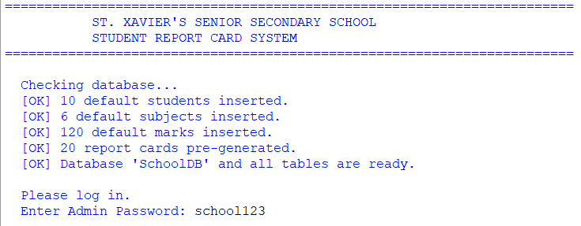Observation:
- On the first run, the program automatically created the database SchoolDB and 4 tables (Students, Subjects, Marks, ReportCards).
- It inserted 10 students, 6 subjects, 120 marks and 20 report cards.
- On the second run, the "inserted" messages did not appear because the SELECT COUNT(*) checks returned non-zero values. This proves the data is stored permanently in the database.
- I noticed the column ClassRank was used instead of Rank. This was a deliberate choice — RANK is a reserved word in MySQL 8.0+ (used by window functions), and using it as a column name would cause an SQL syntax error.

9.2 View All Students (Option 2)
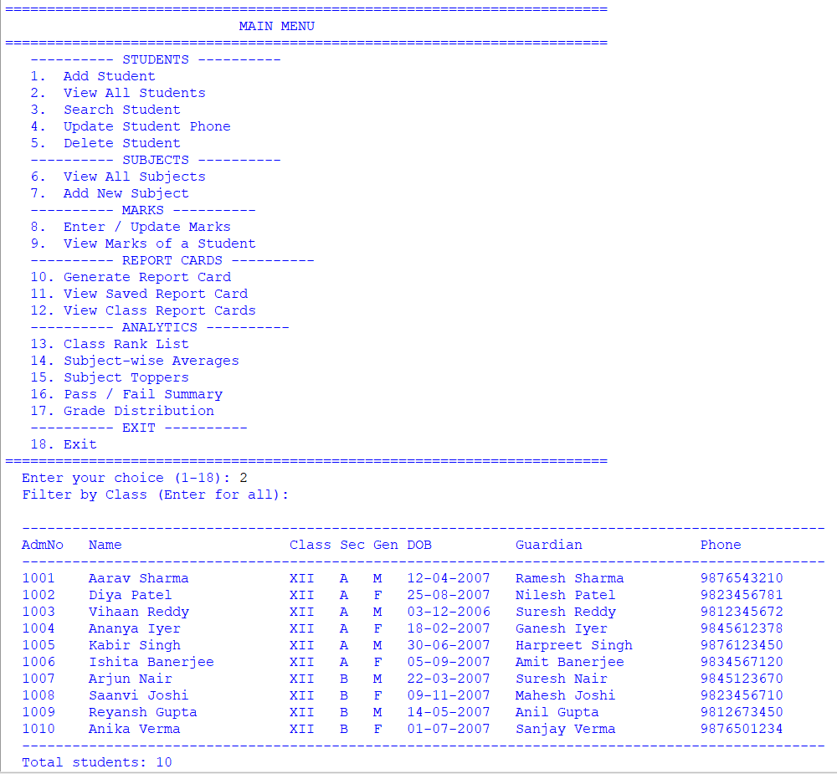Observation:
- There are ______ students registered.
- The student with admission number 1001 is __________________.
- Sections A and B contain ______ and ______ students respectively.
- The date of birth column was formatted as DD-MM-YYYY in the output using the strftime() method.

9.3 View All Subjects (Option 6)
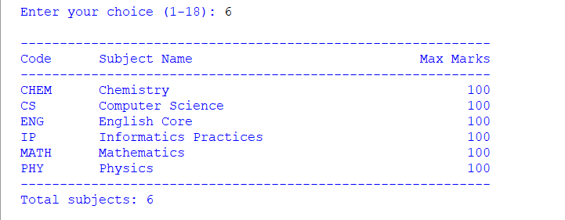Observation:
- There are ______ subjects in the system.
- Every subject has maximum marks of ______.
- The subject with code MATH is Mathematics.

9.4 Enter / Update Marks (Option 8)
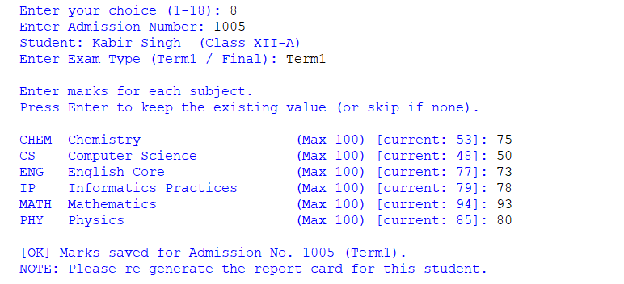Observation:
- I updated the marks for Admission No. ______ in the ______ exam.
- For subjects where a previous mark was already recorded, the current value was displayed as [current: XX] in the prompt — this made it easy to keep unchanged values by simply pressing Enter.
- The program validated that the entered mark was between 0 and the subject's maximum.
- The INSERT ... ON DUPLICATE KEY UPDATE pattern was not strictly needed for marks because the composite primary key (AdmNo, SubCode, ExamType) ensures uniqueness, and the program checks first whether a mark already exists before choosing INSERT or UPDATE.

9.5 Generate Report Card (Option 10)
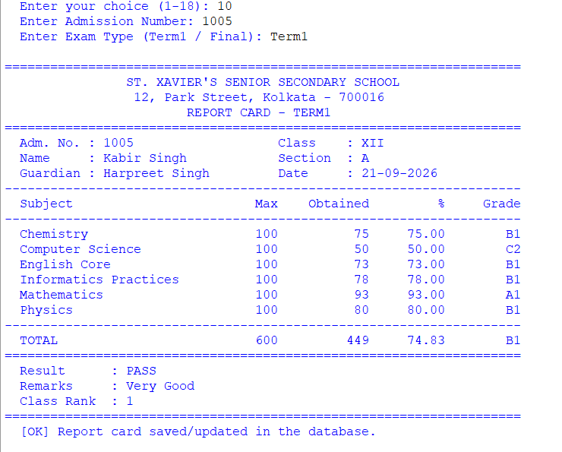Observation:
Field | Value
Admission No. | ______
Name | __________________
Class / Section | ______ / ______
Exam | ______
Total Marks | ______ / ______
Percentage | ______ %
Grade | ______
Result | ______
Class Rank | ______
- The total, percentage and grade were computed automatically — the user did not enter any of them.
- The grade was determined by comparing the percentage against the bands stored in the GRADE_BANDS list.
- The result was determined by checking whether every subject had at least 33% marks — this is why a single weak subject can produce a FAIL result even with a high overall percentage.
- The row was saved to the ReportCards table using INSERT ... ON DUPLICATE KEY UPDATE, so re-generating the same report card did not create a duplicate row.
- Immediately after saving, _recalculate_ranks() was called, so the ClassRank shown on the report card was up-to-date.

9.6 View Saved Report Card (Option 11)
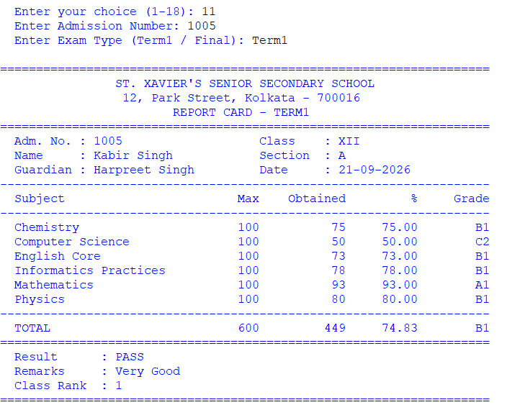Observation:
- The data displayed was identical to when it was generated — this proves it was stored in the database and not just computed in memory.
- The report was retrieved using a JOIN between ReportCards and Students for the header information, plus a LEFT JOIN between Subjects and Marks for the subject rows.
- The LEFT JOIN was important because if a subject had no marks, it would still appear in the list with Not Entered instead of being silently dropped.

9.7 View Class Report Cards (Option 12)
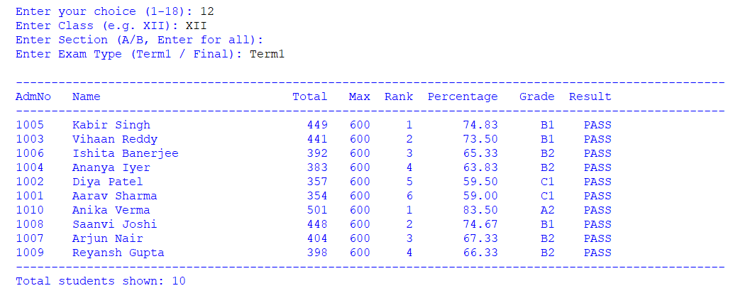Observation:
- The table showed ______ students of Class XII for the ______ exam.
- The results were sorted by ClassRank — the topper appeared first.
- This view is exactly what the examination cell would use to prepare the merit list for a class.

9.8 Class Rank List (Option 13)
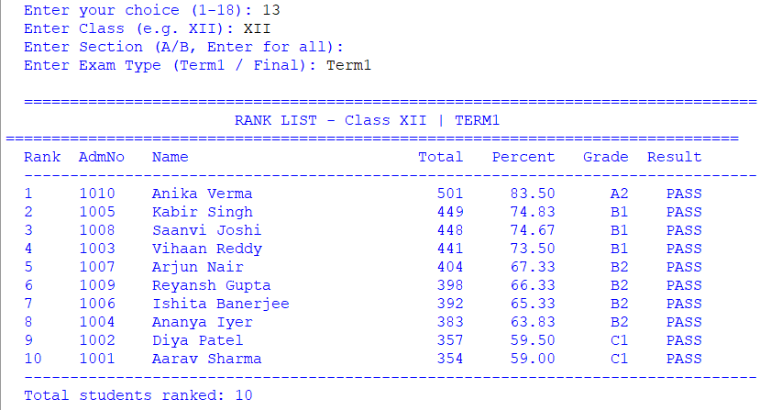Observation:
Rank | AdmNo | Name | Total | Percentage | Grade | Result
1 | ______ | __________________ | ______ | ______ | ______ | ______
2 | ______ | __________________ | ______ | ______ | ______ | ______
3 | ______ | __________________ | ______ | ______ | ______ | ______
- The topper of Class XII-____ in ______ was __________________ with ______ %.
- The ranking was computed in Python by sorting the data with the key (-percentage, -total), so students with equal percentage were ordered by their total marks — a standard tie-break rule.
- Important: The rank list function updates the ClassRank column in the ReportCards table every time it runs. This means after viewing the rank list, opening the individual report card of any student will show the updated rank.
- The entire operation was wrapped in a single transaction with con.commit() at the end — this ensures that if any error occurred midway, the entire rank update would be rolled back and the database would remain consistent.

9.9 Subject-wise Averages (Option 14)
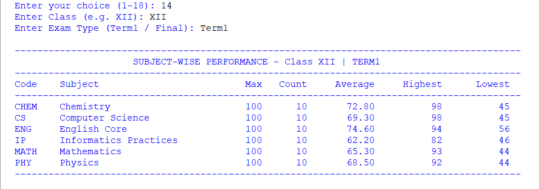Observation:
Code | Subject | Max | Count | Average | Highest | Lowest
______ | ______ | 100 | ______ | ______ | ______ | ______
______ | ______ | 100 | ______ | ______ | ______ | ______
- The averages were computed entirely by MySQL using the AVG() aggregate function — not in Python. This is more efficient because the data never had to leave the database.
- The JOIN between Marks, Students and Subjects allowed the query to filter by class and exam type while still displaying the full subject name.
- Conclusion: The subject with the highest class average is __________________, which means the students are strongest in this subject. The subject with the lowest average, __________________, may need additional teaching support.

9.10 Subject Toppers (Option 15)
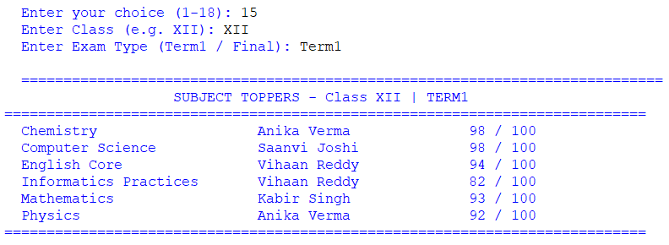Observation:
- The topper in English Core was __________________ with ______ / 100 marks.
- The topper in Mathematics was __________________ with ______ / 100 marks.
- The query used ORDER BY MarksObtained DESC LIMIT 1 — a very useful SQL pattern for finding the maximum value in each group without needing a sub-query.

9.11 Pass / Fail Summary (Option 16)
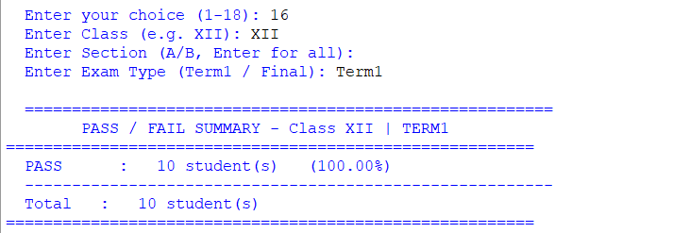Observation:
- Total students: ______
- Passed: ______ (______ %)
- Failed: ______ (______ %)
- Conclusion: The pass percentage gives a quick measure of the class's overall academic health. The GROUP BY r.Result clause in the SQL query made this computation a single line of code.

9.12 Grade Distribution (Option 17)
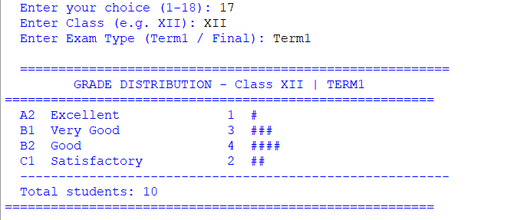Observation:
- Grade A1: ______ students
- Grade A2: ______ students
- Grade B1: ______ students
- Grade B2: ______ students
- The text-based bar (# repeated count times) provided a quick visualisation of the distribution without needing any charting library.
- Conclusion: The distribution shows whether the class is clustered around a middle grade or spread widely — useful information for the school administration.

10. CONCLUSION AND FUTURE SCOPE
Conclusion
In this project I successfully developed a complete, database-driven Student Report Card System using Python and MySQL. Through this project I learnt and applied:
- Python–MySQL Connectivity: Using mysql.connector.connect(), cursor(), execute(), executemany(), fetchone(), fetchall(), commit() and rollback() to run SQL statements from inside Python.
- Relational database design: Creating four linked tables using a composite primary key in Marks and ReportCards, and foreign keys to Students and Subjects. This enforces referential integrity — a mark cannot exist without a student, and a subject cannot be deleted while marks reference it.
- Automatic schema initialisation: Using CREATE DATABASE IF NOT EXISTS and CREATE TABLE IF NOT EXISTS so the program needs no manual SQL setup.
- Automatic grade calculation: Implementing the standard CBSE grade bands in a Python list and looking them up with a simple loop.
- Result logic: Declaring a student PASS only when every subject meets the per-subject passing mark of 33%.
- Class rank computation: Sorting the whole class-section by percentage and updating the ClassRank column in the database in a single transaction.
- Insert-or-update pattern: Using INSERT ... ON DUPLICATE KEY UPDATE so that regenerating a report card never creates a duplicate row.
- Aggregate functions and grouping: Generating meaningful analytics with COUNT(), AVG(), MAX() and MIN() combined with JOIN and GROUP BY.
- The datetime module: Storing dates of birth and stamping the current date on every generated report card.
The project demonstrated the true power of a relational database: data is structured, relationships are enforced, complex calculations can be pushed into SQL for efficiency, and everything runs fast — even as the number of students grows.
Future Scope
- Graphical User Interface (GUI) using Tkinter so the examination cell can click buttons instead of typing menu options.
- Printable PDF Report Cards using the reportlab library.
- Attendance Integration: A separate Attendance table so the report card can also show attendance percentage.
- Co-Scholastic Grades: Additional columns for discipline, sports, and art.
- Rank Certificate Generation: Auto-generate certificates for the top 3 students of each class.
- Term-over-Term Progress: A comparison view showing how a student improved between Term1 and Final.
- Subject Choice / Electives: Support for students choosing optional subjects.
- Web Interface: A Flask or Django web portal so teachers can enter marks from their phones.
- Backup Utility: A one-click feature to export the entire database as a CSV backup.

11. TROUBLESHOOTING
11.1 Database Connection Errors
If you see:
text
Database Connection Error: 1045 (28000): Access denied for user 'root'@'localhost' (using password: YES)
follow the same steps as in the previous projects:
- Ensure MySQL is running (XAMPP Control Panel → Start MySQL).
- Test credentials from the command line: mysql -u root -p. If login works, use the same password in the script.
- Create a dedicated user (recommended):
sql
CREATE USER 'school_user'@'localhost' IDENTIFIED BY 'your_password';
GRANT ALL PRIVILEGES ON *.* TO 'school_user'@'localhost';
FLUSH PRIVILEGES;
Then set DB_USER = "school_user" and DB_PASSWORD = "your_password".
- Change authentication plugin (MySQL 8.0+ only):
sql
ALTER USER 'school_user'@'localhost'
IDENTIFIED WITH mysql_native_password BY 'your_password';
FLUSH PRIVILEGES;
- Install / upgrade the connector: pip install --upgrade mysql-connector-python.
11.2 Common SQL / Python Errors
Error | Reason | Solution
Not all parameters were used in the SQL statement | The tuple has more values than %s placeholders in the SQL | Count the placeholders and match them to the tuple. In this project every INSERT matches exactly (8, 3, 4, 8).
Unknown column 'Rank' in 'field list' | RANK is a reserved word in MySQL 8.0+ | Use ClassRank (already done in this project) or wrap the column name in back-ticks: `Rank`
Duplicate entry '...' for key 'PRIMARY' | Trying to insert a row whose PK already exists | Use INSERT ... ON DUPLICATE KEY UPDATE (already done for ReportCards)
Cannot add or update a child row: a foreign key constraint fails | Trying to enter marks for a student or subject that does not exist | Add the student/subject first
Cannot delete or update a parent row: a foreign key constraint fails | Trying to delete a student who still has marks or report cards | Delete the related Marks and ReportCards rows first (this project's delete_student() does this automatically)
Incorrect date value: '15/07/2007' | Wrong date format | Always use DD-MM-YYYY at the input, which is then converted using strptime
Data too long for column 'Name' | Name longer than 80 characters | Enter a shorter name or increase the column size
Report card shows Not Entered for a subject | Marks were not entered for that subject | Use Option 8 to enter the missing marks, then regenerate the report card
Rank list appears outdated | Marks were updated after the last rank computation | Run Option 13 (Class Rank List) or Option 10 (Generate Report Card) again — both recalculate ranks

12. BIBLIOGRAPHY
- Websites:
  - MySQL Connector/Python Documentation (dev.mysql.com/doc/connector-python)
  - Python Official Documentation — datetime (docs.python.org/3/library/datetime.html)
  - W3Schools — SQL Tutorial (www.w3schools.com/sql)
  - GeeksforGeeks (www.geeksforgeeks.org)
  - Stack Overflow (www.stackoverflow.com)
- Study Material:
  - NCERT Informatics Practices Textbook for Class XII
  - Sumita Arora, Informatics Practices with Python, Dhanpat Rai & Co.
- Reference Manual:
  - MySQL 8.0 Reference Manual — including the full list of reserved words (dev.mysql.com/doc/refman/8.0/en/keywords.html)

