PROJECT FILE
INFORMATICS PRACTICES (CLASS XII)
SESSION: [Year, e.g., 2023-2024]

SALES DATA VISUALIZATION
(Analysis of Company Sales Data using Pandas and Matplotlib)
Submitted By:
[Your Name]
Class: XII – [Section]
Roll No: [Your Roll Number]
Submitted To:
[Teacher's Name]
Department of Computer Science
[Your School Name]

CERTIFICATE
This is to certify that [Your Name] of Class XII has successfully completed the Informatics Practices project titled "Sales Data Visualization" under the guidance of [Teacher's Name] during the academic year [Year].
This project is a bonafide record of work done by the candidate independently and fulfills the requirements of the Central Board of Secondary Education (CBSE) for the AISSCE Examination.
Teacher In-Charge: __________________
Signature: __________________
External Examiner: __________________
Signature: __________________
School Seal:

ACKNOWLEDGEMENT
I would like to express my sincere thanks to my Informatics Practices teacher [Teacher's Name] and our Principal [Principal's Name] for giving me the opportunity to work on this project titled "Sales Data Visualization".
Through this project I learnt how to analyse real business data using Pandas and how to present the results visually using Matplotlib. I would also like to thank my parents and friends who supported and encouraged me throughout the completion of this project.
Name: [Your Name]
Class: XII

TABLE OF CONTENTS
- Introduction
- Objectives of the Project
- Proposed System
- System Requirements (Hardware & Software)
- Theory: Pandas and Matplotlib
- Data Description (Dataset Structure)
- Functions Used (Quick Reference)
- Source Code
- Output Screens and Observations
- Conclusion and Future Scope
- Troubleshooting / Common Errors
- Bibliography

1. INTRODUCTION
Every company generates a large amount of sales data every day. If this data is simply stored in files or registers, it is of no use. To make good business decisions, the company must analyse this data and visualise it in the form of graphs and charts.
Sales Data Visualization is a project that reads a company's sales data, analyses it using the Pandas library of Python, and then presents the results using different types of graphs drawn with the Matplotlib library.
The project answers important business questions such as:
- Which region earns the highest revenue?
- Which product sells the most?
- In which month are the sales the highest?
- Who is the best salesperson?
- Is there a relationship between the number of units sold and the revenue earned?
The dataset used in this project is generated automatically by the program itself and stored in a CSV (Comma Separated Values) file named sales_data.csv. The program then reads this file using Pandas and produces both tabular output and graphical output.
2. OBJECTIVES
The main objectives of this project are:
- To understand how a CSV file is read and analysed using the Pandas library.
- To learn how to create a DataFrame and perform operations on it.
- To add a derived (calculated) column Revenue using existing columns.
- To group and summarise data using groupby() and sum().
- To sort and filter data to find the top and bottom performers.
- To visualise data using different types of charts — Bar, Line, Pie, Histogram, Scatter and Stacked Bar.
- To interpret the graphs and draw meaningful conclusions from them.
3. PROPOSED SYSTEM
The proposed system is a menu-driven Python program consisting of the following modules:
- Dataset Module
  - Automatically creates a CSV file sales_data.csv containing 48 sales records (12 months × 4 regions).
  - If the file already exists, the user is asked whether to regenerate it.
- Analysis Module (Pandas)
  - Loads the CSV file into a DataFrame.
  - Adds a calculated column Revenue = Units_Sold × Unit_Price.
  - Displays head, tail, shape, data types and statistical summary.
  - Performs grouping and aggregation region-wise, product-wise, month-wise and salesperson-wise.
- Visualization Module (Matplotlib)
  - Draws 7 different charts and saves each one as a PNG image file.
  - Displays all charts in a single dashboard (2 × 2 subplots).
4. SYSTEM REQUIREMENTS
Hardware Requirements:
- Processor: Intel Core i3 or above
- RAM: 4 GB or above
- Hard Disk: 100 GB or above
Software Requirements:
- Operating System: Windows 7/8/10/11 or Linux
- Python 3.x (IDLE / PyCharm / Jupyter Notebook)
- Pandas library (pip install pandas)
- Matplotlib library (pip install matplotlib)
- MS Word / MS Excel (for documentation and viewing the CSV)
Note: No database (MySQL) is required for this project.
5. THEORY: PANDAS AND MATPLOTLIB
5.1 Pandas
Pandas is an open-source Python library used for data analysis and data manipulation. It provides two main data structures:
Structure | Description
Series | A one-dimensional labelled array. It is like a single column of data.
DataFrame | A two-dimensional labelled data structure (rows and columns) — like a spreadsheet or a table.
In this project, the entire CSV file is loaded into a DataFrame and all analysis is performed on it.
5.2 Matplotlib
Matplotlib is a Python library used for creating static, animated and interactive visualisations. The pyplot module (matplotlib.pyplot) is used to draw graphs. Each chart is created inside a figure object, and show() displays it on the screen while savefig() saves it as an image.
5.3 Types of Charts Used in This Project
Chart | Purpose
Bar Chart | Comparing revenue of different regions / products
Horizontal Bar Chart | Comparing many categories with long names
Line Chart | Showing the monthly trend of revenue
Pie Chart | Showing the percentage share of each region
Histogram | Showing the frequency distribution of units sold
Scatter Plot | Showing the relationship between units sold and revenue
Stacked Bar Chart | Showing monthly revenue divided by region
6. DATA DESCRIPTION (DATASET STRUCTURE)
The program generates a file named sales_data.csv with 48 records (12 months × 4 regions).
Column Name | Data Type | Description
Month | Text | Month of sale (Jan, Feb, … Dec)
Region | Text | North, South, East, West
Product | Text | Laptop, Mobile, Tablet, Printer, Camera
Salesperson | Text | Name of the salesperson
Units_Sold | Integer | Number of units sold (5 to 60)
Unit_Price | Integer | Price of one unit
Revenue | Float | Calculated column = Units_Sold × Unit_Price
Sample of the generated dataset (your actual values may differ slightly — copy the real output of Option 1 here):
Month | Region | Product | Salesperson | Units_Sold | Unit_Price | Revenue
Jan | North | Laptop | Rahul | 42 | 55000 | 2310000
Jan | South | Tablet | Neha | 17 | 35000 | 595000
Jan | East | Printer | Amit | 55 | 15000 | 825000
Jan | West | Mobile | Priya | 28 | 25000 | 700000
Feb | North | Camera | Vikram | 33 | 45000 | 1485000
7. FUNCTIONS USED (QUICK REFERENCE)
7.1 Pandas Functions
Function | Use in this Project
read_csv() | Reads the CSV file into a DataFrame
to_csv() | Writes the DataFrame to a CSV file
head() / tail() | Displays first / last 5 rows
shape | Returns number of rows and columns
columns | Returns the column names
dtypes | Returns the data type of each column
describe() | Gives statistical summary (count, mean, min, max, etc.)
groupby() | Groups data by a column
sum() | Adds values within each group
sort_values() | Sorts data in ascending / descending order
pivot_table() | Creates a cross-tab (Month × Region) of revenue
to_string() | Prints a DataFrame neatly without truncation
Boolean filtering | df[df["Revenue"] > 1000000]
7.2 Matplotlib Functions
Function | Use in this Project
figure() | Creates a new figure of a given size
bar() / barh() | Draws vertical / horizontal bar charts
plot() | Draws a line chart
pie() | Draws a pie chart
hist() | Draws a histogram
scatter() | Draws a scatter plot
subplots() | Creates a grid of charts (dashboard)
title(), xlabel(), ylabel() | Adds titles and axis labels
legend() | Displays the legend
grid() | Adds grid lines for readability
xticks(rotation=) | Rotates x-axis labels
tight_layout() | Adjusts spacing so labels don't overlap
savefig() | Saves the chart as an image file
show() | Displays the chart on the screen
8. SOURCE CODE
Below is the complete Python code for the project. It creates its own dataset, so no external file is needed.
python
# ==========================================================
# SALES DATA VISUALIZATION
# Class 12 Informatics Practices Project
# Tools Used: Python, Pandas, Matplotlib
# ==========================================================

import os
import random
import pandas as pd
import matplotlib.pyplot as plt

# ---------------------- GLOBAL SETTINGS ----------------------

CSV_FILE = "sales_data.csv"

MONTHS = ["Jan", "Feb", "Mar", "Apr", "May", "Jun",
"Jul", "Aug", "Sep", "Oct", "Nov", "Dec"]

REGIONS = ["North", "South", "East", "West"]

PRODUCTS = ["Laptop", "Mobile", "Tablet", "Printer", "Camera"]

PRICE_LIST = {"Laptop": 55000, "Mobile": 25000, "Tablet": 35000,
"Printer": 15000, "Camera": 45000}

SALESPERSONS = ["Amit", "Neha", "Rahul", "Priya", "Vikram"]

# ==================== 1. CREATE THE DATASET ====================

def create_dataset():
"""Creates a CSV file containing 48 sales records (12 months x 4 regions)."""
if os.path.exists(CSV_FILE):
print("Dataset file '" + CSV_FILE + "' already exists.")
choice = input("Do you want to regenerate it? (y/n): ").lower()
if choice != "y":
return

random.seed(10) # seed ensures the same data every time
records = []

for month in MONTHS:
for region in REGIONS:
product = random.choice(PRODUCTS)
records.append([
month,
region,
product,
random.choice(SALESPERSONS),
random.randint(5, 60),
PRICE_LIST[product]
])

df = pd.DataFrame(records, columns=["Month", "Region", "Product",
"Salesperson", "Units_Sold",
"Unit_Price"])
df.to_csv(CSV_FILE, index=False)
print("Dataset created successfully with", len(df), "records.")
print("File saved as:", CSV_FILE)

# ==================== 2. LOAD AND PREPARE DATA ====================

def load_data():
"""Reads the CSV file and adds the calculated 'Revenue' column."""
df = pd.read_csv(CSV_FILE)
df["Revenue"] = df["Units_Sold"] * df["Unit_Price"]
# Make Month an ordered category so charts appear Jan -> Dec
df["Month"] = pd.Categorical(df["Month"], categories=MONTHS, ordered=True)
return df

# ==================== 3. ANALYSIS FUNCTIONS (TABLES) ====================

def show_basic_info(df):
print("\n----- FIRST 5 RECORDS (head) -----")
print(df.head())

print("\n----- LAST 5 RECORDS (tail) -----")
print(df.tail())

print("\n----- SHAPE (rows, columns) -----")
print(df.shape)

print("\n----- COLUMN NAMES -----")
print(list(df.columns))

print("\n----- DATA TYPES -----")
print(df.dtypes)

print("\n----- STATISTICAL SUMMARY (describe) -----")
print(df.describe())

print("\n----- ROWS WHERE REVENUE > 10,00,000 -----")
high = df[df["Revenue"] > 1000000]
print(high.to_string(index=False))
print("Total such records:", len(high))

print("\n----- TOTAL REVENUE OF THE COMPANY -----")
print("Rs.", format(df["Revenue"].sum(), ",.2f"))

def table_revenue_by_region(df):
print("\n----- REVENUE BY REGION -----")
data = df.groupby("Region", as_index=False)["Revenue"].sum()
data = data.sort_values("Revenue", ascending=False)
print(data.to_string(index=False))
return data

def table_revenue_by_product(df):
print("\n----- REVENUE BY PRODUCT -----")
data = df.groupby("Product", as_index=False)["Revenue"].sum()
data = data.sort_values("Revenue", ascending=False)
print(data.to_string(index=False))
return data

def table_monthly_trend(df):
print("\n----- MONTH-WISE REVENUE -----")
data = df.groupby("Month", as_index=False, observed=False)["Revenue"].sum()
print(data.to_string(index=False))
return data

def table_top_salespersons(df):
print("\n----- TOP 5 SALESPERSONS BY REVENUE -----")
data = df.groupby("Salesperson", as_index=False)["Revenue"].sum()
data = data.sort_values("Revenue", ascending=False)
print(data.head(5).to_string(index=False))
return data

# ==================== 4. VISUALIZATION FUNCTIONS (CHARTS) ====================

def chart_revenue_by_region(df):
data = df.groupby("Region", as_index=False)["Revenue"].sum()
data = data.sort_values("Revenue", ascending=False)

plt.figure(figsize=(8, 5))
bars = plt.bar(data["Region"], data["Revenue"],
color=["#4C72B0", "#DD8452", "#55A868", "#C44E52"],
width=0.55, edgecolor="black")

for b in bars:
plt.text(b.get_x() + b.get_width() / 2, b.get_height(),
format(b.get_height(), ",.0f"),
ha="center", va="bottom", fontsize=9)

plt.title("Total Revenue by Region", fontsize=14, fontweight="bold")
plt.xlabel("Region")
plt.ylabel("Revenue (in Rs.)")
plt.grid(axis="y", linestyle="--", alpha=0.5)
plt.tight_layout()
plt.savefig("chart1_region_bar.png", dpi=150)
plt.show()

def chart_revenue_by_product(df):
data = df.groupby("Product", as_index=False)["Revenue"].sum()
data = data.sort_values("Revenue")

plt.figure(figsize=(8, 5))
plt.barh(data["Product"], data["Revenue"],
color="teal", edgecolor="black")

for i, v in enumerate(data["Revenue"]):
plt.text(v, i, " " + format(v, ",.0f"), va="center", fontsize=9)

plt.title("Total Revenue by Product", fontsize=14, fontweight="bold")
plt.xlabel("Revenue (in Rs.)")
plt.ylabel("Product")
plt.grid(axis="x", linestyle="--", alpha=0.5)
plt.tight_layout()
plt.savefig("chart2_product_barh.png", dpi=150)
plt.show()

def chart_monthly_trend(df):
data = df.groupby("Month", as_index=False, observed=False)["Revenue"].sum()
avg = data["Revenue"].mean()

plt.figure(figsize=(10, 5))
plt.plot(data["Month"], data["Revenue"], marker="o", markersize=7,
color="darkorange", linewidth=2, label="Monthly Revenue")
plt.axhline(avg, color="grey", linestyle="--",
label="Average Revenue = " + format(avg, ",.0f"))

plt.title("Month-wise Revenue Trend", fontsize=14, fontweight="bold")
plt.xlabel("Month")
plt.ylabel("Revenue (in Rs.)")
plt.legend()
plt.grid(linestyle="--", alpha=0.5)
plt.tight_layout()
plt.savefig("chart3_monthly_line.png", dpi=150)
plt.show()

def chart_region_share(df):
data = df.groupby("Region")["Revenue"].sum()

plt.figure(figsize=(7, 7))
plt.pie(data, labels=data.index, autopct="%1.1f%%", startangle=90,
explode=(0.03, 0.03, 0.03, 0.03), shadow=True,
colors=["#4C72B0", "#DD8452", "#55A868", "#C44E52"])
plt.title("Region-wise Share of Total Revenue",
fontsize=14, fontweight="bold")
plt.tight_layout()
plt.savefig("chart4_region_pie.png", dpi=150)
plt.show()

def chart_units_histogram(df):
plt.figure(figsize=(8, 5))
plt.hist(df["Units_Sold"], bins=10, color="mediumpurple",
edgecolor="black")
plt.axvline(df["Units_Sold"].mean(), color="red", linestyle="--",
label="Mean Units = " + format(df["Units_Sold"].mean(), ".1f"))

plt.title("Distribution of Units Sold", fontsize=14, fontweight="bold")
plt.xlabel("Units Sold")
plt.ylabel("Frequency (Number of Records)")
plt.legend()
plt.grid(axis="y", linestyle="--", alpha=0.5)
plt.tight_layout()
plt.savefig("chart5_units_histogram.png", dpi=150)
plt.show()

def chart_units_vs_revenue(df):
plt.figure(figsize=(8, 5))
plt.scatter(df["Units_Sold"], df["Revenue"], color="crimson",
alpha=0.6, edgecolor="black", s=60)

plt.title("Relationship between Units Sold and Revenue",
fontsize=14, fontweight="bold")
plt.xlabel("Units Sold")
plt.ylabel("Revenue (in Rs.)")
plt.grid(linestyle="--", alpha=0.5)
plt.tight_layout()
plt.savefig("chart6_scatter.png", dpi=150)
plt.show()

def chart_stacked_monthly_region(df):
pivot = df.pivot_table(index="Month", columns="Region",
values="Revenue", aggfunc="sum",
observed=False)

pivot.plot(kind="bar", stacked=True, figsize=(11, 6),
colormap="viridis", edgecolor="black")

plt.title("Month-wise Revenue by Region (Stacked)",
fontsize=14, fontweight="bold")
plt.xlabel("Month")
plt.ylabel("Revenue (in Rs.)")
plt.legend(title="Region")
plt.grid(axis="y", linestyle="--", alpha=0.5)
plt.tight_layout()
plt.savefig("chart7_stacked_bar.png", dpi=150)
plt.show()

def show_dashboard(df):
"""Displays 4 main charts in a single 2 x 2 window."""
fig, ax = plt.subplots(2, 2, figsize=(14, 10))

# (a) Bar chart - Region
d1 = df.groupby("Region", as_index=False)["Revenue"].sum()
ax[0, 0].bar(d1["Region"], d1["Revenue"], color="#4C72B0",
edgecolor="black")
ax[0, 0].set_title("Revenue by Region")
ax[0, 0].set_xlabel("Region")
ax[0, 0].set_ylabel("Revenue")
ax[0, 0].grid(axis="y", linestyle="--", alpha=0.5)

# (b) Line chart - Month
d2 = df.groupby("Month", as_index=False, observed=False)["Revenue"].sum()
ax[0, 1].plot(d2["Month"], d2["Revenue"], marker="o", color="darkorange")
ax[0, 1].set_title("Monthly Revenue Trend")
ax[0, 1].set_xlabel("Month")
ax[0, 1].set_ylabel("Revenue")
ax[0, 1].grid(linestyle="--", alpha=0.5)

# (c) Pie chart - Product share
d3 = df.groupby("Product")["Revenue"].sum()
ax[1, 0].pie(d3, labels=d3.index, autopct="%1.1f%%", startangle=90)
ax[1, 0].set_title("Product-wise Revenue Share")

# (d) Scatter - Units vs Revenue
ax[1, 1].scatter(df["Units_Sold"], df["Revenue"], color="crimson",
alpha=0.6, edgecolor="black")
ax[1, 1].set_title("Units Sold vs Revenue")
ax[1, 1].set_xlabel("Units Sold")
ax[1, 1].set_ylabel("Revenue")
ax[1, 1].grid(linestyle="--", alpha=0.5)

fig.suptitle("SALES DATA DASHBOARD", fontsize=16, fontweight="bold")
plt.tight_layout()
plt.savefig("chart8_dashboard.png", dpi=150)
plt.show()

# ==================== 5. MAIN MENU ====================

def main():
print("=" * 58)
print(" SALES DATA VISUALIZATION SYSTEM")
print("=" * 58)

if not os.path.exists(CSV_FILE):
print("Dataset not found. Creating a new dataset...")
create_dataset()

df = load_data()
print("Data loaded successfully. Total records:", len(df))

while True:
print("\n" + "=" * 58)
print(" MAIN MENU")
print("=" * 58)
print("1. Show Basic Information about the Data")
print("2. Revenue by Region (Table)")
print("3. Revenue by Product (Table)")
print("4. Month-wise Revenue Trend (Table)")
print("5. Top 5 Salespersons (Table)")
print("6. Bar Chart - Revenue by Region")
print("7. Bar Chart - Revenue by Product")
print("8. Line Chart - Monthly Revenue Trend")
print("9. Pie Chart - Region-wise Revenue Share")
print("10. Histogram - Distribution of Units Sold")
print("11. Scatter - Units Sold vs Revenue")
print("12. Stacked Bar- Monthly Revenue by Region")
print("13. Dashboard - All Main Charts Together")
print("14. Exit")
print("=" * 58)

choice = input("Enter your choice (1-14): ")

if choice == "1":
show_basic_info(df)
elif choice == "2":
table_revenue_by_region(df)
elif choice == "3":
table_revenue_by_product(df)
elif choice == "4":
table_monthly_trend(df)
elif choice == "5":
table_top_salespersons(df)
elif choice == "6":
chart_revenue_by_region(df)
elif choice == "7":
chart_revenue_by_product(df)
elif choice == "8":
chart_monthly_trend(df)
elif choice == "9":
chart_region_share(df)
elif choice == "10":
chart_units_histogram(df)
elif choice == "11":
chart_units_vs_revenue(df)
elif choice == "12":
chart_stacked_monthly_region(df)
elif choice == "13":
show_dashboard(df)
elif choice == "14":
print("Thank you for using the Sales Data Visualization System.")
break
else:
print("Invalid choice. Please enter a number between 1 and 14.")

# ---------------------- PROGRAM STARTS HERE ----------------------
if __name__ == "__main__":
main()

9. OUTPUT SCREENS AND OBSERVATIONS
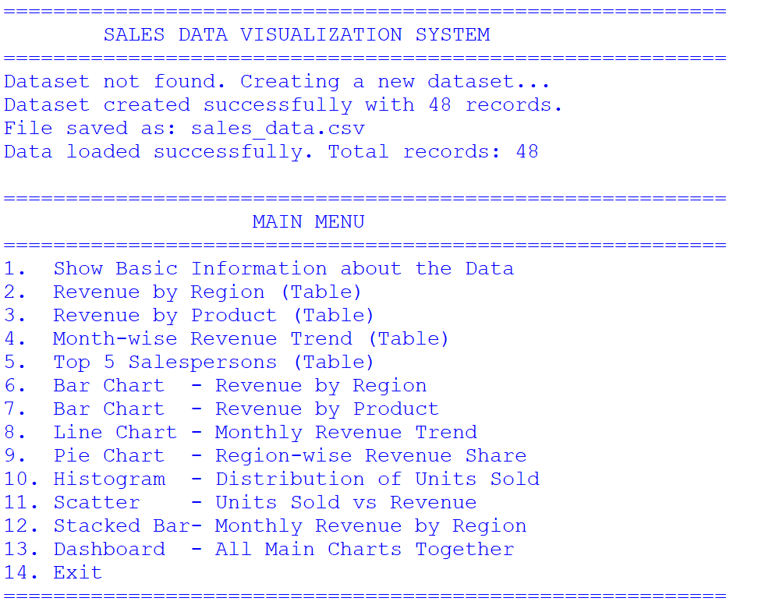

9.1 Basic Information about the Data (Option 1)
Screenshot to insert: Output showing head(), tail(), shape, dtypes and describe().
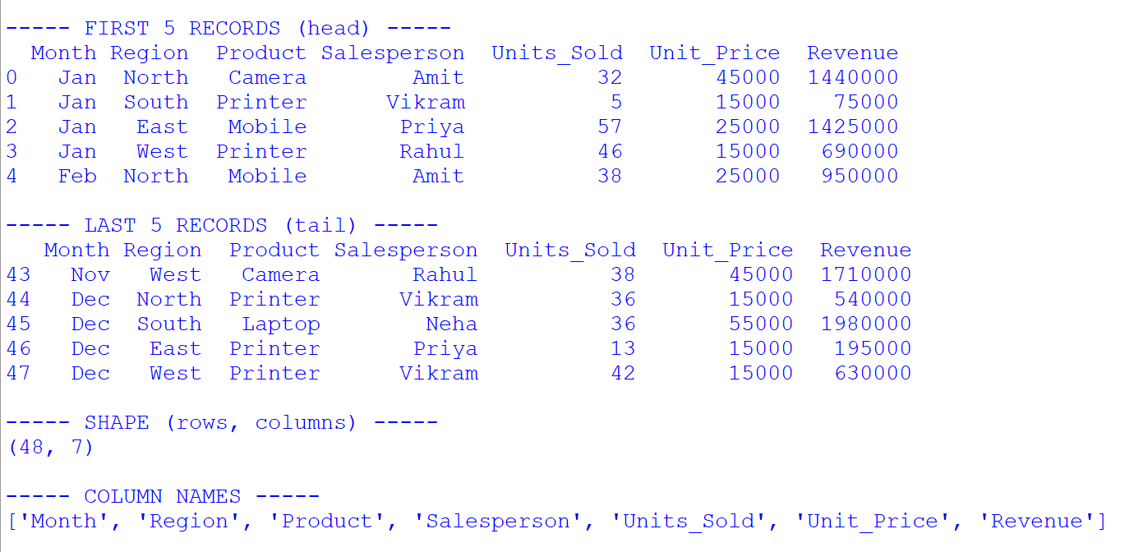
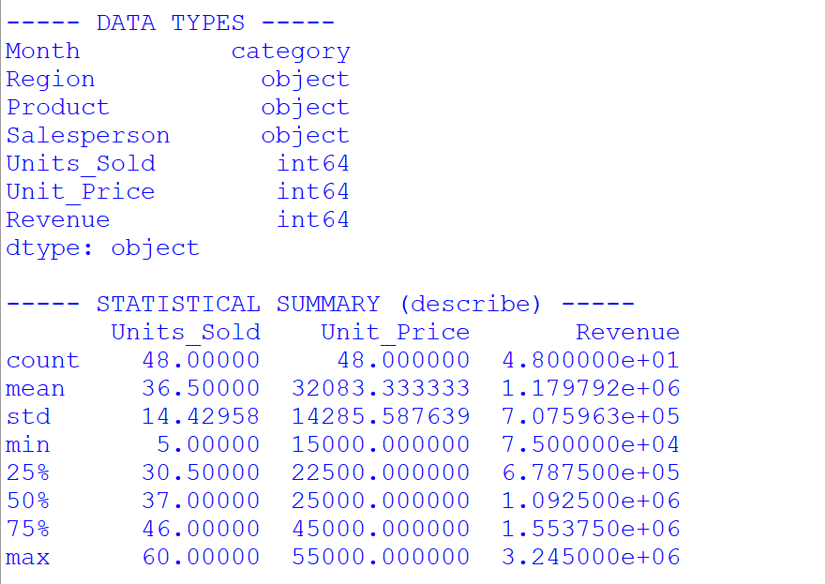
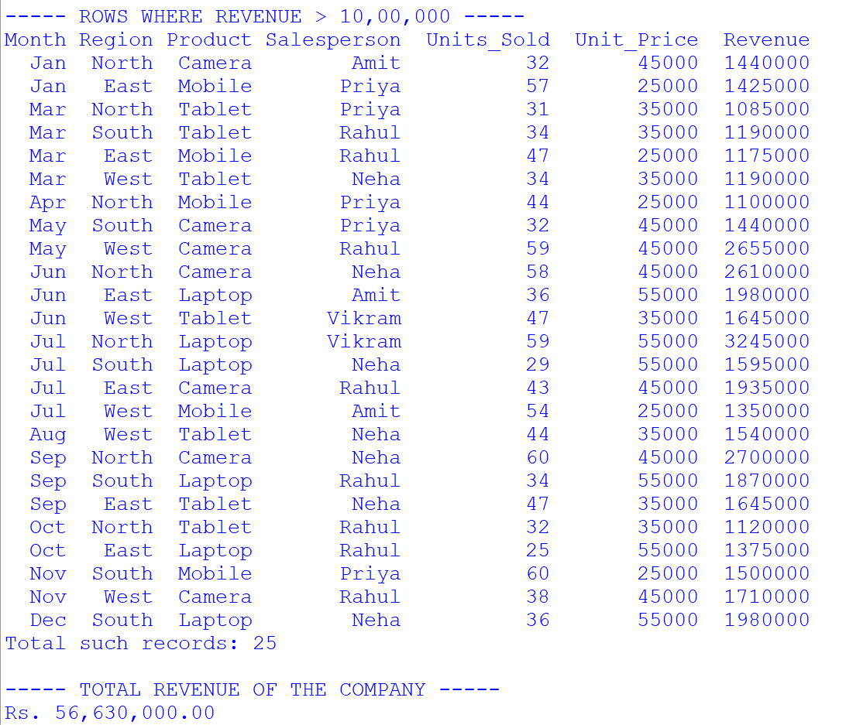
Observation:
- The dataset contains 48 rows and 7 columns (including the calculated Revenue column).
- The describe() output shows the minimum, maximum and average values of Units_Sold, Unit_Price and Revenue.
- The filtered output lists all records where the revenue of a single transaction exceeded Rs. 10,00,000.

9.2 Revenue by Region — Bar Chart (Option 6)
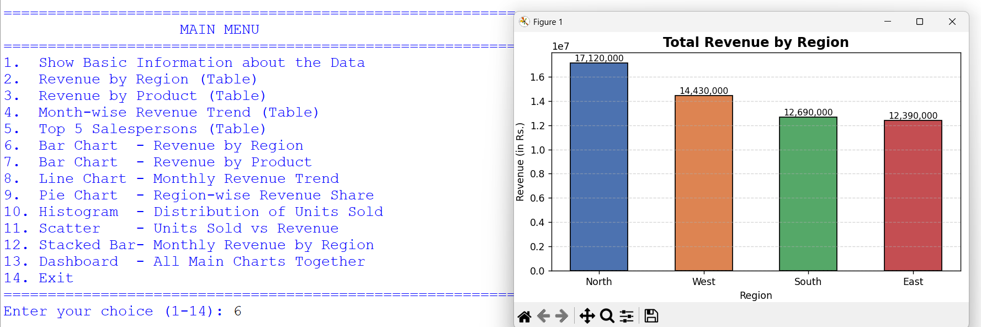Observation:
- The bar chart clearly shows which region generates the highest and which generates the lowest revenue.
- The highest revenue-earning region in this dataset is: ________________ (write the region shown in your chart).
- The lowest revenue-earning region is: ________________.
- Conclusion: The company should focus its marketing budget on the weaker regions to improve overall sales.

9.3 Revenue by Product — Horizontal Bar Chart (Option 7)
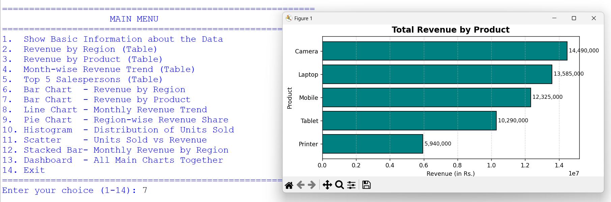Observation:
- Products are arranged in ascending order of revenue, so the best-selling product appears at the top.
- The product contributing the maximum revenue is: ________________.
- Even though the Laptop has the highest unit price, its revenue depends on the number of units sold — this shows that both price and quantity matter.

9.4 Monthly Revenue Trend — Line Chart (Option 8)
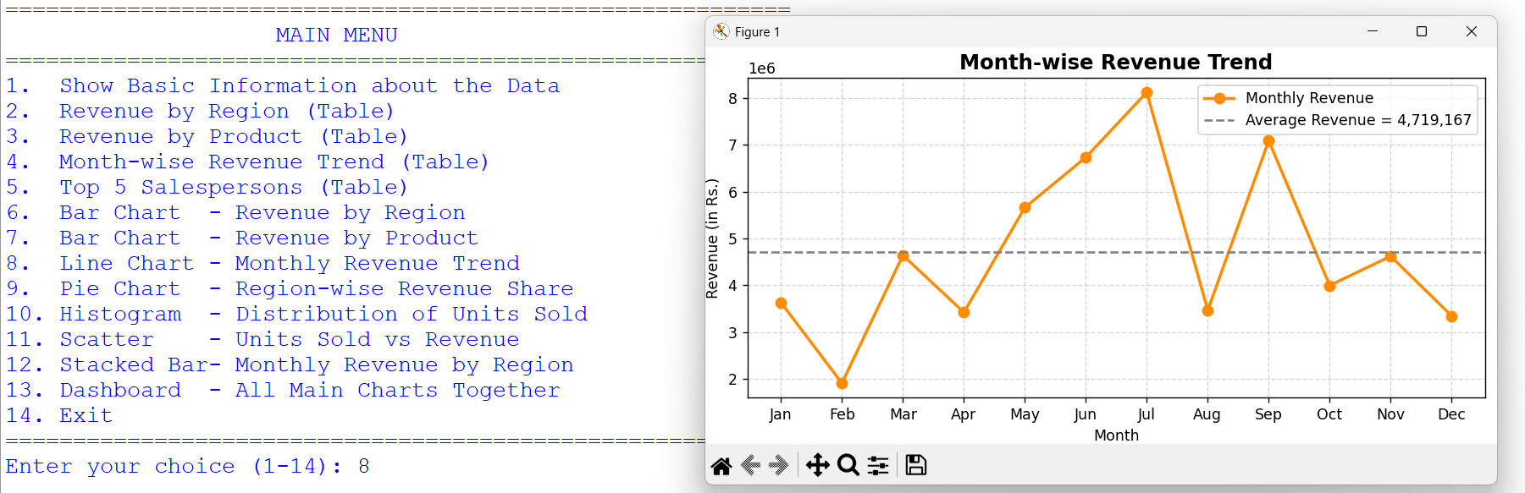Observation:
- The line chart shows how revenue rises and falls across the twelve months.
- The peak (highest) sales month is: ________________.
- The lowest sales month is: ________________.
- The dashed grey line represents the average monthly revenue. Months above this line performed better than average.
- Conclusion: The company can plan its stock and promotions around the peak and lean months.

9.5 Region-wise Revenue Share — Pie Chart (Option 9)
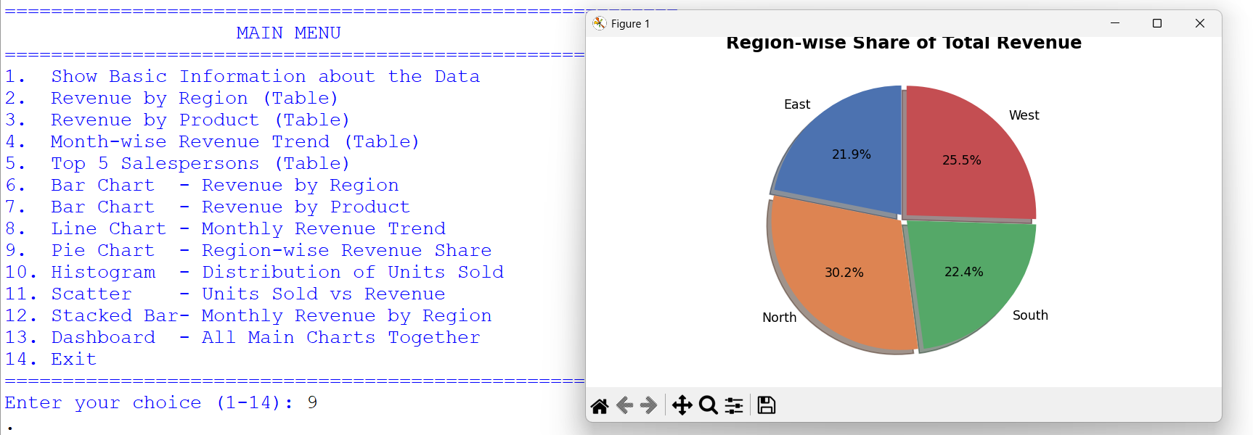Observation:
- The pie chart shows each region's percentage contribution to the total revenue.
- The largest slice belongs to: ________________, contributing approximately ______ % of the total revenue.
- Conclusion: Revenue is not evenly distributed among the regions.

9.6 Distribution of Units Sold — Histogram (Option 10)
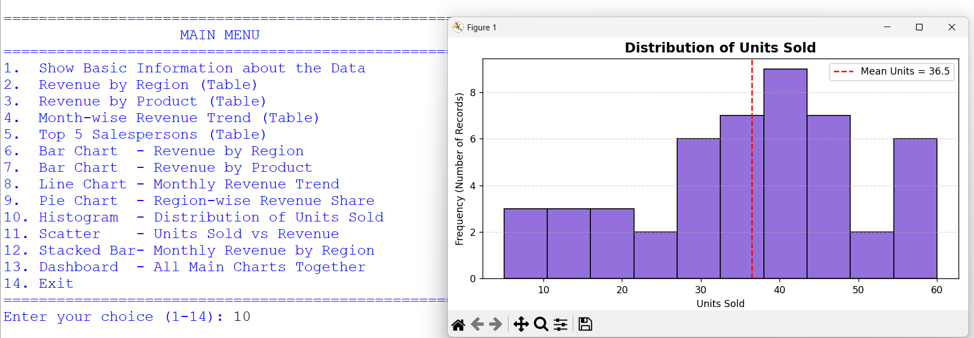Observation:
- The histogram shows how frequently different quantities of units were sold.
- Most transactions involve between ______ and ______ units.
- The red dashed line marks the mean value of units sold, which is approximately ______.
- Conclusion: The distribution indicates whether sales are mostly small-sized orders or large bulk orders.

9.7 Units Sold vs Revenue — Scatter Plot (Option 11)
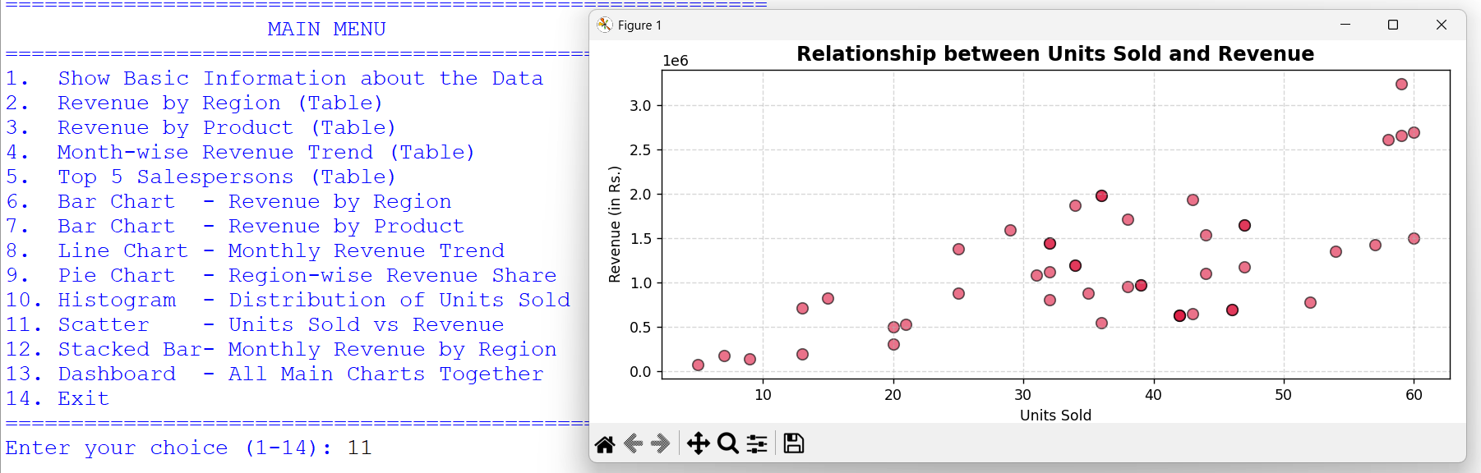Observation:
- Each dot represents one sales record.
- There is a clear positive correlation — as the number of units sold increases, the revenue also increases.
- The dots are spread out because different products have different unit prices; a high-priced product can earn more revenue even with fewer units sold.

9.8 Month-wise Revenue by Region — Stacked Bar Chart (Option 12)
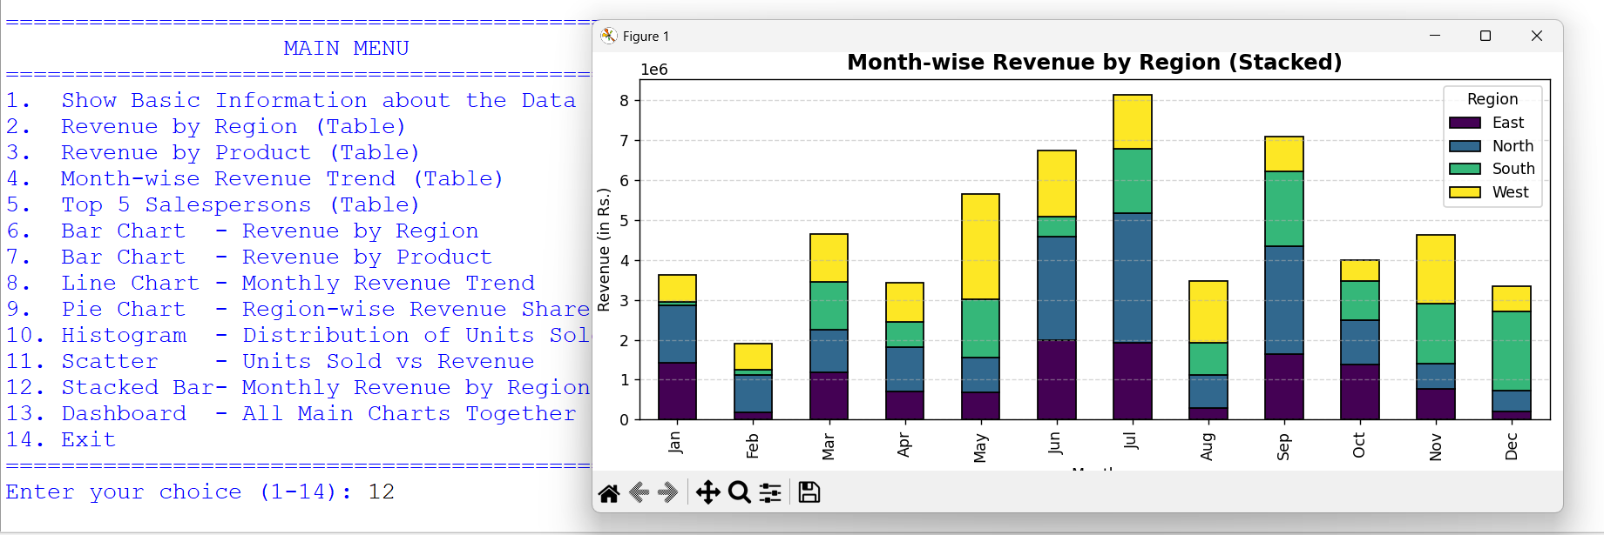Observation:
- Each bar represents a month, and each coloured segment inside the bar represents a region.
- The total height of the bar is the total revenue of that month.
- The tallest bar corresponds to the month of ________________.

9.9 Dashboard (Option 13)
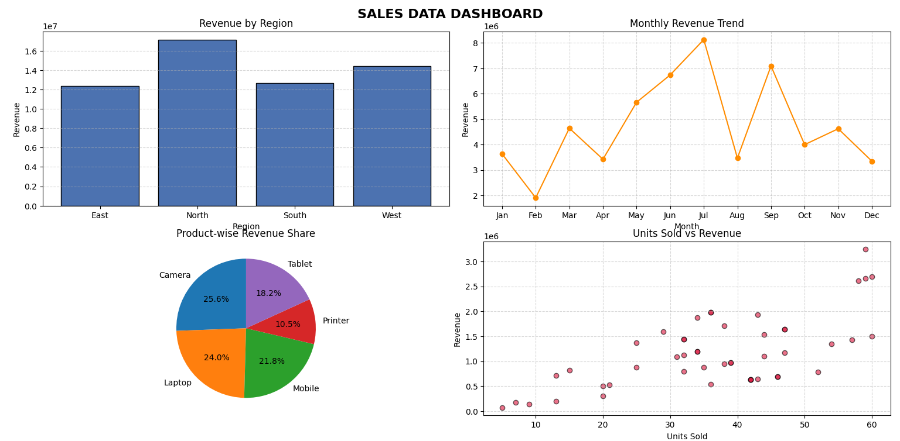Observation:
- The dashboard combines four key charts into a single window, giving a complete summary of the company's sales performance at a glance.
- This type of dashboard is used by real companies to monitor business performance.

10. CONCLUSION AND FUTURE SCOPE
Conclusion
In this project I successfully analysed a company's sales dataset using the Pandas library and presented the results using Matplotlib. The project covered the complete data-handling cycle:
- Creating a dataset and storing it as a CSV file.
- Reading the CSV file into a DataFrame.
- Adding a derived column (Revenue) using arithmetic on existing columns.
- Summarising data using groupby(), sum(), sort_values() and pivot_table().
- Filtering records using Boolean conditions.
- Visualising the results through bar, line, pie, histogram, scatter and stacked bar charts.
- Interpreting each graph to draw business conclusions.
The project proved that visualisation makes data much easier to understand than plain numbers. Patterns such as the best region, the best product and the peak sales month were instantly visible in the charts but were difficult to spot in the raw data.
Future Scope
Error Message | Reason | Solution
ModuleNotFoundError: No module named 'pandas' | Pandas is not installed | Run pip install pandas in the terminal
ModuleNotFoundError: No module named 'matplotlib' | Matplotlib is not installed | Run pip install matplotlib
FileNotFoundError: sales_data.csv | The CSV file was deleted or moved | Delete nothing; simply run the program again — it recreates the file automatically
KeyError: 'Revenue' | The column name is typed incorrectly | Check spelling and capital letters — Python is case sensitive (Revenue, not revenue)
ValueError: could not convert string to float | Non-numeric data present in a numeric column | Open the CSV in Excel and verify the data
Graph window opens and closes immediately | The program ended before you could see it | Always keep plt.show() at the end of the plotting function
Labels of the x-axis overlap | Too many categories | Use plt.xticks(rotation=45) or plt.tight_layout()
FutureWarning about observed parameter | Pandas version difference with categorical grouping | Already handled in the code with observed=False
Charts do not get saved | Wrong path or no write permission | Save in the same folder as the Python script (default behaviour of the code)
- The dataset can be replaced with real company data from an Excel or CSV file of any size.
- Seaborn can be used for more advanced and attractive statistical charts.
- A GUI can be added using Tkinter so that a non-technical user can select which chart to display.
- A monthly sales report can be automatically exported to a PDF file.
- Machine Learning models can be applied to predict next month's sales based on past data.

11. TROUBLESHOOTING / COMMON ERRORS
Note for Jupyter Notebook users: Add the line %matplotlib inline at the top of the notebook so that the charts appear inside the notebook itself.

12. BIBLIOGRAPHY
- Websites:
  - Pandas Official Documentation (pandas.pydata.org)
  - Matplotlib Official Documentation (matplotlib.org)
  - W3Schools (www.w3schools.com)
  - GeeksforGeeks (www.geeksforgeeks.org)
  - Stack Overflow (www.stackoverflow.com)
- Study Material:
  - NCERT Informatics Practices Textbook for Class XII
  - Sumita Arora, Informatics Practices with Python, Dhanpat Rai & Co.
- Software Documentation:
  - Python 3 Official Documentation (docs.python.org)

