PROJECT FILE
INFORMATICS PRACTICES (CLASS XII)
SESSION: [Year, e.g., 2023-2024]

RAILWAY TICKET BOOKING SYSTEM
(PNR Generation, Seat Availability and Electronic Reservation Slip)
Submitted By:
[Your Name]
Class: XII – [Section]
Roll No: [Your Roll Number]
Submitted To:
[Teacher's Name]
Department of Computer Science
[Your School Name]

CERTIFICATE
This is to certify that [Your Name] of Class XII has successfully completed the Informatics Practices project titled "Railway Ticket Booking System" under the guidance of [Teacher's Name] during the academic year [Year].
This project is a bonafide record of work done by the candidate independently and fulfills the requirements of the Central Board of Secondary Education (CBSE) for the AISSCE Examination.
Teacher In-Charge: __________________
Signature: __________________
External Examiner: __________________
Signature: __________________
School Seal:

ACKNOWLEDGEMENT
I would like to express my sincere thanks to my Informatics Practices teacher [Teacher's Name] and our Principal [Principal's Name] for giving me the opportunity to work on this project titled "Railway Ticket Booking System".
While working on this project I learnt how a real-world ticket reservation system works. I learnt how a relational database is designed with primary keys and foreign keys, how a PNR is generated uniquely, how seat availability is calculated dynamically by counting confirmed passengers, how GST is applied only to air-conditioned classes, and how refund rules are implemented using date arithmetic. I would also like to thank my parents and friends who supported and encouraged me throughout the completion of this project.
Name: [Your Name]
Class: XII

TABLE OF CONTENTS
- Introduction
- Objectives of the Project
- Proposed System
- System Requirements (Hardware & Software)
- System Design (Table Structures)
- Python Libraries Used
- Functions Used (Quick Reference)
- Source Code
- Output Screens and Observations
- Conclusion and Future Scope
- Troubleshooting Database Connection
- Bibliography

1. INTRODUCTION
The Indian Railways carries more than 2 crore passengers every day. To manage such a huge volume, a computerised reservation system is essential. In a manual system, the booking clerk had to physically search for vacant berths, maintain a chart register, calculate fares, issue carbon-copy tickets and prepare refund statements. This was extremely slow and error-prone.
The Railway Ticket Booking System is a software application that automates this entire process. It is a menu-driven Python program backed by a MySQL relational database. It allows the reservation clerk to:
- View the complete train timetable with routes, timings and class-wise fares.
- Search trains between a source and destination station.
- Check seat availability for any train, class and journey date.
- Book tickets for up to six passengers in one PNR.
- Automatically generate a unique 10-digit PNR for every booking.
- Automatically allot individual seat numbers to each passenger.
- Print an Electronic Reservation Slip (ERS) with full passenger details.
- Search tickets by PNR or by passenger name.
- Cancel tickets and compute the refund using the standard railway refund rules.
- Generate a revenue report grouped by class and by train.
The database stores all data permanently, so bookings survive even after the program is closed and reopened. This is the most important advantage of a database-driven system over a file-based one.
2. OBJECTIVES
The main objectives of this project are:
- To understand how Python and MySQL are connected using the mysql.connector library.
- To design a relational database with four linked tables (Trains, Classes, Tickets, Passengers) using primary keys, composite primary keys and foreign keys.
- To generate a unique PNR at run-time using the random and string modules.
- To implement seat availability logic by dynamically counting confirmed passengers for a given train, class and journey date.
- To allot individual seat numbers to passengers without any clash.
- To record journey date and booking date using the datetime module, and to calculate the number of days remaining for the refund rule.
- To apply GST @ 5% only to AC classes (1A, 2A, 3A) and no GST on Sleeper and Second Sitting — exactly as IRCTC does.
- To implement the real cancellation refund rules:
  - More than 2 days before journey → 90% refund
  - Between 1 and 2 days before journey → 75% refund
  - Less than 24 hours before journey → 50% refund
  - After departure → No refund
- To use SQL aggregate functions (COUNT, SUM, AVG) and GROUP BY with JOIN to generate a revenue report.
3. PROPOSED SYSTEM
The system is a menu-driven program divided into four modules:
3.1 Timetable Module
- View all trains with train number, name, source, destination, departure and arrival times.
- View the class-wise fares for a selected train.
- Search for trains between a given source and destination.
3.2 Availability Module
- Check seat availability for any train, class and journey date.
- Displays TotalSeats, BookedSeats and AvailableSeats for every class on that train.
- Validates the journey date (must be at least 1 day and at most 120 days in advance).
3.3 Reservation Module
- Book a ticket for 1 to 6 passengers in a single PNR.
- Generate a unique 10-digit PNR (checked against the database).
- Automatically allot seat numbers by finding the first free seats in that class.
- Print an Electronic Reservation Slip.
- View a ticket by PNR.
- Search passengers by name (using LIKE).
- View all bookings.
3.4 Cancellation and Report Module
- Cancel a ticket by PNR.
- Compute the refund using the railway refund rules.
- Mark the ticket and all its passengers as Cancelled.
- Generate a Revenue Report grouped by class and by train.
4. SYSTEM REQUIREMENTS
Hardware Requirements:
- Processor: Intel Core i3 or above
- RAM: 4 GB or above
- Hard Disk: 100 GB or above
Software Requirements:
- Operating System: Windows 7/8/10/11 or Linux
- Python 3.x (IDLE / PyCharm)
- MySQL Server 5.7 or above (or XAMPP's MariaDB)
- Python-MySQL Connector (mysql-connector-python)
5. SYSTEM DESIGN (TABLE STRUCTURES)
The system uses a database named RailwayDB. The database and tables are created automatically by the Python script on first execution.
Table 1: Trains
Column | Data Type | Constraint | Description
TrainNo | INT | PRIMARY KEY | Unique train number
TrainName | VARCHAR(60) | NOT NULL | Name of the train
Source | VARCHAR(40) | NOT NULL | Starting station
Destination | VARCHAR(40) | NOT NULL | Terminating station
DepartureTime | VARCHAR(10) | NULL | Departure time from source
ArrivalTime | VARCHAR(10) | NULL | Arrival time at destination
Table 2: Classes
Column | Data Type | Constraint | Description
TrainNo | INT | COMPOSITE PRIMARY KEY, FOREIGN KEY → Trains | Train number
ClassCode | VARCHAR(4) | COMPOSITE PRIMARY KEY | 2S / SL / 3A / 2A / 1A
TotalSeats | INT | NOT NULL | Total seats in that class
Fare | DECIMAL(10,2) | NOT NULL | Fare per passenger
Composite primary key (TrainNo, ClassCode) ensures no duplicate rows for the same train and class.
Table 3: Tickets
Column | Data Type | Constraint | Description
PNR | VARCHAR(12) | PRIMARY KEY | Unique 10-digit PNR
TrainNo | INT | FOREIGN KEY → Trains | Train booked
ClassCode | VARCHAR(4) | NOT NULL | Class booked
JourneyDate | DATE | NOT NULL | Date of travel
BookingDate | DATE | NULL | Date of booking
PassengerCount | INT | NULL | Number of passengers in this PNR
BaseFare | DECIMAL(10,2) | NULL | Fare × passengers
GST | DECIMAL(10,2) | NULL | 5% for AC classes, 0 for SL/2S
TotalFare | DECIMAL(10,2) | NULL | BaseFare + GST
Status | VARCHAR(15) | DEFAULT 'Confirmed' | Confirmed / Cancelled
Table 4: Passengers
Column | Data Type | Constraint | Description
PassengerID | INT | AUTO_INCREMENT PRIMARY KEY | Unique passenger ID
PNR | VARCHAR(12) | FOREIGN KEY → Tickets | Parent ticket
Name | VARCHAR(80) | NOT NULL | Passenger name
Age | INT | NULL | Age in years
Gender | VARCHAR(10) | NULL | M / F / O
SeatNo | VARCHAR(10) | NULL | e.g. SL-15, 3A-22
Status | VARCHAR(15) | DEFAULT 'Confirmed' | Confirmed / Cancelled
Relationship Diagram (in words):
text
Trains (1) ─── (many) Classes
Trains (1) ─── (many) Tickets
Tickets (1) ─── (many) Passengers
Default Data
On first run, the script inserts 8 trains and 5 classes per train (40 rows in Classes).
Train No | Train Name | Source | Destination | Dep | Arr
12301 | Rajdhani Express | New Delhi | Mumbai Central | 16:25 | 08:15
12302 | Shatabdi Express | New Delhi | Bhopal | 06:00 | 14:00
12303 | Duronto Express | Mumbai CST | Chennai Central | 22:15 | 20:30
12304 | Garib Rath Express | Kolkata | Patna | 23:55 | 09:30
12305 | Tejas Express | Mumbai | Goa | 05:30 | 14:45
12306 | Vande Bharat Express | New Delhi | Varanasi | 06:00 | 14:00
12307 | Intercity Express | Bengaluru | Mysuru | 07:15 | 10:30
12308 | Sampark Kranti Express | Chennai | Hyderabad | 14:20 | 22:00
Class configuration (same for every train):
Code | Class | Seats | Fare (multiplier on SL base)
2S | Second Sitting | 120 | 0.60 × SL
SL | Sleeper | 72 | 1.00 × SL
3A | AC 3 Tier | 64 | 2.50 × SL
2A | AC 2 Tier | 46 | 3.50 × SL
1A | AC First Class | 24 | 6.00 × SL
6. PYTHON LIBRARIES USED
- mysql.connector — connects Python to MySQL and executes SQL statements.
- datetime — used to record the booking date, and to calculate the number of days left before the journey (for the refund rule).
- random — used to generate the 10-digit PNR.
- string — provides string.digits used with random.choices() to build the PNR.
7. FUNCTIONS USED (QUICK REFERENCE)
7.1 MySQL Connector Functions
Function / Method | Description
mysql.connector.connect(...) | Opens a connection to MySQL
con.cursor() | Creates a cursor to execute SQL
cur.execute(sql, params) | Runs a single SQL statement
cur.executemany(sql, list) | Runs the same SQL for many rows
cur.fetchone() / cur.fetchall() | Fetches one / all result rows
cur.rowcount | Number of rows affected
cur.lastrowid | Auto-increment value of the last inserted row
con.commit() / con.rollback() | Save / undo changes
cur.close() / con.close() | Release resources
7.2 SQL Statements Used
Statement | Purpose
CREATE DATABASE IF NOT EXISTS | Auto-create the database
CREATE TABLE IF NOT EXISTS | Auto-create the four tables
INSERT INTO | Add trains, classes, tickets, passengers
SELECT ... WHERE | Look up a train, ticket or passenger
SELECT ... LIKE | Search passengers by name
SELECT COUNT(*) | Count confirmed passengers for availability
UPDATE ... SET | Change ticket and passenger status to Cancelled
JOIN (Tickets ⟗ Trains, Passengers ⟗ Tickets) | Combine related tables
GROUP BY + SUM() / COUNT() | Build the revenue report
IFNULL() | Replace NULL with 0 in reports
8. SOURCE CODE
Below is the complete Python code. It creates the database, tables and default data automatically, so no prior SQL setup is required.
python
# ==========================================================
# RAILWAY TICKET BOOKING SYSTEM
# Class 12 Informatics Practices Project
# Tools Used: Python 3 + MySQL (mysql-connector-python)
# ==========================================================

import mysql.connector
import datetime
import random
import string

# ------------------------- CONFIGURATION (EDIT THESE) -------------------------
DB_HOST = "localhost"
DB_USER = "root" # <-- Change to your MySQL username
DB_PASSWORD = "" # <-- Change to your MySQL password (empty for XAMPP default)
DB_NAME = "RailwayDB"

RAILWAY_NAME = "INDIAN RAILWAYS"
ADMIN_PASSWORD = "rail123" # Simple receptionist password

MIN_ADVANCE_DAYS = 1 # Booking must be at least 1 day before journey
MAX_ADVANCE_DAYS = 120 # Booking allowed up to 120 days in advance

AC_CLASSES = ("1A", "2A", "3A") # GST applies only to these

DEFAULT_TRAINS = [
(12301, "Rajdhani Express", "New Delhi", "Mumbai Central", "16:25", "08:15", 750),
(12302, "Shatabdi Express", "New Delhi", "Bhopal", "06:00", "14:00", 620),
(12303, "Duronto Express", "Mumbai CST", "Chennai Central", "22:15", "20:30", 680),
(12304, "Garib Rath Express", "Kolkata", "Patna", "23:55", "09:30", 340),
(12305, "Tejas Express", "Mumbai", "Goa", "05:30", "14:45", 580),
(12306, "Vande Bharat Express", "New Delhi", "Varanasi", "06:00", "14:00", 890),
(12307, "Intercity Express", "Bengaluru", "Mysuru", "07:15", "10:30", 210),
(12308, "Sampark Kranti Express", "Chennai", "Hyderabad", "14:20", "22:00", 450),
]

CLASS_MULTIPLIER = {"2S": 0.60, "SL": 1.00, "3A": 2.50, "2A": 3.50, "1A": 6.00}
CLASS_SEATS = {"2S": 120, "SL": 72, "3A": 64, "2A": 46, "1A": 24}
CLASS_FULL = {"2S": "Second Sitting", "SL": "Sleeper",
"3A": "AC 3 Tier", "2A": "AC 2 Tier", "1A": "AC First Class"}

# ==================== 1. DATABASE INITIALISATION ====================

def initialize_database():
"""Create database, tables and default train data if they do not exist."""
try:
con = mysql.connector.connect(host=DB_HOST, user=DB_USER, password=DB_PASSWORD)
cur = con.cursor()
cur.execute("CREATE DATABASE IF NOT EXISTS " + DB_NAME)
cur.execute("USE " + DB_NAME)

cur.execute("""
CREATE TABLE IF NOT EXISTS Trains (
TrainNo INT PRIMARY KEY,
TrainName VARCHAR(60) NOT NULL,
Source VARCHAR(40) NOT NULL,
Destination VARCHAR(40) NOT NULL,
DepartureTime VARCHAR(10),
ArrivalTime VARCHAR(10)
)
""")

cur.execute("""
CREATE TABLE IF NOT EXISTS Classes (
TrainNo INT,
ClassCode VARCHAR(4) NOT NULL,
TotalSeats INT NOT NULL,
Fare DECIMAL(10,2) NOT NULL,
PRIMARY KEY (TrainNo, ClassCode),
FOREIGN KEY (TrainNo) REFERENCES Trains(TrainNo)
)
""")

cur.execute("""
CREATE TABLE IF NOT EXISTS Tickets (
PNR VARCHAR(12) PRIMARY KEY,
TrainNo INT,
ClassCode VARCHAR(4),
JourneyDate DATE NOT NULL,
BookingDate DATE,
PassengerCount INT,
BaseFare DECIMAL(10,2),
GST DECIMAL(10,2),
TotalFare DECIMAL(10,2),
Status VARCHAR(15) DEFAULT 'Confirmed',
FOREIGN KEY (TrainNo) REFERENCES Trains(TrainNo)
)
""")

cur.execute("""
CREATE TABLE IF NOT EXISTS Passengers (
PassengerID INT AUTO_INCREMENT PRIMARY KEY,
PNR VARCHAR(12),
Name VARCHAR(80) NOT NULL,
Age INT,
Gender VARCHAR(10),
SeatNo VARCHAR(10),
Status VARCHAR(15) DEFAULT 'Confirmed',
FOREIGN KEY (PNR) REFERENCES Tickets(PNR)
)
""")

# Insert default trains and classes only if the Trains table is empty
cur.execute("SELECT COUNT(*) FROM Trains")
if cur.fetchone()[0] == 0:
cur.executemany(
"INSERT INTO Trains VALUES (%s, %s, %s, %s, %s, %s)",
[t[:6] for t in DEFAULT_TRAINS])
class_rows = []
for t in DEFAULT_TRAINS:
train_no = t[0]
base_sl = t[6]
for code in CLASS_MULTIPLIER:
fare = round(base_sl * CLASS_MULTIPLIER[code], 2)
class_rows.append((train_no, code, CLASS_SEATS[code], fare))
cur.executemany(
"INSERT INTO Classes (TrainNo, ClassCode, TotalSeats, Fare) "
"VALUES (%s, %s, %s, %s)", class_rows)
print(" [OK] " + str(len(DEFAULT_TRAINS)) + " trains and "
+ str(len(class_rows)) + " class records inserted.")

con.commit()
print(" [OK] Database '" + DB_NAME + "' and all tables are ready.")
cur.close()
con.close()

except mysql.connector.Error as err:
print("Database Initialisation Error:", err)
print("Please check DB_USER and DB_PASSWORD in the CONFIGURATION section.")
exit(1)

def connect_db():
try:
con = mysql.connector.connect(
host=DB_HOST, user=DB_USER, password=DB_PASSWORD, database=DB_NAME)
return con
except mysql.connector.Error as err:
print("Database Connection Error:", err)
return None

# ==================== 2. HELPER FUNCTIONS ====================

def ask_journey_date():
"""Prompt for a journey date and validate the range. Returns a date or None."""
txt = input(" Enter Journey Date (DD-MM-YYYY): ").strip()
try:
d = datetime.datetime.strptime(txt, "%d-%m-%Y").date()
except ValueError:
print(" [!] Invalid date format. Please use DD-MM-YYYY.")
return None
today = datetime.date.today()
diff = (d - today).days
if diff < MIN_ADVANCE_DAYS:
print(" [!] Booking must be at least " + str(MIN_ADVANCE_DAYS) + " day(s) in advance.")
return None
if diff > MAX_ADVANCE_DAYS:
print(" [!] Booking is allowed only up to " + str(MAX_ADVANCE_DAYS) + " days in advance.")
return None
return d

def get_booked_count(cur, train_no, class_code, jdate):
"""Count confirmed passengers in a class on a specific date."""
cur.execute("""SELECT COUNT(*) FROM Passengers p
JOIN Tickets t ON p.PNR = t.PNR
WHERE t.TrainNo = %s AND t.ClassCode = %s
AND t.JourneyDate = %s AND p.Status = 'Confirmed'""",
(train_no, class_code, jdate))
return cur.fetchone()[0]

def get_free_seats(cur, train_no, class_code, jdate, total_seats, n):
"""Return a list of the first 'n' unused seat numbers for that class and date."""
cur.execute("""SELECT p.SeatNo FROM Passengers p
JOIN Tickets t ON p.PNR = t.PNR
WHERE t.TrainNo = %s AND t.ClassCode = %s
AND t.JourneyDate = %s AND p.Status = 'Confirmed'""",
(train_no, class_code, jdate))
used = set()
for r in cur.fetchall():
s = r[0]
if s is None:
continue
try:
num = int(str(s).split("-")[-1])
used.add(num)
except (ValueError, IndexError):
pass
free = []
for i in range(1, total_seats + 1):
if i not in used:
free.append(i)
if len(free) == n:
break
return free

def generate_pnr(cur):
"""Generate a unique 10-digit numeric PNR."""
while True:
pnr = "".join(random.choices(string.digits, k=10))
cur.execute("SELECT PNR FROM Tickets WHERE PNR = %s", (pnr,))
if cur.fetchone() is None:
return pnr

def view_all_trains_short(cur):
"""Display the compact train list used during booking."""
cur.execute("SELECT TrainNo, TrainName, Source, Destination, "
"DepartureTime, ArrivalTime FROM Trains ORDER BY TrainNo")
rows = cur.fetchall()
print("\n " + "-" * 96)
print(" {:<7}{:<26}{:<16}{:<18}{:>10}{:>12}".format(
"Train", "Train Name", "From", "To", "Dep", "Arr"))
print(" " + "-" * 96)
for r in rows:
print(" {:<7}{:<26}{:<16}{:<18}{:>10}{:>12}".format(
r[0], r[1][:25], r[2][:15], r[3][:17], r[4], r[5]))
print(" " + "-" * 96)

# ==================== 3. TIMETABLE MODULE ====================

def view_all_trains():
con = connect_db()
if not con:
return
cur = con.cursor()
view_all_trains_short(cur)

# Ask if the user wants to see fares for a particular train
ch = input("\n Enter a Train Number to see class-wise fares (Enter to skip): ").strip()
if ch == "":
cur.close(); con.close(); return
try:
train_no = int(ch)
except ValueError:
print(" [!] Invalid train number.")
cur.close(); con.close(); return

cur.execute("SELECT TrainName FROM Trains WHERE TrainNo = %s", (train_no,))
t = cur.fetchone()
if not t:
print(" [!] Train not found.")
cur.close(); con.close(); return

cur.execute("SELECT ClassCode, TotalSeats, Fare FROM Classes "
"WHERE TrainNo = %s ORDER BY Fare", (train_no,))
rows = cur.fetchall()
print("\n Class-wise fares for " + str(train_no) + " - " + t[0])
print(" " + "-" * 55)
print(" {:<6}{:<24}{:>10}{:>12}".format("Code", "Class", "Seats", "Fare"))
print(" " + "-" * 55)
for r in rows:
print(" {:<6}{:<24}{:>10}{:>12.2f}".format(
r[0], CLASS_FULL.get(r[0], r[0]), r[1], float(r[2])))
print(" " + "-" * 55)
cur.close(); con.close()

def search_trains():
con = connect_db()
if not con:
return
cur = con.cursor()
src = input(" Enter Source station (or part of it): ").strip()
dst = input(" Enter Destination station (or part of it): ").strip()

cur.execute("""SELECT TrainNo, TrainName, Source, Destination,
DepartureTime, ArrivalTime FROM Trains
WHERE Source LIKE %s AND Destination LIKE %s
ORDER BY TrainNo""",
("%" + src + "%", "%" + dst + "%"))
rows = cur.fetchall()
if not rows:
print(" [!] No trains found on this route.")
else:
print("\n Trains found: " + str(len(rows)))
print(" " + "-" * 96)
print(" {:<7}{:<26}{:<16}{:<18}{:>10}{:>12}".format(
"Train", "Train Name", "From", "To", "Dep", "Arr"))
print(" " + "-" * 96)
for r in rows:
print(" {:<7}{:<26}{:<16}{:<18}{:>10}{:>12}".format(
r[0], r[1][:25], r[2][:15], r[3][:17], r[4], r[5]))
cur.close(); con.close()

# ==================== 4. AVAILABILITY MODULE ====================

def check_availability():
con = connect_db()
if not con:
return
cur = con.cursor()
try:
train_no = int(input(" Enter Train Number: "))
except ValueError:
print(" [!] Invalid train number.")
cur.close(); con.close(); return

cur.execute("SELECT TrainName, Source, Destination FROM Trains WHERE TrainNo = %s",
(train_no,))
t = cur.fetchone()
if not t:
print(" [!] Train not found.")
cur.close(); con.close(); return

print(" Train : " + str(train_no) + " - " + t[0])
print(" Route : " + t[1] + " -> " + t[2])

jdate = ask_journey_date()
if jdate is None:
cur.close(); con.close(); return

cur.execute("SELECT ClassCode, TotalSeats, Fare FROM Classes "
"WHERE TrainNo = %s ORDER BY Fare", (train_no,))
rows = cur.fetchall()

print("\n SEAT AVAILABILITY on " + jdate.strftime("%d-%m-%Y"))
print(" " + "-" * 72)
print(" {:<5}{:<22}{:>10}{:>10}{:>12}{:>12}".format(
"Code", "Class", "Total", "Booked", "Available", "Fare"))
print(" " + "-" * 72)
for r in rows:
code, total, fare = r[0], r[1], float(r[2])
booked = get_booked_count(cur, train_no, code, jdate)
avail = total - booked
print(" {:<5}{:<22}{:>10}{:>10}{:>12}{:>12.2f}".format(
code, CLASS_FULL.get(code, code), total, booked, avail, fare))
print(" " + "-" * 72)
cur.close(); con.close()

# ==================== 5. RESERVATION MODULE ====================

def book_ticket():
con = connect_db()
if not con:
return
cur = con.cursor()

view_all_trains_short(cur)

try:
train_no = int(input("\n Enter Train Number to book: "))
except ValueError:
print(" [!] Invalid input.")
cur.close(); con.close(); return

cur.execute("SELECT TrainName, Source, Destination, DepartureTime "
"FROM Trains WHERE TrainNo = %s", (train_no,))
t = cur.fetchone()
if not t:
print(" [!] Train not found.")
cur.close(); con.close(); return

print("\n Selected : " + str(train_no) + " - " + t[0])
print(" Route : " + t[1] + " -> " + t[2])
print(" Departs : " + t[3])

jdate = ask_journey_date()
if jdate is None:
cur.close(); con.close(); return

# Show class-wise availability for the chosen date
cur.execute("SELECT ClassCode, TotalSeats, Fare FROM Classes "
"WHERE TrainNo = %s ORDER BY Fare", (train_no,))
classes = cur.fetchall()
print("\n Classes available on " + jdate.strftime("%d-%m-%Y"))
print(" " + "-" * 62)
print(" {:<5}{:<22}{:>10}{:>10}{:>14}".format(
"Code", "Class", "Total", "Avail", "Fare"))
print(" " + "-" * 62)
for c in classes:
booked = get_booked_count(cur, train_no, c[0], jdate)
print(" {:<5}{:<22}{:>10}{:>10}{:>14.2f}".format(
c[0], CLASS_FULL.get(c[0], c[0]), c[1], c[1] - booked, float(c[2])))
print(" " + "-" * 62)

code = input(" Enter Class Code (2S/SL/3A/2A/1A): ").strip().upper()
chosen = None
for c in classes:
if c[0] == code:
chosen = c
break
if chosen is None:
print(" [!] That class is not available on this train.")
cur.close(); con.close(); return

total_seats, fare = chosen[1], float(chosen[2])
booked = get_booked_count(cur, train_no, code, jdate)
avail = total_seats - booked
if avail <= 0:
print(" [!] No seats available in " + code + " on " + jdate.strftime("%d-%m-%Y"))
cur.close(); con.close(); return

print(" Available in " + code + " : " + str(avail) + " seat(s)")

try:
np = int(input(" Number of passengers (1-6): "))
except ValueError:
print(" [!] Invalid number.")
cur.close(); con.close(); return

if np < 1 or np > 6:
print(" [!] You can book between 1 and 6 passengers per PNR.")
cur.close(); con.close(); return
if np > avail:
print(" [!] Only " + str(avail) + " seat(s) available.")
cur.close(); con.close(); return

# Collect passenger details
passengers = []
print("\n Enter passenger details:")
for i in range(np):
print(" --- Passenger " + str(i + 1) + " ---")
name = input(" Name : ").strip()
if name == "":
print(" [!] Name cannot be empty.")
cur.close(); con.close(); return
try:
age = int(input(" Age : "))
if age < 1 or age > 120:
raise ValueError
except ValueError:
print(" [!] Invalid age.")
cur.close(); con.close(); return
gender = input(" Gender (M/F/O) : ").strip().upper()
if gender not in ("M", "F", "O"):
gender = "O"
passengers.append((name, age, gender))

# Fare calculation
base_fare = round(fare * np, 2)
gst = round(base_fare * 0.05, 2) if code in AC_CLASSES else 0.0
total_fare = round(base_fare + gst, 2)

print("\n ----- FARE BREAKDOWN -----")
print(" Fare per passenger : Rs. {:>10.2f}".format(fare))
print(" Number of passengers: " + str(np))
print(" Base Fare : Rs. {:>10.2f}".format(base_fare))
if code in AC_CLASSES:
print(" GST @ 5% (AC class) : Rs. {:>10.2f}".format(gst))
else:
print(" GST : Not applicable (non-AC class)")
print(" --------------------------------")
print(" TOTAL FARE : Rs. {:>10.2f}".format(total_fare))

confirm = input("\n Confirm booking? (y/n): ").strip().lower()
if confirm != "y":
print(" [!] Booking cancelled. No changes made.")
cur.close(); con.close(); return

try:
pnr = generate_pnr(cur)
today = datetime.date.today()

cur.execute("""INSERT INTO Tickets
(PNR, TrainNo, ClassCode, JourneyDate, BookingDate,
PassengerCount, BaseFare, GST, TotalFare, Status)
VALUES (%s, %s, %s, %s, %s, %s, %s, %s, %s, 'Confirmed')""",
(pnr, train_no, code, jdate, today, np,
base_fare, gst, total_fare))

seats = get_free_seats(cur, train_no, code, jdate, total_seats, np)
for i in range(len(passengers)):
name, age, gender = passengers[i]
seat_label = code + "-" + str(seats[i])
cur.execute("""INSERT INTO Passengers
(PNR, Name, Age, Gender, SeatNo, Status)
VALUES (%s, %s, %s, %s, %s, 'Confirmed')""",
(pnr, name, age, gender, seat_label))

con.commit()

print("\n ================================================")
print(" BOOKING CONFIRMED")
print(" ================================================")
print(" PNR : " + pnr)
print(" Train : " + str(train_no) + " - " + t[0])
print(" Route : " + t[1] + " -> " + t[2])
print(" Journey Date : " + jdate.strftime("%d-%m-%Y"))
print(" Class : " + code + " (" + CLASS_FULL.get(code, code) + ")")
print(" Passengers : " + str(np))
print(" Total Fare : Rs. {:.2f}".format(total_fare))
print(" ------------------------------------------------")
print(" {:<4}{:<22}{:>5}{:>6}{:>12}".format("No", "Name", "Age", "Sex", "Seat"))
print(" " + "-" * 48)
for i in range(len(passengers)):
print(" {:<4}{:<22}{:>5}{:>6}{:>12}".format(
i + 1, passengers[i][0][:21], passengers[i][1],
passengers[i][2], code + "-" + str(seats[i])))
print(" ================================================")
print(" Please note your PNR for future reference.")

except mysql.connector.Error as err:
con.rollback()
print(" [!] Booking failed:", err)
finally:
cur.close(); con.close()

def view_ticket():
con = connect_db()
if not con:
return
cur = con.cursor()
pnr = input(" Enter PNR: ").strip()

cur.execute("""SELECT t.PNR, t.TrainNo, tr.TrainName, tr.Source, tr.Destination,
t.ClassCode, t.JourneyDate, t.BookingDate, t.PassengerCount,
t.BaseFare, t.GST, t.TotalFare, t.Status
FROM Tickets t JOIN Trains tr ON t.TrainNo = tr.TrainNo
WHERE t.PNR = %s""", (pnr,))
r = cur.fetchone()
if not r:
print(" [!] No ticket found for this PNR.")
cur.close(); con.close(); return

print("\n" + "=" * 62)
print(RAILWAY_NAME.center(62))
print("ELECTRONIC RESERVATION SLIP".center(62))
print("=" * 62)
print(" PNR : " + r[0])
print(" Ticket Status : " + r[12])
print(" Train : " + str(r[1]) + " - " + r[2])
print(" From : " + r[3])
print(" To : " + r[4])
print(" Journey Date : " + r[6].strftime("%d-%m-%Y"))
print(" Booking Date : " + r[7].strftime("%d-%m-%Y"))
print(" Class : " + r[5] + " (" + CLASS_FULL.get(r[5], r[5]) + ")")
print("-" * 62)
print(" PASSENGER DETAILS")
print(" {:<4}{:<26}{:>5}{:>8}{:>12}".format("No", "Name", "Age", "Sex", "Seat"))
print(" " + "-" * 58)

cur.execute("SELECT Name, Age, Gender, SeatNo, Status FROM Passengers "
"WHERE PNR = %s ORDER BY PassengerID", (pnr,))
for i, p in enumerate(cur.fetchall(), 1):
print(" {:<4}{:<26}{:>5}{:>8}{:>12}".format(
i, p[0][:25], p[1], p[2], p[3]))

print("-" * 62)
print(" Base Fare : Rs. {:>10.2f}".format(float(r[9])))
print(" GST : Rs. {:>10.2f}".format(float(r[10])))
print(" TOTAL FARE : Rs. {:>10.2f}".format(float(r[11])))
print("=" * 62)
cur.close(); con.close()

def search_passenger():
con = connect_db()
if not con:
return
cur = con.cursor()
name = input(" Enter part of passenger name: ").strip()
cur.execute("""SELECT p.Name, p.Age, p.Gender, p.SeatNo, p.Status,
t.PNR, t.TrainNo, tr.TrainName, t.ClassCode, t.JourneyDate
FROM Passengers p
JOIN Tickets t ON p.PNR = t.PNR
JOIN Trains tr ON t.TrainNo = tr.TrainNo
WHERE p.Name LIKE %s
ORDER BY t.JourneyDate DESC""",
("%" + name + "%",))
rows = cur.fetchall()
if not rows:
print(" [!] No passenger found with that name.")
else:
print("\n Records found: " + str(len(rows)))
print(" " + "-" * 120)
print(" {:<22}{:>4}{:>4}{:>10}{:<12}{:<12}{:<7}{:<24}{:<5}{:<12}".format(
"Name", "Age", "Sex", "Seat", "PaxStatus", "PNR", "Train", "Train Name",
"Cls", "Journey"))
print(" " + "-" * 120)
for r in rows:
print(" {:<22}{:>4}{:>4}{:>10}{:<12}{:<12}{:<7}{:<24}{:<5}{:<12}".format(
r[0][:21], r[1], r[2], r[3], r[4], r[5], r[6],
r[7][:23], r[8], r[9].strftime("%d-%m-%Y")))
cur.close(); con.close()

def view_all_bookings():
con = connect_db()
if not con:
return
cur = con.cursor()
cur.execute("""SELECT t.PNR, t.TrainNo, tr.TrainName, t.ClassCode,
t.JourneyDate, t.PassengerCount, t.TotalFare, t.Status
FROM Tickets t JOIN Trains tr ON t.TrainNo = tr.TrainNo
ORDER BY t.BookingDate DESC, t.PNR DESC""")
rows = cur.fetchall()
if not rows:
print(" [!] No bookings have been made yet.")
else:
print("\n " + "-" * 112)
print(" {:<12}{:<7}{:<24}{:<5}{:<13}{:>5}{:>12}{:<12}".format(
"PNR", "Train", "Train Name", "Cls", "Journey", "Pax", "Fare", "Status"))
print(" " + "-" * 112)
for r in rows:
print(" {:<12}{:<7}{:<24}{:<5}{:<13}{:>5}{:>12.2f}{:<12}".format(
r[0], r[1], r[2][:23], r[3], r[4].strftime("%d-%m-%Y"),
r[5], float(r[6]), r[7]))
print(" " + "-" * 112)
print(" Total tickets: " + str(len(rows)))
cur.close(); con.close()

# ==================== 6. CANCELLATION MODULE ====================

def cancel_ticket():
con = connect_db()
if not con:
return
cur = con.cursor()
pnr = input(" Enter PNR to cancel: ").strip()

cur.execute("""SELECT PNR, TrainNo, ClassCode, JourneyDate, TotalFare, Status
FROM Tickets WHERE PNR = %s""", (pnr,))
r = cur.fetchone()
if not r:
print(" [!] No ticket found for this PNR.")
cur.close(); con.close(); return
if r[5] == "Cancelled":
print(" [!] This ticket has already been cancelled.")
cur.close(); con.close(); return

jdate = r[3]
today = datetime.date.today()
days_left = (jdate - today).days

if days_left > 2:
pct, rule = 0.90, "More than 2 days before journey"
elif days_left >= 1:
pct, rule = 0.75, "Between 1 and 2 days before journey"
elif days_left >= 0:
pct, rule = 0.50, "Less than 24 hours before journey"
else:
pct, rule = 0.00, "After departure - No refund"

total = float(r[4])
refund = round(total * pct, 2)
charges = round(total - refund, 2)

print("\n ----- CANCELLATION DETAILS -----")
print(" PNR : " + r[0])
print(" Train No. : " + str(r[1]))
print(" Class : " + r[2])
print(" Journey Date : " + jdate.strftime("%d-%m-%Y"))
print(" Days before journey: " + str(days_left))
print(" Rule applied : " + rule)
print(" Total Fare Paid : Rs. {:>10.2f}".format(total))
print(" Cancellation Chgs : Rs. {:>10.2f}".format(charges))
print(" REFUND AMOUNT : Rs. {:>10.2f}".format(refund))
print(" ---------------------------------")

confirm = input(" Confirm cancellation? (y/n): ").strip().lower()
if confirm != "y":
print(" [!] Cancellation aborted. No changes made.")
cur.close(); con.close(); return

try:
cur.execute("UPDATE Tickets SET Status = 'Cancelled' WHERE PNR = %s", (pnr,))
cur.execute("UPDATE Passengers SET Status = 'Cancelled' WHERE PNR = %s", (pnr,))
con.commit()
print("\n [OK] Ticket cancelled successfully.")
print(" [OK] Refund of Rs. {:.2f} will be credited to the payment source.".format(refund))
print(" [OK] The seats have been released back to the pool.")
except mysql.connector.Error as err:
con.rollback()
print(" [!] Cancellation failed:", err)
finally:
cur.close(); con.close()

# ==================== 7. REPORT MODULE ====================

def revenue_report():
con = connect_db()
if not con:
return
cur = con.cursor()

cur.execute("SELECT COUNT(*) FROM Tickets")
total = cur.fetchone()[0]
cur.execute("SELECT COUNT(*) FROM Tickets WHERE Status='Confirmed'")
confirmed = cur.fetchone()[0]
cur.execute("SELECT COUNT(*) FROM Tickets WHERE Status='Cancelled'")
cancelled = cur.fetchone()[0]
cur.execute("SELECT IFNULL(SUM(TotalFare),0) FROM Tickets WHERE Status='Confirmed'")
revenue = float(cur.fetchone()[0])
cur.execute("SELECT IFNULL(SUM(PassengerCount),0) FROM Tickets WHERE Status='Confirmed'")
pax = cur.fetchone()[0]
cur.execute("SELECT IFNULL(AVG(TotalFare),0) FROM Tickets WHERE Status='Confirmed'")
avg = float(cur.fetchone()[0])

print("\n " + "=" * 58)
print(" RESERVATION REVENUE REPORT")
print(" " + "=" * 58)
print(" Total Tickets Booked : " + str(total))
print(" Confirmed Tickets : " + str(confirmed))
print(" Cancelled Tickets : " + str(cancelled))
print(" Total Passengers : " + str(pax))
print(" Total Revenue : Rs. {:>12,.2f}".format(revenue))
print(" Average Ticket Value : Rs. {:>12,.2f}".format(avg))
print(" " + "=" * 58)

print("\n Revenue by Class (GROUP BY):")
cur.execute("""SELECT ClassCode, COUNT(*), IFNULL(SUM(TotalFare),0)
FROM Tickets WHERE Status = 'Confirmed'
GROUP BY ClassCode
ORDER BY SUM(TotalFare) DESC""")
rows = cur.fetchall()
if not rows:
print(" No confirmed bookings.")
else:
print(" " + "-" * 62)
print(" {:<6}{:<24}{:>12}{:>18}".format("Code", "Class", "Tickets", "Revenue"))
print(" " + "-" * 62)
for r in rows:
print(" {:<6}{:<24}{:>12}{:>18,.2f}".format(
r[0], CLASS_FULL.get(r[0], r[0]), r[1], float(r[2])))
print(" " + "-" * 62)

print("\n Top 5 Trains by Revenue (JOIN + GROUP BY):")
cur.execute("""SELECT t.TrainNo, tr.TrainName, COUNT(*), IFNULL(SUM(t.TotalFare),0)
FROM Tickets t JOIN Trains tr ON t.TrainNo = tr.TrainNo
WHERE t.Status = 'Confirmed'
GROUP BY t.TrainNo, tr.TrainName
ORDER BY SUM(t.TotalFare) DESC
LIMIT 5""")
rows = cur.fetchall()
if not rows:
print(" No data to report.")
else:
print(" " + "-" * 65)
print(" {:<7}{:<26}{:>12}{:>18}".format("Train", "Name", "Tickets", "Revenue"))
print(" " + "-" * 65)
for r in rows:
print(" {:<7}{:<26}{:>12}{:>18,.2f}".format(
r[0], r[1][:25], r[2], float(r[3])))
print(" " + "-" * 65)
cur.close(); con.close()

# ==================== 8. MAIN MENU ====================

def main():
print("=" * 70)
print(" " + RAILWAY_NAME + " - TICKET BOOKING SYSTEM")
print("=" * 70)

print("\n Checking database...")
initialize_database()

print("\n Please log in.")
pwd = input(" Enter Admin Password: ").strip()
if pwd != ADMIN_PASSWORD:
print(" [!] Wrong password. Exiting.")
return

while True:
print("\n" + "=" * 70)
print(" MAIN MENU")
print("=" * 70)
print(" ---------- TIMETABLE ----------")
print(" 1. View All Trains and Class Fares")
print(" 2. Search Trains Between Stations")
print(" ---------- AVAILABILITY ----------")
print(" 3. Check Seat Availability")
print(" ---------- RESERVATION ----------")
print(" 4. Book a Ticket (PNR Generation)")
print(" 5. View Ticket by PNR")
print(" 6. Search Passenger by Name")
print(" 7. View All Bookings")
print(" ---------- CANCELLATION ----------")
print(" 8. Cancel a Ticket and Calculate Refund")
print(" ---------- REPORTS ----------")
print(" 9. Reservation Revenue Report")
print(" ---------- EXIT ----------")
print(" 10. Exit")
print("=" * 70)

ch = input(" Enter your choice (1-10): ").strip()

if ch == "1":
view_all_trains()
elif ch == "2":
search_trains()
elif ch == "3":
check_availability()
elif ch == "4":
book_ticket()
elif ch == "5":
view_ticket()
elif ch == "6":
search_passenger()
elif ch == "7":
view_all_bookings()
elif ch == "8":
cancel_ticket()
elif ch == "9":
revenue_report()
elif ch == "10":
print("\n Thank you for using the Railway Ticket Booking System. Goodbye!")
break
else:
print(" [!] Invalid choice. Please enter a number from 1 to 10.")

# ---------------------- PROGRAM STARTS HERE ----------------------
if __name__ == "__main__":
main()

9. OUTPUT SCREENS AND OBSERVATIONS
9.1 Program Start and Database Initialisation
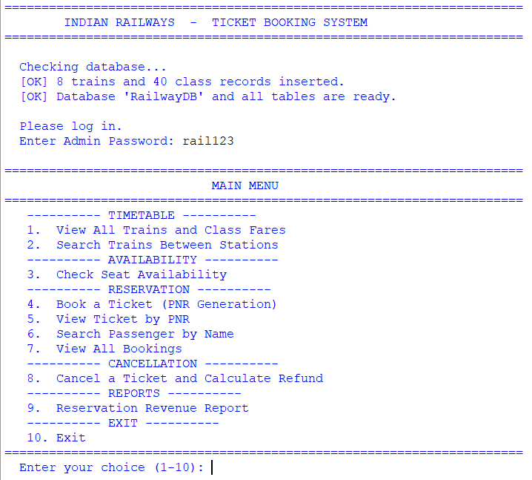Observation:
- On first run the program automatically created the database RailwayDB and 4 tables (Trains, Classes, Tickets, Passengers).
- It inserted ______ trains and ______ class records.
- On the second run the "inserted" message did not appear because the SELECT COUNT(*) check found that the Trains table was not empty. This proves the data is stored permanently in the database.

9.2 View All Trains (Option 1)
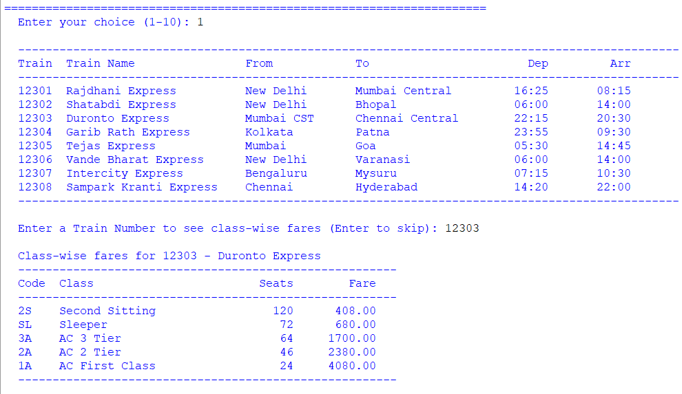Observation:
- The railway has ______ trains running on different routes.
- The train with the longest route in this list is __________________.
- For Train No. ______ (__________________), the fare structure was:
Code | Class | Seats | Fare
2S | Second Sitting | ______ | Rs. ______
SL | Sleeper | ______ | Rs. ______
3A | AC 3 Tier | ______ | Rs. ______
2A | AC 2 Tier | ______ | Rs. ______
1A | AC First Class | ______ | Rs. ______
- The fare ratios matched the defined multipliers — 1A is 6 times SL, 2A is 3.5 times SL, 3A is 2.5 times SL.

9.3 Search Trains Between Stations (Option 2)
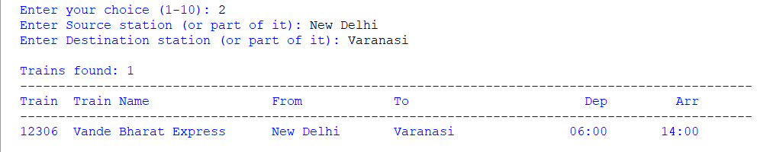Observation:
- Searching for trains from __________ to __________ returned ______ train(s).
- The LIKE %...% operator allowed me to enter only part of the station name, which is very convenient.

9.4 Check Seat Availability (Option 3)
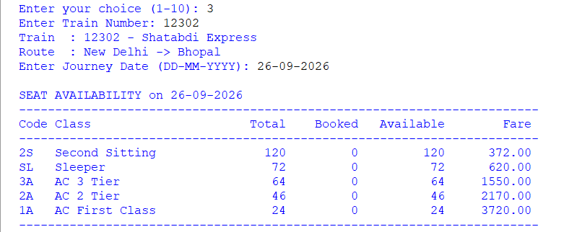Observation:
Code | Class | Total | Booked | Available | Fare
2S | Second Sitting | ______ | ______ | ______ | Rs. ______
SL | Sleeper | ______ | ______ | ______ | Rs. ______
3A | AC 3 Tier | ______ | ______ | ______ | Rs. ______
2A | AC 2 Tier | ______ | ______ | ______ | Rs. ______
1A | AC First Class | ______ | ______ | ______ | Rs. ______
- Important observation: The Booked column is calculated dynamically using SELECT COUNT(*) from the Passengers table joined with Tickets. The Availability table does not store a BookedSeats column, because the number of booked seats changes every time a booking is made or a ticket is cancelled. Computing it live keeps the value 100% accurate.
- When I entered a date that was today, the program correctly rejected it because the journey date must be at least 1 day in advance.
- When I entered a date more than 120 days ahead, the program also rejected it.

9.5 Book a Ticket (Option 4) — PNR Generation
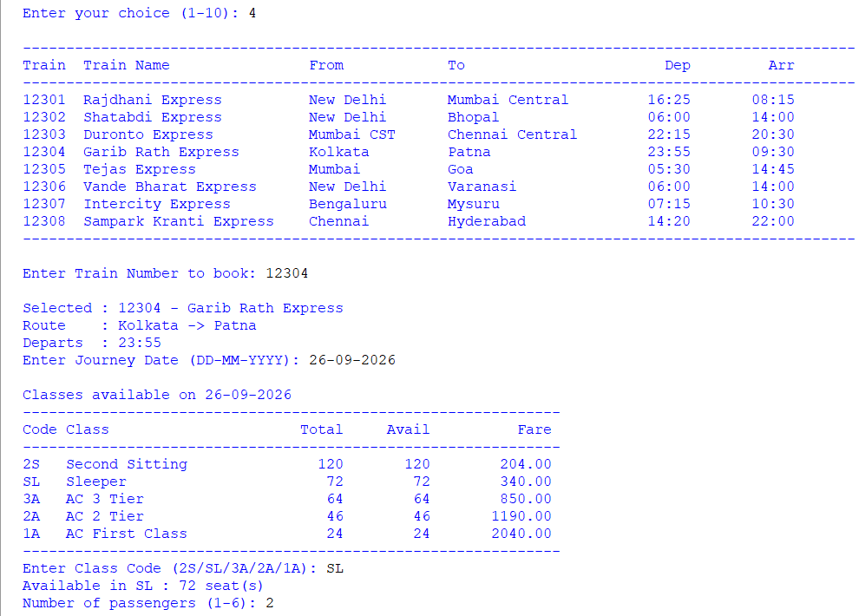
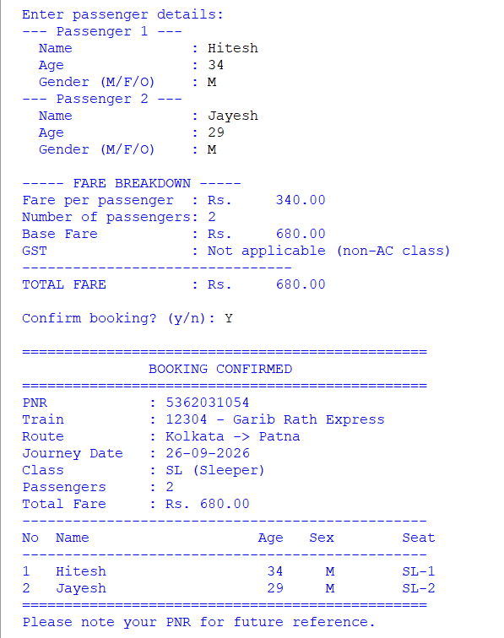
Observation:
- I booked Train ______, Class ______ for ______ passenger(s) on ______.
- The PNR generated was ______ (a 10-digit numeric code).
- The PNR was generated randomly using random.choices(string.digits, k=10) and then checked against the database with SELECT PNR FROM Tickets WHERE PNR = %s. If it already existed, a new PNR was generated — this is how uniqueness of the primary key is guaranteed.
- Seat allotment: the program automatically allotted the seats:
Passenger | Age | Gender | Seat Allotted
______ | ______ | ______ | ______
______ | ______ | ______ | ______
______ | ______ | ______ | ______
- Fare calculation:
Item | Value
Fare per passenger | Rs. ______
Base Fare (Fare × Passengers) | Rs. ______
GST @ 5% (only if AC class) | Rs. ______
Total Fare | Rs. ______
- Important observation: I booked a Sleeper (SL) ticket and confirmed that no GST was added. Then I booked an AC 3 Tier (3A) ticket and observed that 5% GST was added. This matches how the real IRCTC calculates fares.

9.6 Seat Allotment without Clash — Second Booking
Screenshot to insert: A second booking on the same train, same class, same journey date to show that seat numbers continue from where the previous booking left off.
Observation:
- After the first booking of ______ passengers with seat numbers ______, ______ the second booking of ______ passenger(s) received seat numbers ______ — no clash occurred.
- This was made possible by the get_free_seats() function, which reads all currently used seat numbers for that train, class and journey date, and returns the first free ones.

9.7 View Ticket by PNR (Option 5)
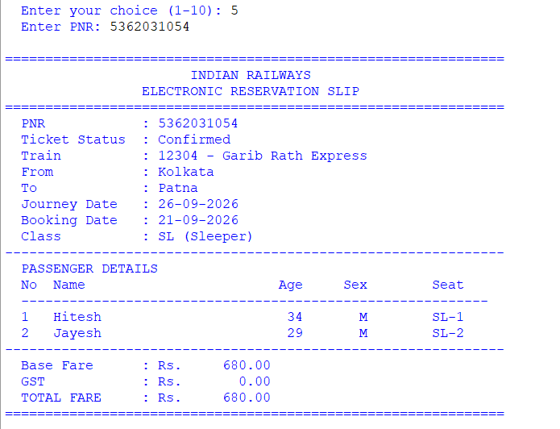Observation:
- The ERS displayed all passenger names, ages, genders and seat numbers.
- The booking was retrieved using a JOIN between Tickets and Trains to display the train name, and a separate query on Passengers for the passenger list.
- The output resembled a real IRCTC ticket, with the railway name centred at the top.

9.8 Search Passenger by Name (Option 6)
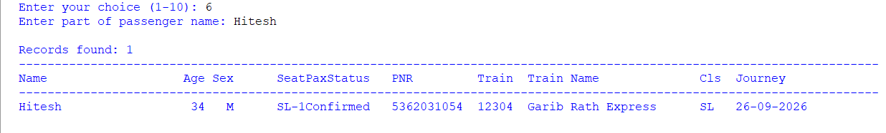Observation:
- Searching for part of a name (e.g., "Ra") returned ______ passenger record(s).
- The search used a 3-table JOIN (Passengers ⟗ Tickets ⟗ Trains) because the passenger's train name is stored in the Trains table, not in Passengers.
- This demonstrates the real power of a relational database — data is stored in normalised form and assembled only when needed.

9.9 Cancel a Ticket (Option 8) — Refund Calculation
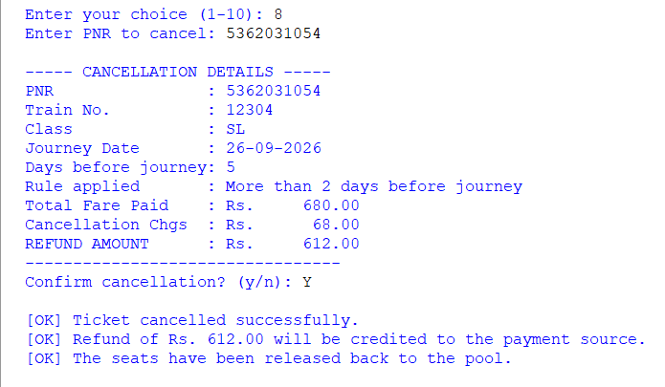Observation:
Item | Value
PNR Cancelled | ______
Journey Date | ______
Days Before Journey | ______
Rule Applied | ______
Total Fare Paid | Rs. ______
Cancellation Charges | Rs. ______
Refund Amount | Rs. ______
- The refund was calculated automatically by comparing the journey date with today's date using (jdate - today).days.
- Important: The program applied the correct rule:
  - More than 2 days → 90% refund
  - 1–2 days → 75% refund
  - Less than 24 hours → 50% refund
  - After departure → No refund
- After cancellation, the ticket status was changed to Cancelled, all its passengers were marked as Cancelled, and the seats became immediately available again — I verified this by checking availability (Option 3) for the same train and date, and the Available count had gone back up.

9.10 View All Bookings (Option 7)
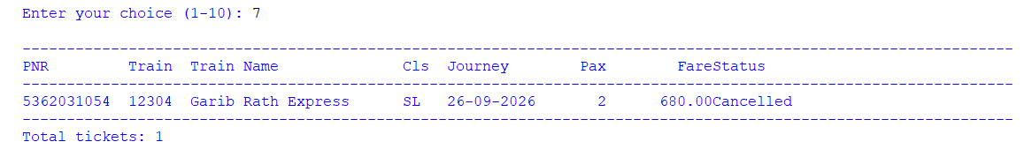Observation:
- The list showed both Confirmed and Cancelled tickets side by side.
- The ORDER BY BookingDate DESC, PNR DESC clause ensured the most recent bookings appeared first.

9.11 Revenue Report (Option 9)
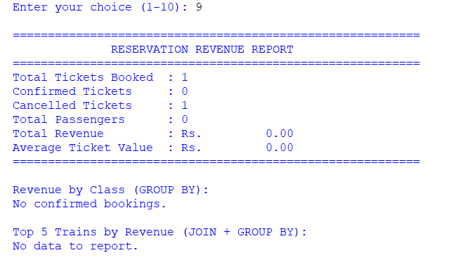
Observation:
Metric | Value
Total Tickets Booked | ______
Confirmed Tickets | ______
Cancelled Tickets | ______
Total Passengers | ______
Total Revenue | Rs. ______
Average Ticket Value | Rs. ______
Revenue by Class:
Code | Class | Tickets | Revenue
______ | ______ | ______ | Rs. ______
______ | ______ | ______ | Rs. ______
______ | ______ | ______ | Rs. ______
Top 5 Trains by Revenue:
Train No | Train Name | Tickets | Revenue
______ | ______ | ______ | Rs. ______
______ | ______ | ______ | Rs. ______
- Conclusion: The revenue-by-class table was produced using GROUP BY ClassCode with SUM(TotalFare) and COUNT(*), and the top-trains table used a JOIN followed by GROUP BY — the most important SQL techniques demonstrated in this project. The WHERE Status='Confirmed' condition ensured that cancelled tickets were excluded from revenue — exactly like real accounting.

10. CONCLUSION AND FUTURE SCOPE
Conclusion
In this project I successfully developed a complete, database-driven Railway Ticket Booking System using Python and MySQL. Through this project I learnt and applied:
- Python–MySQL Connectivity: Using mysql.connector.connect(), cursor(), execute(), fetchone(), fetchall(), commit() and rollback() to run SQL statements from inside Python.
- Relational database design: Creating four linked tables using a composite primary key in Classes and foreign keys in Classes.TrainNo, Tickets.TrainNo and Passengers.PNR. This enforces referential integrity — a passenger can never exist without a parent ticket.
- Automatic schema initialisation: Using CREATE DATABASE IF NOT EXISTS and CREATE TABLE IF NOT EXISTS so the program needs no manual SQL setup.
- PNR generation: Generating a unique 10-digit numeric PNR at run-time using random.choices(string.digits, k=10) and checking uniqueness against the database.
- Dynamic seat availability: Computing available seats live by joining Passengers and Tickets — instead of storing a BookedSeats column that could get out of sync.
- Individual seat allotment: Finding the first free seat numbers using Python sets, so different passengers never receive the same seat.
- The datetime module: Recording booking dates and calculating the number of days before the journey, which drives the refund rule.
- Conditional GST: Applying 5% GST only on AC classes (1A, 2A, 3A) and no GST on Sleeper and Second Sitting — exactly like IRCTC.
- Aggregate functions and grouping: Generating meaningful business reports using COUNT(), SUM(), AVG() and GROUP BY combined with JOIN.
The project demonstrated the true power of a relational database over simple files: data is structured, relationships are enforced, complex queries (joins, grouping, aggregate functions) are easy, and everything runs fast — even as the volume of data grows.
Future Scope
- Waiting List and RAC: When a class is full, passengers could be added to a waiting list with a WL number.
- Tatkal Quota: A separate quota that opens 48 hours before departure with a higher fare.
- Graphical User Interface (GUI): Use Tkinter so the clerk can click buttons instead of typing menu options.
- Web Interface: Build a Flask/Django web application so users can book from home.
- Live Seat Map: Display a coach chart with each seat marked as vacant/occupied.
- Email and SMS confirmation using Python's smtplib.
- Cancellation Refund Tracking: A separate Refunds table to record all refund transactions.
- Waitlist Auto-Promotion: When a confirmed passenger cancels, automatically promote the first waiting-list passenger.
- Chart Preparation: Generate a coach-wise chart of passengers for the Train Ticket Examiner (TTE).

11. TROUBLESHOOTING DATABASE CONNECTION
If you see an error such as:
text
Database Connection Error: 1045 (28000): Access denied for user 'root'@'localhost' (using password: YES)
follow these steps:
- Ensure MySQL is running
  - If using XAMPP: Start the MySQL service in the XAMPP Control Panel. By default the XAMPP root user has no password (leave DB_PASSWORD empty).
  - If using a standalone MySQL: Check the service status and ensure it is running.
- Test credentials from the command line
text
mysql -u your_username -p
Enter the same password you will put in the Python script. If login fails, reset the password or create a new user.
- Create a dedicated user (recommended)
sql
CREATE USER 'rail_user'@'localhost' IDENTIFIED BY 'your_password';
GRANT ALL PRIVILEGES ON *.* TO 'rail_user'@'localhost';
FLUSH PRIVILEGES;
Then set DB_USER = "rail_user" and DB_PASSWORD = "your_password" in the script.
- Change the authentication plugin (MySQL 8.0+ only)
sql
ALTER USER 'rail_user'@'localhost'
IDENTIFIED WITH mysql_native_password BY 'your_password';
FLUSH PRIVILEGES;
- Install/upgrade the connector
text
pip install --upgrade mysql-connector-python
Other common errors:
Error | Reason | Solution
Unknown database 'RailwayDB' | The database was dropped | Run the script again — it recreates the database automatically
Table 'RailwayDB.Trains' doesn't exist | Table dropped | Run the script again — CREATE TABLE IF NOT EXISTS recreates it
Foreign key constraint fails | Booking a train that does not exist | The script already checks this — but ensure the Classes table is populated
Data too long for column 'Name' | Guest name entered with more than 80 characters | Enter a shorter name or increase the column size
Duplicate entry '...' for key 'PRIMARY' | Extremely rare, since PNR is re-generated | Just try again — the loop generates a new PNR
Date parsed incorrectly | Wrong format entered (e.g., 2025/07/15) | Always use DD-MM-YYYY format

12. BIBLIOGRAPHY
- Websites:
  - MySQL Connector/Python Documentation (dev.mysql.com/doc/connector-python)
  - Python Official Documentation — datetime (docs.python.org/3/library/datetime.html)
  - Python Official Documentation — random and string (docs.python.org/3/library/random.html)
  - W3Schools — SQL Tutorial (www.w3schools.com/sql)
  - GeeksforGeeks (www.geeksforgeeks.org)
  - Stack Overflow (www.stackoverflow.com)
- Study Material:
  - NCERT Informatics Practices Textbook for Class XII
  - Sumita Arora, Informatics Practices with Python, Dhanpat Rai & Co.
- Reference Manual:
  - MySQL 8.0 Reference Manual (dev.mysql.com/doc)

