Your Institutional Name
PROJECT FILE
INFORMATICS PRACTICES (CLASS XII)
SESSION: [Year, 20_ _ - _ _]

LIBRARY MANAGEMENT SYSTEM
Submitted By:
[Your Name]
Class: XII – [Section]
Roll No: [Your Roll Number]
Submitted To:
[Teacher's Name]
Department of Computer Science
[Your School Name]

CERTIFICATE
This is to certify that [Your Name] of Class XII has successfully completed the Informatics Practices project titled "Library Management System" under the guidance of [Teacher's Name] during the academic year [Year] .
This project is a bonafide record of work done by the candidate independently and fulfills the requirements of the Central Board of Secondary Education (CBSE) for the AISSCE Examination.
Teacher In-Charge: __________________
Signature: __________________
External Examiner: __________________
Signature: __________________
School Seal:

ACKNOWLEDGEMENT
I would like to express my special thanks of gratitude to my Informatics Practices teacher [Teacher's Name] as well as our principal [Principal's Name] for giving me the golden opportunity to do this wonderful project on the topic "Library Management System".
I came to know about so many new things regarding Python and SQL connectivity while making this project. Secondly, I would also like to thank my parents and friends who helped me a lot in finalizing this project within the limited time frame.
Name: [Your Name]
Class: XII

TABLE OF CONTENTS
- Introduction
- Objectives of the Project
- Proposed System
- System Requirements (Hardware & Software)
- System Design (Table Structure)
- Python Libraries Used
- Source Code
- Output Screens
- Conclusion
- Bibliography

1. INTRODUCTION
The Library Management System is a software application designed to automate the day-to-day operations of a library. Managing a library manually is a tedious job involving the maintenance of registers, handling book issue/return logs, and tracking fines. This project aims to digitize the process, making it faster, more efficient, and less prone to errors.
This system acts as an interface between the Librarian and the Students. It allows the librarian to add new books, remove old books, search for books, issue books to students, and return books. The backend data is stored in a MySQL database, and the frontend logic is written in Python.

2. OBJECTIVES
The primary objectives of this project are:
- To eliminate manual paperwork in a library.
- To provide a user-friendly interface for managing book records.
- To maintain a centralized database of all books and student transactions.
- To ensure data integrity and security.
- To generate instant reports regarding available books and issued books.
- To implement CRUD (Create, Read, Update, Delete) operations using Python and MySQL.

3. PROPOSED SYSTEM
The proposed system consists of two main modules:
- Admin/Librarian Module:
  - Login to the system using a password.
  - Add new books to the database.
  - Delete books from the database.
  - Search for a specific book by ID or Title.
  - View all books.
  - Issue a book to a student.
  - Return a book.
- Database Module (MySQL):
  - Stores Book information (Book ID, Title, Author, Price, Quantity).
  - Stores Issued Book information (Book ID, Student Name, Issue Date).

4. SYSTEM REQUIREMENTS
Hardware Requirements:
- Processor: Intel Core i3 or above
- RAM: 4 GB or above
- Hard Disk: 100 GB or above
Software Requirements:
- Operating System: Windows 7/8/10/11 or Linux
- Python 3.x (IDLE or any IDE like PyCharm)
- MySQL Server 5.7 or above
- Python-MySQL Connector Module (mysql.connector)

5. SYSTEM DESIGN (Table Structure)
The system uses a database named Library.
It contains two tables: Books and Issued.
Table 1: Books
Column Name | Data Type | Constraint | Description
BookID | INT | PRIMARY KEY | Unique ID of the book
Title | VARCHAR(100) | NOT NULL | Name of the book
Author | VARCHAR(100) | NOT NULL | Author of the book
Price | DECIMAL(8,2) | NULL | Cost of the book
Quantity | INT | NULL | Stock available
Table 2: Issued
Column Name | Data Type | Constraint | Description
BookID | INT | FOREIGN KEY | References Books table
StudentName | VARCHAR(100) | NOT NULL | Name of the student
IssueDate | DATE | NULL | Date of issue

6. PYTHON LIBRARIES USED
- mysql.connector: This is the main library used to establish a connection between the Python frontend and the MySQL backend. It allows Python code to execute SQL queries.
- datetime: This built-in Python library is used to fetch the current date from the system automatically when a book is issued. This removes manual date entry errors.
- os (Optional): Used to clear the terminal screen for better presentation of the menu.

7. SOURCE CODE
Below is the complete Python code for the Library Management System.
python
# Library Management System
# Class 12 Informatics Practices Project

import mysql.connector
import datetime

# ------------------------- DATABASE CONNECTION -------------------------

def connect_db():
try:
con = mysql.connector.connect(
host="localhost",
user="root", # Change your username
password="admin", # Change your password
database="library"
)
return con
except mysql.connector.Error as err:
print(f"Database Connection Error: {err}")
return None

# ------------------------- FUNCTIONS (MENU OPTIONS) -------------------------

def add_book():
con = connect_db()
if con:
cur = con.cursor()
book_id = int(input("Enter Book ID: "))
title = input("Enter Title: ")
author = input("Enter Author: ")
price = float(input("Enter Price: "))
qty = int(input("Enter Quantity: "))

query = "INSERT INTO Books VALUES (%s, %s, %s, %s, %s)"
values = (book_id, title, author, price, qty)

try:
cur.execute(query, values)
con.commit()
print("Book added successfully!")
except mysql.connector.Error as err:
print(f"Error: {err}")
finally:
cur.close()
con.close()

def delete_book():
con = connect_db()
if con:
cur = con.cursor()
book_id = int(input("Enter Book ID to delete: "))
query = "DELETE FROM Books WHERE BookID = %s"

try:
cur.execute(query, (book_id,))
con.commit()
if cur.rowcount > 0:
print("Book deleted successfully!")
else:
print("Book not found.")
except mysql.connector.Error as err:
print(f"Error: {err}")
finally:
cur.close()
con.close()

def search_book():
con = connect_db()
if con:
cur = con.cursor()
print("1. Search by ID")
print("2. Search by Title")
choice = input("Enter choice: ")

if choice == '1':
val = int(input("Enter Book ID: "))
query = "SELECT * FROM Books WHERE BookID = %s"
else:
val = input("Enter Title: ")
query = "SELECT * FROM Books WHERE Title LIKE %s"
val = '%' + val + '%'

cur.execute(query, (val,))
rows = cur.fetchall()

if rows:
print(f"{'ID':<5} {'Title':<30} {'Author':<20} {'Price':<10} {'Qty'}")
for row in rows:
print(f"{row[0]:<5} {row[1]:<30} {row[2]:<20} {row[3]:<10} {row[4]}")
else:
print("No matching records found.")

cur.close()
con.close()

def show_books():
con = connect_db()
if con:
cur = con.cursor()
cur.execute("SELECT * FROM Books")
rows = cur.fetchall()

if rows:
print(f"{'ID':<5} {'Title':<30} {'Author':<20} {'Price':<10} {'Qty'}")
print("-" * 80)
for row in rows:
print(f"{row[0]:<5} {row[1]:<30} {row[2]:<20} {row[3]:<10} {row[4]}")
else:
print("Library is empty.")

cur.close()
con.close()

def issue_book():
con = connect_db()
if con:
cur = con.cursor()
book_id = int(input("Enter Book ID to issue: "))

# Check if book exists and has quantity
cur.execute("SELECT Quantity FROM Books WHERE BookID = %s", (book_id,))
result = cur.fetchone()

if result and result[0] > 0:
student = input("Enter Student Name: ")
today = datetime.date.today()

# Insert into Issued table
query_issue = "INSERT INTO Issued VALUES (%s, %s, %s)"
cur.execute(query_issue, (book_id, student, today))

# Decrease quantity in Books table
query_update = "UPDATE Books SET Quantity = Quantity - 1 WHERE BookID = %s"
cur.execute(query_update, (book_id,))

con.commit()
print("Book issued successfully to", student)
else:
print("Book not available or out of stock.")

cur.close()
con.close()

def return_book():
con = connect_db()
if con:
cur = con.cursor()
book_id = int(input("Enter Book ID to return: "))
student = input("Enter Student Name: ")

# Delete from Issued table
query_delete = "DELETE FROM Issued WHERE BookID = %s AND StudentName = %s"
cur.execute(query_delete, (book_id, student))

if cur.rowcount > 0:
# Increase quantity in Books table
query_update = "UPDATE Books SET Quantity = Quantity + 1 WHERE BookID = %s"
cur.execute(query_update, (book_id,))
con.commit()
print("Book returned successfully!")
else:
print("No such issue record found.")

cur.close()
con.close()

# ------------------------- MAIN PROGRAM LOOP -------------------------

def main():
# Admin Login (Simple Password Protection)
password = input("Enter Admin Password: ")
if password != "admin123": # Change password if needed
print("Wrong Password. Exiting...")
return

while True:
print("\n" + "="*40)
print(" LIBRARY MANAGEMENT SYSTEM")
print("="*40)
print("1. Add Book")
print("2. Delete Book")
print("3. Search Book")
print("4. Show All Books")
print("5. Issue Book")
print("6. Return Book")
print("7. Exit")
print("="*40)

choice = input("Enter your choice: ")

if choice == '1':
add_book()
elif choice == '2':
delete_book()
elif choice == '3':
search_book()
elif choice == '4':
show_books()
elif choice == '5':
issue_book()
elif choice == '6':
return_book()
elif choice == '7':
print("Thank you for using LSM. Goodbye!")
break
else:
print("Invalid choice. Please try again.")

if __name__ == "__main__":
main()

8. OUTPUT SCREENS

Figure 1: Main Menu
Description: The terminal window showing the initial password prompt followed by the Main Menu options (Add Book, Delete Book, etc.).
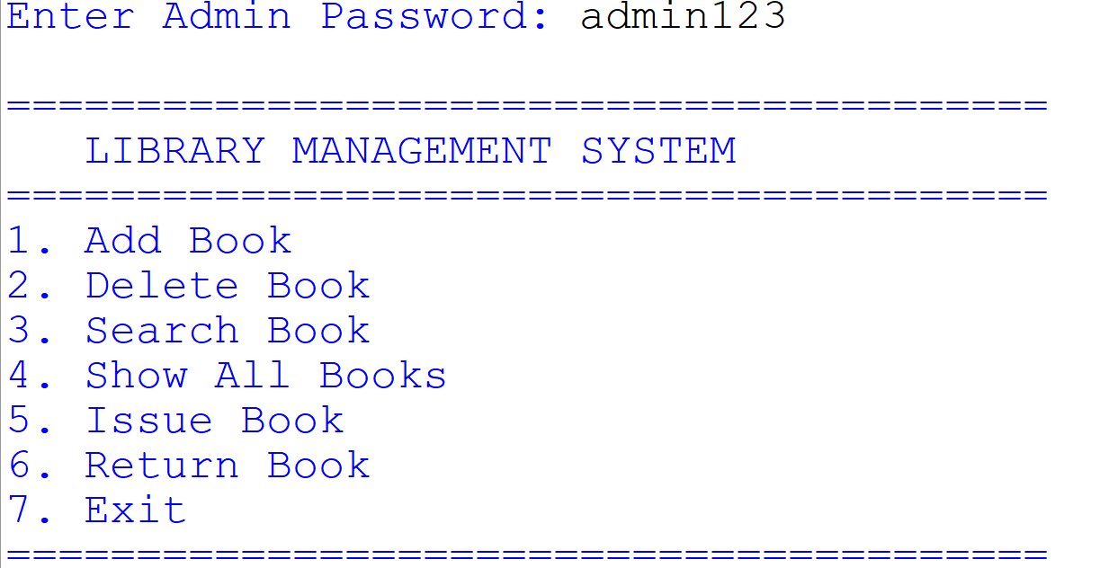

Figure 2: Adding a Book
Description: The user selects option 1, enters the details (ID, Title, Author, Price, Qty), and the system responds with "Book added successfully!".
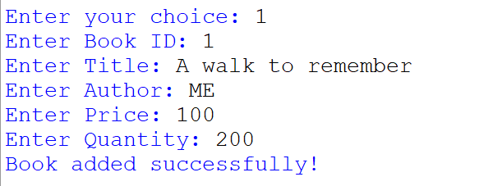

Figure 3: Displaying All Books
Description: The user selects option 4, and a formatted table listing all the books currently in the database is displayed.
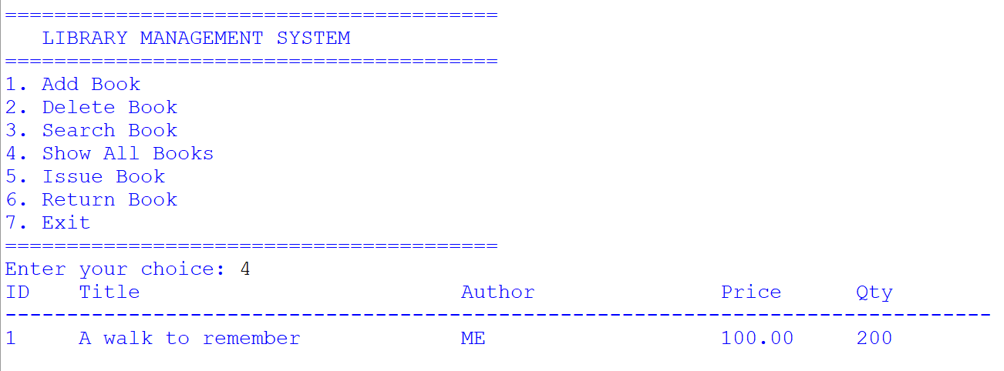

Figure 4: Issuing a Book
Description: The user selects option 5, enters a Book ID and Student Name. The system confirms the issue.
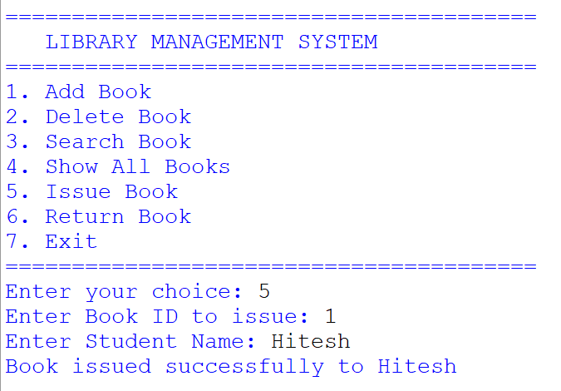
Figure 5: MySQL Database View
Description: A screenshot of MySQL Command Line Client or Workbench showing the SELECT * FROM Books; query results after the Python operations have been performed.
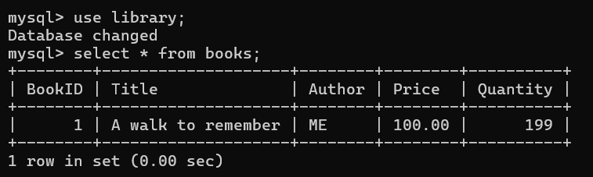

9. CONCLUSION
Through this project, I successfully developed a fully functional Library Management System using Python and MySQL. The project taught me how to integrate a high-level programming language (Python) with a Relational Database Management System (MySQL) using the mysql.connector library.
The system significantly reduces the workload of a librarian by automating book keeping. It ensures that data is managed centrally and accurately. While developing this project, I learned important concepts like CRUD operations, SQL queries (INSERT, SELECT, UPDATE, DELETE), and handling Python-MySQL connectivity errors.
Future Scope:
- A Graphical User Interface (GUI) can be added using Tkinter or PyQt.
- A separate Student Login panel can be created so students can browse books remotely.
- A "Fine Calculation" feature for overdue books can be implemented.

10. BIBLIOGRAPHY
- Websites:
  - Stack Overflow (www.stackoverflow.com)
  - GeeksforGeeks (www.geeksforgeeks.org)
  - W3Schools (www.w3schools.com)
- Study Material:
  - NCERT Informatics Practices Textbook for Class XII
  - Sumita Arora Informatics Practices (Python) Textbook
- Reference Manual:
  - MySQL Official Documentation (dev.mysql.com)

Thank You!

