PROJECT FILE
INFORMATICS PRACTICES (CLASS XII)
SESSION: [Year, e.g., 2023-2024]

HOTEL RESERVATION SYSTEM
(Database-Driven Room Booking, Guest Management and Billing Application)
Submitted By:
[Your Name]
Class: XII – [Section]
Roll No: [Your Roll Number]
Submitted To:
[Teacher's Name]
Department of Computer Science
[Your School Name]

CERTIFICATE
This is to certify that [Your Name] of Class XII has successfully completed the Informatics Practices project titled "Hotel Reservation System" under the guidance of [Teacher's Name] during the academic year [Year].
This project is a bonafide record of work done by the candidate independently and fulfills the requirements of the Central Board of Secondary Education (CBSE) for the AISSCE Examination.
Teacher In-Charge: __________________
Signature: __________________
External Examiner: __________________
Signature: __________________
School Seal:

ACKNOWLEDGEMENT
I would like to express my sincere thanks to my Informatics Practices teacher [Teacher's Name] and our Principal [Principal's Name] for giving me the opportunity to work on this project titled "Hotel Reservation System".
While working on this project I learnt how a relational database can be connected to a Python program to build a real-world application. I learnt how to write INSERT, SELECT, UPDATE and DELETE queries from Python, how to use foreign keys to link tables, how to work with the datetime module to calculate the number of days a guest stayed, and how to use SQL aggregate functions to generate reports. I would also like to thank my parents and friends who supported and encouraged me throughout the completion of this project.
Name: [Your Name]
Class: XII

TABLE OF CONTENTS
- Introduction
- Objectives of the Project
- Proposed System
- System Requirements (Hardware & Software)
- System Design (Table Structures)
- Python Libraries Used
- Functions Used (Quick Reference)
- Source Code
- Output Screens and Observations
- Conclusion and Future Scope
- Troubleshooting Database Connection
- Bibliography

1. INTRODUCTION
A hotel receives a large number of guests every day. For every guest the receptionist must find a vacant room, record the guest's details, note the check-in and check-out dates, collect an advance, and finally calculate the bill at the time of check-out. If all of this is done on paper, mistakes are common — double booking of rooms, lost guest records, wrong bills, and difficulty in preparing occupancy reports.
The Hotel Reservation System is a software application that automates these tasks. It is a menu-driven Python program backed by a MySQL relational database. It allows the receptionist to:
- View all rooms and their current status (Available / Occupied).
- Add new rooms to the hotel.
- Register a new booking for a guest by allotting an available room.
- View all currently active bookings.
- Search a booking by Booking ID, by Guest Name, or by Room Number.
- Perform check-out — automatically calculate the number of nights stayed, compute the room charge, add extra service charges, apply GST, deduct the advance paid, and store the final bill in a Bills table.
- Generate an occupancy report using SQL aggregate functions such as COUNT(), SUM() and AVG().
The database stores data permanently, so even after the program is closed and reopened, all rooms, bookings and bills remain intact. This is the key advantage of a database-driven system over a file-based system.
2. OBJECTIVES
The main objectives of this project are:
- To understand how Python and MySQL can be connected using the mysql.connector library.
- To design a relational database with three related tables (Rooms, Bookings, Bills) using primary keys and foreign keys.
- To perform all four CRUD operations — Create, Read, Update and Delete — using SQL queries executed from Python.
- To use the datetime module to record check-in dates and to calculate the number of nights stayed.
- To use SQL aggregate functions (COUNT, SUM, AVG, MAX, MIN) and GROUP BY to generate business reports.
- To apply GST and business logic for bill calculation.
- To understand the importance of commit() and rollback() in a database transaction.
- To automatically initialise the schema using CREATE DATABASE IF NOT EXISTS and CREATE TABLE IF NOT EXISTS.
3. PROPOSED SYSTEM
The system is a menu-driven program divided into four modules:
3.1 Room Management Module
- View all rooms (with type, tariff and current status).
- View only the available rooms.
- View rooms filtered by type (Single, Double, Deluxe, Suite, Presidential Suite).
- Add a new room to the hotel.
- Update the tariff of an existing room.
- Delete a room (only if it is not currently occupied).
3.2 Booking Module
- Create a new booking by entering the guest's name, phone, ID proof, room number, planned check-out date and advance amount.
- Validate that the room is available before booking.
- Automatically update the room's status to Occupied.
- View all active bookings.
- Search a booking by Booking ID, Guest Name or Room Number.
3.3 Check-out & Billing Module
- Perform check-out for a given Booking ID.
- Automatically calculate the number of nights stayed using (CheckOut - CheckIn).days.
- Compute: Room Charge = Nights × Tariff.
- Add extra service charges (restaurant / laundry / spa) entered at the time of checkout.
- Apply GST @ 12% on the subtotal.
- Deduct the advance paid at the time of booking.
- Display the final balance payable.
- Save the bill permanently in the Bills table.
- Free the room by updating its status back to Available.
- Mark the booking as Closed.
3.4 Report Module
- Occupancy report (total rooms, occupied, available, percentage).
- Total revenue collected.
- Average bill amount.
- Highest and lowest bill.
- Revenue grouped by room type using GROUP BY.
- View a saved bill by Bill Number.
4. SYSTEM REQUIREMENTS
Hardware Requirements:
- Processor: Intel Core i3 or above
- RAM: 4 GB or above
- Hard Disk: 100 GB or above
Software Requirements:
- Operating System: Windows 7/8/10/11 or Linux
- Python 3.x (IDLE / PyCharm)
- MySQL Server 5.7 or above (or XAMPP's MariaDB)
- Python-MySQL Connector (mysql-connector-python)
5. SYSTEM DESIGN (TABLE STRUCTURES)
The system uses a database named HotelDB.
The database and tables are created automatically by the Python script on first execution.
Table 1: Rooms
Column | Data Type | Constraint | Description
RoomNo | INT | PRIMARY KEY | Unique room number
RoomType | VARCHAR(25) | NOT NULL | Single / Double / Deluxe / Suite / Presidential Suite
Tariff | DECIMAL(10,2) | NOT NULL | Price per night in rupees
Status | VARCHAR(15) | DEFAULT 'Available' | 'Available' or 'Occupied'
Table 2: Bookings
Column | Data Type | Constraint | Description
BookingID | INT | AUTO_INCREMENT PRIMARY KEY | Unique booking number
GuestName | VARCHAR(100) | NOT NULL | Full name of guest
Phone | VARCHAR(15) | NULL | Contact number
IDProof | VARCHAR(30) | NULL | Aadhaar / PAN / Passport
RoomNo | INT | FOREIGN KEY → Rooms | Room allotted
CheckIn | DATE | NOT NULL | Date guest checked in
PlannedCheckOut | DATE | NOT NULL | Date guest plans to check out
Advance | DECIMAL(10,2) | DEFAULT 0 | Advance amount collected
BookingDate | DATE | NULL | Date booking was made
Status | VARCHAR(15) | DEFAULT 'Active' | 'Active' or 'Closed'
Table 3: Bills
Column | Data Type | Constraint | Description
BillNo | INT | AUTO_INCREMENT PRIMARY KEY | Unique bill number
BookingID | INT | NULL | Reference to the booking
GuestName | VARCHAR(100) | NULL | Guest name (for easy reading)
RoomNo | INT | NULL | Room number
Days | INT | NULL | Number of nights stayed
RoomCharge | DECIMAL(10,2) | NULL | Days × Tariff
ExtraServices | DECIMAL(10,2) | NULL | Restaurant / Laundry charges
Subtotal | DECIMAL(10,2) | NULL | RoomCharge + ExtraServices
GST | DECIMAL(10,2) | NULL | 12% of subtotal
GrandTotal | DECIMAL(10,2) | NULL | Subtotal + GST
Advance | DECIMAL(10,2) | NULL | Advance already paid
Balance | DECIMAL(10,2) | NULL | GrandTotal − Advance
PaymentMode | VARCHAR(15) | NULL | Cash / Card / UPI
BillDate | DATE | NULL | Date of checkout
Relationship:
Bookings.RoomNo is a foreign key referencing Rooms.RoomNo.
This ensures that a booking can never be made for a room that does not exist.
Default Data
On first run, the script inserts 14 default rooms:
Room Type | Room Numbers | Tariff per Night
Single | 101, 102, 103, 104 | Rs. 1,500
Double | 201, 202, 203, 204 | Rs. 2,500
Deluxe | 301, 302, 303 | Rs. 4,000
Suite | 401, 402 | Rs. 7,000
Presidential Suite | 501 | Rs. 15,000
6. PYTHON LIBRARIES USED
- mysql.connector — the main library that connects Python to the MySQL server. It is used to run SQL queries, fetch results and commit changes.
- datetime — a built-in Python library used to:
  - Record the current date (datetime.date.today()).
  - Calculate the number of nights between two dates: (checkout - checkin).days.
7. FUNCTIONS USED (QUICK REFERENCE)
7.1 MySQL Connector Functions
Function / Method | Description
mysql.connector.connect(...) | Opens a connection to the MySQL server
con.cursor() | Creates a cursor to execute SQL statements
cur.execute(sql, params) | Executes a single SQL statement (with optional parameters)
cur.executemany(sql, list) | Executes the same SQL for many rows at once
cur.fetchone() | Returns the next row of the result as a tuple
cur.fetchall() | Returns all remaining rows as a list of tuples
cur.rowcount | Number of rows affected by the last INSERT / UPDATE / DELETE
con.commit() | Saves the changes permanently to the database
con.rollback() | Undoes changes since the last commit
cur.close() / con.close() | Closes the cursor and connection
7.2 SQL Statements Used
Statement | Purpose in This Project
CREATE DATABASE IF NOT EXISTS | Auto-create the database
CREATE TABLE IF NOT EXISTS | Auto-create the three tables
INSERT INTO | Add new rooms, bookings and bills
SELECT ... FROM ... WHERE | Retrieve specific records
SELECT ... LIKE | Search by a part of the guest name
UPDATE ... SET | Update room status, room tariff, booking status
DELETE FROM | Remove a room
COUNT(), SUM(), AVG(), MAX(), MIN() | Aggregate functions for reports
GROUP BY | Revenue grouped by room type
8. SOURCE CODE
Below is the complete Python code. It creates the database, tables and default room data automatically, so no prior SQL setup is required.
python
# ==========================================================
# HOTEL RESERVATION SYSTEM
# Class 12 Informatics Practices Project
# Tools Used: Python 3 + MySQL (mysql-connector-python)
# ==========================================================

import mysql.connector
import datetime

# ------------------------- CONFIGURATION (EDIT THESE) -------------------------
DB_HOST = "localhost"
DB_USER = "root" # <-- Change to your MySQL username
DB_PASSWORD = "" # <-- Change to your MySQL password (empty for XAMPP default)
DB_NAME = "HotelDB"

HOTEL_NAME = "GRAND PALM HOTEL"
GST_RATE = 0.12 # 12% GST on hotel bills

ADMIN_PASSWORD = "hotel123" # Simple password for the receptionist

# Default rooms inserted on first run
DEFAULT_ROOMS = [
(101, "Single", 1500.00), (102, "Single", 1500.00),
(103, "Single", 1500.00), (104, "Single", 1500.00),
(201, "Double", 2500.00), (202, "Double", 2500.00),
(203, "Double", 2500.00), (204, "Double", 2500.00),
(301, "Deluxe", 4000.00), (302, "Deluxe", 4000.00),
(303, "Deluxe", 4000.00),
(401, "Suite", 7000.00), (402, "Suite", 7000.00),
(501, "Presidential Suite", 15000.00),
]

# ==================== 1. DATABASE INITIALISATION ====================

def initialize_database():
"""Create database, tables and default rooms if they do not exist."""
try:
con = mysql.connector.connect(
host=DB_HOST, user=DB_USER, password=DB_PASSWORD)
cur = con.cursor()

cur.execute("CREATE DATABASE IF NOT EXISTS " + DB_NAME)
cur.execute("USE " + DB_NAME)

cur.execute("""
CREATE TABLE IF NOT EXISTS Rooms (
RoomNo INT PRIMARY KEY,
RoomType VARCHAR(25) NOT NULL,
Tariff DECIMAL(10,2) NOT NULL,
Status VARCHAR(15) DEFAULT 'Available'
)
""")

cur.execute("""
CREATE TABLE IF NOT EXISTS Bookings (
BookingID INT AUTO_INCREMENT PRIMARY KEY,
GuestName VARCHAR(100) NOT NULL,
Phone VARCHAR(15),
IDProof VARCHAR(30),
RoomNo INT NOT NULL,
CheckIn DATE NOT NULL,
PlannedCheckOut DATE NOT NULL,
Advance DECIMAL(10,2) DEFAULT 0,
BookingDate DATE,
Status VARCHAR(15) DEFAULT 'Active',
FOREIGN KEY (RoomNo) REFERENCES Rooms(RoomNo)
)
""")

cur.execute("""
CREATE TABLE IF NOT EXISTS Bills (
BillNo INT AUTO_INCREMENT PRIMARY KEY,
BookingID INT,
GuestName VARCHAR(100),
RoomNo INT,
Days INT,
RoomCharge DECIMAL(10,2),
ExtraServices DECIMAL(10,2),
Subtotal DECIMAL(10,2),
GST DECIMAL(10,2),
GrandTotal DECIMAL(10,2),
Advance DECIMAL(10,2),
Balance DECIMAL(10,2),
PaymentMode VARCHAR(15),
BillDate DATE
)
""")

# Insert default rooms only if the table is empty
cur.execute("SELECT COUNT(*) FROM Rooms")
if cur.fetchone()[0] == 0:
cur.executemany(
"INSERT INTO Rooms (RoomNo, RoomType, Tariff) VALUES (%s, %s, %s)",
DEFAULT_ROOMS)
print(" [OK] " + str(len(DEFAULT_ROOMS)) + " default rooms inserted.")

con.commit()
print(" [OK] Database '" + DB_NAME + "' and all tables are ready.")
cur.close()
con.close()

except mysql.connector.Error as err:
print("Database Initialisation Error:", err)
print("Please check DB_USER and DB_PASSWORD in the CONFIGURATION section.")
exit(1)

def connect_db():
try:
con = mysql.connector.connect(
host=DB_HOST, user=DB_USER, password=DB_PASSWORD,
database=DB_NAME)
return con
except mysql.connector.Error as err:
print("Database Connection Error:", err)
return None

# ==================== 2. ROOM MANAGEMENT ====================

def show_rooms(where_clause=""):
con = connect_db()
if not con:
return
cur = con.cursor()
sql = "SELECT RoomNo, RoomType, Tariff, Status FROM Rooms " + where_clause
cur.execute(sql)
rows = cur.fetchall()

if not rows:
print(" [!] No rooms found.")
else:
print("\n " + "-" * 62)
print(" {:<8}{:<24}{:>14}{:>16}".format(
"RoomNo", "Room Type", "Tariff", "Status"))
print(" " + "-" * 62)
for r in rows:
print(" {:<8}{:<24}{:>14.2f}{:>16}".format(
r[0], r[1], r[2], r[3]))
print(" " + "-" * 62)
print(" Total rooms listed:", len(rows))

cur.close()
con.close()

def view_available_rooms():
show_rooms("WHERE Status = 'Available' ORDER BY RoomNo")

def view_rooms_by_type():
rtype = input(" Enter room type (Single/Double/Deluxe/Suite/Presidential Suite): ").strip()
con = connect_db()
if not con:
return
cur = con.cursor()
cur.execute("""SELECT RoomNo, RoomType, Tariff, Status FROM Rooms
WHERE RoomType LIKE %s ORDER BY RoomNo""",
("%" + rtype + "%",))
rows = cur.fetchall()
if not rows:
print(" [!] No rooms of this type found.")
else:
print("\n {:<8}{:<24}{:>14}{:>16}".format("RoomNo", "Room Type", "Tariff", "Status"))
print(" " + "-" * 62)
for r in rows:
print(" {:<8}{:<24}{:>14.2f}{:>16}".format(r[0], r[1], r[2], r[3]))
cur.close()
con.close()

def add_room():
con = connect_db()
if not con:
return
cur = con.cursor()
try:
rno = int(input(" Enter new Room Number: "))
rtype = input(" Enter Room Type: ").strip()
tariff = float(input(" Enter Tariff per night (Rs.): "))
except ValueError:
print(" [!] Room number and tariff must be numbers.")
cur.close(); con.close(); return

try:
cur.execute("INSERT INTO Rooms (RoomNo, RoomType, Tariff) VALUES (%s, %s, %s)",
(rno, rtype, tariff))
con.commit()
print(" [OK] Room " + str(rno) + " added successfully.")
except mysql.connector.Error as err:
print(" [!] Error:", err)
finally:
cur.close(); con.close()

def update_tariff():
con = connect_db()
if not con:
return
cur = con.cursor()
try:
rno = int(input(" Enter Room Number to update tariff: "))
new_tariff = float(input(" Enter new Tariff (Rs.): "))
except ValueError:
print(" [!] Please enter valid numbers.")
cur.close(); con.close(); return

cur.execute("UPDATE Rooms SET Tariff = %s WHERE RoomNo = %s", (new_tariff, rno))
if cur.rowcount > 0:
con.commit()
print(" [OK] Tariff updated for Room " + str(rno) + ".")
else:
print(" [!] Room not found.")
cur.close(); con.close()

def delete_room():
con = connect_db()
if not con:
return
cur = con.cursor()
try:
rno = int(input(" Enter Room Number to delete: "))
except ValueError:
print(" [!] Please enter a valid number.")
cur.close(); con.close(); return

cur.execute("SELECT Status FROM Rooms WHERE RoomNo = %s", (rno,))
row = cur.fetchone()
if not row:
print(" [!] Room not found.")
elif row[0] == "Occupied":
print(" [!] This room is currently occupied and cannot be deleted.")
else:
cur.execute("DELETE FROM Rooms WHERE RoomNo = %s", (rno,))
con.commit()
print(" [OK] Room " + str(rno) + " deleted.")
cur.close(); con.close()

# ==================== 3. BOOKING MODULE ====================

def new_booking():
con = connect_db()
if not con:
return
cur = con.cursor()

show_rooms("WHERE Status = 'Available' ORDER BY RoomNo")

try:
rno = int(input("\n Enter Room Number to book: "))
except ValueError:
print(" [!] Please enter a valid room number.")
cur.close(); con.close(); return

cur.execute("SELECT RoomType, Tariff, Status FROM Rooms WHERE RoomNo = %s", (rno,))
row = cur.fetchone()

if not row:
print(" [!] Room does not exist.")
cur.close(); con.close(); return
if row[2] != "Available":
print(" [!] Room is already occupied.")
cur.close(); con.close(); return

rtype, tariff = row[0], float(row[1])
print(" Room Type :", rtype)
print(" Tariff : Rs.", tariff, "per night")

name = input(" Enter Guest Name : ").strip()
if name == "":
print(" [!] Guest name cannot be empty.")
cur.close(); con.close(); return
phone = input(" Enter Phone Number : ").strip()
idproof = input(" Enter ID Proof (Aadhaar/PAN/Passport): ").strip()

try:
days = int(input(" Number of nights planned: "))
if days <= 0:
raise ValueError
except ValueError:
print(" [!] Number of nights must be a positive whole number.")
cur.close(); con.close(); return

try:
advance = float(input(" Advance Amount Paid (Rs.): "))
except ValueError:
print(" [!] Advance must be a number.")
cur.close(); con.close(); return

today = datetime.date.today()
checkout = today + datetime.timedelta(days=days)

try:
cur.execute("""INSERT INTO Bookings
(GuestName, Phone, IDProof, RoomNo, CheckIn,
PlannedCheckOut, Advance, BookingDate, Status)
VALUES (%s, %s, %s, %s, %s, %s, %s, %s, 'Active')""",
(name, phone, idproof, rno, today, checkout,
advance, today))
cur.execute("UPDATE Rooms SET Status = 'Occupied' WHERE RoomNo = %s", (rno,))
con.commit()
booking_id = cur.lastrowid
print("\n ============================================")
print(" BOOKING CONFIRMED")
print(" ============================================")
print(" Booking ID :", booking_id)
print(" Guest Name :", name)
print(" Room No. :", rno, "(" + rtype + ")")
print(" Check-In Date :", today.strftime("%d-%m-%Y"))
print(" Planned Out :", checkout.strftime("%d-%m-%Y"))
print(" Advance Paid : Rs. {:.2f}".format(advance))
print(" ============================================")
except mysql.connector.Error as err:
con.rollback()
print(" [!] Booking failed:", err)
finally:
cur.close(); con.close()

def view_active_bookings():
con = connect_db()
if not con:
return
cur = con.cursor()
cur.execute("""SELECT b.BookingID, b.GuestName, b.RoomNo, r.RoomType,
b.CheckIn, b.PlannedCheckOut, b.Advance
FROM Bookings b JOIN Rooms r ON b.RoomNo = r.RoomNo
WHERE b.Status = 'Active'
ORDER BY b.BookingID""")
rows = cur.fetchall()
if not rows:
print(" [!] No active bookings currently.")
else:
print("\n " + "-" * 90)
print(" {:<6}{:<22}{:<7}{:<14}{:<13}{:<13}{:>10}".format(
"ID", "Guest Name", "Room", "Room Type", "Check-In",
"Plan-Out", "Advance"))
print(" " + "-" * 90)
for r in rows:
print(" {:<6}{:<22}{:<7}{:<14}{:<13}{:<13}{:>10.2f}".format(
r[0], r[1][:21], r[2], r[3][:13],
r[4].strftime("%d-%m-%Y"),
r[5].strftime("%d-%m-%Y"),
float(r[6])))
print(" " + "-" * 90)
print(" Active bookings:", len(rows))
cur.close(); con.close()

def search_booking():
print("\n Search by:")
print(" 1. Booking ID")
print(" 2. Guest Name")
print(" 3. Room Number")
ch = input(" Enter choice (1/2/3): ").strip()

con = connect_db()
if not con:
return
cur = con.cursor()

if ch == "1":
try:
bid = int(input(" Enter Booking ID: "))
except ValueError:
print(" [!] Invalid ID."); cur.close(); con.close(); return
cur.execute("""SELECT BookingID, GuestName, Phone, RoomNo, CheckIn,
PlannedCheckOut, Advance, Status
FROM Bookings WHERE BookingID = %s""", (bid,))
elif ch == "2":
name = input(" Enter part of Guest Name: ").strip()
cur.execute("""SELECT BookingID, GuestName, Phone, RoomNo, CheckIn,
PlannedCheckOut, Advance, Status
FROM Bookings WHERE GuestName LIKE %s""",
("%" + name + "%",))
elif ch == "3":
try:
rno = int(input(" Enter Room Number: "))
except ValueError:
print(" [!] Invalid room number."); cur.close(); con.close(); return
cur.execute("""SELECT BookingID, GuestName, Phone, RoomNo, CheckIn,
PlannedCheckOut, Advance, Status
FROM Bookings WHERE RoomNo = %s""", (rno,))
else:
print(" [!] Invalid choice."); cur.close(); con.close(); return

rows = cur.fetchall()
if not rows:
print(" [!] No matching booking found.")
else:
print("\n " + "-" * 100)
print(" {:<6}{:<22}{:<14}{:<7}{:<13}{:<13}{:>10}{:<12}".format(
"ID", "Guest Name", "Phone", "Room", "Check-In",
"Plan-Out", "Advance", "Status"))
print(" " + "-" * 100)
for r in rows:
print(" {:<6}{:<22}{:<14}{:<7}{:<13}{:<13}{:>10.2f}{:<12}".format(
r[0], r[1][:21], r[2] or "-", r[3],
r[4].strftime("%d-%m-%Y"),
r[5].strftime("%d-%m-%Y"),
float(r[6]), r[7]))
cur.close(); con.close()

# ==================== 4. CHECK-OUT AND BILLING ====================

def checkout_and_bill():
con = connect_db()
if not con:
return
cur = con.cursor()

view_active_bookings()
try:
bid = int(input("\n Enter Booking ID to check-out: "))
except ValueError:
print(" [!] Invalid Booking ID.")
cur.close(); con.close(); return

cur.execute("""SELECT b.BookingID, b.GuestName, b.RoomNo, r.RoomType,
r.Tariff, b.CheckIn, b.Advance
FROM Bookings b JOIN Rooms r ON b.RoomNo = r.RoomNo
WHERE b.BookingID = %s AND b.Status = 'Active'""", (bid,))
row = cur.fetchone()
if not row:
print(" [!] No active booking with this ID.")
cur.close(); con.close(); return

guest, rno, rtype, tariff, checkin, advance = row[1], row[2], row[3], float(row[4]), row[5], float(row[6])

checkout_date = datetime.date.today()
nights = (checkout_date - checkin).days
if nights <= 0:
nights = 1 # minimum one night

room_charge = nights * tariff

print("\n ----- CHECK-OUT SUMMARY -----")
print(" Guest Name :", guest)
print(" Room No. :", rno, "(" + rtype + ")")
print(" Check-In Date :", checkin.strftime("%d-%m-%Y"))
print(" Check-Out Date :", checkout_date.strftime("%d-%m-%Y"))
print(" Nights Stayed :", nights)
print(" Tariff / Night : Rs. {:.2f}".format(tariff))
print(" Room Charge : Rs. {:.2f}".format(room_charge))
print(" Advance Paid : Rs. {:.2f}".format(advance))

try:
extras = float(input(" Extra Services (Restaurant/Laundry) Rs.: ") or 0)
except ValueError:
extras = 0.0

subtotal = room_charge + extras
gst = round(subtotal * GST_RATE, 2)
grand_total = round(subtotal + gst, 2)
balance = round(grand_total - advance, 2)

print("\n ----- FINAL BILL -----")
print(" Room Charge : Rs. {:>10.2f}".format(room_charge))
print(" Extra Services : Rs. {:>10.2f}".format(extras))
print(" Subtotal : Rs. {:>10.2f}".format(subtotal))
print(" GST @ 12% : Rs. {:>10.2f}".format(gst))
print(" --------------------------------")
print(" Grand Total : Rs. {:>10.2f}".format(grand_total))
print(" Advance Paid : Rs. {:>10.2f}".format(advance))
print(" BALANCE PAYABLE : Rs. {:>10.2f}".format(balance))
print(" --------------------------------")

print(" Payment Modes: 1-Cash 2-Card 3-UPI")
mode = {"1": "Cash", "2": "Card", "3": "UPI"}.get(
input(" Select payment mode (1/2/3): ").strip(), "Cash")

confirm = input(" Confirm check-out and save bill? (y/n): ").strip().lower()
if confirm != "y":
print(" [!] Check-out cancelled. No changes made.")
cur.close(); con.close(); return

try:
cur.execute("""INSERT INTO Bills
(BookingID, GuestName, RoomNo, Days, RoomCharge,
ExtraServices, Subtotal, GST, GrandTotal,
Advance, Balance, PaymentMode, BillDate)
VALUES (%s, %s, %s, %s, %s, %s, %s, %s, %s, %s, %s, %s, %s)""",
(bid, guest, rno, nights, room_charge, extras,
subtotal, gst, grand_total, advance, balance,
mode, checkout_date))
cur.execute("UPDATE Bookings SET Status = 'Closed' WHERE BookingID = %s", (bid,))
cur.execute("UPDATE Rooms SET Status = 'Available' WHERE RoomNo = %s", (rno,))
con.commit()
bill_no = cur.lastrowid
print("\n ============================================")
print(" CHECK-OUT SUCCESSFUL")
print(" Bill No. :", bill_no)
print(" Balance Paid : Rs. {:.2f} ({})".format(balance, mode))
print(" Room", rno, "is now marked AVAILABLE.")
print(" ============================================")
except mysql.connector.Error as err:
con.rollback()
print(" [!] Check-out failed:", err)
finally:
cur.close(); con.close()

def view_bill():
con = connect_db()
if not con:
return
cur = con.cursor()
try:
bill_no = int(input(" Enter Bill Number: "))
except ValueError:
print(" [!] Invalid Bill Number."); cur.close(); con.close(); return

cur.execute("SELECT * FROM Bills WHERE BillNo = %s", (bill_no,))
b = cur.fetchone()
if not b:
print(" [!] Bill not found.")
else:
print("\n" + "=" * 62)
print(HOTEL_NAME.center(62))
print("TAX INVOICE".center(62))
print("=" * 62)
print("Bill No. :", b[0])
print("Bill Date :", b[13].strftime("%d-%m-%Y"))
print("Booking ID :", b[1])
print("Guest Name :", b[2])
print("Room No. :", b[3])
print("-" * 62)
print("Nights Stayed : {:>10}".format(b[4]))
print("Room Charge : Rs. {:>10.2f}".format(float(b[5])))
print("Extra Services : Rs. {:>10.2f}".format(float(b[6])))
print("Subtotal : Rs. {:>10.2f}".format(float(b[7])))
print("GST @ 12% : Rs. {:>10.2f}".format(float(b[8])))
print("-" * 62)
print("GRAND TOTAL : Rs. {:>10.2f}".format(float(b[9])))
print("Advance Paid : Rs. {:>10.2f}".format(float(b[10])))
print("BALANCE PAID : Rs. {:>10.2f}".format(float(b[11])))
print("Payment Mode : {:>10}".format(b[12]))
print("=" * 62)
print(" Thank you for staying with us! Visit again.")
print("=" * 62)
cur.close(); con.close()

# ==================== 5. REPORTS ====================

def occupancy_report():
con = connect_db()
if not con:
return
cur = con.cursor()

cur.execute("SELECT COUNT(*) FROM Rooms")
total_rooms = cur.fetchone()[0]

cur.execute("SELECT COUNT(*) FROM Rooms WHERE Status = 'Occupied'")
occupied = cur.fetchone()[0]

available = total_rooms - occupied
percent = (occupied / total_rooms * 100) if total_rooms else 0

print("\n " + "=" * 50)
print(" OCCUPANCY REPORT")
print(" " + "=" * 50)
print(" Total Rooms :", total_rooms)
print(" Occupied Rooms :", occupied)
print(" Available Rooms :", available)
print(" Occupancy Rate : {:.2f}%".format(percent))
print(" " + "=" * 50)

print("\n Occupied Rooms Details:")
cur.execute("""SELECT b.BookingID, b.GuestName, b.RoomNo, r.RoomType,
b.CheckIn, b.PlannedCheckOut
FROM Bookings b JOIN Rooms r ON b.RoomNo = r.RoomNo
WHERE b.Status = 'Active' ORDER BY b.RoomNo""")
rows = cur.fetchall()
if not rows:
print(" No rooms are occupied.")
else:
print(" {:<6}{:<22}{:<7}{:<14}{:<13}{:<13}".format(
"ID", "Guest Name", "Room", "Type", "Check-In", "Plan-Out"))
print(" " + "-" * 80)
for r in rows:
print(" {:<6}{:<22}{:<7}{:<14}{:<13}{:<13}".format(
r[0], r[1][:21], r[2], r[3][:13],
r[4].strftime("%d-%m-%Y"),
r[5].strftime("%d-%m-%Y")))
cur.close(); con.close()

def revenue_report():
con = connect_db()
if not con:
return
cur = con.cursor()

cur.execute("SELECT COUNT(*), IFNULL(SUM(Balance),0), IFNULL(AVG(Balance),0), " +
"IFNULL(MAX(Balance),0), IFNULL(MIN(Balance),0) FROM Bills")
r = cur.fetchone()

print("\n " + "=" * 55)
print(" REVENUE REPORT (from Bills)")
print(" " + "=" * 55)
print(" Total Bills Generated :", r[0])
print(" Total Revenue : Rs. {:>12,.2f}".format(float(r[1])))
print(" Average Bill Value : Rs. {:>12,.2f}".format(float(r[2])))
print(" Highest Bill : Rs. {:>12,.2f}".format(float(r[3])))
print(" Lowest Bill : Rs. {:>12,.2f}".format(float(r[4])))
print(" " + "=" * 55)

print("\n Revenue by Room Type (GROUP BY):")
cur.execute("""SELECT r.RoomType, COUNT(*), SUM(b.GrandTotal)
FROM Bills b JOIN Rooms r ON b.RoomNo = r.RoomNo
GROUP BY r.RoomType
ORDER BY SUM(b.GrandTotal) DESC""")
rows = cur.fetchall()
if not rows:
print(" No bills to report.")
else:
print(" {:<25}{:>12}{:>20}".format("Room Type", "Bills", "Total Revenue"))
print(" " + "-" * 58)
for rr in rows:
print(" {:<25}{:>12}{:>20,.2f}".format(rr[0], rr[1], float(rr[2])))
cur.close(); con.close()

def view_all_bills():
con = connect_db()
if not con:
return
cur = con.cursor()
cur.execute("""SELECT BillNo, BookingID, GuestName, RoomNo, Days,
GrandTotal, Balance, PaymentMode, BillDate
FROM Bills ORDER BY BillNo DESC""")
rows = cur.fetchall()
if not rows:
print(" [!] No bills generated yet.")
else:
print("\n " + "-" * 100)
print(" {:<6}{:<6}{:<22}{:<7}{:<6}{:>12}{:>12}{:<10}{:<12}".format(
"BillNo", "BookID", "Guest Name", "Room", "Days",
"GrandTotal", "Balance", "Mode", "Date"))
print(" " + "-" * 100)
for r in rows:
print(" {:<6}{:<6}{:<22}{:<7}{:<6}{:>12,.2f}{:>12,.2f}{:<10}{:<12}".format(
r[0], r[1], r[2][:21], r[3], r[4],
float(r[5]), float(r[6]), r[7],
r[8].strftime("%d-%m-%Y")))
print(" " + "-" * 100)
print(" Total bills:", len(rows))
cur.close(); con.close()

# ==================== 6. MAIN MENU ====================

def main():
print("=" * 70)
print(" " + HOTEL_NAME + " - RESERVATION SYSTEM")
print("=" * 70)

print("\n Checking database...")
initialize_database()

print("\n Please log in.")
pwd = input(" Enter Admin Password: ").strip()
if pwd != ADMIN_PASSWORD:
print(" [!] Wrong password. Exiting.")
return

while True:
print("\n" + "=" * 70)
print(" MAIN MENU")
print("=" * 70)
print(" ---------- ROOMS ----------")
print(" 1. View All Rooms")
print(" 2. View Available Rooms")
print(" 3. View Rooms by Type")
print(" 4. Add New Room")
print(" 5. Update Room Tariff")
print(" 6. Delete a Room")
print(" ---------- BOOKINGS ----------")
print(" 7. New Booking")
print(" 8. View Active Bookings")
print(" 9. Search Booking")
print(" ---------- CHECK-OUT & BILLING ----------")
print(" 10. Check-Out and Generate Bill")
print(" 11. View a Bill")
print(" 12. View All Bills")
print(" ---------- REPORTS ----------")
print(" 13. Occupancy Report")
print(" 14. Revenue Report")
print(" ---------- EXIT ----------")
print(" 15. Exit")
print("=" * 70)

ch = input(" Enter your choice (1-15): ").strip()

if ch == "1":
show_rooms("ORDER BY RoomNo")
elif ch == "2":
view_available_rooms()
elif ch == "3":
view_rooms_by_type()
elif ch == "4":
add_room()
elif ch == "5":
update_tariff()
elif ch == "6":
delete_room()
elif ch == "7":
new_booking()
elif ch == "8":
view_active_bookings()
elif ch == "9":
search_booking()
elif ch == "10":
checkout_and_bill()
elif ch == "11":
view_bill()
elif ch == "12":
view_all_bills()
elif ch == "13":
occupancy_report()
elif ch == "14":
revenue_report()
elif ch == "15":
print("\n Thank you for using the Hotel Reservation System. Goodbye!")
break
else:
print(" [!] Invalid choice. Please enter a number from 1 to 15.")

# ---------------------- PROGRAM STARTS HERE ----------------------
if __name__ == "__main__":
main()

9. OUTPUT SCREENS AND OBSERVATIONS
9.1 Program Start and Database Initialisation
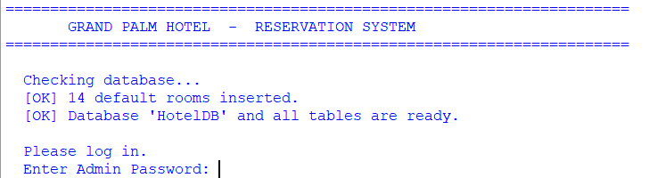
Observation:
- On the first run, the program automatically created the database HotelDB and 3 tables (Rooms, Bookings, Bills).
- It also inserted ______ default rooms across 5 room categories.
- On the second run, the message "default rooms inserted" did not appear because the SELECT COUNT(*) check found that the table was not empty — this proves the data is stored permanently in the database.

9.2 View All Rooms (Option 1)
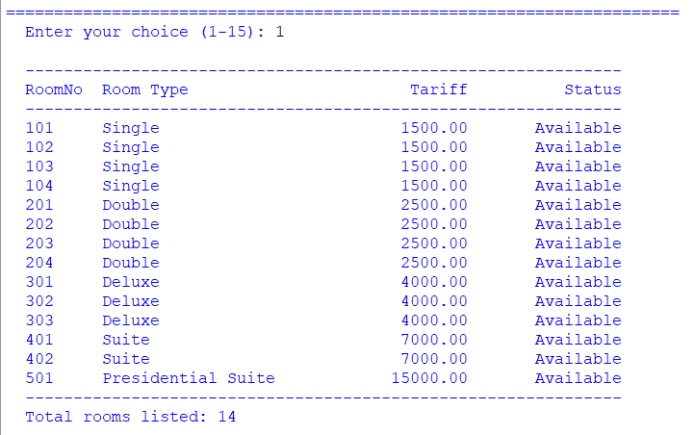Observation:
- The hotel has ______ rooms in total.
- The cheapest room is Room No. ______ of type ______ at Rs. ______ per night.
- The most expensive room is Room No. ______ of type ______ at Rs. ______ per night.
- Initially, all rooms show the status Available.

9.3 New Booking (Option 7)
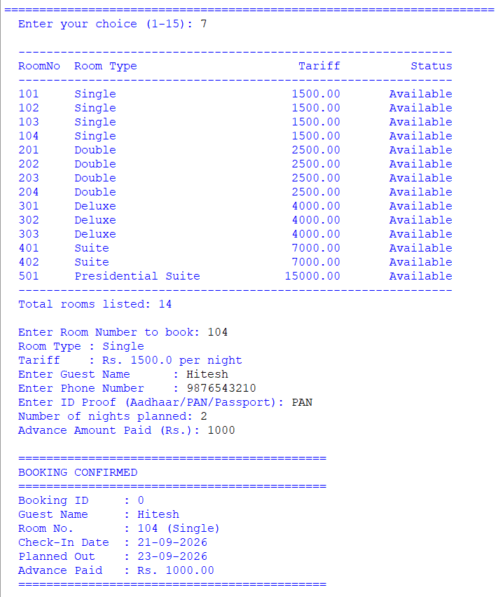Observation:
- I booked Room No. ______ (type ______) for the guest __________________.
- Booking ID assigned: ______
- Check-In Date: ______ / Planned Check-Out: ______
- Advance Paid: Rs. ______
- Important: After the booking, when I viewed all rooms again, the status of Room No. ______ had changed from Available to Occupied automatically. This shows that the program correctly performed two operations — an INSERT into Bookings and an UPDATE on Rooms — in the same transaction.
- When I tried to book the same room again, the program displayed the message "Room is already occupied." and did not allow double booking.

9.4 View Active Bookings (Option 8)
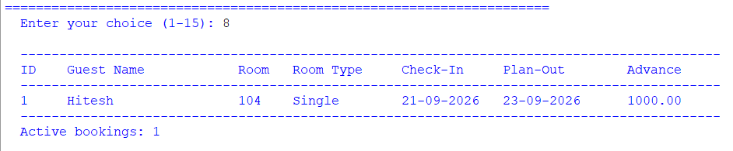Observation:
- There were ______ active booking(s) at this moment.
- The list was retrieved using a JOIN between the Bookings and Rooms tables (Bookings.RoomNo = Rooms.RoomNo).
- The join allowed me to display the room type alongside the booking, which is not stored in the Bookings table itself.

9.5 Search Booking (Option 9)
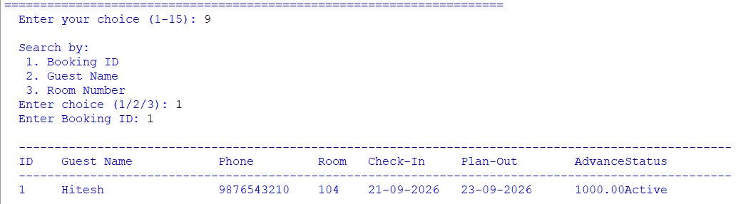
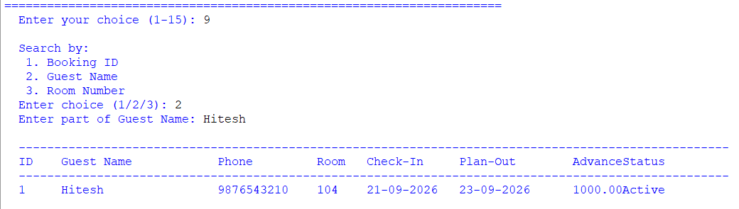
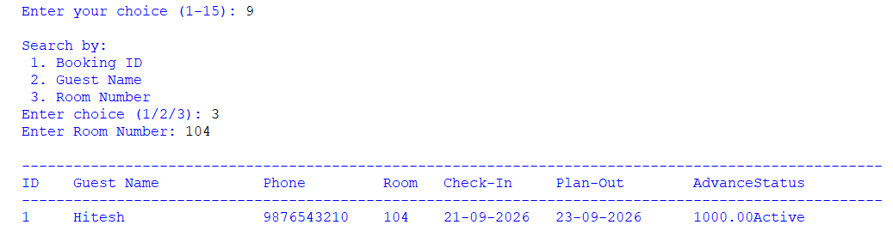
Observation:
- Searching by Booking ID returned exactly one record.
- Searching by a partial guest name (using LIKE %name%) returned all guests whose name contained that substring.
- Searching by Room Number returned the current active booking of that room.
- Conclusion: The LIKE operator with % wildcards provides a powerful "contains" search that is much faster than scanning by eye.

9.6 Check-Out and Bill Generation (Option 10)
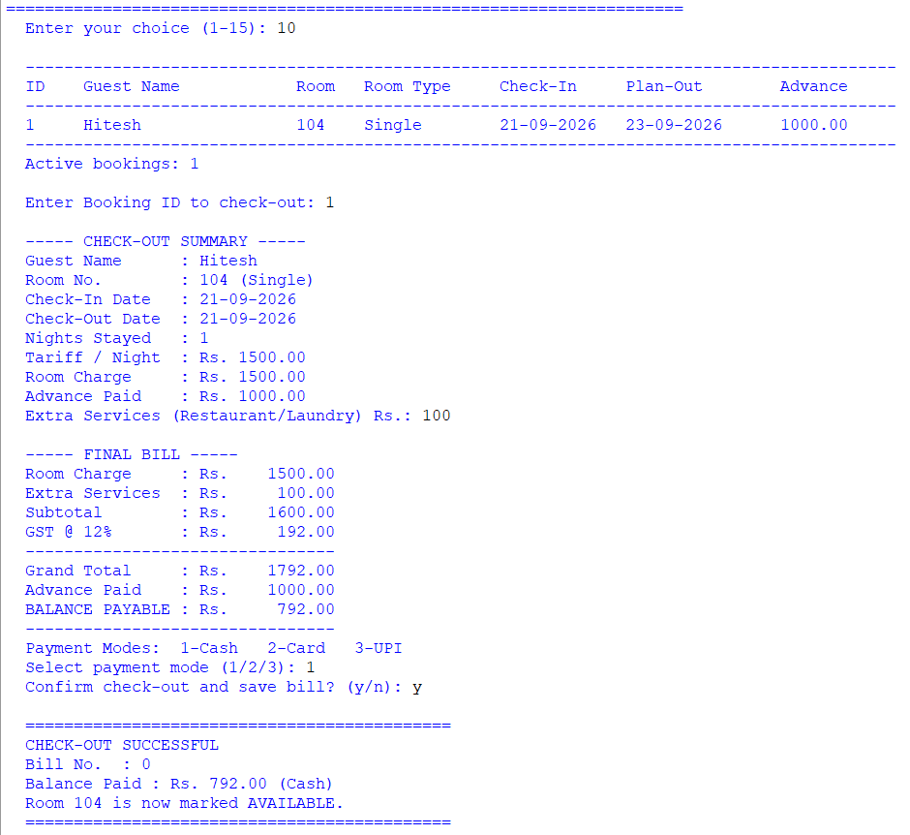Observation:
Field | Value
Guest Name | ______________
Room No. | ______
Nights Stayed | ______
Room Charge | Rs. ______________
Extra Services | Rs. ______________
Subtotal | Rs. ______________
GST @ 12% | Rs. ______________
Grand Total | Rs. ______________
Advance Paid | Rs. ______________
Balance Paid | Rs. ______________
Payment Mode | ______________
Bill Number | ______
- The number of nights was calculated automatically by Python using
(checkout_date - checkin).days, not entered manually.
- The GST was calculated as 12% of the subtotal, and the balance was computed as GrandTotal − Advance.
- Important: After check-out, the room's status was automatically changed back to Available and the booking status was set to Closed. This means the room can now be booked by a new guest.

9.7 View a Bill (Option 11)
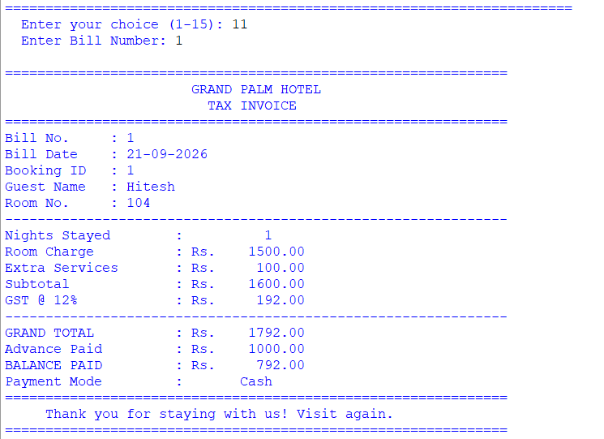
Observation:
- The bill displayed a properly formatted TAX INVOICE with the hotel name centred at the top.
- All values (nights, room charge, GST, grand total, balance) matched the values shown at the time of check-out.
- Conclusion: The Bills table acts as a permanent archive — even after many other transactions have taken place, the bill can be re-printed at any time simply by entering the Bill Number.

9.8 Occupancy Report (Option 13)
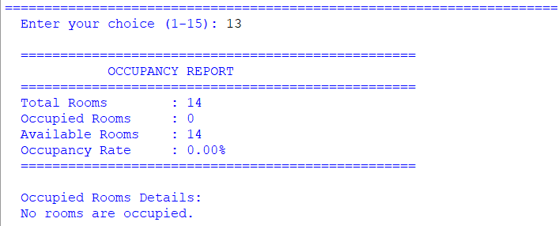Observation:
- Total rooms: ______
- Occupied rooms: ______
- Available rooms: ______
- Occupancy rate: ______ %
- The report was generated using a simple SELECT COUNT(*) query with a WHERE Status = 'Occupied' condition — an example of an aggregate function combined with a filter.

9.9 Revenue Report (Option 14)
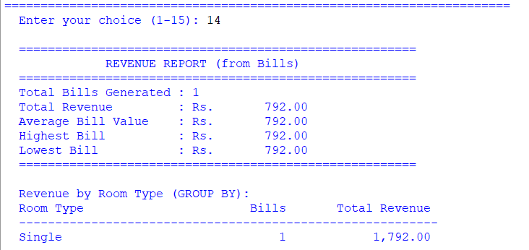Observation:
- Total bills generated: ______
- Total revenue collected: Rs. ______________
- Average bill value: Rs. ______________
- Highest bill: Rs. ______________
- Lowest bill: Rs. ______________
- Revenue by room type:
Room Type | Bills | Total Revenue
______ | ______ | Rs. ______________
______ | ______ | Rs. ______________
______ | ______ | Rs. ______________
- Conclusion: The revenue-by-room-type table was produced using a JOIN combined with GROUP BY and SUM() — the most important SQL technique demonstrated in this project. It allowed us to see which room type earns the most revenue for the hotel.

10. CONCLUSION AND FUTURE SCOPE
Conclusion
In this project I successfully developed a complete, database-driven Hotel Reservation System using Python and MySQL. Through this project I learnt and applied:
- Python–MySQL Connectivity: Using mysql.connector.connect(), cursor(), execute(), fetchone(), fetchall(), commit() and rollback() to run SQL statements from inside Python.
- Relational database design: Creating three linked tables with a primary key in each and a foreign key from Bookings.RoomNo to Rooms.RoomNo, which guarantees referential integrity.
- CRUD operations: Performing Create (INSERT), Read (SELECT), Update (UPDATE) and Delete (DELETE) — the four fundamental operations of every database application.
- Automatic schema initialisation: Using CREATE DATABASE IF NOT EXISTS and CREATE TABLE IF NOT EXISTS so the program needs no manual SQL setup — making it portable and easy to use.
- The datetime module: Recording the current date and calculating the number of nights stayed using (checkout - checkin).days.
- Aggregate functions and grouping: Generating meaningful reports using COUNT(), SUM(), AVG(), MAX(), MIN() and GROUP BY with a JOIN.
- Transactions and rollback: Ensuring that if the booking or check-out fails midway, the database is left in a consistent state.
The project demonstrated the true power of using a database over simple files: data is structured, relationships are enforced, complex queries are possible, and everything runs much faster.
Future Scope
- Graphical User Interface (GUI) using Tkinter so that the receptionist can click buttons instead of typing menu numbers.
- Multiple Users and Roles — separate logins for the Manager, Receptionist and Housekeeping staff with different permissions.
- Online Booking Portal — integrate with a web application so customers can book rooms themselves.
- Room Availability Calendar showing booked and free dates visually.
- Email / SMS confirmation of bookings using Python's smtplib module.
- Advanced Reports — month-wise revenue, seasonality analysis, and customer-stay statistics using SQL date functions.
- Payment Gateway integration for online advance payments.
- Housekeeping module to mark rooms as "Under Cleaning" between checkouts.

11. TROUBLESHOOTING DATABASE CONNECTION
If you see an error such as:
text
Database Connection Error: 1045 (28000): Access denied for user 'root'@'localhost' (using password: YES)
follow these steps:
- Ensure MySQL is running
  - If using XAMPP: Start the MySQL service in the XAMPP Control Panel. By default the XAMPP root user has no password (leave DB_PASSWORD empty).
  - If using a standalone MySQL: Check the service status and ensure it is running.
- Test credentials from the command line
Open a terminal and type:
text
mysql -u your_username -p
Enter the same password you will put in the Python script. If login fails, reset the password or create a new user.
- Create a dedicated user (recommended)
sql
CREATE USER 'hotel_user'@'localhost' IDENTIFIED BY 'your_password';
GRANT ALL PRIVILEGES ON *.* TO 'hotel_user'@'localhost';
FLUSH PRIVILEGES;
Then set DB_USER = "hotel_user" and DB_PASSWORD = "your_password" in the script.
- Change the authentication plugin (MySQL 8.0+ only)
sql
ALTER USER 'hotel_user'@'localhost'
IDENTIFIED WITH mysql_native_password BY 'your_password';
FLUSH PRIVILEGES;
- Install/upgrade the connector
text
pip install --upgrade mysql-connector-python
- Check port and host
The default is localhost on port 3306. If your MySQL uses a different port, add port=3307 (or your port) inside the connect() calls.
Error | Reason | Solution
Unknown database 'HotelDB' | The database was dropped | Run the script again — it recreates the database automatically
Table 'HotelDB.Rooms' doesn't exist | The table was dropped | Run the script again — CREATE TABLE IF NOT EXISTS recreates it
Foreign key constraint fails | Trying to book a room that does not exist in Rooms | Add the room first (Option 4), then make the booking
Data too long for column | Entered a value longer than the column size (e.g. 30+ chars for IDProof) | Enter shorter values or increase the column size in the table
Data truncated for column 'Status' | Typo in the value assigned to Status | Ensure only 'Available' / 'Occupied' / 'Active' / 'Closed' are used
Other common errors:

12. BIBLIOGRAPHY
- Websites:
  - MySQL Connector/Python Documentation (dev.mysql.com/doc/connector-python)
  - Python Official Documentation — datetime (docs.python.org/3/library/datetime.html)
  - W3Schools — SQL Tutorial (www.w3schools.com/sql)
  - GeeksforGeeks (www.geeksforgeeks.org)
  - Stack Overflow (www.stackoverflow.com)
- Study Material:
  - NCERT Informatics Practices Textbook for Class XII
  - Sumita Arora, Informatics Practices with Python, Dhanpat Rai & Co.
- Reference Manual:
  - MySQL 8.0 Reference Manual (dev.mysql.com/doc)

