PROJECT FILE
INFORMATICS PRACTICES (CLASS XII)
SESSION: [Year, e.g., 2023-2024]

CAR RENTAL MANAGEMENT SYSTEM
(Vehicle Inventory, Customer Rentals and Return Tracking with Python-SQL Connectivity)
Submitted By:
[Your Name]
Class: XII – [Section]
Roll No: [Your Roll Number]
Submitted To:
[Teacher's Name]
Department of Computer Science
[Your School Name]

CERTIFICATE
This is to certify that [Your Name] of Class XII has successfully completed the Informatics Practices project titled "Car Rental Management System" under the guidance of [Teacher's Name] during the academic year [Year].
This project is a bonafide record of work done by the candidate independently and fulfills the requirements of the Central Board of Secondary Education (CBSE) for the AISSCE Examination.
Teacher In-Charge: __________________
Signature: __________________
External Examiner: __________________
Signature: __________________
School Seal:

ACKNOWLEDGEMENT
I would like to express my sincere thanks to my Informatics Practices teacher [Teacher's Name] and our Principal [Principal's Name] for giving me the opportunity to work on this project titled "Car Rental Management System".
While working on this project I learnt how a real car rental agency like Zoomcar or Revv tracks its vehicle inventory, records customer rentals and calculates the return date, the late fee and the final bill. I learnt how to design a relational database with primary keys and foreign keys, how to use datetime arithmetic to calculate rental days and late days, how to run INSERT, SELECT, UPDATE and DELETE queries from Python, and how to generate business reports using SQL aggregate functions and joins. I would also like to thank my parents and friends who supported and encouraged me throughout the completion of this project.
Name: [Your Name]
Class: XII

TABLE OF CONTENTS
- Introduction
- Objectives of the Project
- Proposed System
- System Requirements (Hardware & Software)
- System Design (Table Structures)
- Business Rules Used
- Python Libraries Used
- Functions Used (Quick Reference)
- Source Code
- Output Screens and Observations
- Conclusion and Future Scope
- Troubleshooting Database Connection
- Bibliography

1. INTRODUCTION
A car rental agency owns dozens or hundreds of vehicles, and every day some vehicles are rented out, some are returned, and some are under servicing. Managing this on paper is nearly impossible — customers may be told a car is available when it is not, return dates get mixed up, and late fees are calculated incorrectly. A single mistake damages the agency's reputation and revenue.
The Car Rental Management System is a software application that automates this process. It is a menu-driven Python program backed by a MySQL relational database. It allows the front-desk staff to:
- Maintain a complete vehicle inventory with brand, model, type, fuel type, seating capacity, rent per day and current status.
- Maintain a register of registered customers with their driving licence and contact details.
- Rent a vehicle to a customer by entering the rent date and the planned number of days.
- Automatically compute the due date and base amount at the time of renting.
- Return a vehicle — the system automatically calculates the number of days used, detects any late return, computes the late fine using the business rule, adds everything up, and generates the final bill.
- Search vehicles by number, brand or type; search customers by name.
- Generate business reports — total revenue, revenue by vehicle, top customers, overdue vehicles and fleet utilisation.
The database stores all data permanently, so records survive even after the program is closed and reopened.
2. OBJECTIVES
The main objectives of this project are:
- To understand how Python and MySQL are connected using the mysql.connector library.
- To design a relational database with three linked tables — Customers, Vehicles and Rentals — using primary keys and foreign keys.
- To perform all four CRUD operations — Create, Read, Update and Delete — using SQL statements executed from Python.
- To use the datetime module to record rent and return dates, and to calculate the number of days between them using (date2 - date1).days.
- To implement automatic business logic — due-date calculation, base amount, late fine and total bill.
- To use SQL aggregate functions (COUNT, SUM, AVG, MAX, MIN) with GROUP BY and JOIN to generate business reports.
- To automatically initialise the schema using CREATE DATABASE IF NOT EXISTS and CREATE TABLE IF NOT EXISTS.
3. PROPOSED SYSTEM
The system is a menu-driven program divided into four modules:
3.1 Customer Module
- Add a new customer (name, phone, email, driving licence, address).
- View all registered customers.
- Search a customer by ID or by partial name.
- Update a customer's phone number.
- Delete a customer (only if there is no active rental).
3.2 Vehicle Module
- View the complete fleet.
- View only available vehicles.
- View vehicles filtered by brand, type or fuel.
- Add a new vehicle to the fleet.
- Update the daily rent of a vehicle.
- Delete a vehicle (only if it is not currently rented).
3.3 Rental Module
- Rent out a vehicle — check availability, capture the customer and the number of days, automatically compute the due date and the base amount, and mark the vehicle as Rented.
- View all currently active rentals.
- View overdue rentals (where the return date has passed).
- Return a vehicle — automatically compute days used, late days, late fine and total amount, save to the Rentals table, and mark the vehicle as Available.
- View all rentals (including completed ones).
- Search a rental by Rental ID or by customer name.
3.4 Report Module
- Overall business summary (customers, vehicles, active rentals, total revenue).
- Revenue by vehicle (GROUP BY + JOIN).
- Top customers by total spend.
- Fleet utilisation by vehicle type.
4. SYSTEM REQUIREMENTS
Hardware Requirements:
- Processor: Intel Core i3 or above
- RAM: 4 GB or above
- Hard Disk: 100 GB or above
Software Requirements:
- Operating System: Windows 7/8/10/11 or Linux
- Python 3.x (IDLE / PyCharm)
- MySQL Server 5.7 or above (or XAMPP's MariaDB)
- Python-MySQL Connector (mysql-connector-python)
5. SYSTEM DESIGN (TABLE STRUCTURES)
The database is named CarRentalDB. The database and tables are created automatically by the Python script on first execution.
Table 1: Customers
Column | Data Type | Constraint | Description
CustID | INT | PRIMARY KEY | Unique customer ID
Name | VARCHAR(80) | NOT NULL | Customer's full name
Phone | VARCHAR(15) | NULL | Contact number
Email | VARCHAR(80) | NULL | Email address
DLNumber | VARCHAR(25) | NULL | Driving licence number
Address | VARCHAR(120) | NULL | Residential address
Table 2: Vehicles
Column | Data Type | Constraint | Description
VehicleNo | VARCHAR(12) | PRIMARY KEY | Registration number (e.g. KA01AB1234)
Brand | VARCHAR(30) | NOT NULL | Manufacturer
Model | VARCHAR(40) | NOT NULL | Model name
VehicleType | VARCHAR(15) | NOT NULL | Hatchback / Sedan / SUV / Luxury / MUV
FuelType | VARCHAR(10) | NULL | Petrol / Diesel / CNG / Electric
Seats | INT | NULL | Seating capacity
RentPerDay | DECIMAL(10,2) | NOT NULL | Rental charge per day
Status | VARCHAR(15) | DEFAULT 'Available' | Available / Rented / Service
Table 3: Rentals
Column | Data Type | Constraint | Description
RentalID | INT | AUTO_INCREMENT PRIMARY KEY | Unique rental ID
CustID | INT | FOREIGN KEY → Customers | Customer who rented
VehicleNo | VARCHAR(12) | FOREIGN KEY → Vehicles | Vehicle rented
RentDate | DATE | NOT NULL | Date of renting
DueDate | DATE | NOT NULL | Planned return date
ReturnDate | DATE | NULL | Actual return date (filled at return)
Days | INT | NULL | Number of days actually used
BaseAmount | DECIMAL(10,2) | NULL | Days × RentPerDay
LateFine | DECIMAL(10,2) | DEFAULT 0 | Fine for late return
TotalAmount | DECIMAL(10,2) | NULL | BaseAmount + LateFine
PaymentMode | VARCHAR(15) | NULL | Cash / Card / UPI
Status | VARCHAR(15) | DEFAULT 'Active' | Active / Completed
Relationship Diagram (in words):
text
Customers (1) ─── (many) Rentals
Vehicles (1) ─── (many) Rentals
Default Data Inserted on First Run
6 customers (CustID 1 to 6) and 15 vehicles across 5 vehicle types.
Vehicle Type | Examples | Daily Rent (approx.)
Hatchback | Maruti Swift, Hyundai i10, Tata Tiago | Rs. 1,200 – 1,400
Sedan | Honda City, Maruti Dzire, Hyundai Verna | Rs. 1,800 – 2,200
SUV | Hyundai Creta, Kia Seltos, Tata Nexon | Rs. 2,800 – 3,200
MUV | Toyota Innova, Maruti Ertiga | Rs. 3,500
Luxury | BMW 3 Series, Mercedes C-Class | Rs. 12,000 – 15,000
6. BUSINESS RULES USED
These rules drive the automatic calculation logic of the system.
6.1 Due Date
text
DueDate = RentDate + NumberOfDays
Computed in Python using datetime.timedelta(days=n).
6.2 Base Amount
text
BaseAmount = DaysUsed × RentPerDay
DaysUsed is calculated on the day of return as (ReturnDate - RentDate).days, with a minimum of 1 day even if the car is returned on the same day.
6.3 Late Days
text
LateDays = ReturnDate - DueDate (if positive; otherwise 0)
If the vehicle is returned before or on the due date, there is no late fee.
6.4 Late Fine
text
LateFine = LateDays × (RentPerDay × 0.25)
The fine is 25% of the daily rent for each late day — a common industry practice that is steeper than normal rent to discourage late returns.
6.5 Total Amount
text
TotalAmount = BaseAmount + LateFine
6.6 Vehicle Status Rules
Event | Vehicle Status Changes To
Vehicle added | Available
Vehicle rented out | Rented
Vehicle returned | Available
Vehicle sent for servicing | Service (manually updatable)
7. PYTHON LIBRARIES USED
- mysql.connector — connects Python to MySQL, executes SQL statements, fetches results and commits changes.
- datetime — used to record the rent date, compute the due date with timedelta, and calculate the days used and late days on return.
8. FUNCTIONS USED (QUICK REFERENCE)
8.1 MySQL Connector Methods
Method | Purpose
mysql.connector.connect(...) | Opens a connection to MySQL
con.cursor() | Creates a cursor to execute SQL
cur.execute(sql, params) | Runs a single SQL statement
cur.executemany(sql, list) | Runs the same SQL for many rows
cur.fetchone() / cur.fetchall() | Fetches one / all result rows
cur.rowcount | Number of rows affected
cur.lastrowid | Auto-increment value of the last INSERT
con.commit() / con.rollback() | Save / undo changes
cur.close() / con.close() | Release resources
8.2 SQL Statements Used
Statement | Purpose in This Project
CREATE DATABASE IF NOT EXISTS | Auto-create the database
CREATE TABLE IF NOT EXISTS | Auto-create the three tables
INSERT INTO | Add customers, vehicles, rentals
SELECT ... WHERE / LIKE | Search customers, vehicles, rentals
UPDATE ... SET | Change vehicle status, customer phone, rent
DELETE FROM | Remove a customer or vehicle
JOIN | Combine Rentals with Customers and Vehicles
GROUP BY + SUM() / COUNT() | Revenue by vehicle, top customers
IFNULL() | Replace NULL with 0 in reports
9. SOURCE CODE
Below is the complete Python code. It creates the database, tables and default data automatically, so no prior SQL setup is required.
python
# ==========================================================
# CAR RENTAL MANAGEMENT SYSTEM
# Class 12 Informatics Practices Project
# Tools Used: Python 3 + MySQL (mysql-connector-python)
# ==========================================================

import mysql.connector
import datetime

# ------------------------- CONFIGURATION (EDIT THESE) -------------------------
DB_HOST = "localhost"
DB_USER = "root" # <-- Change to your MySQL username
DB_PASSWORD = "" # <-- Change to your MySQL password (empty for XAMPP)
DB_NAME = "CarRentalDB"

AGENCY_NAME = "SPEEDWHEELS CAR RENTALS"
ADMIN_PASSWORD = "car123"

LATE_FINE_FACTOR = 0.25 # 25% of daily rent per late day

# Default customers - exactly 6 values per tuple
DEFAULT_CUSTOMERS = [
(1, "Rohan Mehta", "9876543210", "rohan@example.com", "KA0120200012345", "MG Road, Bengaluru"),
(2, "Priya Nair", "9823456781", "priya@example.com", "KA0120190056789", "Koramangala, Bengaluru"),
(3, "Amit Sharma", "9812345672", "amit@example.com", "DL0520180034567", "Connaught Place, New Delhi"),
(4, "Sneha Reddy", "9845612378", "sneha@example.com", "TS0920210078901", "Banjara Hills, Hyderabad"),
(5, "Vikram Singh", "9876123450", "vikram@example.com", "MH1220170023456", "Andheri West, Mumbai"),
(6, "Ananya Iyer", "9834567120", "ananya@example.com", "TN1020190045678", "Adyar, Chennai"),
]

# Default vehicles - exactly 8 values per tuple
DEFAULT_VEHICLES = [
("KA01AB1234", "Maruti", "Swift", "Hatchback", "Petrol", 5, 1200.00, "Available"),
("KA01CD5678", "Hyundai", "i10", "Hatchback", "Petrol", 5, 1300.00, "Available"),
("KA01EF9012", "Tata", "Tiago", "Hatchback", "Petrol", 5, 1400.00, "Available"),
("KA02GH3456", "Honda", "City", "Sedan", "Petrol", 5, 2000.00, "Available"),
("KA02IJ7890", "Maruti", "Dzire", "Sedan", "Diesel", 5, 1800.00, "Available"),
("KA02KL2345", "Hyundai", "Verna", "Sedan", "Petrol", 5, 2200.00, "Available"),
("KA03MN6789", "Hyundai", "Creta", "SUV", "Diesel", 5, 3000.00, "Available"),
("KA03OP1234", "Kia", "Seltos", "SUV", "Petrol", 5, 3200.00, "Available"),
("KA03QR5678", "Tata", "Nexon", "SUV", "Electric", 5, 2800.00, "Available"),
("KA04ST9012", "Toyota", "Innova", "MUV", "Diesel", 7, 3500.00, "Available"),
("KA04UV3456", "Maruti", "Ertiga", "MUV", "CNG", 7, 3500.00, "Available"),
("KA05WX7890", "BMW", "3 Series", "Luxury", "Petrol", 5, 12000.00, "Available"),
("KA05YZ2345", "Mercedes", "C-Class", "Luxury", "Petrol", 5, 15000.00, "Available"),
("KA06AA4567", "Audi", "A4", "Luxury", "Petrol", 5, 13500.00, "Available"),
("KA06BB8901", "Mahindra", "XUV700", "SUV", "Diesel", 7, 3800.00, "Available"),
]

# ==================== 1. DATABASE INITIALISATION ====================

def initialize_database():
"""Create database, tables and default data if they do not exist."""
try:
con = mysql.connector.connect(host=DB_HOST, user=DB_USER, password=DB_PASSWORD)
cur = con.cursor()
cur.execute("CREATE DATABASE IF NOT EXISTS " + DB_NAME)
cur.execute("USE " + DB_NAME)

cur.execute("""
CREATE TABLE IF NOT EXISTS Customers (
CustID INT PRIMARY KEY,
Name VARCHAR(80) NOT NULL,
Phone VARCHAR(15),
Email VARCHAR(80),
DLNumber VARCHAR(25),
Address VARCHAR(120)
)
""")

cur.execute("""
CREATE TABLE IF NOT EXISTS Vehicles (
VehicleNo VARCHAR(12) PRIMARY KEY,
Brand VARCHAR(30) NOT NULL,
Model VARCHAR(40) NOT NULL,
VehicleType VARCHAR(15) NOT NULL,
FuelType VARCHAR(10),
Seats INT,
RentPerDay DECIMAL(10,2) NOT NULL,
Status VARCHAR(15) DEFAULT 'Available'
)
""")

cur.execute("""
CREATE TABLE IF NOT EXISTS Rentals (
RentalID INT AUTO_INCREMENT PRIMARY KEY,
CustID INT,
VehicleNo VARCHAR(12),
RentDate DATE NOT NULL,
DueDate DATE NOT NULL,
ReturnDate DATE,
Days INT,
BaseAmount DECIMAL(10,2),
LateFine DECIMAL(10,2) DEFAULT 0,
TotalAmount DECIMAL(10,2),
PaymentMode VARCHAR(15),
Status VARCHAR(15) DEFAULT 'Active',
FOREIGN KEY (CustID) REFERENCES Customers(CustID),
FOREIGN KEY (VehicleNo) REFERENCES Vehicles(VehicleNo)
)
""")

# Insert default customers (6 values per tuple, 6 placeholders)
cur.execute("SELECT COUNT(*) FROM Customers")
if cur.fetchone()[0] == 0:
cur.executemany(
"INSERT INTO Customers VALUES (%s, %s, %s, %s, %s, %s)",
DEFAULT_CUSTOMERS)
print(" [OK] " + str(len(DEFAULT_CUSTOMERS)) + " default customers inserted.")

# Insert default vehicles (8 values per tuple, 8 placeholders)
cur.execute("SELECT COUNT(*) FROM Vehicles")
if cur.fetchone()[0] == 0:
cur.executemany(
"INSERT INTO Vehicles VALUES (%s, %s, %s, %s, %s, %s, %s, %s)",
DEFAULT_VEHICLES)
print(" [OK] " + str(len(DEFAULT_VEHICLES)) + " default vehicles inserted.")

con.commit()
print(" [OK] Database '" + DB_NAME + "' and all tables are ready.")
cur.close()
con.close()

except mysql.connector.Error as err:
print("Database Initialisation Error:", err)
print("Please check DB_USER and DB_PASSWORD in the CONFIGURATION section.")
exit(1)

def connect_db():
try:
con = mysql.connector.connect(
host=DB_HOST, user=DB_USER, password=DB_PASSWORD, database=DB_NAME)
return con
except mysql.connector.Error as err:
print("Database Connection Error:", err)
return None

# ==================== 2. HELPER FUNCTIONS ====================

def ask_int(prompt, lo=None, hi=None):
try:
v = int(input(prompt).strip())
except ValueError:
print(" [!] Please enter a whole number.")
return None
if lo is not None and v < lo:
print(" [!] Value must be at least " + str(lo))
return None
if hi is not None and v > hi:
print(" [!] Value must be at most " + str(hi))
return None
return v

def ask_date(prompt, allow_blank=False):
txt = input(prompt).strip()
if txt == "" and allow_blank:
return None
try:
return datetime.datetime.strptime(txt, "%d-%m-%Y").date()
except ValueError:
print(" [!] Invalid date. Use DD-MM-YYYY format.")
return False

# ==================== 3. CUSTOMER MODULE ====================

def add_customer():
con = connect_db()
if not con:
return
cur = con.cursor()
cid = ask_int(" Enter Customer ID: ", 1)
if cid is None:
cur.close(); con.close(); return

cur.execute("SELECT CustID FROM Customers WHERE CustID = %s", (cid,))
if cur.fetchone():
print(" [!] Customer ID already exists.")
cur.close(); con.close(); return

name = input(" Enter Name : ").strip()
if name == "":
print(" [!] Name cannot be blank.")
cur.close(); con.close(); return
phone = input(" Enter Phone : ").strip()
email = input(" Enter Email : ").strip()
dl = input(" Enter DL Number : ").strip()
addr = input(" Enter Address : ").strip()

try:
cur.execute("INSERT INTO Customers VALUES (%s, %s, %s, %s, %s, %s)",
(cid, name, phone, email, dl, addr))
con.commit()
print(" [OK] Customer '" + name + "' added successfully.")
except mysql.connector.Error as err:
print(" [!] Error:", err)
finally:
cur.close(); con.close()

def view_customers():
con = connect_db()
if not con:
return
cur = con.cursor()
cur.execute("SELECT CustID, Name, Phone, Email, DLNumber, Address "
"FROM Customers ORDER BY CustID")
rows = cur.fetchall()
if not rows:
print(" [!] No customers registered.")
else:
print("\n " + "-" * 116)
print(" {:<6}{:<22}{:<14}{:<24}{:<18}{:<30}".format(
"ID", "Name", "Phone", "Email", "DL Number", "Address"))
print(" " + "-" * 116)
for r in rows:
print(" {:<6}{:<22}{:<14}{:<24}{:<18}{:<30}".format(
r[0], r[1][:21], (r[2] or "-"), (r[3] or "-")[:23],
(r[4] or "-")[:17], (r[5] or "-")[:29]))
print(" " + "-" * 116)
print(" Total customers:", len(rows))
cur.close(); con.close()

def search_customer():
con = connect_db()
if not con:
return
cur = con.cursor()
print(" 1. By Customer ID")
print(" 2. By Name (contains)")
ch = input(" Enter choice (1/2): ").strip()

if ch == "1":
cid = ask_int(" Enter Customer ID: ")
if cid is None:
cur.close(); con.close(); return
cur.execute("SELECT * FROM Customers WHERE CustID = %s", (cid,))
elif ch == "2":
key = input(" Enter part of the name: ").strip()
cur.execute("SELECT * FROM Customers WHERE Name LIKE %s ORDER BY Name",
("%" + key + "%",))
else:
print(" [!] Invalid choice.")
cur.close(); con.close(); return

rows = cur.fetchall()
if not rows:
print(" [!] No matching customer.")
else:
print("\n " + "-" * 116)
print(" {:<6}{:<22}{:<14}{:<24}{:<18}{:<30}".format(
"ID", "Name", "Phone", "Email", "DL Number", "Address"))
print(" " + "-" * 116)
for r in rows:
print(" {:<6}{:<22}{:<14}{:<24}{:<18}{:<30}".format(
r[0], r[1][:21], (r[2] or "-"), (r[3] or "-")[:23],
(r[4] or "-")[:17], (r[5] or "-")[:29]))
cur.close(); con.close()

def update_customer_phone():
con = connect_db()
if not con:
return
cur = con.cursor()
cid = ask_int(" Enter Customer ID: ")
if cid is None:
cur.close(); con.close(); return
cur.execute("SELECT Name, Phone FROM Customers WHERE CustID = %s", (cid,))
r = cur.fetchone()
if not r:
print(" [!] Customer not found.")
cur.close(); con.close(); return
print(" Customer: " + r[0] + " | Current phone: " + (r[1] or "-"))
new_phone = input(" Enter new Phone: ").strip()
if new_phone == "":
print(" [!] No change made.")
cur.close(); con.close(); return
cur.execute("UPDATE Customers SET Phone = %s WHERE CustID = %s",
(new_phone, cid))
con.commit()
print(" [OK] Phone updated.")
cur.close(); con.close()

def delete_customer():
con = connect_db()
if not con:
return
cur = con.cursor()
cid = ask_int(" Enter Customer ID to delete: ")
if cid is None:
cur.close(); con.close(); return

cur.execute("SELECT Name FROM Customers WHERE CustID = %s", (cid,))
r = cur.fetchone()
if not r:
print(" [!] Customer not found.")
cur.close(); con.close(); return

cur.execute("SELECT COUNT(*) FROM Rentals WHERE CustID = %s AND Status = 'Active'",
(cid,))
if cur.fetchone()[0] > 0:
print(" [!] This customer has an active rental and cannot be deleted.")
cur.close(); con.close(); return

confirm = input(" Delete customer '" + r[0] + "'? (y/n): ").strip().lower()
if confirm != "y":
print(" [!] Deletion cancelled.")
cur.close(); con.close(); return

try:
# Also remove completed rental history rows so the FK is not violated
cur.execute("DELETE FROM Rentals WHERE CustID = %s", (cid,))
cur.execute("DELETE FROM Customers WHERE CustID = %s", (cid,))
con.commit()
print(" [OK] Customer and related rental history deleted.")
except mysql.connector.Error as err:
con.rollback()
print(" [!] Error:", err)
finally:
cur.close(); con.close()

# ==================== 4. VEHICLE MODULE ====================

def show_vehicle_rows(rows, title):
if not rows:
print(" [!] No vehicles to show.")
return
print("\n " + "-" * 106)
print(" " + title)
print(" " + "-" * 106)
print(" {:<14}{:<12}{:<20}{:<14}{:<12}{:>6}{:>12}{:<12}".format(
"Vehicle No", "Brand", "Model", "Type", "Fuel", "Seats", "Rent/Day", "Status"))
print(" " + "-" * 106)
for r in rows:
print(" {:<14}{:<12}{:<20}{:<14}{:<12}{:>6}{:>12.2f}{:<12}".format(
r[0], r[1][:11], r[2][:19], r[3][:13], (r[4] or "-")[:11],
r[5] or 0, float(r[6]), r[7]))
print(" " + "-" * 106)
print(" Total shown:", len(rows))

def view_all_vehicles():
con = connect_db()
if not con:
return
cur = con.cursor()
cur.execute("SELECT * FROM Vehicles ORDER BY VehicleType, VehicleNo")
show_vehicle_rows(cur.fetchall(), "COMPLETE FLEET")
cur.close(); con.close()

def view_available_vehicles():
con = connect_db()
if not con:
return
cur = con.cursor()
cur.execute("SELECT * FROM Vehicles WHERE Status = 'Available' "
"ORDER BY VehicleType, RentPerDay")
show_vehicle_rows(cur.fetchall(), "AVAILABLE VEHICLES")
cur.close(); con.close()

def view_vehicles_by_type():
con = connect_db()
if not con:
return
cur = con.cursor()
print(" Choose type: Hatchback / Sedan / SUV / MUV / Luxury")
vtype = input(" Enter Vehicle Type (or part of it): ").strip()
cur.execute("SELECT * FROM Vehicles WHERE VehicleType LIKE %s "
"ORDER BY RentPerDay", ("%" + vtype + "%",))
show_vehicle_rows(cur.fetchall(), "VEHICLES OF TYPE: " + vtype)
cur.close(); con.close()

def add_vehicle():
con = connect_db()
if not con:
return
cur = con.cursor()
vno = input(" Enter Vehicle Number (e.g. KA01AB1234): ").strip().upper()
if vno == "":
print(" [!] Vehicle number cannot be blank.")
cur.close(); con.close(); return

cur.execute("SELECT VehicleNo FROM Vehicles WHERE VehicleNo = %s", (vno,))
if cur.fetchone():
print(" [!] This vehicle number already exists.")
cur.close(); con.close(); return

brand = input(" Enter Brand : ").strip()
model = input(" Enter Model : ").strip()
vtype = input(" Enter Vehicle Type : ").strip()
fuel = input(" Enter Fuel Type : ").strip()
seats = ask_int(" Enter Seats : ", 2, 20)
if seats is None:
cur.close(); con.close(); return

try:
rent = float(input(" Enter Rent Per Day : "))
if rent <= 0:
raise ValueError
except ValueError:
print(" [!] Rent must be a positive number.")
cur.close(); con.close(); return

try:
cur.execute("INSERT INTO Vehicles VALUES (%s, %s, %s, %s, %s, %s, %s, %s)",
(vno, brand, model, vtype, fuel, seats, rent, "Available"))
con.commit()
print(" [OK] Vehicle " + vno + " added to the fleet.")
except mysql.connector.Error as err:
print(" [!] Error:", err)
finally:
cur.close(); con.close()

def update_vehicle_rent():
con = connect_db()
if not con:
return
cur = con.cursor()
vno = input(" Enter Vehicle Number: ").strip().upper()
cur.execute("SELECT Brand, Model, RentPerDay FROM Vehicles WHERE VehicleNo = %s",
(vno,))
r = cur.fetchone()
if not r:
print(" [!] Vehicle not found.")
cur.close(); con.close(); return
print(" Vehicle: " + r[0] + " " + r[1] +
" | Current rent: Rs. " + format(float(r[2]), ".2f"))

try:
new_rent = float(input(" Enter new Rent Per Day: "))
if new_rent <= 0:
raise ValueError
except ValueError:
print(" [!] Rent must be a positive number.")
cur.close(); con.close(); return

cur.execute("UPDATE Vehicles SET RentPerDay = %s WHERE VehicleNo = %s",
(new_rent, vno))
con.commit()
print(" [OK] Rent updated.")
cur.close(); con.close()

def delete_vehicle():
con = connect_db()
if not con:
return
cur = con.cursor()
vno = input(" Enter Vehicle Number to delete: ").strip().upper()
cur.execute("SELECT Brand, Model, Status FROM Vehicles WHERE VehicleNo = %s",
(vno,))
r = cur.fetchone()
if not r:
print(" [!] Vehicle not found.")
cur.close(); con.close(); return

if r[2] == "Rented":
print(" [!] This vehicle is currently rented and cannot be deleted.")
cur.close(); con.close(); return

confirm = input(" Delete " + vno + " (" + r[0] + " " + r[1] +
")? (y/n): ").strip().lower()
if confirm != "y":
print(" [!] Deletion cancelled.")
cur.close(); con.close(); return

try:
cur.execute("DELETE FROM Rentals WHERE VehicleNo = %s", (vno,))
cur.execute("DELETE FROM Vehicles WHERE VehicleNo = %s", (vno,))
con.commit()
print(" [OK] Vehicle and its rental history deleted.")
except mysql.connector.Error as err:
con.rollback()
print(" [!] Error:", err)
finally:
cur.close(); con.close()

# ==================== 5. RENTAL MODULE ====================

def rent_vehicle():
con = connect_db()
if not con:
return
cur = con.cursor()

view_customers()
cid = ask_int("\n Enter Customer ID: ", 1)
if cid is None:
cur.close(); con.close(); return
cur.execute("SELECT Name FROM Customers WHERE CustID = %s", (cid,))
r = cur.fetchone()
if not r:
print(" [!] Customer not found.")
cur.close(); con.close(); return
print(" Customer: " + r[0])

view_available_vehicles()
vno = input("\n Enter Vehicle Number to rent: ").strip().upper()
cur.execute("SELECT Brand, Model, RentPerDay, Status FROM Vehicles "
"WHERE VehicleNo = %s", (vno,))
v = cur.fetchone()
if not v:
print(" [!] Vehicle not found.")
cur.close(); con.close(); return
if v[3] != "Available":
print(" [!] This vehicle is not available (current status: " + v[3] + ").")
cur.close(); con.close(); return

rent = float(v[2])
print(" Vehicle : " + vno + " - " + v[0] + " " + v[1])
print(" Rent/Day: Rs. " + format(rent, ".2f"))

days = ask_int(" Number of days for rent: ", 1, 90)
if days is None:
cur.close(); con.close(); return

rent_date = datetime.date.today()
due_date = rent_date + datetime.timedelta(days=days)
base_amount = round(rent * days, 2)

print("\n Rent Date : " + rent_date.strftime("%d-%m-%Y"))
print(" Due Date : " + due_date.strftime("%d-%m-%Y"))
print(" Base Amt : Rs. " + format(base_amount, ".2f"))

confirm = input("\n Confirm rental? (y/n): ").strip().lower()
if confirm != "y":
print(" [!] Rental cancelled. No changes made.")
cur.close(); con.close(); return

try:
cur.execute("""
INSERT INTO Rentals
(CustID, VehicleNo, RentDate, DueDate, ReturnDate, Days,
BaseAmount, LateFine, TotalAmount, PaymentMode, Status)
VALUES (%s, %s, %s, %s, NULL, NULL, NULL, 0, NULL, NULL, 'Active')
""", (cid, vno, rent_date, due_date))

cur.execute("UPDATE Vehicles SET Status = 'Rented' WHERE VehicleNo = %s",
(vno,))
con.commit()

rental_id = cur.lastrowid
print("\n ====================================================")
print(" RENTAL CONFIRMED")
print(" ====================================================")
print(" Rental ID : " + str(rental_id))
print(" Customer : " + r[0])
print(" Vehicle : " + vno + " - " + v[0] + " " + v[1])
print(" Rent Date : " + rent_date.strftime("%d-%m-%Y"))
print(" Due Date : " + due_date.strftime("%d-%m-%Y"))
print(" Days : " + str(days))
print(" Base Amount : Rs. {:.2f}".format(base_amount))
print(" ====================================================")
print(" NOTE: Rs.{:.2f} X {} late day fine applies if returned late."
.format(rent * LATE_FINE_FACTOR, "each"))
except mysql.connector.Error as err:
con.rollback()
print(" [!] Rental failed:", err)
finally:
cur.close(); con.close()

def view_active_rentals():
con = connect_db()
if not con:
return
cur = con.cursor()
today = datetime.date.today()

cur.execute("""
SELECT r.RentalID, c.Name, r.VehicleNo, v.Brand, v.Model,
r.RentDate, r.DueDate,
DATEDIFF(r.DueDate, %s) AS DaysRemaining
FROM Rentals r
JOIN Customers c ON r.CustID = c.CustID
JOIN Vehicles v ON r.VehicleNo = v.VehicleNo
WHERE r.Status = 'Active'
ORDER BY r.DueDate
""", (today,))
rows = cur.fetchall()
if not rows:
print(" [!] No active rentals.")
else:
print("\n " + "-" * 118)
print(" {:<6}{:<20}{:<14}{:<24}{:<13}{:<13}{:>14}".format(
"ID", "Customer", "Vehicle No", "Brand Model", "Rent Date",
"Due Date", "Days Left"))
print(" " + "-" * 118)
for r in rows:
days_left = int(r[7])
tag = ""
if days_left < 0:
tag = " << OVERDUE by " + str(-days_left) + " day(s) >>"
print(" {:<6}{:<20}{:<14}{:<24}{:<13}{:<13}{:>14}{}".format(
r[0], r[1][:19], r[2], (r[3] + " " + r[4])[:23],
r[5].strftime("%d-%m-%Y"),
r[6].strftime("%d-%m-%Y"), days_left, tag))
print(" " + "-" * 118)
print(" Total active rentals:", len(rows))
cur.close(); con.close()

def view_overdue_rentals():
con = connect_db()
if not con:
return
cur = con.cursor()
today = datetime.date.today()

cur.execute("""
SELECT r.RentalID, c.Name, c.Phone, r.VehicleNo, v.Brand, v.Model,
r.DueDate, DATEDIFF(%s, r.DueDate) AS DaysLate,
v.RentPerDay
FROM Rentals r
JOIN Customers c ON r.CustID = c.CustID
JOIN Vehicles v ON r.VehicleNo = v.VehicleNo
WHERE r.Status = 'Active' AND r.DueDate < %s
ORDER BY r.DueDate
""", (today, today))
rows = cur.fetchall()
if not rows:
print(" [OK] No overdue rentals currently.")
else:
print("\n " + "-" * 128)
print(" {:<6}{:<20}{:<14}{:<14}{:<24}{:<13}{:>10}{:>14}".format(
"ID", "Customer", "Phone", "Vehicle No", "Brand Model",
"Due Date", "DaysLate", "Est. Fine"))
print(" " + "-" * 128)
for r in rows:
days_late = int(r[7])
rent = float(r[8])
est_fine = round(days_late * rent * LATE_FINE_FACTOR, 2)
print(" {:<6}{:<20}{:<14}{:<14}{:<24}{:<13}{:>10}{:>14.2f}".format(
r[0], r[1][:19], (r[2] or "-"), r[3],
(r[4] + " " + r[5])[:23],
r[6].strftime("%d-%m-%Y"), days_late, est_fine))
print(" " + "-" * 128)
print(" Total overdue rentals:", len(rows))
cur.close(); con.close()

def return_vehicle():
con = connect_db()
if not con:
return
cur = con.cursor()

view_active_rentals()
rid = ask_int("\n Enter Rental ID to return: ", 1)
if rid is None:
cur.close(); con.close(); return

cur.execute("""
SELECT r.RentalID, r.CustID, c.Name, r.VehicleNo, v.Brand, v.Model,
v.RentPerDay, r.RentDate, r.DueDate
FROM Rentals r
JOIN Customers c ON r.CustID = c.CustID
JOIN Vehicles v ON r.VehicleNo = v.VehicleNo
WHERE r.RentalID = %s AND r.Status = 'Active'
""", (rid,))
row = cur.fetchone()
if not row:
print(" [!] No active rental with this ID.")
cur.close(); con.close(); return

cust_name = row[2]
vno = row[3]
rent = float(row[6])
rent_date = row[7]
due_date = row[8]

today = datetime.date.today()
days_used = (today - rent_date).days
if days_used < 1:
days_used = 1 # minimum one-day charge

base_amount = round(days_used * rent, 2)

late_days = (today - due_date).days
if late_days < 0:
late_days = 0
late_fine = round(late_days * rent * LATE_FINE_FACTOR, 2)

total = round(base_amount + late_fine, 2)

print("\n ----- RETURN SUMMARY -----")
print(" Rental ID : " + str(rid))
print(" Customer : " + cust_name)
print(" Vehicle : " + vno + " - " + row[4] + " " + row[5])
print(" Rent Date : " + rent_date.strftime("%d-%m-%Y"))
print(" Due Date : " + due_date.strftime("%d-%m-%Y"))
print(" Return Date : " + today.strftime("%d-%m-%Y"))
print(" Days Used : " + str(days_used))
print(" Rent Per Day : Rs. {:.2f}".format(rent))
print(" Base Amount : Rs. {:.2f}".format(base_amount))
if late_days > 0:
print(" Late Days : " + str(late_days))
print(" Late Fine @25% : Rs. {:.2f}".format(late_fine))
else:
print(" Late Days : 0 (returned on time)")
print(" --------------------------------")
print(" TOTAL AMOUNT : Rs. {:.2f}".format(total))
print(" --------------------------------")

print(" Payment Modes: 1-Cash 2-Card 3-UPI")
mode = {"1": "Cash", "2": "Card", "3": "UPI"}.get(
input(" Select payment mode (1/2/3): ").strip(), "Cash")

confirm = input(" Confirm return and save bill? (y/n): ").strip().lower()
if confirm != "y":
print(" [!] Return cancelled. No changes made.")
cur.close(); con.close(); return

try:
cur.execute("""
UPDATE Rentals
SET ReturnDate = %s, Days = %s, BaseAmount = %s,
LateFine = %s, TotalAmount = %s, PaymentMode = %s,
Status = 'Completed'
WHERE RentalID = %s
""", (today, days_used, base_amount, late_fine, total, mode, rid))

cur.execute("UPDATE Vehicles SET Status = 'Available' WHERE VehicleNo = %s",
(vno,))
con.commit()

print("\n ====================================================")
print(" VEHICLE RETURNED")
print(" ====================================================")
print(" Total Paid : Rs. {:.2f} ({})".format(total, mode))
print(" Vehicle " + vno + " is now marked AVAILABLE.")
print(" ====================================================")
except mysql.connector.Error as err:
con.rollback()
print(" [!] Return failed:", err)
finally:
cur.close(); con.close()

def view_all_rentals():
con = connect_db()
if not con:
return
cur = con.cursor()
cur.execute("""
SELECT r.RentalID, c.Name, r.VehicleNo, r.RentDate, r.DueDate,
r.ReturnDate, r.Days, r.BaseAmount, r.LateFine,
r.TotalAmount, r.PaymentMode, r.Status
FROM Rentals r
JOIN Customers c ON r.CustID = c.CustID
ORDER BY r.RentalID DESC
""")
rows = cur.fetchall()
if not rows:
print(" [!] No rentals recorded yet.")
else:
print("\n " + "-" * 132)
print(" {:<6}{:<20}{:<14}{:<12}{:<12}{:<12}{:>5}{:>11}{:>10}{:>12}{:<10}{:<11}".format(
"ID", "Customer", "Vehicle No", "Rent", "Due", "Returned",
"Days", "Base", "Fine", "Total", "Mode", "Status"))
print(" " + "-" * 132)
for r in rows:
rd = r[5].strftime("%d-%m-%Y") if r[5] else "-"
base = float(r[7]) if r[7] is not None else 0.0
fine = float(r[8]) if r[8] is not None else 0.0
tot = float(r[9]) if r[9] is not None else 0.0
print(" {:<6}{:<20}{:<14}{:<12}{:<12}{:<12}{:>5}{:>11.2f}{:>10.2f}{:>12.2f}{:<10}{:<11}".format(
r[0], r[1][:19], r[2], r[3].strftime("%d-%m-%Y"),
r[4].strftime("%d-%m-%Y"), rd,
r[6] if r[6] is not None else 0,
base, fine, tot,
(r[10] or "-"), r[11]))
print(" " + "-" * 132)
print(" Total rental records:", len(rows))
cur.close(); con.close()

def search_rental():
con = connect_db()
if not con:
return
cur = con.cursor()
print(" 1. By Rental ID")
print(" 2. By Customer Name")
ch = input(" Enter choice (1/2): ").strip()

if ch == "1":
rid = ask_int(" Enter Rental ID: ")
if rid is None:
cur.close(); con.close(); return
cur.execute("""
SELECT r.RentalID, c.Name, r.VehicleNo, r.RentDate, r.DueDate,
r.ReturnDate, r.Days, r.LateFine, r.TotalAmount, r.Status
FROM Rentals r JOIN Customers c ON r.CustID = c.CustID
WHERE r.RentalID = %s
""", (rid,))
elif ch == "2":
name = input(" Enter part of the customer name: ").strip()
cur.execute("""
SELECT r.RentalID, c.Name, r.VehicleNo, r.RentDate, r.DueDate,
r.ReturnDate, r.Days, r.LateFine, r.TotalAmount, r.Status
FROM Rentals r JOIN Customers c ON r.CustID = c.CustID
WHERE c.Name LIKE %s
ORDER BY r.RentalID DESC
""", ("%" + name + "%",))
else:
print(" [!] Invalid choice.")
cur.close(); con.close(); return

rows = cur.fetchall()
if not rows:
print(" [!] No matching rentals.")
else:
print("\n " + "-" * 118)
print(" {:<6}{:<20}{:<14}{:<12}{:<12}{:<12}{:>5}{:>10}{:>12}{:<11}".format(
"ID", "Customer", "Vehicle No", "Rent", "Due", "Returned",
"Days", "Fine", "Total", "Status"))
print(" " + "-" * 118)
for r in rows:
rd = r[5].strftime("%d-%m-%Y") if r[5] else "-"
fine = float(r[7]) if r[7] is not None else 0.0
tot = float(r[8]) if r[8] is not None else 0.0
print(" {:<6}{:<20}{:<14}{:<12}{:<12}{:<12}{:>5}{:>10.2f}{:>12.2f}{:<11}".format(
r[0], r[1][:19], r[2],
r[3].strftime("%d-%m-%Y"),
r[4].strftime("%d-%m-%Y"), rd,
r[6] if r[6] is not None else 0,
fine, tot, r[9]))
cur.close(); con.close()

# ==================== 6. REPORT MODULE ====================

def overall_summary():
con = connect_db()
if not con:
return
cur = con.cursor()

cur.execute("SELECT COUNT(*) FROM Customers")
cust_count = cur.fetchone()[0]
cur.execute("SELECT COUNT(*) FROM Vehicles")
veh_count = cur.fetchone()[0]
cur.execute("SELECT COUNT(*) FROM Vehicles WHERE Status = 'Available'")
avail = cur.fetchone()[0]
cur.execute("SELECT COUNT(*) FROM Vehicles WHERE Status = 'Rented'")
rented = cur.fetchone()[0]
cur.execute("SELECT COUNT(*) FROM Rentals WHERE Status = 'Active'")
active = cur.fetchone()[0]
cur.execute("SELECT COUNT(*) FROM Rentals WHERE Status = 'Completed'")
completed = cur.fetchone()[0]

cur.execute("SELECT IFNULL(SUM(TotalAmount),0) FROM Rentals WHERE Status='Completed'")
revenue = float(cur.fetchone()[0])
cur.execute("SELECT IFNULL(SUM(LateFine),0) FROM Rentals WHERE Status='Completed'")
fine_total = float(cur.fetchone()[0])
cur.execute("SELECT IFNULL(AVG(TotalAmount),0) FROM Rentals WHERE Status='Completed'")
avg_bill = float(cur.fetchone()[0])

print("\n " + "=" * 60)
print(" " + AGENCY_NAME + " - BUSINESS SUMMARY")
print(" " + "=" * 60)
print(" Registered Customers : " + str(cust_count))
print(" Vehicles in Fleet : " + str(veh_count))
print(" Available : " + str(avail))
print(" Rented : " + str(rented))
print(" Active Rentals : " + str(active))
print(" Completed Rentals : " + str(completed))
print(" ------------------------------------------")
print(" Total Revenue : Rs. {:>12,.2f}".format(revenue))
print(" Total Late Fines : Rs. {:>12,.2f}".format(fine_total))
print(" Average Bill Amount : Rs. {:>12,.2f}".format(avg_bill))
print(" " + "=" * 60)
cur.close(); con.close()

def revenue_by_vehicle():
con = connect_db()
if not con:
return
cur = con.cursor()
cur.execute("""
SELECT v.VehicleNo, v.Brand, v.Model, v.VehicleType,
COUNT(r.RentalID), IFNULL(SUM(r.TotalAmount),0)
FROM Vehicles v
LEFT JOIN Rentals r ON v.VehicleNo = r.VehicleNo
AND r.Status = 'Completed'
GROUP BY v.VehicleNo, v.Brand, v.Model, v.VehicleType
ORDER BY SUM(r.TotalAmount) DESC
""")
rows = cur.fetchall()

print("\n " + "=" * 100)
print(" REVENUE BY VEHICLE (Completed Rentals Only)")
print(" " + "=" * 100)
print(" {:<14}{:<14}{:<22}{:<14}{:>10}{:>20}".format(
"Vehicle No", "Brand", "Model", "Type", "Rentals", "Total Revenue"))
print(" " + "-" * 100)
grand = 0.0
for r in rows:
rev = float(r[5])
grand += rev
print(" {:<14}{:<14}{:<22}{:<14}{:>10}{:>20,.2f}".format(
r[0], r[1][:13], r[2][:21], r[3][:13], r[4], rev))
print(" " + "-" * 100)
print(" {:<64}{:>20,.2f}".format("GRAND TOTAL", grand))
print(" " + "=" * 100)
cur.close(); con.close()

def top_customers():
con = connect_db()
if not con:
return
cur = con.cursor()
cur.execute("""
SELECT c.CustID, c.Name, c.Phone,
COUNT(r.RentalID) AS TotalRentals,
IFNULL(SUM(r.TotalAmount),0) AS Spend
FROM Customers c
LEFT JOIN Rentals r ON c.CustID = r.CustID
AND r.Status = 'Completed'
GROUP BY c.CustID, c.Name, c.Phone
ORDER BY SUM(r.TotalAmount) DESC
""")
rows = cur.fetchall()
print("\n " + "=" * 88)
print(" TOP CUSTOMERS BY TOTAL SPEND")
print(" " + "=" * 88)
print(" {:<6}{:<24}{:<16}{:>12}{:>24}".format(
"ID", "Name", "Phone", "Rentals", "Total Spend (Rs.)"))
print(" " + "-" * 88)
for r in rows:
print(" {:<6}{:<24}{:<16}{:>12}{:>24,.2f}".format(
r[0], r[1][:23], (r[2] or "-"), r[3], float(r[4])))
print(" " + "=" * 88)
cur.close(); con.close()

def fleet_utilisation():
con = connect_db()
if not con:
return
cur = con.cursor()
cur.execute("""
SELECT v.VehicleType,
COUNT(DISTINCT v.VehicleNo) AS FleetSize,
COUNT(r.RentalID) AS TotalRentals,
IFNULL(SUM(r.TotalAmount),0) AS Revenue,
IFNULL(AVG(r.Days),0) AS AvgDays
FROM Vehicles v
LEFT JOIN Rentals r ON v.VehicleNo = r.VehicleNo
AND r.Status = 'Completed'
GROUP BY v.VehicleType
ORDER BY SUM(r.TotalAmount) DESC
""")
rows = cur.fetchall()
print("\n " + "=" * 92)
print(" FLEET UTILISATION BY VEHICLE TYPE")
print(" " + "=" * 92)
print(" {:<16}{:>14}{:>16}{:>24}{:>16}".format(
"Vehicle Type", "Fleet Size", "Total Rentals", "Revenue (Rs.)", "Avg Days"))
print(" " + "-" * 92)
for r in rows:
print(" {:<16}{:>14}{:>16}{:>24,.2f}{:>16.1f}".format(
r[0], r[1], r[2], float(r[3]), float(r[4])))
print(" " + "=" * 92)
cur.close(); con.close()

# ==================== 7. MAIN MENU ====================

def main():
print("=" * 72)
print(" " + AGENCY_NAME + " - MANAGEMENT SYSTEM")
print("=" * 72)

print("\n Checking database...")
initialize_database()

print("\n Please log in.")
pwd = input(" Enter Admin Password: ").strip()
if pwd != ADMIN_PASSWORD:
print(" [!] Wrong password. Exiting.")
return

while True:
print("\n" + "=" * 72)
print(" MAIN MENU")
print("=" * 72)
print(" ---------- CUSTOMERS ----------")
print(" 1. Add Customer")
print(" 2. View All Customers")
print(" 3. Search Customer")
print(" 4. Update Customer Phone")
print(" 5. Delete Customer")
print(" ---------- VEHICLES ----------")
print(" 6. View Complete Fleet")
print(" 7. View Available Vehicles")
print(" 8. View Vehicles by Type")
print(" 9. Add New Vehicle")
print(" 10. Update Vehicle Rent")
print(" 11. Delete a Vehicle")
print(" ---------- RENTALS ----------")
print(" 12. Rent a Vehicle")
print(" 13. View Active Rentals")
print(" 14. View Overdue Rentals")
print(" 15. Return a Vehicle")
print(" 16. View All Rentals")
print(" 17. Search Rental")
print(" ---------- REPORTS ----------")
print(" 18. Overall Business Summary")
print(" 19. Revenue by Vehicle")
print(" 20. Top Customers")
print(" 21. Fleet Utilisation")
print(" ---------- EXIT ----------")
print(" 22. Exit")
print("=" * 72)

ch = input(" Enter your choice (1-22): ").strip()

if ch == "1":
add_customer()
elif ch == "2":
view_customers()
elif ch == "3":
search_customer()
elif ch == "4":
update_customer_phone()
elif ch == "5":
delete_customer()
elif ch == "6":
view_all_vehicles()
elif ch == "7":
view_available_vehicles()
elif ch == "8":
view_vehicles_by_type()
elif ch == "9":
add_vehicle()
elif ch == "10":
update_vehicle_rent()
elif ch == "11":
delete_vehicle()
elif ch == "12":
rent_vehicle()
elif ch == "13":
view_active_rentals()
elif ch == "14":
view_overdue_rentals()
elif ch == "15":
return_vehicle()
elif ch == "16":
view_all_rentals()
elif ch == "17":
search_rental()
elif ch == "18":
overall_summary()
elif ch == "19":
revenue_by_vehicle()
elif ch == "20":
top_customers()
elif ch == "21":
fleet_utilisation()
elif ch == "22":
print("\n Thank you for using the Car Rental Management System. Goodbye!")
break
else:
print(" [!] Invalid choice. Please enter a number from 1 to 22.")

# ---------------------- PROGRAM STARTS HERE ----------------------
if __name__ == "__main__":
main()

10. OUTPUT SCREENS AND OBSERVATIONS
10.1 Program Start and Database Initialisation
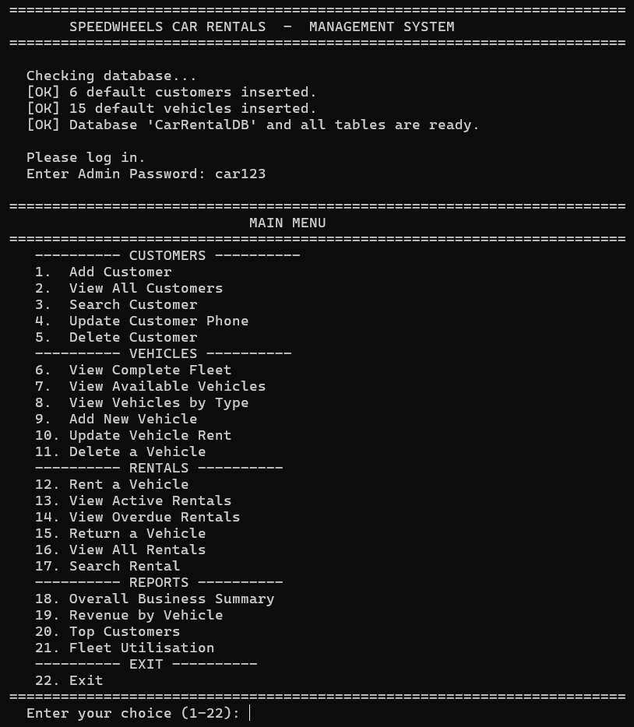Observation:
- On the first run the program automatically created the database CarRentalDB and 3 tables (Customers, Vehicles, Rentals).
- It inserted 6 customers and 15 vehicles across 5 vehicle categories.
- On the second run the "inserted" messages did not appear because the SELECT COUNT(*) checks returned non-zero values. This proves the data is stored permanently in the database.

10.2 View Complete Fleet (Option 6)
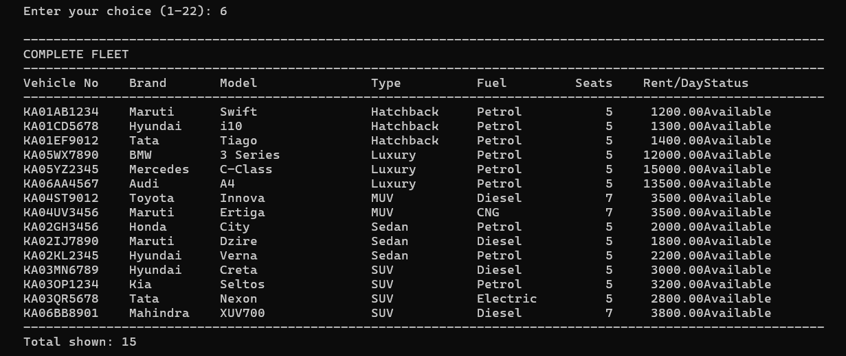Observation:
- The fleet contains ______ vehicles in total.
- The vehicle with the highest daily rent is __________________ at Rs. ______ per day.
- The vehicle with the lowest daily rent is __________________ at Rs. ______ per day.
- Vehicles are grouped by type (Hatchback → Sedan → SUV → MUV → Luxury) because the SQL used ORDER BY VehicleType, VehicleNo.

10.3 View Available Vehicles (Option 7)
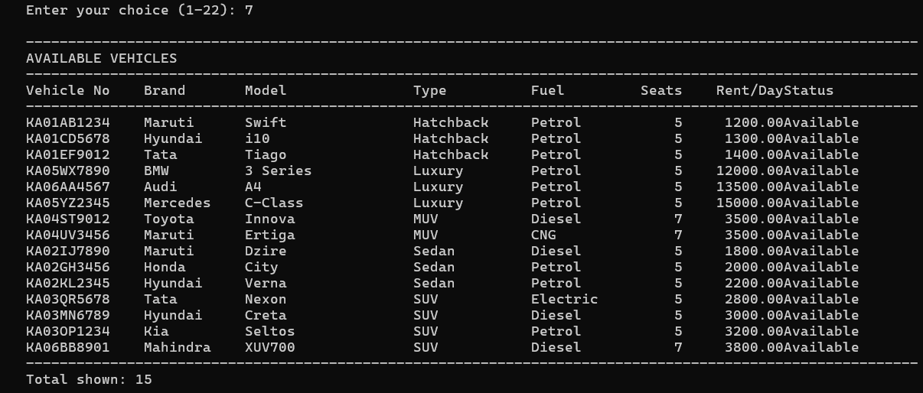Observation:
- Initially, all 15 vehicles were available because the fleet was just created.
- The SELECT ... WHERE Status = 'Available' clause filtered the list correctly. This is the same query that runs inside rent_vehicle() to show only hireable cars.

10.4 Rent a Vehicle (Option 12)
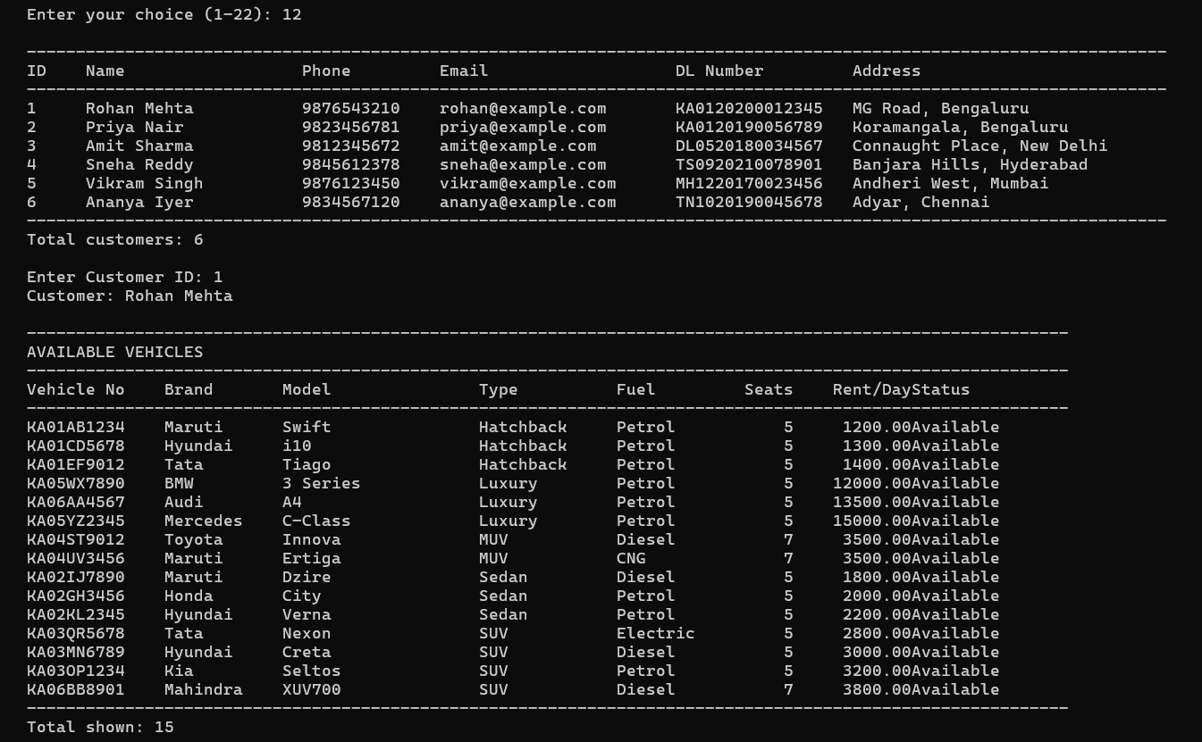
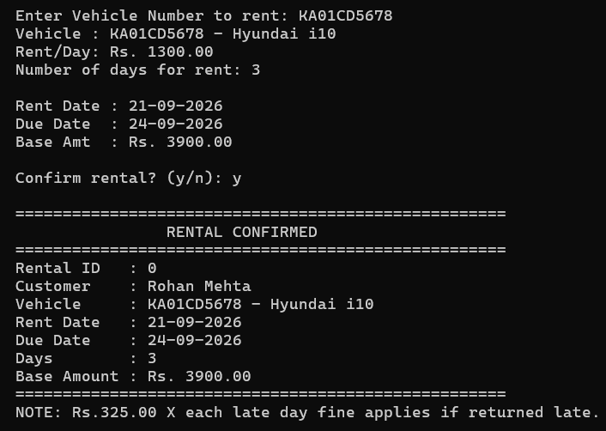
Observation:
Field | Value
Rental ID | ______
Customer | __________________
Vehicle No. | __________________
Vehicle Model | __________________
Rent Date | ______
Due Date | ______
Days | ______
Base Amount | Rs. ______
- The Due Date was computed automatically using rent_date + datetime.timedelta(days=days) — the user never typed it.
- The Base Amount was computed automatically as RentPerDay × Days.
- Important: After renting, when I viewed the fleet again (Option 6), the vehicle's status had changed from Available to Rented. This proves that the program correctly performed two operations in a single transaction: an INSERT into Rentals and an UPDATE on Vehicles.
- When I tried to rent the same vehicle again, the program displayed the message "This vehicle is not available (current status: Rented)." — preventing double-booking.

10.5 View Active Rentals (Option 13)
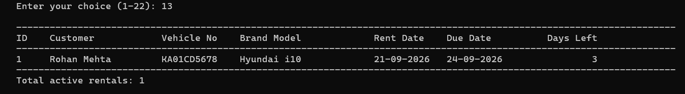Observation:
- There were ______ active rental(s).
- The Days Left column was computed by MySQL using DATEDIFF(r.DueDate, today) — this is a very useful MySQL function for date arithmetic.
- A negative Days Left would indicate an overdue rental, which the program highlights with a << OVERDUE by N day(s) >> tag.

10.6 Return a Vehicle (Option 15)
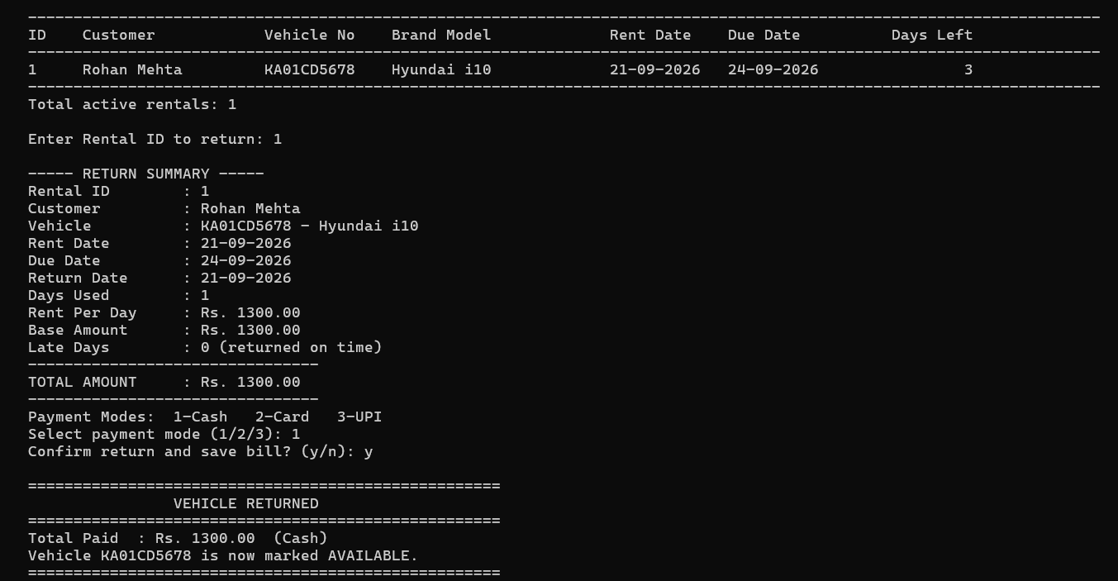Observation:
Field | Value
Rental ID | ______
Customer | __________________
Vehicle | __________________
Rent Date | ______
Due Date | ______
Return Date | ______
Days Used | ______
Rent Per Day | Rs. ______
Base Amount | Rs. ______
Late Days | ______
Late Fine | Rs. ______
Total Amount | Rs. ______
Payment Mode | ______
- The Days Used was computed with (today - rent_date).days — with a minimum of 1 day.
- The Late Days was computed as (today - due_date).days, and set to 0 if negative (i.e., returned on time).
- The Late Fine was computed as LateDays × RentPerDay × 0.25 (25% of the daily rent for each late day).
- The Total Amount was computed as BaseAmount + LateFine.
- Important: After the return, the vehicle's status changed back to Available — I verified this in the fleet view (Option 6). The room can now be rented by another customer.

10.7 Overdue Rentals (Option 14)
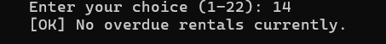
Observation:
- The query WHERE Status = 'Active' AND DueDate < today selected only rentals whose due date had passed.
- For each overdue rental the program also showed the estimated fine as DaysLate × RentPerDay × 0.25 — giving the front desk a preview of what the customer will owe.
- Conclusion: The program can be run every morning to check for overdue rentals and follow up with customers.

10.8 View All Rentals (Option 16)
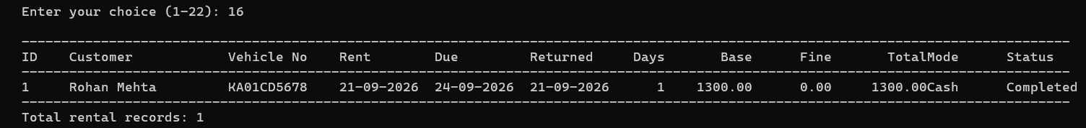Observation:
- The table showed both Active and Completed rentals.
- ORDER BY RentalID DESC ensured the most recent rentals appeared first.
- For active rentals, the columns Days, Base, Fine, Total, Mode were shown as 0 or - because the values are only filled in at the time of return.

10.9 Search Rental (Option 17)
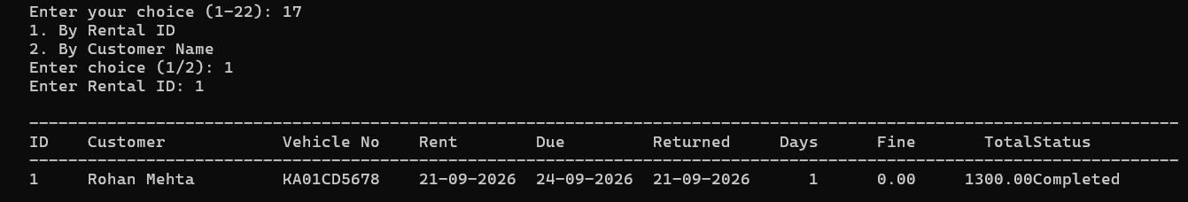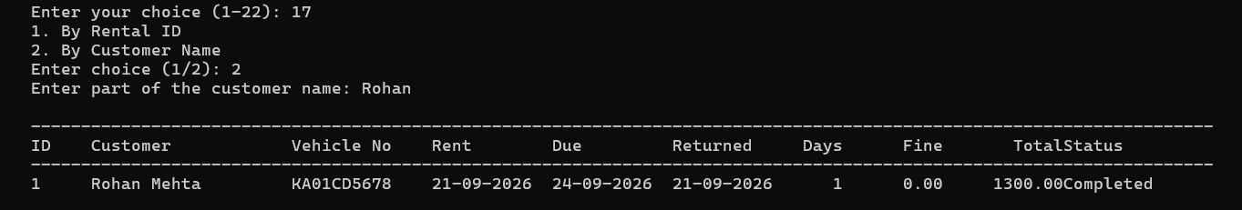Observation:
- Searching by Rental ID returned exactly one record.
- Searching by partial customer name using LIKE %name% returned all rentals belonging to customers whose name contained that substring.
- This demonstrates the use of the LIKE operator with the JOIN between Rentals and Customers.

10.10 Overall Business Summary (Option 18)
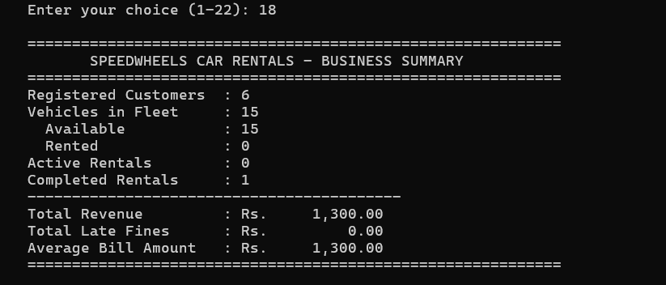Observation:
Metric | Value
Registered Customers | ______
Vehicles in Fleet | ______
Available Vehicles | ______
Rented Vehicles | ______
Active Rentals | ______
Completed Rentals | ______
Total Revenue | Rs. ______
Total Late Fines | Rs. ______
Average Bill Amount | Rs. ______
- The revenue and late fine totals were computed by MySQL using SUM() with the IFNULL() function to replace NULL with 0.
- The average bill amount was computed using AVG(TotalAmount) — a single line of SQL instead of iterating in Python.

10.11 Revenue by Vehicle (Option 19)
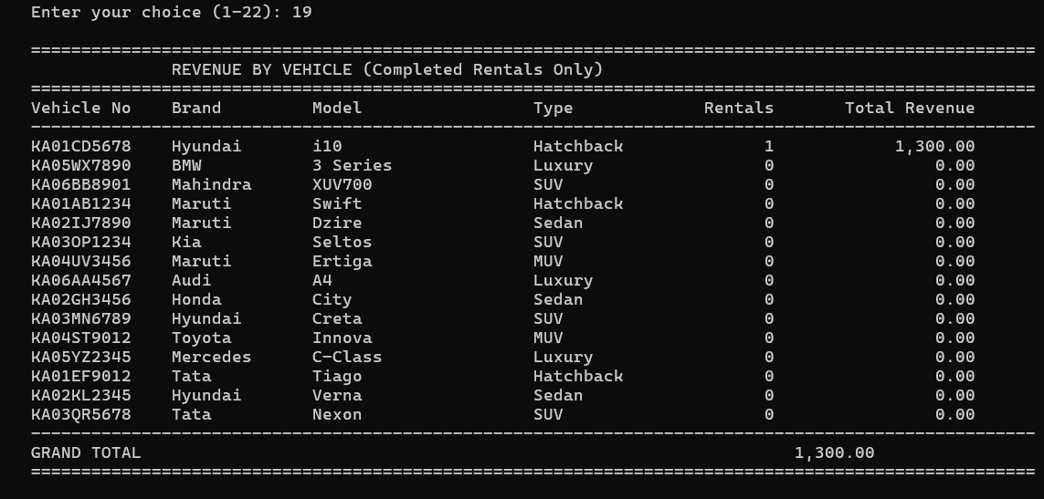Observation:
- The vehicle generating the highest revenue was __________________ at Rs. ______.
- The query used a LEFT JOIN between Vehicles and Rentals so that vehicles with no rentals (yet) still appeared in the list with a revenue of Rs. 0.00.
- The WHERE r.Status = 'Completed' condition ensured that only completed rentals contributed to the revenue — active rentals are not yet revenue.

10.12 Top Customers (Option 20)
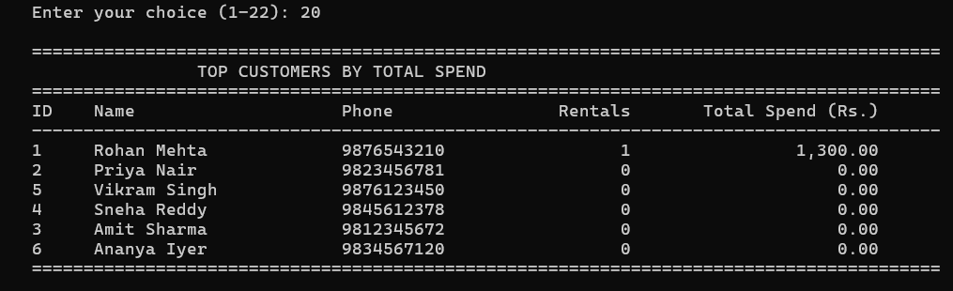Observation:
- The highest-spending customer was __________________ with Rs. ______ spent across ______ rental(s).
- The query used COUNT() and SUM() with GROUP BY c.CustID to compute both the number of rentals and the total spend for each customer.
- Conclusion: This type of report is used by real rental agencies to identify loyal customers who can be offered discounts or loyalty programs.

10.13 Fleet Utilisation (Option 21)
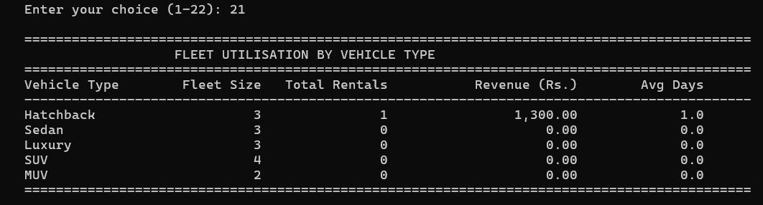Observation:
Vehicle Type | Fleet Size | Total Rentals | Revenue (Rs.) | Avg Days
______ | ______ | ______ | ______ | ______
______ | ______ | ______ | ______ | ______
- The SUV category typically shows the best mix of rental count and revenue.
- Conclusion: This report tells the agency which type of vehicle to invest in when expanding the fleet. If a category has many vehicles but low utilisation, the agency should consider selling some and buying more of a high-demand category.

11. CONCLUSION AND FUTURE SCOPE
Conclusion
In this project I successfully developed a complete, database-driven Car Rental Management System using Python and MySQL. Through this project I learnt and applied:
- Python–MySQL Connectivity — using mysql.connector.connect(), cursor(), execute(), executemany(), fetchone(), fetchall(), commit() and rollback() to run SQL from Python.
- Relational database design — creating three linked tables with a primary key in each and foreign keys from Rentals to Customers and Vehicles. This enforces referential integrity.
- Automatic schema initialisation — using CREATE DATABASE IF NOT EXISTS and CREATE TABLE IF NOT EXISTS so the program needs no manual SQL setup.
- The datetime module — computing the due date using timedelta, and calculating the days used and late days on return.
- Automatic business logic — implementing the due-date rule, the base amount calculation, the late-fine rule (25% of rent per late day) and the final bill — all without any manual computation.
- MySQL date functions — using DATEDIFF() inside a SQL query to compute days remaining, instead of computing them in Python.
- Aggregate functions and grouping — generating meaningful business reports with COUNT(), SUM(), AVG() and GROUP BY combined with JOIN and LEFT JOIN.
- The IFNULL() function — safely converting NULL values to 0 in reports, avoiding NoneType errors.
The project demonstrated the true power of a relational database: data is structured, relationships are enforced, complex business reports are produced in a single SQL query, and everything runs fast — even as the volume of rentals grows.
Future Scope
- Graphical User Interface (GUI) using Tkinter so the front-desk clerk can click buttons instead of typing.
- Online Booking Portal using Flask / Django so customers can book from their phones.
- Vehicle Photo Upload and display using BLOB columns.
- Fuel & Maintenance Log — track how much fuel each vehicle used and when it was last serviced.
- GPS Integration — display the current location of each rented vehicle.
- SMS / Email Reminder — send a reminder to the customer one day before the due date using smtplib.
- Insurance and Damage Tracking — record any damage reported at return and add the repair cost to the bill.
- Driver Assignment — allow booking with a driver, storing driver details in a new table.
- Automatic Late-Fee Escalation — charge more per late day after the 3rd day of delay.
- Dashboard with Charts — use matplotlib to display revenue trends.

12. TROUBLESHOOTING DATABASE CONNECTION
If you see:
text
Database Connection Error: 1045 (28000): Access denied for user 'root'@'localhost' (using password: YES)
follow these steps:
- Ensure MySQL is running — Start the MySQL service in the XAMPP Control Panel, or check the Windows Service.
- Test credentials from the command line: mysql -u root -p — enter the same password you will use in the script.
- Create a dedicated user (recommended):
sql
CREATE USER 'car_user'@'localhost' IDENTIFIED BY 'your_password';
GRANT ALL PRIVILEGES ON *.* TO 'car_user'@'localhost';
FLUSH PRIVILEGES;
Then set DB_USER = "car_user" and DB_PASSWORD = "your_password".
- Change authentication plugin (MySQL 8.0+ only):
sql
ALTER USER 'car_user'@'localhost'
IDENTIFIED WITH mysql_native_password BY 'your_password';
FLUSH PRIVILEGES;
- Install / upgrade the connector: pip install --upgrade mysql-connector-python.
Common Errors
Error | Reason | Solution
Unknown database 'CarRentalDB' | The database was dropped | Run the script again — it recreates the database automatically
Table 'CarRentalDB.Rentals' doesn't exist | Table dropped | Run the script again — CREATE TABLE IF NOT EXISTS recreates it
Not all parameters were used in the SQL statement | More values than %s placeholders | This project uses exactly 6 placeholders for 6 customer values and 8 placeholders for 8 vehicle values — no mismatch is possible
Cannot add or update a child row: a foreign key constraint fails | Trying to rent a vehicle or assign a customer that does not exist | Add the customer and vehicle first
Cannot delete or update a parent row: a foreign key constraint fails | Deleting a customer or vehicle that still has rentals | The program's delete_customer() and delete_vehicle() already clean up related rentals automatically
Data too long for column 'VehicleNo' | Vehicle number longer than 12 characters | Enter a shorter number, or increase the column size in CREATE TABLE
Incorrect date value | Wrong date format | Always use DD-MM-YYYY format
Late fine shows 0 even when return is late | Vehicle returned before the due date | Check the Due Date column in Option 13 — the fine only applies after the due date has passed

13. BIBLIOGRAPHY
- Websites:
  - MySQL Connector/Python Documentation (dev.mysql.com/doc/connector-python)
  - Python Official Documentation — datetime (docs.python.org/3/library/datetime.html)
  - W3Schools — SQL Tutorial (www.w3schools.com/sql)
  - GeeksforGeeks (www.geeksforgeeks.org)
  - Stack Overflow (www.stackoverflow.com)
- Study Material:
  - NCERT Informatics Practices Textbook for Class XII
  - Sumita Arora, Informatics Practices with Python, Dhanpat Rai & Co.
- Reference Manual:
  - MySQL 8.0 Reference Manual (dev.mysql.com/doc)

