PROJECT FILE
INFORMATICS PRACTICES (CLASS XII)
SESSION: [Year, e.g., 2023-2024]

COVID-19 DATA TRACKER
(Analysis of Active Cases, Recoveries and Mortality Rates using Pandas and Matplotlib)
Submitted By:
[Your Name]
Class: XII – [Section]
Roll No: [Your Roll Number]
Submitted To:
[Teacher's Name]
Department of Computer Science
[Your School Name]

CERTIFICATE
This is to certify that [Your Name] of Class XII has successfully completed the Informatics Practices project titled "COVID-19 Data Tracker" under the guidance of [Teacher's Name] during the academic year [Year].
This project is a bonafide record of work done by the candidate independently and fulfills the requirements of the Central Board of Secondary Education (CBSE) for the AISSCE Examination.
Teacher In-Charge: __________________
Signature: __________________
External Examiner: __________________
Signature: __________________
School Seal:

ACKNOWLEDGEMENT
I would like to express my sincere thanks to my Informatics Practices teacher [Teacher's Name] and our Principal [Principal's Name] for giving me the opportunity to work on this project titled "COVID-19 Data Tracker".
Through this project I learnt how real-world epidemiological data is analysed using Pandas and how trends, peaks and rates are presented visually using Matplotlib. I learnt how to calculate derived quantities such as recovery rate, mortality rate and active rate, and how to interpret these numbers to understand the progress of a pandemic. I would also like to thank my parents and friends who supported and encouraged me throughout the completion of this project.
Name: [Your Name]
Class: XII

TABLE OF CONTENTS
- Introduction
- Objectives of the Project
- Proposed System
- System Requirements (Hardware & Software)
- Theory: Pandas and Matplotlib
- Data Description (Dataset Structure)
- Key Formulas Used
- Functions Used (Quick Reference)
- Source Code
- Output Screens and Observations
- Conclusion and Future Scope
- Troubleshooting / Common Errors
- Bibliography

1. INTRODUCTION
The COVID-19 pandemic produced an enormous amount of data every single day — number of new cases, active cases, recoveries and deaths, for every state and every country. Without proper analysis, this data is just a mountain of numbers. To understand how a pandemic is progressing, governments and health authorities must analyse this data and visualise it as charts and trends.
The COVID-19 Data Tracker is a project that reads a pandemic dataset, analyses it using the Pandas library of Python, and presents the results using Matplotlib graphs.
The project answers important epidemiological questions such as:
- How did the number of daily new cases change over time?
- When did the peak of the wave occur?
- How many cases are currently active?
- What is the recovery rate and mortality rate?
- Which state was the worst affected?
- Is there a relationship between the number of cases and the number of deaths?
- How did the recovery rate improve over time?
The dataset used in this project is generated automatically by the program itself and stored as a CSV file named covid_data.csv. The program then reads this file using Pandas and produces both tabular output and graphical output (line charts, bar charts, pie charts, a histogram and a scatter plot).
2. OBJECTIVES
The main objectives of this project are:
- To understand how a CSV file is read and analysed using the Pandas library.
- To learn how to create and manipulate a DataFrame.
- To add derived columns such as Active, RecoveryRate and MortalityRate using existing columns.
- To group and summarise data using groupby(), sum() and mean().
- To sort and filter data to find the top-affected states and the peak day.
- To visualise data using different chart types — Line, Bar, Horizontal Bar, Pie, Histogram, Scatter and Stacked Line.
- To interpret the graphs and draw meaningful epidemiological conclusions.
3. PROPOSED SYSTEM
The proposed system is a menu-driven Python program consisting of three modules:
- Dataset Module
  - Automatically creates a CSV file covid_data.csv containing daily COVID-19 records for 6 Indian states over a 90-day period (540 rows).
  - If the file already exists, the user is asked whether to regenerate it.
- Analysis Module (Pandas)
  - Loads the CSV file into a DataFrame.
  - Adds calculated columns: Active, RecoveryRate, MortalityRate.
  - Displays head, tail, shape, data types and statistical summary.
  - Performs state-wise, date-wise and overall aggregation.
- Visualization Module (Matplotlib)
  - Draws 10 different charts and saves each one as a PNG image file.
  - Displays a combined dashboard with four key charts.
4. SYSTEM REQUIREMENTS
Hardware Requirements:
- Processor: Intel Core i3 or above
- RAM: 4 GB or above
- Hard Disk: 100 GB or above
Software Requirements:
- Operating System: Windows 7/8/10/11 or Linux
- Python 3.x (IDLE / PyCharm / Jupyter Notebook)
- Pandas library (pip install pandas)
- Matplotlib library (pip install matplotlib)
- MS Word / MS Excel (for documentation and viewing the CSV)
Note: No database (MySQL) is required for this project.
5. THEORY: PANDAS AND MATPLOTLIB
5.1 Pandas
Pandas is an open-source Python library used for data analysis and data manipulation. It provides two main data structures:
Structure | Description
Series | A one-dimensional labelled array — like a single column.
DataFrame | A two-dimensional labelled table (rows × columns) — like a spreadsheet.
In this project, the entire CSV file is loaded into a DataFrame and all analysis is performed on it.
5.2 Matplotlib
Matplotlib is a Python library for creating visualisations. The pyplot module (matplotlib.pyplot) is used to draw graphs. Each chart is created inside a figure object; show() displays it, savefig() saves it as a PNG image.
5.3 Types of Charts Used in This Project
Chart | Purpose
Line Chart | Daily new cases trend, active cases trend
Multi-line Chart | Comparing Confirmed vs Recovered vs Deaths over time
Bar Chart | State-wise comparison of total cases
Horizontal Bar Chart | Comparing recovery rate across states
Pie Chart | Percentage share of each state in total confirmed cases
Histogram | Frequency distribution of daily new cases
Scatter Plot | Relationship between confirmed cases and deaths
Stacked Line Chart | Cumulative confirmed vs recovered vs deaths
6. DATA DESCRIPTION (DATASET STRUCTURE)
The program generates a file named covid_data.csv with 540 rows (6 states × 90 days).
Column Name | Data Type | Description
Date | Text | Date of record (DD-MM-YYYY)
State | Text | Maharashtra, Kerala, Karnataka, Tamil Nadu, Delhi, Gujarat
NewCases | Integer | New cases reported on that day
NewRecoveries | Integer | New recoveries reported on that day
NewDeaths | Integer | New deaths reported on that day
TotalConfirmed | Integer | Cumulative confirmed cases till that day
TotalRecovered | Integer | Cumulative recovered cases till that day
TotalDeaths | Integer | Cumulative deaths till that day
Active | Integer | Calculated column = TotalConfirmed − TotalRecovered − TotalDeaths
RecoveryRate | Float | Calculated column = TotalRecovered / TotalConfirmed × 100
MortalityRate | Float | Calculated column = TotalDeaths / TotalConfirmed × 100
Sample of the generated dataset (your actual values may differ slightly — copy the real output of Option 1 here):
Date | State | NewCases | NewRecoveries | NewDeaths | TotalConfirmed | TotalRecovered | TotalDeaths | Active | RecoveryRate | MortalityRate
01-01-2024 | Maharashtra | 520 | 480 | 8 | 520 | 480 | 8 | 32 | 92.31 | 1.54
01-01-2024 | Kerala | 310 | 290 | 4 | 310 | 290 | 4 | 16 | 93.55 | 1.29
02-01-2024 | Maharashtra | 615 | 512 | 10 | 1135 | 992 | 18 | 125 | 87.40 | 1.59
The dataset simulates a realistic wave pattern — cases rise gradually, peak around day 55–65, and then decline — using sine curves and random noise, seeded with random.seed(11) so the same data is produced on every computer.
7. KEY FORMULAS USED
7.1 Active Cases
text
Active = TotalConfirmed − TotalRecovered − TotalDeaths
The active cases represent people who are currently infected and can still spread the virus.
7.2 Recovery Rate
text
RecoveryRate (%) = (TotalRecovered / TotalConfirmed) × 100
A higher recovery rate is a positive indicator — it means the healthcare system is successfully treating patients.
7.3 Mortality Rate (Case Fatality Rate)
text
MortalityRate (%) = (TotalDeaths / TotalConfirmed) × 100
A lower mortality rate is a positive indicator — it means fewer patients are dying from the disease.
7.4 Active Rate
text
ActiveRate (%) = (Active / TotalConfirmed) × 100
A very high active rate means the pandemic is still growing; a low active rate means the wave is receding.
7.5 Doubling Time (Conceptual)
Doubling time is an important epidemiological measure. It is not calculated in this project because it requires smoothing, but the concept helps explain why the "daily new cases" chart rises so steeply during the early part of the wave.
8. FUNCTIONS USED (QUICK REFERENCE)
8.1 Pandas Functions
Function | Use in this Project
read_csv() | Reads the CSV into a DataFrame
to_csv() | Writes the DataFrame to a CSV file
head() / tail() | Displays the first / last 5 rows
shape | Returns rows and columns
columns | Returns the column names
dtypes | Returns the data type of each column
describe() | Statistical summary (count, mean, min, max, std, percentiles)
groupby() | Groups data by state or by date
sum() / mean() | Aggregates the grouped data
sort_values() | Sorts in ascending / descending order
pivot_table() | Creates a cross-tab (Date × State)
to_string() | Prints a DataFrame neatly without truncation
Boolean filtering | df[df["NewCases"] > 5000]
8.2 Matplotlib Functions
Function | Use in this Project
figure(figsize=...) | Creates a new figure
plot() | Draws a line chart
bar() / barh() | Draws vertical / horizontal bar charts
pie() | Draws a pie chart
hist() | Draws a histogram
scatter() | Draws a scatter plot
fill_between() | Shades the area under a line chart
stackplot() | Draws a stacked area chart
subplots() | Creates a grid of charts (dashboard)
axhline() | Draws a horizontal reference line (e.g., average)
title(), xlabel(), ylabel() | Adds titles and axis labels
legend() | Displays the legend
grid() | Adds grid lines
xticks(rotation=...) | Rotates x-axis labels
tight_layout() | Adjusts spacing
savefig() | Saves the chart as an image
show() | Displays the chart
9. SOURCE CODE
Below is the complete Python code. It creates its own dataset, so no external file is needed.
python
# ==========================================================
# COVID-19 DATA TRACKER
# Class 12 Informatics Practices Project
# Tools Used: Python, Pandas, Matplotlib
# ==========================================================

import os
import math
import random
import datetime
import pandas as pd
import matplotlib.pyplot as plt

# ---------------------- GLOBAL SETTINGS ----------------------

CSV_FILE = "covid_data.csv"

STATES = ["Maharashtra", "Kerala", "Karnataka",
"Tamil Nadu", "Delhi", "Gujarat"]

# Base "population weight" per state (drives scale of cases)
STATE_WEIGHT = {
"Maharashtra": 1.30,
"Kerala": 1.10,
"Karnataka": 1.00,
"Tamil Nadu": 0.95,
"Delhi": 0.80,
"Gujarat": 0.75,
}

STATE_COLORS = {
"Maharashtra": "#4C72B0",
"Kerala": "#DD8452",
"Karnataka": "#55A868",
"Tamil Nadu": "#C44E52",
"Delhi": "#8172B3",
"Gujarat": "#937860",
}

NUM_DAYS = 90
START_DATE = datetime.date(2024, 1, 1)

# ==================== 1. CREATE THE DATASET ====================

def create_dataset():
"""Generate a simulated COVID-19 dataset (6 states x 90 days) as a CSV file."""
if os.path.exists(CSV_FILE):
print("Dataset file '" + CSV_FILE + "' already exists.")
choice = input("Do you want to regenerate it? (y/n): ").lower()
if choice != "y":
return

random.seed(11) # reproducible data

records = []

for state in STATES:
weight = STATE_WEIGHT[state]

confirmed = 0
recovered = 0
deaths = 0

for day in range(NUM_DAYS):
date = START_DATE + datetime.timedelta(days=day)

# Wave shape: sine curve peaks around day 60 of a 90-day cycle.
phase = (day / NUM_DAYS) * math.pi
wave = math.sin(phase) ** 1.4 # 0 -> 1 -> 0 (smooth wave)

# Base daily new cases scaled by state weight and wave
base = 900 * weight * wave
noise = random.randint(-120, 120)
new_cases = max(20, int(base + noise))

# Recoveries lag behind cases by roughly 12 days
lag_day = max(0, day - 12)
lag_phase = (lag_day / NUM_DAYS) * math.pi
lag_wave = math.sin(lag_phase) ** 1.4
rec_base = 850 * weight * lag_wave
rec_noise = random.randint(-100, 100)
new_rec = max(15, int(rec_base + rec_noise))

# Deaths: roughly 1.2% of new cases
new_deaths = max(0, int(new_cases * 0.012 + random.uniform(-1, 2)))

confirmed += new_cases
recovered = min(confirmed - deaths, recovered + new_rec)
deaths += new_deaths

active = confirmed - recovered - deaths
if active < 0:
active = 0

rec_rate = round((recovered / confirmed) * 100, 2) if confirmed else 0.0
mort_rate = round((deaths / confirmed) * 100, 2) if confirmed else 0.0

records.append([
date.strftime("%d-%m-%Y"),
state,
new_cases,
new_rec,
new_deaths,
confirmed,
recovered,
deaths,
active,
rec_rate,
mort_rate,
])

df = pd.DataFrame(records, columns=[
"Date", "State", "NewCases", "NewRecoveries", "NewDeaths",
"TotalConfirmed", "TotalRecovered", "TotalDeaths",
"Active", "RecoveryRate", "MortalityRate",
])
df.to_csv(CSV_FILE, index=False)
print("Dataset created successfully with", len(df), "records.")
print("File saved as:", CSV_FILE)

# ==================== 2. LOAD AND PREPARE DATA ====================

def load_data():
"""Read the CSV and add the derived Active / RecoveryRate / MortalityRate columns."""
df = pd.read_csv(CSV_FILE)

# Some derived columns are already in the CSV (so the CSV is human-readable);
# but we recompute them here to be safe against manual edits.
df["Active"] = df["TotalConfirmed"] - df["TotalRecovered"] - df["TotalDeaths"]
df["RecoveryRate"] = (df["TotalRecovered"] / df["TotalConfirmed"] * 100).round(2)
df["MortalityRate"] = (df["TotalDeaths"] / df["TotalConfirmed"] * 100).round(2)

# Convert Date to datetime so we can sort by it
df["Date"] = pd.to_datetime(df["Date"], format="%d-%m-%Y")
df = df.sort_values(["State", "Date"]).reset_index(drop=True)
return df

# ==================== 3. ANALYSIS FUNCTIONS (TABLES) ====================

def show_basic_info(df):
print("\n----- FIRST 5 RECORDS (head) -----")
print(df.head().to_string(index=False))

print("\n----- LAST 5 RECORDS (tail) -----")
print(df.tail().to_string(index=False))

print("\n----- SHAPE (rows, columns) -----")
print(df.shape)

print("\n----- COLUMN NAMES -----")
print(list(df.columns))

print("\n----- DATA TYPES -----")
print(df.dtypes)

print("\n----- STATISTICAL SUMMARY (describe) -----")
print(df[["NewCases", "NewRecoveries", "NewDeaths",
"TotalConfirmed", "Active", "RecoveryRate",
"MortalityRate"]].describe().round(2))

def overall_summary(df):
"""Take the last day's cumulative numbers for each state and total them."""
last_day = df["Date"].max()
latest = df[df["Date"] == last_day]

total_conf = int(latest["TotalConfirmed"].sum())
total_rec = int(latest["TotalRecovered"].sum())
total_deaths = int(latest["TotalDeaths"].sum())
total_active = int(latest["Active"].sum())

rec_rate = round(total_rec / total_conf * 100, 2) if total_conf else 0
mort_rate = round(total_deaths / total_conf * 100, 2) if total_conf else 0
active_rate = round(total_active / total_conf * 100, 2) if total_conf else 0

print("\n ============================================")
print(" OVERALL COVID-19 SUMMARY (as of " +
last_day.strftime("%d-%m-%Y") + ")")
print(" ============================================")
print(" Total Confirmed Cases : {:,}".format(total_conf))
print(" Total Recovered : {:,}".format(total_rec))
print(" Total Deaths : {:,}".format(total_deaths))
print(" Active Cases : {:,}".format(total_active))
print(" --------------------------------------------")
print(" Recovery Rate : {} %".format(rec_rate))
print(" Mortality Rate : {} %".format(mort_rate))
print(" Active Rate : {} %".format(active_rate))
print(" ============================================")

def table_statewise(df):
"""Show final numbers for each state, sorted by total confirmed."""
last_day = df["Date"].max()
latest = df[df["Date"] == last_day].copy()

latest = latest.sort_values("TotalConfirmed", ascending=False)

print("\n----- STATE-WISE SUMMARY (as of " +
last_day.strftime("%d-%m-%Y") + ") -----")
print(" {:<15}{:>12}{:>12}{:>10}{:>10}{:>10}{:>10}".format(
"State", "Confirmed", "Recovered", "Deaths", "Active",
"Rec%", "Mort%"))
print(" " + "-" * 80)
for _, r in latest.iterrows():
print(" {:<15}{:>12,}{:>12,}{:>10,}{:>10,}{:>10.2f}{:>10.2f}".format(
r["State"], int(r["TotalConfirmed"]), int(r["TotalRecovered"]),
int(r["TotalDeaths"]), int(r["Active"]),
r["RecoveryRate"], r["MortalityRate"]))
print(" " + "-" * 80)

def table_daily_national(df):
"""Sum across states for each day to get national daily cases."""
daily = df.groupby("Date", as_index=False).agg({
"NewCases": "sum",
"NewRecoveries": "sum",
"NewDeaths": "sum",
})
peak_row = daily.loc[daily["NewCases"].idxmax()]

print("\n----- NATIONAL DAILY NEW CASES (last 10 days) -----")
print(daily.tail(10).to_string(index=False))

print("\n Peak day of the wave : " +
peak_row["Date"].strftime("%d-%m-%Y"))
print(" Peak daily new cases : {:,}".format(int(peak_row["NewCases"])))
print(" Average daily cases : {:.0f}".format(daily["NewCases"].mean()))
print(" Average daily deaths : {:.0f}".format(daily["NewDeaths"].mean()))

def table_top_states(df):
print("\n----- TOP 3 STATES BY TOTAL CONFIRMED -----")
last_day = df["Date"].max()
latest = df[df["Date"] == last_day].copy()
latest = latest.sort_values("TotalConfirmed", ascending=False)
print(latest.head(3)[["State", "TotalConfirmed", "TotalDeaths",
"RecoveryRate", "MortalityRate"]].to_string(index=False))

print("\n----- TOP 3 STATES BY MORTALITY RATE -----")
mort_top = latest.sort_values("MortalityRate", ascending=False)
print(mort_top.head(3)[["State", "TotalConfirmed", "TotalDeaths",
"MortalityRate"]].to_string(index=False))

print("\n----- TOP 3 STATES BY RECOVERY RATE -----")
rec_top = latest.sort_values("RecoveryRate", ascending=False)
print(rec_top.head(3)[["State", "TotalConfirmed", "TotalRecovered",
"RecoveryRate"]].to_string(index=False))

# ==================== 4. VISUALIZATION FUNCTIONS (CHARTS) ====================

def chart_national_new_cases(df):
daily = df.groupby("Date", as_index=False)["NewCases"].sum()
avg = daily["NewCases"].mean()

plt.figure(figsize=(11, 5))
plt.plot(daily["Date"], daily["NewCases"],
color="crimson", linewidth=2, label="Daily New Cases")
plt.fill_between(daily["Date"], daily["NewCases"],
color="crimson", alpha=0.15)
plt.axhline(avg, color="navy", linestyle="--",
label="Average = {:.0f}".format(avg))

plt.title("National Daily New COVID-19 Cases",
fontsize=14, fontweight="bold")
plt.xlabel("Date")
plt.ylabel("New Cases")
plt.legend()
plt.grid(linestyle="--", alpha=0.5)
plt.xticks(rotation=45)
plt.tight_layout()
plt.savefig("chart1_national_new_cases.png", dpi=150)
plt.show()

def chart_active_trend(df):
daily = df.groupby("Date", as_index=False)["Active"].sum()

plt.figure(figsize=(11, 5))
plt.plot(daily["Date"], daily["Active"],
color="darkorange", linewidth=2.5, marker="",
label="Active Cases (National)")

plt.title("National Active COVID-19 Cases Over Time",
fontsize=14, fontweight="bold")
plt.xlabel("Date")
plt.ylabel("Active Cases")
plt.legend()
plt.grid(linestyle="--", alpha=0.5)
plt.xticks(rotation=45)
plt.tight_layout()
plt.savefig("chart2_active_trend.png", dpi=150)
plt.show()

def chart_recovered_vs_deaths(df):
daily = df.groupby("Date", as_index=False).agg({
"TotalConfirmed": "sum",
"TotalRecovered": "sum",
"TotalDeaths": "sum",
})

plt.figure(figsize=(11, 5))
plt.plot(daily["Date"], daily["TotalConfirmed"],
color="steelblue", linewidth=2, label="Confirmed")
plt.plot(daily["Date"], daily["TotalRecovered"],
color="seagreen", linewidth=2, label="Recovered")
plt.plot(daily["Date"], daily["TotalDeaths"],
color="darkred", linewidth=2, label="Deaths")

plt.title("Cumulative Confirmed vs Recovered vs Deaths",
fontsize=14, fontweight="bold")
plt.xlabel("Date")
plt.ylabel("Cumulative Count")
plt.legend()
plt.grid(linestyle="--", alpha=0.5)
plt.xticks(rotation=45)
plt.tight_layout()
plt.savefig("chart3_recovered_vs_deaths.png", dpi=150)
plt.show()

def chart_statewise_bar(df):
last_day = df["Date"].max()
latest = df[df["Date"] == last_day]
latest = latest.sort_values("TotalConfirmed", ascending=False)

plt.figure(figsize=(10, 6))
bars = plt.bar(latest["State"], latest["TotalConfirmed"],
color=[STATE_COLORS[s] for s in latest["State"]],
edgecolor="black")

for b in bars:
plt.text(b.get_x() + b.get_width() / 2, b.get_height(),
format(int(b.get_height()), ","),
ha="center", va="bottom", fontsize=9)

plt.title("State-wise Total Confirmed Cases",
fontsize=14, fontweight="bold")
plt.xlabel("State")
plt.ylabel("Total Confirmed Cases")
plt.grid(axis="y", linestyle="--", alpha=0.5)
plt.tight_layout()
plt.savefig("chart4_statewise_bar.png", dpi=150)
plt.show()

def chart_recovery_rate_barh(df):
last_day = df["Date"].max()
latest = df[df["Date"] == last_day]
latest = latest.sort_values("RecoveryRate")

plt.figure(figsize=(10, 6))
bars = plt.barh(latest["State"], latest["RecoveryRate"],
color="seagreen", edgecolor="black")

for b in bars:
plt.text(b.get_width(), b.get_y() + b.get_height() / 2,
" {:.2f}%".format(b.get_width()),
va="center", fontsize=10)

plt.title("State-wise Recovery Rate (as of " +
last_day.strftime("%d-%m-%Y") + ")",
fontsize=14, fontweight="bold")
plt.xlabel("Recovery Rate (%)")
plt.ylabel("State")
plt.xlim(0, 105)
plt.grid(axis="x", linestyle="--", alpha=0.5)
plt.tight_layout()
plt.savefig("chart5_recovery_rate.png", dpi=150)
plt.show()

def chart_pie_share(df):
last_day = df["Date"].max()
latest = df[df["Date"] == last_day]
share = latest.set_index("State")["TotalConfirmed"]

plt.figure(figsize=(8, 8))
plt.pie(share, labels=share.index, autopct="%1.1f%%",
startangle=90, shadow=True,
colors=[STATE_COLORS[s] for s in share.index],
explode=[0.03] * len(share))

plt.title("Share of Total Confirmed Cases by State",
fontsize=14, fontweight="bold")
plt.tight_layout()
plt.savefig("chart6_pie_share.png", dpi=150)
plt.show()

def chart_histogram_newcases(df):
plt.figure(figsize=(10, 5))
plt.hist(df["NewCases"], bins=25, color="mediumpurple",
edgecolor="black")
plt.axvline(df["NewCases"].mean(), color="red", linestyle="--",
label="Mean = {:.0f}".format(df["NewCases"].mean()))

plt.title("Distribution of Daily New Cases Across All States",
fontsize=14, fontweight="bold")
plt.xlabel("New Cases per day (per state)")
plt.ylabel("Frequency")
plt.legend()
plt.grid(axis="y", linestyle="--", alpha=0.5)
plt.tight_layout()
plt.savefig("chart7_histogram.png", dpi=150)
plt.show()

def chart_scatter_cases_vs_deaths(df):
plt.figure(figsize=(10, 6))
for state in STATES:
sub = df[df["State"] == state]
plt.scatter(sub["TotalConfirmed"], sub["TotalDeaths"],
color=STATE_COLORS[state], label=state,
s=25, alpha=0.7, edgecolor="black")

plt.title("Relationship between Total Confirmed Cases and Deaths",
fontsize=14, fontweight="bold")
plt.xlabel("Total Confirmed Cases")
plt.ylabel("Total Deaths")
plt.legend()
plt.grid(linestyle="--", alpha=0.5)
plt.tight_layout()
plt.savefig("chart8_scatter.png", dpi=150)
plt.show()

def chart_stacked_line(df):
daily = df.groupby("Date", as_index=False).agg({
"TotalRecovered": "sum",
"Active": "sum",
"TotalDeaths": "sum",
})

plt.figure(figsize=(11, 5))
plt.stackplot(daily["Date"],
daily["TotalRecovered"], daily["Active"], daily["TotalDeaths"],
labels=["Recovered", "Active", "Deaths"],
colors=["#55A868", "#DD8452", "#C44E52"], alpha=0.85)

plt.title("Composition of Total Cases: Recovered / Active / Deaths",
fontsize=14, fontweight="bold")
plt.xlabel("Date")
plt.ylabel("Total Cases")
plt.legend(loc="upper left")
plt.grid(linestyle="--", alpha=0.4)
plt.xticks(rotation=45)
plt.tight_layout()
plt.savefig("chart9_stacked_line.png", dpi=150)
plt.show()

def chart_multi_state_trend(df):
plt.figure(figsize=(12, 6))
for state in STATES:
sub = df[df["State"] == state]
plt.plot(sub["Date"], sub["TotalConfirmed"],
color=STATE_COLORS[state], linewidth=2, label=state)

plt.title("State-wise Cumulative Confirmed Cases Over Time",
fontsize=14, fontweight="bold")
plt.xlabel("Date")
plt.ylabel("Cumulative Confirmed Cases")
plt.legend(title="State")
plt.grid(linestyle="--", alpha=0.5)
plt.xticks(rotation=45)
plt.tight_layout()
plt.savefig("chart10_multi_state.png", dpi=150)
plt.show()

def show_dashboard(df):
"""Show 4 main charts in a single 2x2 window."""
fig, ax = plt.subplots(2, 2, figsize=(15, 10))

# (a) National daily new cases
daily = df.groupby("Date", as_index=False)["NewCases"].sum()
ax[0, 0].plot(daily["Date"], daily["NewCases"], color="crimson")
ax[0, 0].set_title("National Daily New Cases")
ax[0, 0].set_xlabel("Date")
ax[0, 0].set_ylabel("New Cases")
ax[0, 0].grid(linestyle="--", alpha=0.4)
ax[0, 0].tick_params(axis="x", rotation=45)

# (b) State-wise confirmed bar
last_day = df["Date"].max()
latest = df[df["Date"] == last_day].sort_values("TotalConfirmed",
ascending=False)
ax[0, 1].bar(latest["State"], latest["TotalConfirmed"],
color=[STATE_COLORS[s] for s in latest["State"]],
edgecolor="black")
ax[0, 1].set_title("State-wise Total Confirmed Cases")
ax[0, 1].set_ylabel("Confirmed")
ax[0, 1].grid(axis="y", linestyle="--", alpha=0.4)
ax[0, 1].tick_params(axis="x", rotation=30)

# (c) Pie - share of cases
share = latest.set_index("State")["TotalConfirmed"]
ax[1, 0].pie(share, labels=share.index, autopct="%1.1f%%",
startangle=90,
colors=[STATE_COLORS[s] for s in share.index])
ax[1, 0].set_title("Share of Total Confirmed Cases")

# (d) Scatter - cases vs deaths
for state in STATES:
sub = df[df["State"] == state]
ax[1, 1].scatter(sub["TotalConfirmed"], sub["TotalDeaths"],
color=STATE_COLORS[state], s=15,
alpha=0.6, label=state)
ax[1, 1].set_title("Confirmed vs Deaths")
ax[1, 1].set_xlabel("Total Confirmed")
ax[1, 1].set_ylabel("Total Deaths")
ax[1, 1].legend(fontsize=7)
ax[1, 1].grid(linestyle="--", alpha=0.4)

fig.suptitle("COVID-19 DATA DASHBOARD", fontsize=16, fontweight="bold")
plt.tight_layout()
plt.savefig("chart11_dashboard.png", dpi=150)
plt.show()

# ==================== 5. MAIN MENU ====================

def main():
print("=" * 62)
print(" COVID-19 DATA TRACKER")
print("=" * 62)

if not os.path.exists(CSV_FILE):
print("Dataset not found. Creating a new dataset...")
create_dataset()

df = load_data()
print("Data loaded successfully. Total records: " + str(len(df)))

while True:
print("\n" + "=" * 62)
print(" MAIN MENU")
print("=" * 62)
print("1. Show Basic Information about the Data")
print("2. Overall COVID-19 Summary")
print("3. State-wise Summary Table")
print("4. National Daily Cases Table")
print("5. Top States (Confirmed / Mortality / Recovery)")
print("6. Line Chart - National Daily New Cases")
print("7. Line Chart - National Active Cases Trend")
print("8. Line Chart - Confirmed vs Recovered vs Deaths")
print("9. Bar Chart - State-wise Total Confirmed Cases")
print("10. Bar Chart - State-wise Recovery Rate")
print("11. Pie Chart - Share of Cases by State")
print("12. Histogram - Distribution of Daily New Cases")
print("13. Scatter - Confirmed vs Deaths")
print("14. Stacked Area- Recovered / Active / Deaths Composition")
print("15. Multi-line - State-wise Cumulative Confirmed")
print("16. Dashboard - 4 Main Charts Together")
print("17. Exit")
print("=" * 62)

choice = input("Enter your choice (1-17): ").strip()

if choice == "1":
show_basic_info(df)
elif choice == "2":
overall_summary(df)
elif choice == "3":
table_statewise(df)
elif choice == "4":
table_daily_national(df)
elif choice == "5":
table_top_states(df)
elif choice == "6":
chart_national_new_cases(df)
elif choice == "7":
chart_active_trend(df)
elif choice == "8":
chart_recovered_vs_deaths(df)
elif choice == "9":
chart_statewise_bar(df)
elif choice == "10":
chart_recovery_rate_barh(df)
elif choice == "11":
chart_pie_share(df)
elif choice == "12":
chart_histogram_newcases(df)
elif choice == "13":
chart_scatter_cases_vs_deaths(df)
elif choice == "14":
chart_stacked_line(df)
elif choice == "15":
chart_multi_state_trend(df)
elif choice == "16":
show_dashboard(df)
elif choice == "17":
print("\nThank you for using the COVID-19 Data Tracker. Goodbye!")
break
else:
print("Invalid choice. Please enter a number between 1 and 17.")

# ---------------------- PROGRAM STARTS HERE ----------------------
if __name__ == "__main__":
main()

10. OUTPUT SCREENS AND OBSERVATIONS
10.1 Basic Information about the Data (Option 1)
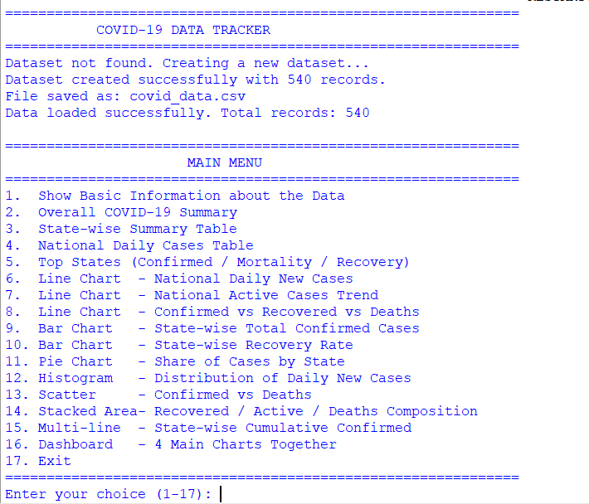Observation:
- The dataset contains 540 rows and 11 columns (including the calculated Active, RecoveryRate and MortalityRate columns).
- The describe() output shows the minimum, maximum and average of NewCases, TotalConfirmed, Active and the two rates.
- The highest daily new cases recorded by any single state was ______, and the lowest was ______.

10.2 Overall COVID-19 Summary (Option 2)
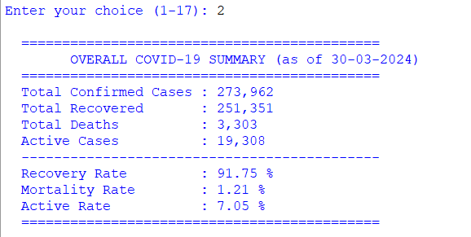Observation:
Metric | Value
Total Confirmed Cases | ______
Total Recovered | ______
Total Deaths | ______
Active Cases | ______
Recovery Rate | ______ %
Mortality Rate | ______ %
Active Rate | ______ %
- The total confirmed cases at the end of the period were ______, out of which ______ had recovered, ______ had died, and ______ were still active.
- Conclusion: The recovery rate of ______ % is much higher than the mortality rate of ______ % — a positive indicator that the healthcare response was largely effective.

10.3 State-wise Summary Table (Option 3)
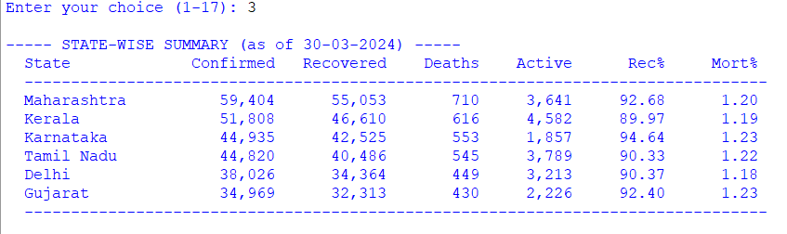Observation:
- The state with the highest total confirmed cases was __________________.
- The state with the highest mortality rate was __________________.
- The state with the highest recovery rate was __________________.
- The state with the lowest confirmed cases was __________________.

10.4 National Daily Cases Table (Option 4)
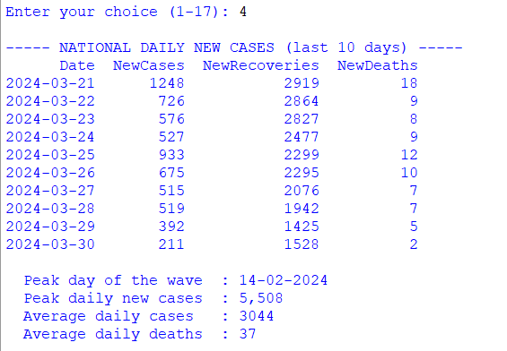Observation:
- The peak day of the wave was __________________ with ______ new cases nationally.
- The average daily cases over the 90-day period was ______, while the average daily deaths was ______.
- Conclusion: The wave rose gradually, peaked around day 60, and then declined — a pattern typical of many real COVID-19 waves.

10.5 Top States (Option 5)
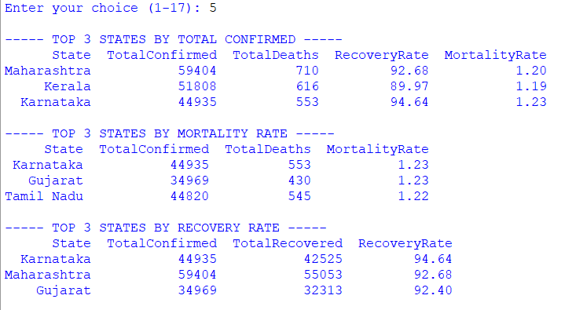Observation:
- Top 3 by total confirmed cases: ______, ______, ______
- Top 3 by mortality rate: ______, ______, ______
- Top 3 by recovery rate: ______, ______, ______
- Note: The state with the most confirmed cases is not necessarily the state with the highest mortality rate — these two metrics measure different things. The mortality rate reflects the quality of healthcare, while the total cases reflect the size of the outbreak.

10.6 National Daily New Cases — Line Chart (Option 6)
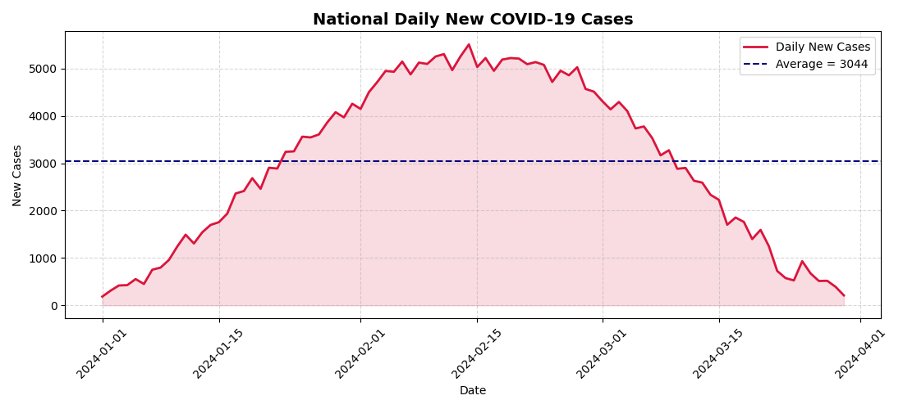Observation:
- The chart shows a clear bell-shaped wave — cases rose from January, peaked in late February/early March, and declined steadily.
- The shaded pink area highlights the volume of cases each day.
- The dashed navy line marks the average daily cases; the peak was well above this line.
- Conclusion: This wave pattern is exactly what health authorities look for when planning hospital capacity — the peak must not exceed the number of available beds.

10.7 National Active Cases Trend — Line Chart (Option 7)
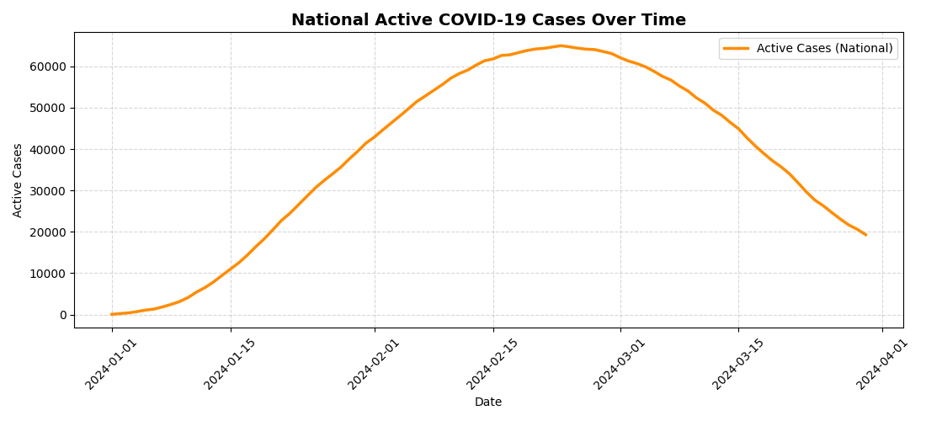Observation:
- The active-case curve lags behind the new-case curve by roughly 12 days because it depends on how quickly patients recover.
- The peak of the active curve is flatter than the peak of the new-case curve — because as long as recoveries keep up with new infections, the number of active patients does not explode.
- Conclusion: A flattened active-case curve is the single most important sign that a healthcare system is not being overwhelmed.

10.8 Cumulative Confirmed vs Recovered vs Deaths (Option 8)
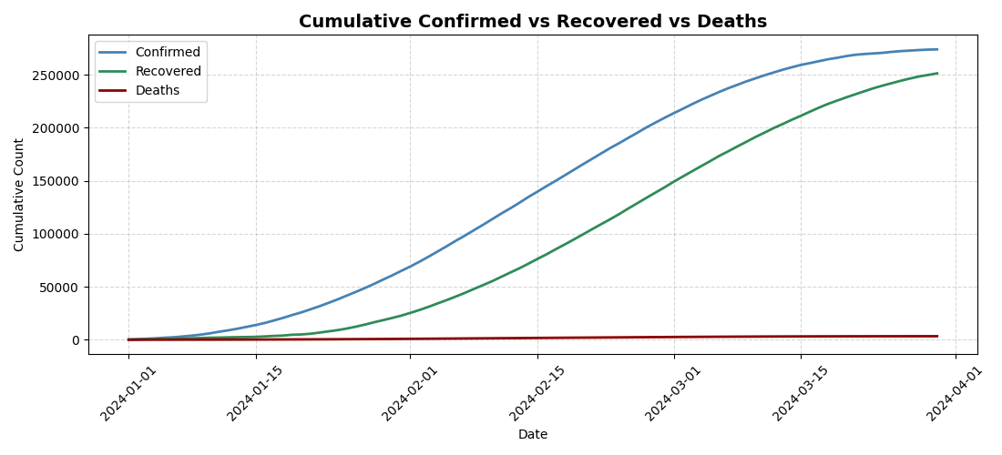Observation:
- All three curves rise continuously but at very different rates.
- The Confirmed line (blue) is the topmost, followed by Recovered (green), and Deaths (dark red) is barely visible at the bottom.
- Conclusion: The huge gap between the Confirmed and Deaths curves visually shows that most infected people recovered — this is the same information as the very low mortality rate in the summary table.

10.9 State-wise Total Confirmed Cases — Bar Chart (Option 9)
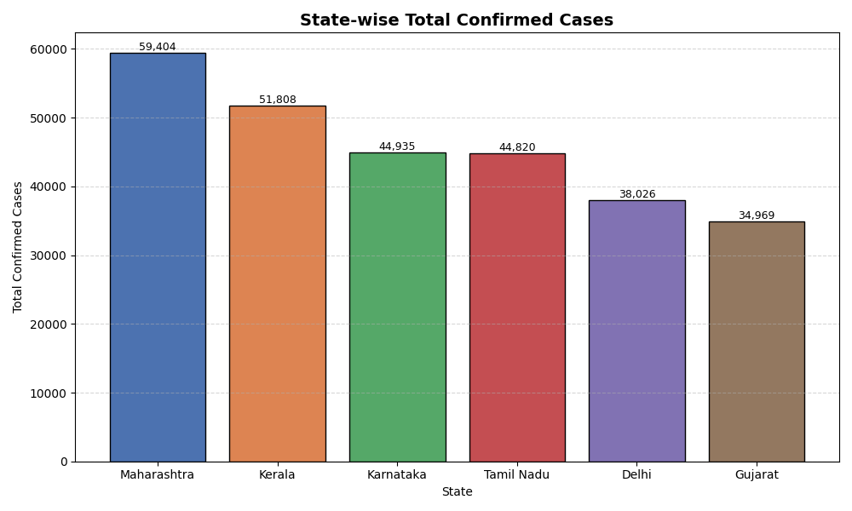Observation:
- Each bar is coloured differently for visual clarity.
- The tallest bar belongs to __________________, showing it is the worst-hit state.
- Conclusion: The state-wise distribution is not uniform — a few states account for a disproportionately large share of cases.

10.10 State-wise Recovery Rate — Horizontal Bar Chart (Option 10)
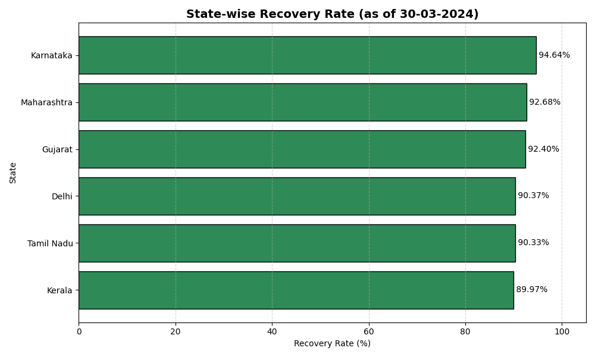Observation:
- The x-axis was set from 0 to 105% so the bars do not touch the right edge.
- The highest recovery-rate bar belongs to __________________ at ______ %.
- The lowest recovery-rate bar belongs to __________________ at ______ %.
- Conclusion: Every state achieved a recovery rate above ______ %, showing that the treatment protocols were broadly effective across the country.

10.11 Share of Cases by State — Pie Chart (Option 11)
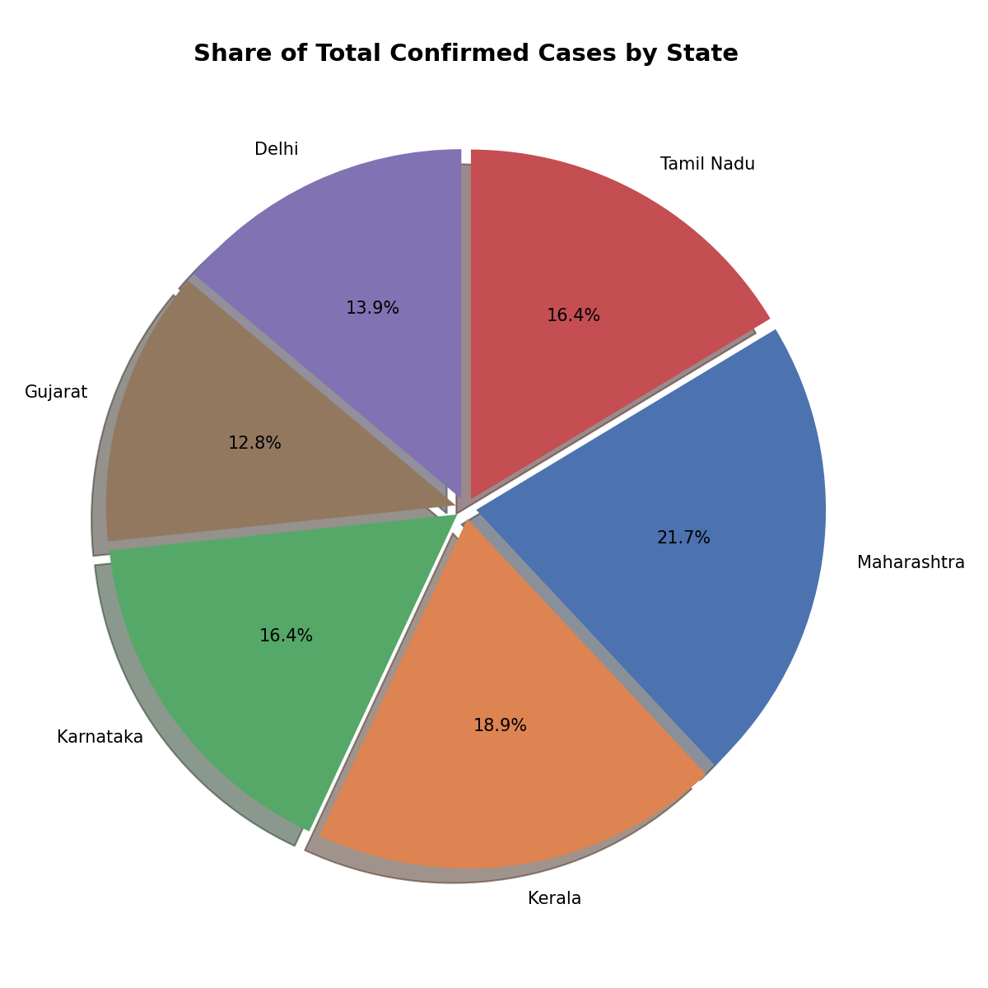Observation:
- The largest slice belongs to __________________, contributing approximately ______ % of the national total.
- The smallest slice belongs to __________________, contributing only ______ %.
- Conclusion: Cases are not distributed evenly — a handful of states bear the majority of the burden, which is important for allocating medical resources.

10.12 Distribution of Daily New Cases — Histogram (Option 12)
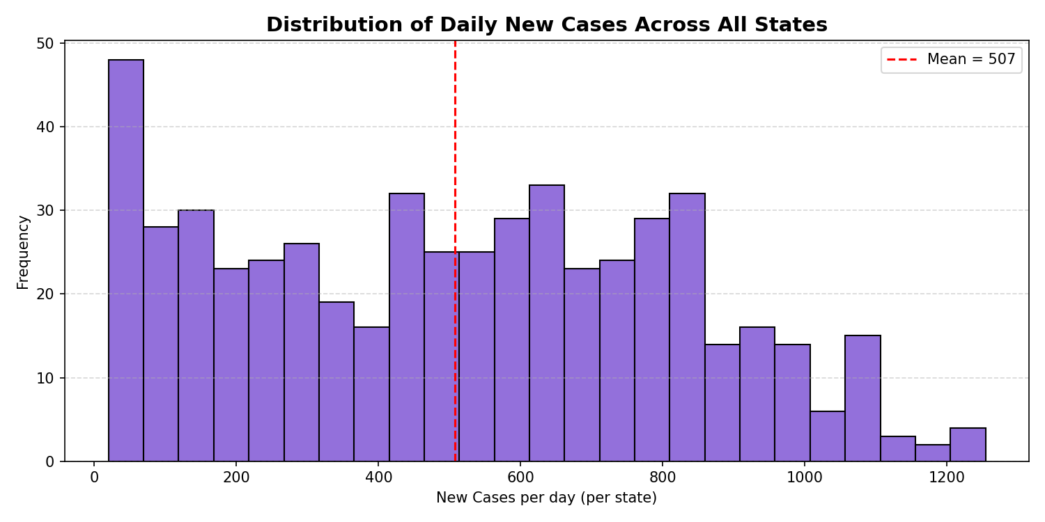Observation:
- Most days recorded between ______ and ______ new cases per state.
- The red dashed line marks the mean, which is approximately ______.
- Conclusion: The distribution is right-skewed — a small number of days had extremely high case counts (the peak of the wave), while most days had moderate numbers.

10.13 Confirmed vs Deaths — Scatter Plot (Option 13)
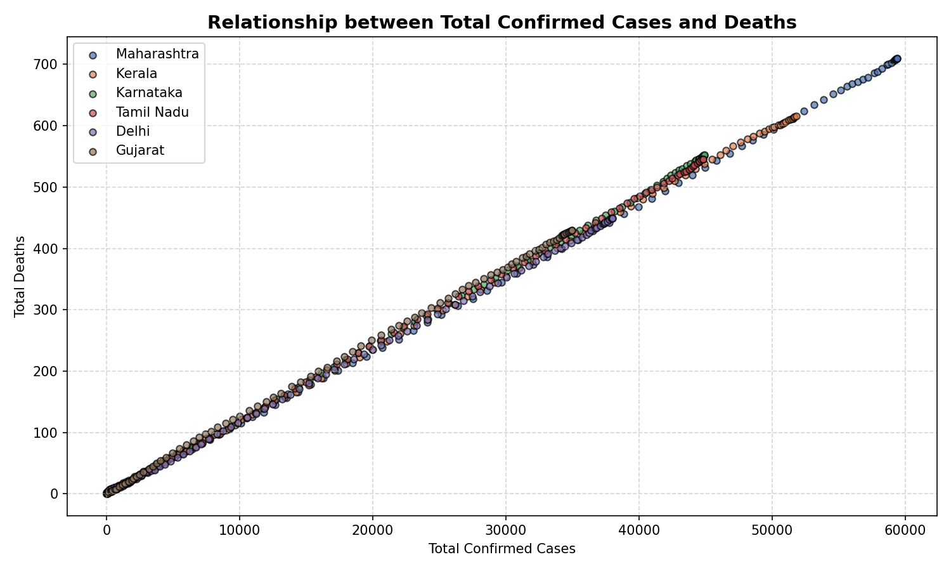Observation:
- Each colour represents a state; each dot is one day's record.
- There is a clear positive correlation — as total confirmed cases increase, total deaths also increase.
- However, the slopes are different for different states — some states have more deaths at the same number of cases, indicating a higher mortality rate.
- Conclusion: A scatter plot like this is used by epidemiologists to compare healthcare performance between regions.

10.14 Composition of Total Cases — Stacked Area Chart (Option 14)
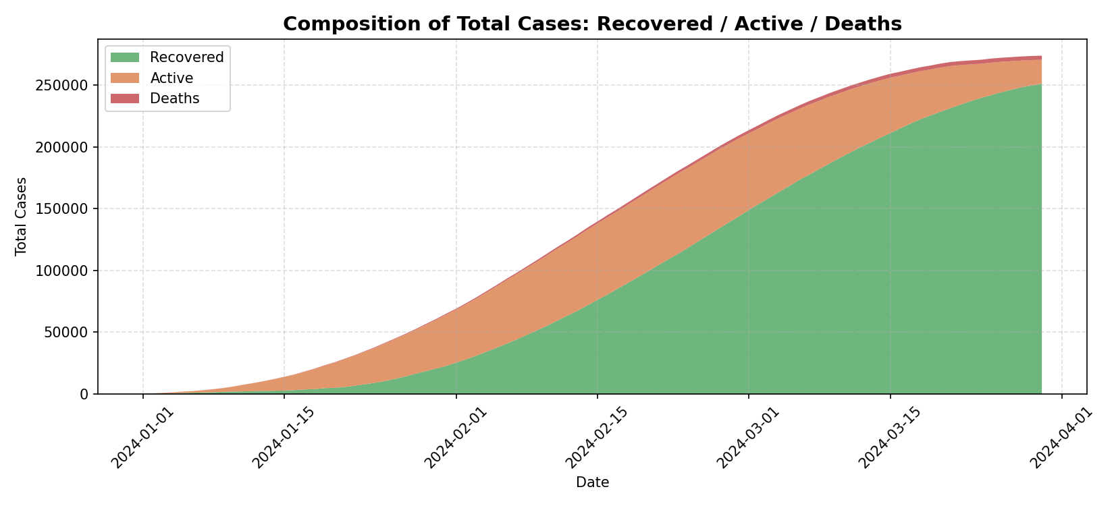Observation:
- The green band (Recovered) is by far the largest, and it grows steadily across all 90 days.
- The orange band (Active) grows, reaches a peak around day 60, then narrows as recoveries catch up.
- The red band (Deaths) is a very thin sliver at the bottom.
- Conclusion: This stacked view is the best single chart to understand the state of the pandemic — it shows simultaneously how many people are recovered, active and deceased at every point in time.

10.15 State-wise Cumulative Trend — Multi-line Chart (Option 15)
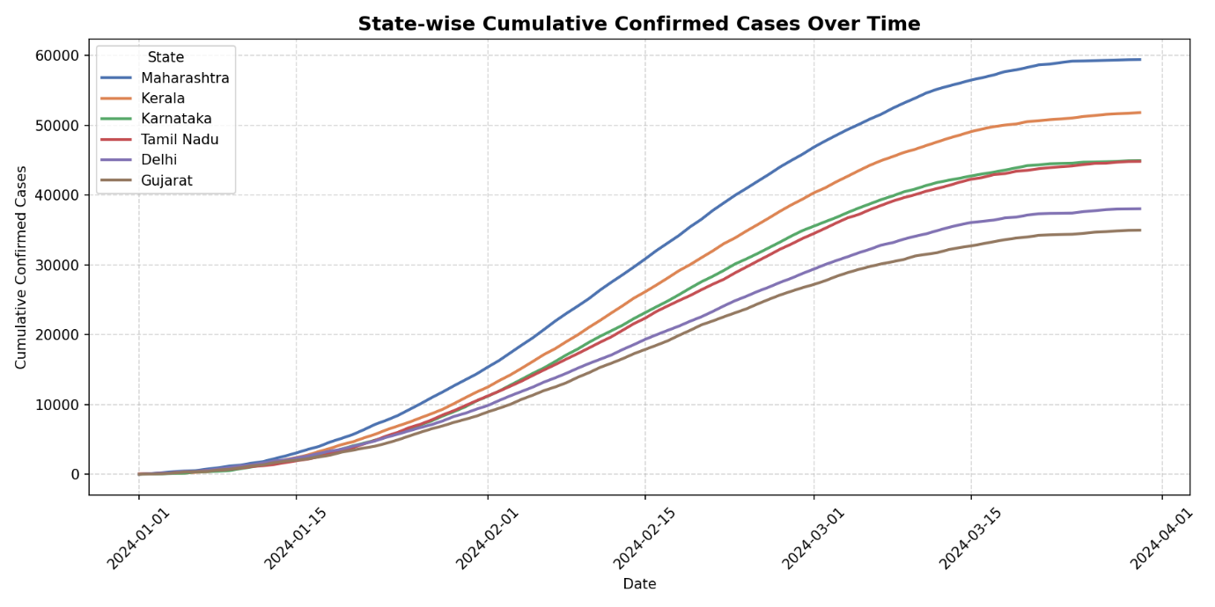Observation:
- Six coloured lines show the cumulative confirmed cases of each state.
- The highest line throughout the period belongs to __________________.
- All lines have the same S-shape (sigmoid) — slow start, steep middle, flattened end — typical of cumulative-case curves.
- Conclusion: Comparing the slopes during the steep phase tells us which states were spreading fastest at the peak of the wave.

10.16 Dashboard (Option 16)
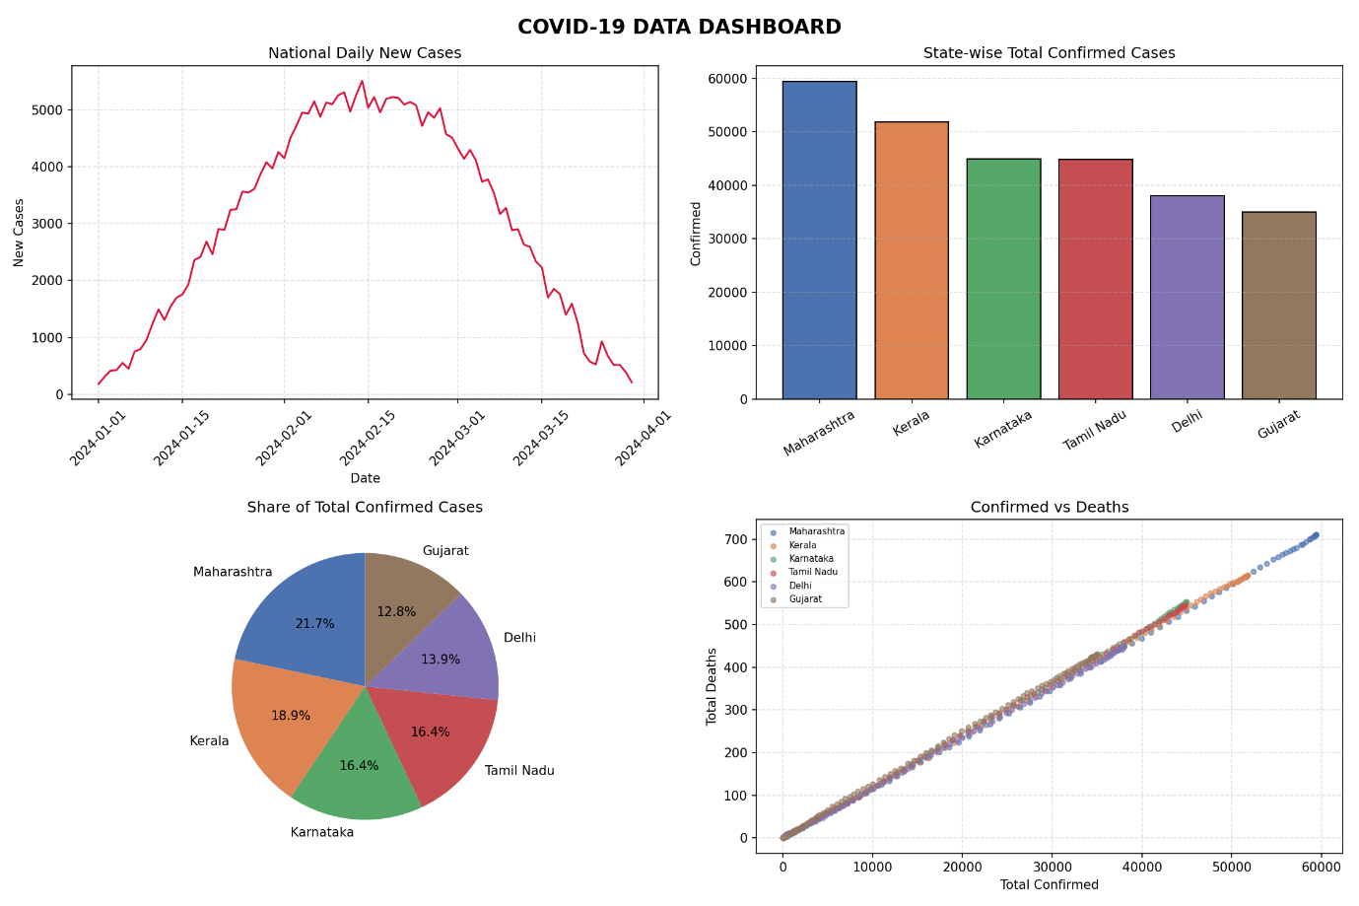Observation:
- The dashboard combined four key charts — daily new cases, state-wise bar, share pie, and confirmed-vs-deaths scatter — into one window.
- This is exactly the format used by health ministries and news organisations to present the state of the pandemic at a glance.

11. CONCLUSION AND FUTURE SCOPE
Conclusion
In this project I successfully analysed a simulated COVID-19 dataset using Pandas and visualised the results using Matplotlib. The project covered the complete data-handling cycle:
- Creating a dataset that simulates a realistic wave of infections.
- Reading the CSV file into a DataFrame.
- Adding derived columns — Active, RecoveryRate, MortalityRate — using arithmetic on existing columns.
- Summarising data using groupby(), sum(), mean() and sort_values().
- Filtering records and finding the peak day with idxmax().
- Visualising the data through line charts, bar charts, a pie chart, a histogram, a scatter plot and a stacked area chart.
- Interpreting each graph to draw meaningful epidemiological conclusions.
The project proved that visualisation makes data far easier to understand than plain numbers. For example, the low mortality rate is a single number in a table, but the huge gap between the Confirmed curve and the Deaths curve in the line chart makes the same fact instantly understandable to any audience.
A key epidemiological insight gained from this project is that active cases lag behind new cases by about the average recovery period. This is why health authorities watch the active-case curve — and not just the daily new-case curve — when deciding whether hospitals are at risk of being overwhelmed.
Future Scope
- Real data: The dataset could be replaced with real data downloaded from covid19india.org, WHO or Johns Hopkins University — the code would work unchanged.
- State comparison over time: An animated chart could show how each state's position changed day by day.
- Doubling Time: Compute the epidemiological doubling time of cases using a rolling average.
- Vaccination Data: Extend the dataset with vaccination numbers and compare vaccination coverage with case reduction.
- Seaborn: Use seaborn for more polished statistical visualisations.
- Interactive Dashboard: Use Plotly or Streamlit for an interactive web dashboard.
- Predictive Modelling: Apply linear regression or ARIMA to predict the next 15 days of cases.
- GUI: Add a Tkinter front-end so a non-technical user can select which chart to view.

12. TROUBLESHOOTING / COMMON ERRORS
Error Message | Reason | Solution
ModuleNotFoundError: No module named 'pandas' | Pandas is not installed | Run pip install pandas
ModuleNotFoundError: No module named 'matplotlib' | Matplotlib is not installed | Run pip install matplotlib
FileNotFoundError: covid_data.csv | The CSV file was deleted or moved | Delete nothing; run the program again — it recreates the file automatically
KeyError: 'Active' | Column name typed incorrectly | Python is case-sensitive — use exact column names
ValueError: could not convert string to float | Non-numeric data in a numeric column | Open the CSV in Excel and verify the data
Graph window opens and closes too fast | Program ended before displaying | Keep plt.show() at the end of each plotting function
x-axis date labels overlap | Too many dates | Use plt.xticks(rotation=45) (already done) and plt.tight_layout()
FutureWarning about observed | Pandas version difference | Not applicable here — this project does not use categorical grouping
Charts are not saved as PNG | Wrong path or no write permission | The code saves PNGs in the same folder as the script — run the script from its own folder
Note for Jupyter Notebook users: Add the line %matplotlib inline at the top of the notebook so the charts appear inside the notebook itself.

13. BIBLIOGRAPHY
- Websites:
  - Pandas Official Documentation (pandas.pydata.org)
  - Matplotlib Official Documentation (matplotlib.org)
  - World Health Organization COVID-19 Dashboard (covid19.who.int)
  - W3Schools (www.w3schools.com)
  - GeeksforGeeks (www.geeksforgeeks.org)
  - Stack Overflow (www.stackoverflow.com)
- Study Material:
  - NCERT Informatics Practices Textbook for Class XII
  - Sumita Arora, Informatics Practices with Python, Dhanpat Rai & Co.
- Reference:
  - Python 3 Official Documentation (docs.python.org)

