PROJECT FILE
INFORMATICS PRACTICES (CLASS XII)
SESSION: [Year, e.g., 2023-2024]

BANK ACCOUNT MANAGEMENT SYSTEM
Submitted By:
[Your Name]
Class: XII – [Section]
Roll No: [Your Roll Number]
Submitted To:
[Teacher's Name]
Department of Computer Science
[Your School Name]

CERTIFICATE
This is to certify that [Your Name] of Class XII has successfully completed the Informatics Practices project titled "Bank Account Management System" under the guidance of [Teacher's Name] during the academic year [Year].
This project is a bonafide record of work done by the candidate independently and fulfills the requirements of the Central Board of Secondary Education (CBSE) for the AISSCE Examination.
Teacher In-Charge: __________________
Signature: __________________
External Examiner: __________________
Signature: __________________
School Seal:

ACKNOWLEDGEMENT
I would like to express my special thanks of gratitude to my Informatics Practices teacher [Teacher's Name] as well as our principal [Principal's Name] for giving me the golden opportunity to do this wonderful project on the topic "Bank Account Management System".
I came to know about so many new things regarding Python and SQL connectivity while making this project. Secondly, I would also like to thank my parents and friends who helped me a lot in finalizing this project within the limited time frame.
Name: [Your Name]
Class: XII

TABLE OF CONTENTS
- Introduction
- Objectives of the Project
- Proposed System
- System Requirements (Hardware & Software)
- System Design (Table Structure)
- Python Libraries Used
- Source Code
- Output Screens
- Conclusion
- Troubleshooting Database Connection
- Bibliography

1. INTRODUCTION
The Bank Account Management System is a software application designed to automate the basic operations of a bank, such as opening accounts, depositing money, withdrawing money, checking balances, and closing accounts. Manual banking processes are slow, error-prone, and difficult to manage. This project digitizes these operations, making them faster, more secure, and accessible.
This system acts as an interface between the bank staff and the customers. It allows a bank employee (admin) to create new accounts, update customer details, perform transactions, and view account information. The backend data is stored in a MySQL database, and the frontend logic is written in Python. A significant feature is that the database and its tables are created automatically when the program runs for the first time, eliminating the need for manual SQL setup.

2. OBJECTIVES
The primary objectives of this project are:
- To automate core banking operations like account creation, deposit, withdrawal, and balance enquiry.
- To provide a user-friendly interface for managing customer accounts.
- To maintain a centralized database of all accounts and transactions.
- To ensure data integrity and prevent unauthorized access.
- To implement CRUD (Create, Read, Update, Delete) operations using Python and MySQL.
- To automatically initialize the database schema using IF NOT EXISTS.

3. PROPOSED SYSTEM
The proposed system consists of two main modules:
- Admin/Bank Staff Module:
  - Login to the system using a password.
  - Create a new bank account.
  - Close an existing account.
  - Deposit money into an account.
  - Withdraw money from an account.
  - Check account balance.
  - View all account holders.
- Database Module (MySQL):
  - On first run, the script automatically creates the database BankDB if it does not exist.
  - It then creates two tables: Accounts and Transactions (using CREATE TABLE IF NOT EXISTS).
  - Accounts stores customer information (Account Number, Name, Phone, Balance).
  - Transactions logs every deposit/withdrawal (Transaction ID, Account Number, Type, Amount, Date).

4. SYSTEM REQUIREMENTS
Hardware Requirements:
- Processor: Intel Core i3 or above
- RAM: 4 GB or above
- Hard Disk: 100 GB or above
Software Requirements:
- Operating System: Windows 7/8/10/11 or Linux
- Python 3.x (IDLE or any IDE like PyCharm)
- MySQL Server 5.7 or above (or XAMPP’s MariaDB)
- Python-MySQL Connector Module (mysql.connector)

5. SYSTEM DESIGN (Table Structure)
The system uses a database named BankDB.
The database and tables are created automatically by the Python script on first execution.
The schema is as follows:
Table 1: Accounts
Column Name | Data Type | Constraint | Description
AccNo | INT | PRIMARY KEY | Unique account number
Name | VARCHAR(100) | NOT NULL | Customer’s full name
Phone | VARCHAR(15) | NULL | Contact number
Balance | DECIMAL(12,2) | DEFAULT 0.00 | Current account balance
Table 2: Transactions
Column Name | Data Type | Constraint | Description
TxnID | INT | AUTO_INCREMENT PRIMARY KEY | Unique transaction ID
AccNo | INT | FOREIGN KEY | References Accounts table
Type | VARCHAR(10) | NOT NULL | 'Deposit' or 'Withdrawal'
Amount | DECIMAL(12,2) | NOT NULL | Transaction amount
TxnDate | DATE | NULL | Date of transaction
Note: The script uses CREATE DATABASE IF NOT EXISTS BankDB; and CREATE TABLE IF NOT EXISTS statements to ensure the schema is ready without manual intervention.

6. PYTHON LIBRARIES USED
- mysql.connector: Main library for connecting Python to MySQL and executing SQL queries.
- datetime: Built-in library to fetch the current date automatically for transactions.
- random (optional): Could be used to generate account numbers, but in this project account numbers are entered manually.

7. SOURCE CODE
Below is the complete Python code for the Bank Account Management System.
It includes automatic database and table creation, so no prior setup is needed in MySQL.
python
# Bank Account Management System
# Class 12 Informatics Practices Project
# Auto-creates database and tables using IF NOT EXISTS

import mysql.connector
import datetime

# ------------------------- CONFIGURATION (EDIT THESE) -------------------------
DB_HOST = "localhost"
DB_USER = "root" # <-- Change to your MySQL username
DB_PASSWORD = "" # <-- Change to your MySQL password (empty for XAMPP default)
DB_NAME = "BankDB"

# ------------------------- DATABASE CONNECTION & INITIALISATION -------------------------

def initialize_database():
"""Create database and tables if they do not exist."""
try:
# Connect without specifying a database
con = mysql.connector.connect(
host=DB_HOST,
user=DB_USER,
password=DB_PASSWORD
)
cur = con.cursor()
# Create database if not exists
cur.execute(f"CREATE DATABASE IF NOT EXISTS {DB_NAME}")
cur.execute(f"USE {DB_NAME}")
# Create Accounts table if not exists
cur.execute("""
CREATE TABLE IF NOT EXISTS Accounts (
AccNo INT PRIMARY KEY,
Name VARCHAR(100) NOT NULL,
Phone VARCHAR(15),
Balance DECIMAL(12,2) DEFAULT 0.00
)
""")
# Create Transactions table if not exists
cur.execute("""
CREATE TABLE IF NOT EXISTS Transactions (
TxnID INT AUTO_INCREMENT PRIMARY KEY,
AccNo INT,
Type VARCHAR(10) NOT NULL,
Amount DECIMAL(12,2) NOT NULL,
TxnDate DATE,
FOREIGN KEY (AccNo) REFERENCES Accounts(AccNo)
)
""")
con.commit()
print("Database and tables initialised successfully.")
cur.close()
con.close()
except mysql.connector.Error as err:
print(f"Database Initialisation Error: {err}")
print("Please check your MySQL username and password in the CONFIGURATION section.")
exit(1) # Stop execution if DB cannot be initialised

def connect_db():
"""Connect to the BankDB database."""
try:
con = mysql.connector.connect(
host=DB_HOST,
user=DB_USER,
password=DB_PASSWORD,
database=DB_NAME
)
return con
except mysql.connector.Error as err:
print(f"Database Connection Error: {err}")
print("Check credentials or ensure MySQL is running.")
return None

# ------------------------- FUNCTIONS (MENU OPTIONS) -------------------------

def create_account():
con = connect_db()
if con:
cur = con.cursor()
acc_no = int(input("Enter Account Number: "))
name = input("Enter Customer Name: ")
phone = input("Enter Phone Number: ")
balance = float(input("Enter Opening Balance: "))

query = "INSERT INTO Accounts (AccNo, Name, Phone, Balance) VALUES (%s, %s, %s, %s)"
values = (acc_no, name, phone, balance)

try:
cur.execute(query, values)
con.commit()
print("Account created successfully!")
except mysql.connector.Error as err:
print(f"Error: {err}")
finally:
cur.close()
con.close()

def close_account():
con = connect_db()
if con:
cur = con.cursor()
acc_no = int(input("Enter Account Number to close: "))

# Check if account exists
cur.execute("SELECT * FROM Accounts WHERE AccNo = %s", (acc_no,))
if cur.fetchone() is None:
print("Account does not exist.")
cur.close()
con.close()
return

# Delete from Accounts and related Transactions
try:
cur.execute("DELETE FROM Transactions WHERE AccNo = %s", (acc_no,))
cur.execute("DELETE FROM Accounts WHERE AccNo = %s", (acc_no,))
con.commit()
print("Account closed successfully.")
except mysql.connector.Error as err:
print(f"Error: {err}")
finally:
cur.close()
con.close()

def deposit():
con = connect_db()
if con:
cur = con.cursor()
acc_no = int(input("Enter Account Number: "))
amount = float(input("Enter Amount to Deposit: "))
today = datetime.date.today()

# Update balance
query_update = "UPDATE Accounts SET Balance = Balance + %s WHERE AccNo = %s"
cur.execute(query_update, (amount, acc_no))
if cur.rowcount == 0:
print("Account not found.")
else:
# Log transaction
query_txn = "INSERT INTO Transactions (AccNo, Type, Amount, TxnDate) VALUES (%s, 'Deposit', %s, %s)"
cur.execute(query_txn, (acc_no, amount, today))
con.commit()
print(f"Deposited ₹{amount:.2f} successfully.")

cur.close()
con.close()

def withdraw():
con = connect_db()
if con:
cur = con.cursor()
acc_no = int(input("Enter Account Number: "))
amount = float(input("Enter Amount to Withdraw: "))
today = datetime.date.today()

# Check balance
cur.execute("SELECT Balance FROM Accounts WHERE AccNo = %s", (acc_no,))
result = cur.fetchone()
if result is None:
print("Account not found.")
cur.close()
con.close()
return

current_balance = result[0]
if amount > current_balance:
print("Insufficient balance.")
else:
query_update = "UPDATE Accounts SET Balance = Balance - %s WHERE AccNo = %s"
cur.execute(query_update, (amount, acc_no))
query_txn = "INSERT INTO Transactions (AccNo, Type, Amount, TxnDate) VALUES (%s, 'Withdrawal', %s, %s)"
cur.execute(query_txn, (acc_no, amount, today))
con.commit()
print(f"Withdrawn ₹{amount:.2f} successfully.")

cur.close()
con.close()

def check_balance():
con = connect_db()
if con:
cur = con.cursor()
acc_no = int(input("Enter Account Number: "))
cur.execute("SELECT Name, Balance FROM Accounts WHERE AccNo = %s", (acc_no,))
result = cur.fetchone()
if result:
print(f"Account Holder: {result[0]}")
print(f"Current Balance: ₹{result[1]:.2f}")
else:
print("Account not found.")
cur.close()
con.close()

def view_all_accounts():
con = connect_db()
if con:
cur = con.cursor()
cur.execute("SELECT * FROM Accounts ORDER BY AccNo")
rows = cur.fetchall()

if rows:
print(f"{'AccNo':<10} {'Name':<25} {'Phone':<15} {'Balance':<15}")
print("-" * 65)
for row in rows:
print(f"{row[0]:<10} {row[1]:<25} {row[2]:<15} ₹{row[3]:<14.2f}")
else:
print("No accounts found.")
cur.close()
con.close()

# ------------------------- MAIN PROGRAM LOOP -------------------------

def main():
# Initialise database and tables automatically
initialize_database()

# Admin Login (Simple Password Protection)
password = input("Enter Admin Password: ")
if password != "bank123": # Change password if needed
print("Wrong Password. Exiting...")
return

while True:
print("\n" + "="*40)
print(" BANK ACCOUNT MANAGEMENT SYSTEM")
print("="*40)
print("1. Create Account")
print("2. Close Account")
print("3. Deposit Money")
print("4. Withdraw Money")
print("5. Check Balance")
print("6. View All Accounts")
print("7. Exit")
print("="*40)

choice = input("Enter your choice: ")

if choice == '1':
create_account()
elif choice == '2':
close_account()
elif choice == '3':
deposit()
elif choice == '4':
withdraw()
elif choice == '5':
check_balance()
elif choice == '6':
view_all_accounts()
elif choice == '7':
print("Thank you for using BAMS. Goodbye!")
break
else:
print("Invalid choice. Please try again.")

if __name__ == "__main__":
main()

8. OUTPUT SCREENS
Figure 1: Database Initialisation
Description: The terminal window showing "Database and tables initialised successfully." on first run. This demonstrates the automatic creation of BankDB and the Accounts and Transactions tables.
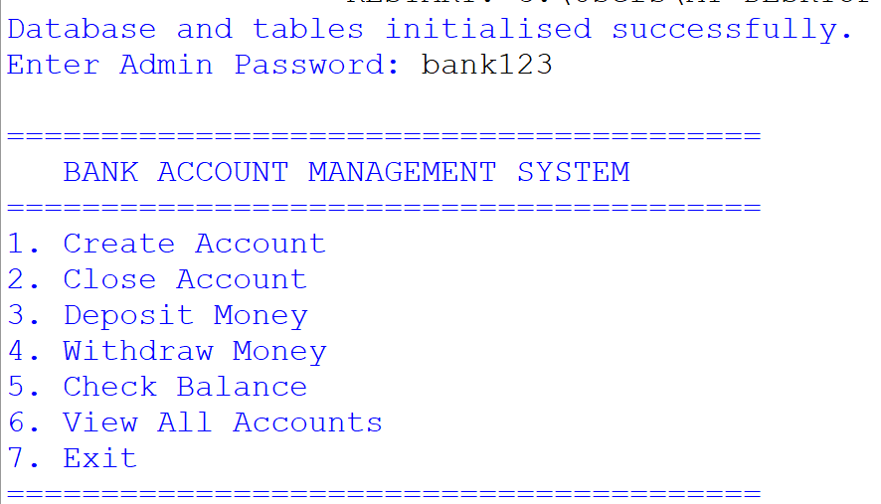

Figure 2: Main Menu
Description: The terminal window showing the password prompt and the main menu with options (Create Account, Close Account, Deposit, etc.).
Figure 3: Creating a New Account
Description: User selects option 1, enters account details (Account Number, Name, Phone, Opening Balance), and the system confirms "Account created successfully!".
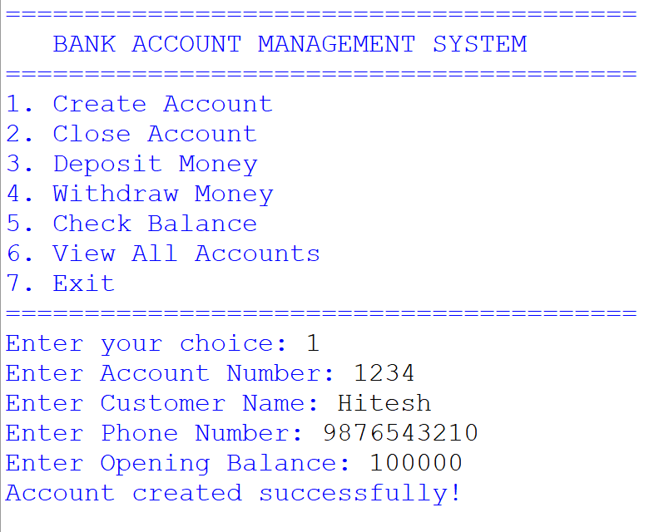
Figure 4: Depositing Money
Description: User selects option 3, enters an account number and amount; the system confirms the deposit and updates the balance.
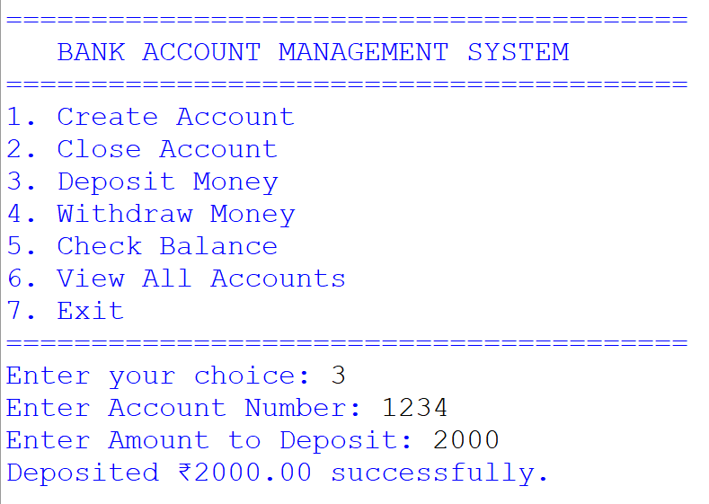
Figure 5: Checking Balance
Description: User selects option 5, enters an account number, and the system displays the account holder’s name and current balance.
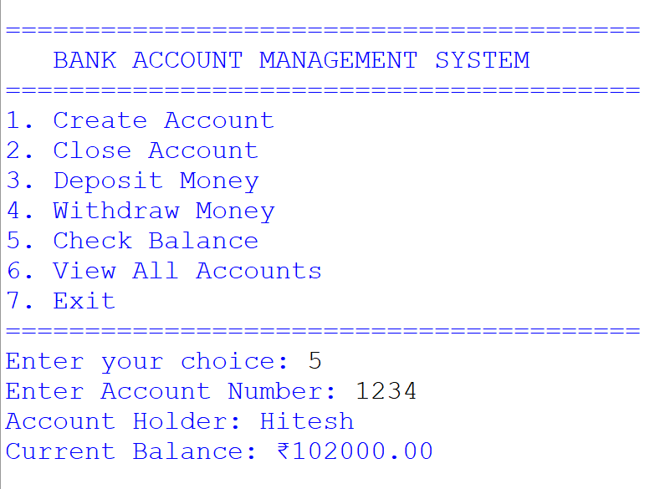
Figure 6: Viewing All Accounts
Description: User selects option 6, and a formatted table lists all accounts with their balances.
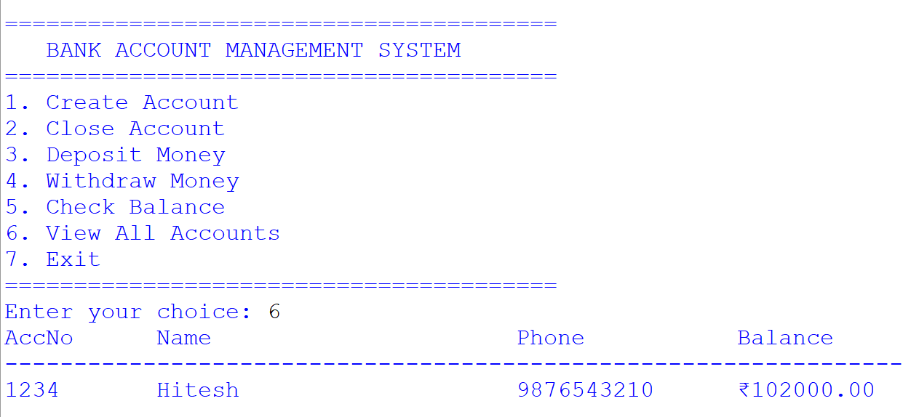

9. CONCLUSION
Through this project, I successfully developed a fully functional Bank Account Management System using Python and MySQL. The project taught me how to integrate a high-level programming language (Python) with a Relational Database Management System (MySQL) using the mysql.connector library.
The system significantly reduces the workload of bank staff by automating account operations. It ensures that data is managed centrally and accurately. While developing this project, I learned important concepts like CRUD operations, SQL queries (INSERT, SELECT, UPDATE, DELETE), and handling Python-MySQL connectivity errors.
A key achievement is the automatic database initialisation feature. The script uses CREATE DATABASE IF NOT EXISTS and CREATE TABLE IF NOT EXISTS to ensure that the required schema is always present, without any manual SQL commands. This makes the project user-friendly and portable.
Future Scope:
- A Graphical User Interface (GUI) can be added using Tkinter or PyQt.
- A separate Customer Login module could allow customers to view their own transactions.
- Interest calculation for savings accounts can be implemented.

11. BIBLIOGRAPHY
- Websites:
  - Stack Overflow (www.stackoverflow.com)
  - GeeksforGeeks (www.geeksforgeeks.org)
  - W3Schools (www.w3schools.com)
- Study Material:
  - NCERT Informatics Practices Textbook for Class XII
  - Sumita Arora Informatics Practices (Python) Textbook
- Reference Manual:
  - MySQL Official Documentation (dev.mysql.com)

