PROJECT FILE
INFORMATICS PRACTICES (CLASS XII)
SESSION: [Year, e.g., 2023-2024]

AIRLINE RESERVATION SYSTEM
(Flight Schedules, Ticket Pricing, Passenger Manifests and E-Ticket Generation)
Submitted By:
[Your Name]
Class: XII – [Section]
Roll No: [Your Roll Number]
Submitted To:
[Teacher's Name]
Department of Computer Science
[Your School Name]

CERTIFICATE
This is to certify that [Your Name] of Class XII has successfully completed the Informatics Practices project titled "Airline Reservation System" under the guidance of [Teacher's Name] during the academic year [Year].
This project is a bonafide record of work done by the candidate independently and fulfills the requirements of the Central Board of Secondary Education (CBSE) for the AISSCE Examination.
Teacher In-Charge: __________________
Signature: __________________
External Examiner: __________________
Signature: __________________
School Seal:

ACKNOWLEDGEMENT
I would like to express my sincere thanks to my Informatics Practices teacher [Teacher's Name] and our Principal [Principal's Name] for giving me the opportunity to work on this project titled "Airline Reservation System".
While working on this project I learnt how a real airline reservation system like IndiGo, Air India or Vistara manages flight schedules, class-wise fares, PNR generation, seat allotment and passenger manifests. I learnt how to design a relational database with primary keys, composite primary keys and foreign keys, how to compute airfare dynamically with class multipliers and GST, how to implement refund rules using date arithmetic, and how to generate complex business reports using SQL joins, aggregate functions and GROUP BY. I would also like to thank my parents and friends who supported and encouraged me throughout the completion of this project.
Name: [Your Name]
Class: XII

TABLE OF CONTENTS
- Introduction
- Objectives of the Project
- Proposed System
- System Requirements (Hardware & Software)
- System Design (Table Structures)
- Business Rules Used
- Python Libraries Used
- Functions Used (Quick Reference)
- Source Code
- Output Screens and Observations
- Conclusion and Future Scope
- Troubleshooting
- Bibliography

1. INTRODUCTION
An airline operates dozens of flights every day between multiple cities. For each flight, it offers multiple travel classes — Economy, Premium Economy and Business — with different seat counts and different fares. When a passenger books a ticket, the airline must reserve a seat for them on a specific flight, on a specific date, in a specific class, generate a unique PNR (Passenger Name Record), print an e-ticket, and later handle cancellations with refund rules. All of this is impossible to manage on paper.
The Airline Reservation System is a software application that automates the entire process. It is a menu-driven Python program backed by a MySQL relational database. It allows the airline's reservation desk to:
- Maintain a flight schedule with airline name, source, destination, departure and arrival times, duration and aircraft type.
- Maintain class-wise fares for every flight with total seat capacity in each class.
- Check seat availability for any flight, class and journey date — computed live by counting confirmed passengers.
- Book tickets for up to 6 passengers in a single PNR with automatic seat allotment.
- Generate a unique 6-character alphanumeric PNR (like real airline PNRs such as K3J9XZ).
- Print an Electronic Ticket with full passenger manifest.
- Search bookings by PNR or by passenger name.
- Cancel tickets with automatic refund calculation based on the standard airline refund rules.
- Generate revenue reports grouped by class, by flight and by route.
The database stores all data permanently, so bookings survive even after the program is closed and reopened.
2. OBJECTIVES
The main objectives of this project are:
- To understand how Python and MySQL are connected using the mysql.connector library.
- To design a relational database with four linked tables (Flights, Fares, Bookings, Passengers) using primary keys, a composite primary key and foreign keys.
- To generate a unique 6-character alphanumeric PNR at run-time using the random and string modules.
- To implement live seat availability by joining Passengers and Bookings — no BookedSeats column is stored, avoiding inconsistency.
- To allot individual seat numbers to passengers without any clash — using a seat-map generator and a Python set.
- To apply GST at different rates — 5% for Economy/Premium Economy and 12% for Business/First — matching real aviation tax rules.
- To implement the standard airline refund rules using datetime arithmetic:
  - More than 7 days before departure → 90% refund
  - 2 to 7 days before departure → 75% refund
  - 24 to 48 hours before departure → 50% refund
  - Less than 24 hours before departure → 25% refund
  - After departure → No refund
- To use SQL aggregate functions (COUNT, SUM, AVG) with JOIN and GROUP BY to generate advanced business reports.
3. PROPOSED SYSTEM
The system is a menu-driven program divided into four modules:
3.1 Flight Schedule Module
- View all flights with airline, route, timings, duration and aircraft.
- View class-wise fares and seat capacity for any flight.
- Search flights between a source and destination city.
- Add a new flight to the schedule (with its class-wise fares).
3.2 Availability Module
- Check class-wise seat availability for any flight and journey date.
- Displays TotalSeats, BookedSeats and AvailableSeats — calculated live.
- Validates the journey date (must be 1 to 120 days in advance).
3.3 Reservation Module
- Book a ticket for 1 to 6 passengers in a single PNR.
- Automatically generate a unique 6-character PNR.
- Automatically allot individual seat numbers without any clash.
- Print an Electronic Ticket with the full passenger manifest.
- View a ticket by PNR.
- Search passengers by name using LIKE.
- View all bookings.
3.4 Cancellation and Report Module
- Cancel a ticket by PNR.
- Compute the refund using the standard airline refund rules.
- Mark the ticket and all passengers as Cancelled, freeing the seats back to the pool.
- Generate a Revenue Report grouped by class and by flight.
4. SYSTEM REQUIREMENTS
Hardware Requirements:
- Processor: Intel Core i3 or above
- RAM: 4 GB or above
- Hard Disk: 100 GB or above
Software Requirements:
- Operating System: Windows 7/8/10/11 or Linux
- Python 3.x (IDLE / PyCharm)
- MySQL Server 5.7 or above (or XAMPP's MariaDB)
- Python-MySQL Connector (mysql-connector-python)
5. SYSTEM DESIGN (TABLE STRUCTURES)
The database is named AirlineDB. The database and tables are created automatically by the Python script on first execution.
Table 1: Flights
Column | Data Type | Constraint | Description
FlightNo | VARCHAR(10) | PRIMARY KEY | e.g. 6E201, AI101
Airline | VARCHAR(30) | NOT NULL | IndiGo, Air India, Vistara, …
Source | VARCHAR(40) | NOT NULL | Departure city
Destination | VARCHAR(40) | NOT NULL | Arrival city
DepartureTime | VARCHAR(10) | NULL | HH:MM format
ArrivalTime | VARCHAR(10) | NULL | HH:MM format
DurationMins | INT | NULL | Duration in minutes
Aircraft | VARCHAR(15) | NULL | e.g. A320, B737, B787
Table 2: Fares
Column | Data Type | Constraint | Description
FlightNo | VARCHAR(10) | COMPOSITE PK, FK → Flights | Flight number
ClassCode | VARCHAR(2) | COMPOSITE PK | Y / W / J / F
ClassName | VARCHAR(25) | NOT NULL | Economy, Premium Economy, Business, First
TotalSeats | INT | NOT NULL | Total seats in that class
BaseFare | DECIMAL(10,2) | NOT NULL | Base fare per passenger
Composite primary key (FlightNo, ClassCode) ensures a flight has exactly one fare row per class.
Table 3: Bookings
Column | Data Type | Constraint | Description
PNR | VARCHAR(6) | PRIMARY KEY | Unique 6-char PNR
FlightNo | VARCHAR(10) | FOREIGN KEY → Flights | Flight booked
ClassCode | VARCHAR(2) | NOT NULL | Class booked
JourneyDate | DATE | NOT NULL | Date of travel
BookingDate | DATE | NULL | Date of booking
PassengerCount | INT | NULL | Number of passengers
BaseAmount | DECIMAL(10,2) | NULL | Sum of base fares
Taxes | DECIMAL(10,2) | NULL | GST at class rate
TotalAmount | DECIMAL(10,2) | NULL | BaseAmount + Taxes
Status | VARCHAR(15) | DEFAULT 'Confirmed' | Confirmed / Cancelled
Table 4: Passengers
Column | Data Type | Constraint | Description
PassengerID | INT | AUTO_INCREMENT PRIMARY KEY | Unique passenger ID
PNR | VARCHAR(6) | FOREIGN KEY → Bookings | Parent booking
Name | VARCHAR(80) | NOT NULL | Passenger name
Age | INT | NULL | Age in years
Gender | VARCHAR(10) | NULL | M / F / O
SeatNo | VARCHAR(6) | NULL | e.g. 12A, 22F
Status | VARCHAR(15) | DEFAULT 'Confirmed' | Confirmed / Cancelled
Relationship Diagram:
text
Flights (1) ─── (many) Fares
Flights (1) ─── (many) Bookings
Bookings (1) ─── (many) Passengers
Default Data Inserted on First Run
- 10 default flights across major Indian and one international route, operated by 6 airlines.
- 30 class-fare rows (10 flights × 3 classes: Y, W, J). Each flight has Economy (150 seats), Premium Economy (24 seats) and Business (12 seats) — a realistic A320/B737 configuration.
6. BUSINESS RULES USED
6.1 Class Fare Multipliers
Code | Class Name | Seats | Multiplier on Base Fare | GST Rate
Y | Economy | 150 | 1.00 × | 5%
W | Premium Economy | 24 | 1.60 × | 5%
J | Business | 12 | 3.00 × | 12%
The BaseFare column stores the Economy class fare. Other classes are computed on the fly using the multiplier. This avoids duplicating data.
6.2 GST Rule
- 5% GST on Economy (Y) and Premium Economy (W).
- 12% GST on Business (J) and First (F) — matching the Indian aviation tax rule for premium cabins.
6.3 Seat Availability (Live Calculation)
text
AvailableSeats = TotalSeats − (Number of Confirmed Passengers in that flight+class+date)
Computed live with a SELECT COUNT(*) joined on Bookings and Passengers. No BookedSeats column is stored — avoiding stale data.
6.4 Seat Number Format
Seats are labelled with row number + column letter — 1A, 1B, …, 1F, 2A, … up to the number of rows needed to accommodate TotalSeats. The seat generator produces only as many seats as the class actually has.
6.5 Seat Allotment
text
UsedSeats = SELECT SeatNo FROM Passengers JOIN Bookings WHERE flight+class+date match
FreeSeats = AllSeats − UsedSeats (first N seats are allotted)
A Python set is used for the "used" seats so lookups are instant.
6.6 PNR Generation
PNR is 6 characters long:
- First character: an uppercase letter (A–Z).
- Remaining 5 characters: a mix of digits and uppercase letters.
The PNR is checked against the database in a loop until a unique one is found — guaranteeing primary-key uniqueness.
6.7 Refund Rules (based on time before departure)
Time before departure | Refund Percentage
More than 7 days | 90%
2 to 7 days | 75%
24 to 48 hours | 50%
Less than 24 hours | 25%
After departure | No refund
7. PYTHON LIBRARIES USED
- mysql.connector — connects Python to MySQL, executes SQL statements, fetches results and commits changes.
- datetime — records booking and journey dates, and calculates days remaining for the refund rule.
- random — used to generate the PNR.
- string — provides string.ascii_uppercase and string.digits for PNR generation.
8. FUNCTIONS USED (QUICK REFERENCE)
8.1 MySQL Connector Methods
Method | Purpose
mysql.connector.connect(...) | Opens a connection to MySQL
con.cursor() | Creates a cursor to execute SQL
cur.execute(sql, params) | Runs a single SQL statement
cur.executemany(sql, list) | Runs the same SQL for many rows
cur.fetchone() / cur.fetchall() | Fetches one / all result rows
cur.rowcount | Number of rows affected
cur.lastrowid | Auto-increment value of the last INSERT
con.commit() / con.rollback() | Save / undo changes
cur.close() / con.close() | Release resources
8.2 SQL Statements Used
Statement | Purpose in This Project
CREATE DATABASE IF NOT EXISTS | Auto-create the database
CREATE TABLE IF NOT EXISTS | Auto-create the four tables
INSERT INTO | Add flights, fares, bookings, passengers
SELECT ... WHERE / LIKE | Search by PNR, by city, by name
UPDATE ... SET | Mark bookings and passengers as cancelled
JOIN | Combine Bookings + Flights + Passengers
GROUP BY + SUM() / COUNT() / AVG() | Revenue by class, by flight, by route
IFNULL() | Replace NULL with 0 in reports
9. SOURCE CODE
Below is the complete Python code. It creates the database, tables and default data automatically, so no prior SQL setup is required.
python
# ==========================================================
# AIRLINE RESERVATION SYSTEM
# Class 12 Informatics Practices Project
# Tools Used: Python 3 + MySQL (mysql-connector-python)
# ==========================================================

import mysql.connector
import datetime
import random
import string

# ------------------------- CONFIGURATION (EDIT THESE) -------------------------
DB_HOST = "localhost"
DB_USER = "root" # <-- Change to your MySQL username
DB_PASSWORD = "" # <-- Change to your MySQL password (empty for XAMPP)
DB_NAME = "AirlineDB"

AIRLINE_NAME = "SKYLINE AIRWAYS"
ADMIN_PASSWORD = "air123"

MIN_ADVANCE_DAYS = 1
MAX_ADVANCE_DAYS = 120

CLASS_MULTIPLIER = {"Y": 1.00, "W": 1.60, "J": 3.00, "F": 5.00}
CLASS_SEATS = {"Y": 150, "W": 24, "J": 12, "F": 4}
CLASS_FULL = {"Y": "Economy", "W": "Premium Economy",
"J": "Business", "F": "First"}
CLASS_GST = {"Y": 0.05, "W": 0.05, "J": 0.12, "F": 0.12}

# 8 values per tuple, exactly 8 placeholders in the INSERT
DEFAULT_FLIGHTS = [
("6E201", "IndiGo", "Delhi", "Mumbai", "06:00", "08:10", 130, "A320"),
("6E305", "IndiGo", "Mumbai", "Bengaluru", "09:15", "11:20", 125, "A320"),
("AI101", "Air India", "Delhi", "Kolkata", "07:30", "09:45", 135, "B737"),
("UK945", "Vistara", "Delhi", "Hyderabad", "10:00", "12:20", 140, "A320"),
("SG815", "SpiceJet", "Mumbai", "Goa", "13:00", "14:20", 80, "B737"),
("QP1102", "Akasa Air", "Bengaluru", "Chennai", "15:30", "16:50", 80, "B737"),
("AI805", "Air India", "Kolkata", "Delhi", "18:00", "20:15", 135, "B787"),
("6E4501", "IndiGo", "Bengaluru", "Delhi", "20:30", "23:15", 165, "A321"),
("UK865", "Vistara", "Mumbai", "Delhi", "21:00", "23:10", 130, "A320"),
("IX118", "Air India Express", "Kochi", "Dubai", "22:45", "01:30", 165, "B737"),
]

# Economy class (Y) base fare for each flight
ECONOMY_BASE = {
"6E201": 4500.00,
"6E305": 4200.00,
"AI101": 4800.00,
"UK945": 5100.00,
"SG815": 3200.00,
"QP1102": 2800.00,
"AI805": 4800.00,
"6E4501": 5600.00,
"UK865": 4500.00,
"IX118": 9800.00,
}

# ==================== 1. DATABASE INITIALISATION ====================

def initialize_database():
"""Create database, tables and default data if they do not exist."""
try:
con = mysql.connector.connect(host=DB_HOST, user=DB_USER, password=DB_PASSWORD)
cur = con.cursor()
cur.execute("CREATE DATABASE IF NOT EXISTS " + DB_NAME)
cur.execute("USE " + DB_NAME)

cur.execute("""
CREATE TABLE IF NOT EXISTS Flights (
FlightNo VARCHAR(10) PRIMARY KEY,
Airline VARCHAR(30) NOT NULL,
Source VARCHAR(40) NOT NULL,
Destination VARCHAR(40) NOT NULL,
DepartureTime VARCHAR(10),
ArrivalTime VARCHAR(10),
DurationMins INT,
Aircraft VARCHAR(15)
)
""")

cur.execute("""
CREATE TABLE IF NOT EXISTS Fares (
FlightNo VARCHAR(10),
ClassCode VARCHAR(2),
ClassName VARCHAR(25) NOT NULL,
TotalSeats INT NOT NULL,
BaseFare DECIMAL(10,2) NOT NULL,
PRIMARY KEY (FlightNo, ClassCode),
FOREIGN KEY (FlightNo) REFERENCES Flights(FlightNo)
)
""")

cur.execute("""
CREATE TABLE IF NOT EXISTS Bookings (
PNR VARCHAR(6) PRIMARY KEY,
FlightNo VARCHAR(10),
ClassCode VARCHAR(2),
JourneyDate DATE NOT NULL,
BookingDate DATE,
PassengerCount INT,
BaseAmount DECIMAL(10,2),
Taxes DECIMAL(10,2),
TotalAmount DECIMAL(10,2),
Status VARCHAR(15) DEFAULT 'Confirmed',
FOREIGN KEY (FlightNo) REFERENCES Flights(FlightNo)
)
""")

cur.execute("""
CREATE TABLE IF NOT EXISTS Passengers (
PassengerID INT AUTO_INCREMENT PRIMARY KEY,
PNR VARCHAR(6),
Name VARCHAR(80) NOT NULL,
Age INT,
Gender VARCHAR(10),
SeatNo VARCHAR(6),
Status VARCHAR(15) DEFAULT 'Confirmed',
FOREIGN KEY (PNR) REFERENCES Bookings(PNR)
)
""")

# Insert default flights - 8 values per tuple, 8 placeholders
cur.execute("SELECT COUNT(*) FROM Flights")
if cur.fetchone()[0] == 0:
cur.executemany(
"INSERT INTO Flights VALUES (%s, %s, %s, %s, %s, %s, %s, %s)",
DEFAULT_FLIGHTS)
print(" [OK] " + str(len(DEFAULT_FLIGHTS)) + " default flights inserted.")

# Insert default fares - 5 values per tuple, 5 placeholders
cur.execute("SELECT COUNT(*) FROM Fares")
if cur.fetchone()[0] == 0:
fare_rows = []
for fl in DEFAULT_FLIGHTS:
fno = fl[0]
base_y = ECONOMY_BASE.get(fno, 4000.00)
for code in ("Y", "W", "J"):
fare = round(base_y * CLASS_MULTIPLIER[code], 2)
fare_rows.append((fno, code, CLASS_FULL[code],
CLASS_SEATS[code], fare))
cur.executemany(
"INSERT INTO Fares (FlightNo, ClassCode, ClassName, TotalSeats, BaseFare) "
"VALUES (%s, %s, %s, %s, %s)", fare_rows)
print(" [OK] " + str(len(fare_rows)) + " fare rows inserted (3 classes x 10 flights).")

con.commit()
print(" [OK] Database '" + DB_NAME + "' and all tables are ready.")
cur.close()
con.close()

except mysql.connector.Error as err:
print("Database Initialisation Error:", err)
print("Please check DB_USER and DB_PASSWORD in the CONFIGURATION section.")
exit(1)

def connect_db():
try:
con = mysql.connector.connect(
host=DB_HOST, user=DB_USER, password=DB_PASSWORD, database=DB_NAME)
return con
except mysql.connector.Error as err:
print("Database Connection Error:", err)
return None

# ==================== 2. HELPER FUNCTIONS ====================

def ask_int(prompt, lo=None, hi=None):
try:
v = int(input(prompt).strip())
except ValueError:
print(" [!] Please enter a whole number.")
return None
if lo is not None and v < lo:
print(" [!] Value must be at least " + str(lo)); return None
if hi is not None and v > hi:
print(" [!] Value must be at most " + str(hi)); return None
return v

def ask_journey_date():
txt = input(" Enter Journey Date (DD-MM-YYYY): ").strip()
try:
d = datetime.datetime.strptime(txt, "%d-%m-%Y").date()
except ValueError:
print(" [!] Invalid date. Use DD-MM-YYYY."); return None
today = datetime.date.today()
diff = (d - today).days
if diff < MIN_ADVANCE_DAYS:
print(" [!] Booking must be at least " + str(MIN_ADVANCE_DAYS) + " day in advance.")
return None
if diff > MAX_ADVANCE_DAYS:
print(" [!] Only bookings up to " + str(MAX_ADVANCE_DAYS) + " days ahead are allowed.")
return None
return d

def fmt_duration(mins):
if mins is None:
return "-"
h = mins // 60
m = mins % 60
return str(h) + "h " + str(m) + "m"

def seats_for_class(total_seats):
"""Return a list of seat labels for a class, e.g. ['1A','1B',...]."""
letters = "ABCDEF"
seats = []
row = 1
while len(seats) < total_seats:
for L in letters:
if len(seats) >= total_seats:
break
seats.append(str(row) + L)
row += 1
return seats

def get_booked_count(cur, flight_no, class_code, jdate):
cur.execute("""SELECT COUNT(*) FROM Passengers p
JOIN Bookings b ON p.PNR = b.PNR
WHERE b.FlightNo = %s AND b.ClassCode = %s
AND b.JourneyDate = %s AND p.Status = 'Confirmed'""",
(flight_no, class_code, jdate))
return cur.fetchone()[0]

def get_used_seats(cur, flight_no, class_code, jdate):
cur.execute("""SELECT p.SeatNo FROM Passengers p
JOIN Bookings b ON p.PNR = b.PNR
WHERE b.FlightNo = %s AND b.ClassCode = %s
AND b.JourneyDate = %s AND p.Status = 'Confirmed'""",
(flight_no, class_code, jdate))
used = set()
for r in cur.fetchall():
if r[0] is not None:
used.add(r[0])
return used

def get_free_seats(cur, flight_no, class_code, jdate, total_seats, n):
used = get_used_seats(cur, flight_no, class_code, jdate)
all_seats = seats_for_class(total_seats)
free = []
for s in all_seats:
if s not in used:
free.append(s)
if len(free) == n:
break
return free

def generate_pnr(cur):
"""Generate a unique 6-char PNR (first char letter, rest alphanumeric)."""
while True:
first = random.choice(string.ascii_uppercase)
rest = "".join(random.choices(string.ascii_uppercase + string.digits, k=5))
pnr = first + rest
cur.execute("SELECT PNR FROM Bookings WHERE PNR = %s", (pnr,))
if cur.fetchone() is None:
return pnr

def show_flight_rows(cur, where_clause="", params=()):
sql = ("SELECT FlightNo, Airline, Source, Destination, "
"DepartureTime, ArrivalTime, DurationMins, Aircraft FROM Flights "
+ where_clause)
cur.execute(sql, params)
rows = cur.fetchall()
if not rows:
print(" [!] No flights found.")
return rows
print("\n " + "-" * 108)
print(" {:<8}{:<18}{:<14}{:<14}{:>8}{:>8}{:>10}{:>10}".format(
"Flight", "Airline", "From", "To", "Dep", "Arr", "Duration", "Aircraft"))
print(" " + "-" * 108)
for r in rows:
print(" {:<8}{:<18}{:<14}{:<14}{:>8}{:>8}{:>10}{:>10}".format(
r[0], r[1][:17], r[2][:13], r[3][:13], r[4], r[5],
fmt_duration(r[6]), r[7] or "-"))
print(" " + "-" * 108)
return rows

# ==================== 3. FLIGHT SCHEDULE MODULE ====================

def view_all_flights():
con = connect_db()
if not con:
return
cur = con.cursor()
show_flight_rows(cur, "ORDER BY FlightNo")
ch = input("\n Enter a Flight No to view class-wise fares (Enter to skip): ").strip().upper()
if ch == "":
cur.close(); con.close(); return

cur.execute("SELECT Airline, Source, Destination FROM Flights WHERE FlightNo = %s",
(ch,))
f = cur.fetchone()
if not f:
print(" [!] Flight not found.")
cur.close(); con.close(); return

cur.execute("SELECT ClassCode, ClassName, TotalSeats, BaseFare FROM Fares "
"WHERE FlightNo = %s ORDER BY BaseFare", (ch,))
rows = cur.fetchall()
print("\n Class-wise fares for " + ch + " - " +
f[0] + " (" + f[1] + " -> " + f[2] + ")")
print(" " + "-" * 68)
print(" {:<6}{:<22}{:>12}{:>14}{:>12}".format(
"Code", "Class", "Seats", "BaseFare", "GST Rate"))
print(" " + "-" * 68)
for r in rows:
gst = CLASS_GST.get(r[0], 0.05) * 100
print(" {:<6}{:<22}{:>12}{:>14.2f}{:>11.0f}%".format(
r[0], r[1], r[2], float(r[3]), gst))
print(" " + "-" * 68)
cur.close(); con.close()

def search_flights():
con = connect_db()
if not con:
return
cur = con.cursor()
src = input(" Enter Source city (or part of it): ").strip()
dst = input(" Enter Destination city (or part of it): ").strip()
show_flight_rows(cur,
"WHERE Source LIKE %s AND Destination LIKE %s ORDER BY FlightNo",
("%" + src + "%", "%" + dst + "%"))
cur.close(); con.close()

def add_flight():
con = connect_db()
if not con:
return
cur = con.cursor()
fno = input(" Enter Flight Number (e.g. 6E999): ").strip().upper()
if fno == "":
print(" [!] Flight number cannot be blank.")
cur.close(); con.close(); return

cur.execute("SELECT FlightNo FROM Flights WHERE FlightNo = %s", (fno,))
if cur.fetchone():
print(" [!] This flight number already exists.")
cur.close(); con.close(); return

airline = input(" Airline : ").strip()
src = input(" Source City : ").strip()
dst = input(" Destination City : ").strip()
dep = input(" Departure Time (HH:MM): ").strip()
arr = input(" Arrival Time (HH:MM) : ").strip()

dur = ask_int(" Duration in minutes : ", 1, 1440)
if dur is None:
cur.close(); con.close(); return
aircraft = input(" Aircraft Type : ").strip()

try:
base = float(input(" Economy Base Fare (Rs.): "))
if base <= 0:
raise ValueError
except ValueError:
print(" [!] Fare must be a positive number.")
cur.close(); con.close(); return

try:
# Insert flight - 8 values, 8 placeholders
cur.execute("INSERT INTO Flights VALUES (%s, %s, %s, %s, %s, %s, %s, %s)",
(fno, airline, src, dst, dep, arr, dur, aircraft))

# Insert fare rows - 5 values per tuple, 5 placeholders
fare_rows = []
for code in ("Y", "W", "J"):
fare_rows.append((fno, code, CLASS_FULL[code],
CLASS_SEATS[code],
round(base * CLASS_MULTIPLIER[code], 2)))
cur.executemany(
"INSERT INTO Fares (FlightNo, ClassCode, ClassName, TotalSeats, BaseFare) "
"VALUES (%s, %s, %s, %s, %s)", fare_rows)

con.commit()
print(" [OK] Flight " + fno + " added with 3 class fares.")
except mysql.connector.Error as err:
con.rollback()
print(" [!] Error:", err)
finally:
cur.close(); con.close()

# ==================== 4. AVAILABILITY MODULE ====================

def check_availability():
con = connect_db()
if not con:
return
cur = con.cursor()

show_flight_rows(cur, "ORDER BY FlightNo")
fno = input("\n Enter Flight Number: ").strip().upper()

cur.execute("SELECT Airline, Source, Destination, DurationMins "
"FROM Flights WHERE FlightNo = %s", (fno,))
f = cur.fetchone()
if not f:
print(" [!] Flight not found.")
cur.close(); con.close(); return

print(" Flight : " + fno + " - " + f[0])
print(" Route : " + f[1] + " -> " + f[2])
print(" Duration: " + fmt_duration(f[3]))

jdate = ask_journey_date()
if jdate is None:
cur.close(); con.close(); return

cur.execute("SELECT ClassCode, ClassName, TotalSeats, BaseFare FROM Fares "
"WHERE FlightNo = %s ORDER BY BaseFare", (fno,))
rows = cur.fetchall()

print("\n SEAT AVAILABILITY on " + jdate.strftime("%d-%m-%Y"))
print(" " + "-" * 92)
print(" {:<5}{:<22}{:>10}{:>10}{:>12}{:>14}{:>12}".format(
"Code", "Class", "Total", "Booked", "Available", "Base Fare", "With GST"))
print(" " + "-" * 92)
for r in rows:
code, cls, total, base = r[0], r[1], r[2], float(r[3])
booked = get_booked_count(cur, fno, code, jdate)
avail = total - booked
gst_rate = CLASS_GST.get(code, 0.05)
with_gst = base * (1 + gst_rate)
print(" {:<5}{:<22}{:>10}{:>10}{:>12}{:>14.2f}{:>12.2f}".format(
code, cls, total, booked, avail, base, with_gst))
print(" " + "-" * 92)
cur.close(); con.close()

# ==================== 5. RESERVATION MODULE ====================

def book_ticket():
con = connect_db()
if not con:
return
cur = con.cursor()

show_flight_rows(cur, "ORDER BY FlightNo")
fno = input("\n Enter Flight Number to book: ").strip().upper()

cur.execute("SELECT Airline, Source, Destination, DepartureTime "
"FROM Flights WHERE FlightNo = %s", (fno,))
f = cur.fetchone()
if not f:
print(" [!] Flight not found.")
cur.close(); con.close(); return

print(" Flight : " + fno + " - " + f[0])
print(" Route : " + f[1] + " -> " + f[2])
print(" Departs: " + f[3])

jdate = ask_journey_date()
if jdate is None:
cur.close(); con.close(); return

cur.execute("SELECT ClassCode, ClassName, TotalSeats, BaseFare FROM Fares "
"WHERE FlightNo = %s ORDER BY BaseFare", (fno,))
classes = cur.fetchall()

print("\n Available classes on " + jdate.strftime("%d-%m-%Y"))
print(" " + "-" * 78)
print(" {:<5}{:<22}{:>10}{:>10}{:>14}{:>14}".format(
"Code", "Class", "Total", "Avail", "Base Fare", "With GST"))
print(" " + "-" * 78)
for c in classes:
booked = get_booked_count(cur, fno, c[0], jdate)
gst_rate = CLASS_GST.get(c[0], 0.05)
with_gst = float(c[3]) * (1 + gst_rate)
print(" {:<5}{:<22}{:>10}{:>10}{:>14.2f}{:>14.2f}".format(
c[0], c[1], c[2], c[2] - booked, float(c[3]), with_gst))
print(" " + "-" * 78)

code = input(" Enter Class Code (Y/W/J): ").strip().upper()
chosen = None
for c in classes:
if c[0] == code:
chosen = c
break
if chosen is None:
print(" [!] That class is not available on this flight.")
cur.close(); con.close(); return

total_seats, base_fare = chosen[2], float(chosen[3])
booked = get_booked_count(cur, fno, code, jdate)
avail = total_seats - booked
if avail <= 0:
print(" [!] No seats available in class " + code + " on this date.")
cur.close(); con.close(); return

print(" Available seats in " + code + " : " + str(avail))

np = ask_int(" Number of passengers (1-6): ", 1, 6)
if np is None:
cur.close(); con.close(); return
if np > avail:
print(" [!] Only " + str(avail) + " seat(s) available.")
cur.close(); con.close(); return

passengers = []
print("\n Enter passenger details:")
for i in range(np):
print(" --- Passenger " + str(i + 1) + " ---")
name = input(" Name : ").strip()
if name == "":
print(" [!] Name cannot be empty.")
cur.close(); con.close(); return
age = ask_int(" Age : ", 1, 120)
if age is None:
cur.close(); con.close(); return
gender = input(" Gender (M/F/O) : ").strip().upper()
if gender not in ("M", "F", "O"):
gender = "O"
passengers.append((name, age, gender))

gst_rate = CLASS_GST.get(code, 0.05)
base_amount = round(base_fare * np, 2)
taxes = round(base_amount * gst_rate, 2)
total_amount = round(base_amount + taxes, 2)

print("\n ----- FARE BREAKDOWN -----")
print(" Base Fare / pax : Rs. {:>10.2f}".format(base_fare))
print(" Passengers : " + str(np))
print(" Base Amount : Rs. {:>10.2f}".format(base_amount))
print(" GST @ {:.0f}% : Rs. {:>10.2f}".format(gst_rate * 100, taxes))
print(" --------------------------------")
print(" TOTAL AMOUNT : Rs. {:>10.2f}".format(total_amount))

confirm = input("\n Confirm booking? (y/n): ").strip().lower()
if confirm != "y":
print(" [!] Booking cancelled. No changes made.")
cur.close(); con.close(); return

try:
pnr = generate_pnr(cur)
today = datetime.date.today()

cur.execute("""INSERT INTO Bookings
(PNR, FlightNo, ClassCode, JourneyDate, BookingDate,
PassengerCount, BaseAmount, Taxes, TotalAmount, Status)
VALUES (%s, %s, %s, %s, %s, %s, %s, %s, %s, 'Confirmed')""",
(pnr, fno, code, jdate, today, np,
base_amount, taxes, total_amount))

seats = get_free_seats(cur, fno, code, jdate, total_seats, np)
for i in range(len(passengers)):
name, age, gender = passengers[i]
cur.execute("""INSERT INTO Passengers
(PNR, Name, Age, Gender, SeatNo, Status)
VALUES (%s, %s, %s, %s, %s, 'Confirmed')""",
(pnr, name, age, gender, seats[i]))

con.commit()

print("\n ====================================================")
print(" BOOKING CONFIRMED")
print(" ====================================================")
print(" PNR : " + pnr)
print(" Flight : " + fno + " - " + f[0])
print(" Route : " + f[1] + " -> " + f[2])
print(" Journey Date : " + jdate.strftime("%d-%m-%Y"))
print(" Class : " + code + " (" + chosen[1] + ")")
print(" Passengers : " + str(np))
print(" Total Amount : Rs. {:.2f}".format(total_amount))
print(" ----------------------------------------------------")
print(" {:<4}{:<26}{:>5}{:>6}{:>10}".format("No", "Name", "Age", "Sex", "Seat"))
print(" " + "-" * 50)
for i in range(len(passengers)):
print(" {:<4}{:<26}{:>5}{:>6}{:>10}".format(
i + 1, passengers[i][0][:25], passengers[i][1],
passengers[i][2], seats[i]))
print(" ====================================================")
print(" Please note your PNR for future reference.")
except mysql.connector.Error as err:
con.rollback()
print(" [!] Booking failed:", err)
finally:
cur.close(); con.close()

def view_ticket():
con = connect_db()
if not con:
return
cur = con.cursor()
pnr = input(" Enter PNR: ").strip().upper()

cur.execute("""SELECT b.PNR, b.FlightNo, f.Airline, f.Source, f.Destination,
f.DepartureTime, f.ArrivalTime, b.ClassCode, b.JourneyDate,
b.BookingDate, b.PassengerCount, b.BaseAmount, b.Taxes,
b.TotalAmount, b.Status
FROM Bookings b JOIN Flights f ON b.FlightNo = f.FlightNo
WHERE b.PNR = %s""", (pnr,))
r = cur.fetchone()
if not r:
print(" [!] No booking found for this PNR.")
cur.close(); con.close(); return

print("\n" + "=" * 68)
print(AIRLINE_NAME.center(68))
print("ELECTRONIC TICKET".center(68))
print("=" * 68)
print(" PNR : " + r[0])
print(" Status : " + r[14])
print(" Flight : " + r[1] + " - " + r[2])
print(" From : " + r[3])
print(" To : " + r[4])
print(" Departs : " + r[5])
print(" Arrives : " + r[6])
print(" Journey Date : " + r[8].strftime("%d-%m-%Y"))
print(" Booking Date : " + r[9].strftime("%d-%m-%Y"))
print(" Class : " + r[7] + " (" + CLASS_FULL.get(r[7], r[7]) + ")")
print("-" * 68)
print(" PASSENGER MANIFEST")
print(" {:<4}{:<28}{:>5}{:>6}{:>12}".format("No", "Name", "Age", "Sex", "Seat"))
print(" " + "-" * 60)

cur.execute("SELECT Name, Age, Gender, SeatNo, Status FROM Passengers "
"WHERE PNR = %s ORDER BY PassengerID", (pnr,))
for i, p in enumerate(cur.fetchall(), 1):
print(" {:<4}{:<28}{:>5}{:>6}{:>12}".format(
i, p[0][:27], p[1], p[2], p[3] or "-"))

print("-" * 68)
print(" Base Amount : Rs. {:>10.2f}".format(float(r[11])))
print(" GST / Taxes : Rs. {:>10.2f}".format(float(r[12])))
print(" TOTAL AMOUNT : Rs. {:>10.2f}".format(float(r[13])))
print("=" * 68)
cur.close(); con.close()

def search_passenger():
con = connect_db()
if not con:
return
cur = con.cursor()
name = input(" Enter part of passenger name: ").strip()
cur.execute("""SELECT p.Name, p.Age, p.Gender, p.SeatNo, p.Status,
b.PNR, b.FlightNo, f.Airline, b.ClassCode, b.JourneyDate
FROM Passengers p
JOIN Bookings b ON p.PNR = b.PNR
JOIN Flights f ON b.FlightNo = f.FlightNo
WHERE p.Name LIKE %s
ORDER BY b.JourneyDate DESC, p.Name""",
("%" + name + "%",))
rows = cur.fetchall()
if not rows:
print(" [!] No passenger found with that name.")
else:
print("\n Records found: " + str(len(rows)))
print(" " + "-" * 128)
print(" {:<22}{:>4}{:>4}{:>8}{:<12}{:<8}{:<8}{:<18}{:<5}{:<12}".format(
"Name", "Age", "Sex", "Seat", "PaxStat", "PNR", "Flight",
"Airline", "Cls", "Journey"))
print(" " + "-" * 128)
for r in rows:
print(" {:<22}{:>4}{:>4}{:>8}{:<12}{:<8}{:<8}{:<18}{:<5}{:<12}".format(
r[0][:21], r[1], r[2], r[3] or "-", r[4],
r[5], r[6], r[7][:17], r[8],
r[9].strftime("%d-%m-%Y")))
cur.close(); con.close()

def view_all_bookings():
con = connect_db()
if not con:
return
cur = con.cursor()
cur.execute("""SELECT b.PNR, b.FlightNo, f.Airline, b.ClassCode,
b.JourneyDate, b.PassengerCount, b.TotalAmount, b.Status
FROM Bookings b JOIN Flights f ON b.FlightNo = f.FlightNo
ORDER BY b.BookingDate DESC, b.PNR DESC""")
rows = cur.fetchall()
if not rows:
print(" [!] No bookings recorded yet.")
else:
print("\n " + "-" * 118)
print(" {:<8}{:<8}{:<18}{:<5}{:<13}{:>5}{:>14}{:<12}".format(
"PNR", "Flight", "Airline", "Cls", "Journey", "Pax", "Total (Rs.)", "Status"))
print(" " + "-" * 118)
for r in rows:
print(" {:<8}{:<8}{:<18}{:<5}{:<13}{:>5}{:>14.2f}{:<12}".format(
r[0], r[1], r[2][:17], r[3],
r[4].strftime("%d-%m-%Y"), r[5], float(r[6]), r[7]))
print(" " + "-" * 118)
print(" Total bookings:", len(rows))
cur.close(); con.close()

# ==================== 6. CANCELLATION MODULE ====================

def cancel_ticket():
con = connect_db()
if not con:
return
cur = con.cursor()
pnr = input(" Enter PNR to cancel: ").strip().upper()

cur.execute("""SELECT PNR, FlightNo, ClassCode, JourneyDate, TotalAmount, Status
FROM Bookings WHERE PNR = %s""", (pnr,))
r = cur.fetchone()
if not r:
print(" [!] No booking found for this PNR.")
cur.close(); con.close(); return
if r[5] == "Cancelled":
print(" [!] This ticket is already cancelled.")
cur.close(); con.close(); return

jdate = r[3]
today = datetime.date.today()
days_left = (jdate - today).days

if days_left > 7:
pct, rule = 0.90, "More than 7 days before departure"
elif days_left >= 2:
pct, rule = 0.75, "Between 2 and 7 days before departure"
elif days_left >= 1:
pct, rule = 0.50, "24 to 48 hours before departure"
elif days_left >= 0:
pct, rule = 0.25, "Less than 24 hours before departure"
else:
pct, rule = 0.00, "After departure - No refund"

total = float(r[4])
refund = round(total * pct, 2)
charges = round(total - refund, 2)

print("\n ----- CANCELLATION DETAILS -----")
print(" PNR : " + r[0])
print(" Flight No. : " + r[1])
print(" Class : " + r[2])
print(" Journey Date : " + jdate.strftime("%d-%m-%Y"))
print(" Days to departure : " + str(days_left))
print(" Refund Rule : " + rule)
print(" Total Fare Paid : Rs. {:>10.2f}".format(total))
print(" Cancellation Chgs : Rs. {:>10.2f}".format(charges))
print(" REFUND AMOUNT : Rs. {:>10.2f}".format(refund))
print(" ---------------------------------")

confirm = input(" Confirm cancellation? (y/n): ").strip().lower()
if confirm != "y":
print(" [!] Cancellation aborted. No changes made.")
cur.close(); con.close(); return

try:
cur.execute("UPDATE Bookings SET Status = 'Cancelled' WHERE PNR = %s", (pnr,))
cur.execute("UPDATE Passengers SET Status = 'Cancelled' WHERE PNR = %s", (pnr,))
con.commit()
print("\n [OK] Ticket cancelled successfully.")
print(" [OK] Refund of Rs. {:.2f} will be credited shortly.".format(refund))
print(" [OK] Seats have been released back to the pool.")
except mysql.connector.Error as err:
con.rollback()
print(" [!] Cancellation failed:", err)
finally:
cur.close(); con.close()

# ==================== 7. REPORT MODULE ====================

def revenue_report():
con = connect_db()
if not con:
return
cur = con.cursor()

cur.execute("SELECT COUNT(*) FROM Bookings")
total = cur.fetchone()[0]
cur.execute("SELECT COUNT(*) FROM Bookings WHERE Status='Confirmed'")
confirmed = cur.fetchone()[0]
cur.execute("SELECT COUNT(*) FROM Bookings WHERE Status='Cancelled'")
cancelled = cur.fetchone()[0]
cur.execute("SELECT IFNULL(SUM(TotalAmount),0) FROM Bookings WHERE Status='Confirmed'")
revenue = float(cur.fetchone()[0])
cur.execute("SELECT IFNULL(SUM(PassengerCount),0) FROM Bookings WHERE Status='Confirmed'")
pax = cur.fetchone()[0]
cur.execute("SELECT IFNULL(AVG(TotalAmount),0) FROM Bookings WHERE Status='Confirmed'")
avg = float(cur.fetchone()[0])

print("\n " + "=" * 60)
print(" " + AIRLINE_NAME + " - REVENUE REPORT")
print(" " + "=" * 60)
print(" Total Bookings : " + str(total))
print(" Confirmed Bookings : " + str(confirmed))
print(" Cancelled Bookings : " + str(cancelled))
print(" Total Passengers : " + str(pax))
print(" Total Revenue : Rs. {:>12,.2f}".format(revenue))
print(" Average Booking Value : Rs. {:>12,.2f}".format(avg))
print(" " + "=" * 60)

print("\n Revenue by Class (GROUP BY):")
cur.execute("""SELECT ClassCode, COUNT(*), IFNULL(SUM(TotalAmount),0)
FROM Bookings WHERE Status = 'Confirmed'
GROUP BY ClassCode
ORDER BY SUM(TotalAmount) DESC""")
rows = cur.fetchall()
if not rows:
print(" No confirmed bookings.")
else:
print(" " + "-" * 66)
print(" {:<6}{:<24}{:>12}{:>22}".format("Code", "Class", "Bookings", "Revenue (Rs.)"))
print(" " + "-" * 66)
for r in rows:
print(" {:<6}{:<24}{:>12}{:>22,.2f}".format(
r[0], CLASS_FULL.get(r[0], r[0]), r[1], float(r[2])))
print(" " + "-" * 66)

print("\n Top 5 Flights by Revenue (JOIN + GROUP BY):")
cur.execute("""SELECT b.FlightNo, f.Airline, f.Source, f.Destination,
COUNT(*), IFNULL(SUM(b.TotalAmount),0)
FROM Bookings b JOIN Flights f ON b.FlightNo = f.FlightNo
WHERE b.Status = 'Confirmed'
GROUP BY b.FlightNo, f.Airline, f.Source, f.Destination
ORDER BY SUM(b.TotalAmount) DESC
LIMIT 5""")
rows = cur.fetchall()
if not rows:
print(" No data to report.")
else:
print(" " + "-" * 96)
print(" {:<8}{:<18}{:<14}{:<14}{:>10}{:>22}".format(
"Flight", "Airline", "From", "To", "Bookings", "Revenue (Rs.)"))
print(" " + "-" * 96)
for r in rows:
print(" {:<8}{:<18}{:<14}{:<14}{:>10}{:>22,.2f}".format(
r[0], r[1][:17], r[2][:13], r[3][:13], r[4], float(r[5])))
print(" " + "-" * 96)
cur.close(); con.close()

def route_report():
con = connect_db()
if not con:
return
cur = con.cursor()
cur.execute("""SELECT f.Source, f.Destination,
COUNT(DISTINCT f.FlightNo) AS Flights,
COUNT(b.PNR) AS Bookings,
IFNULL(AVG(b.TotalAmount),0) AS AvgFare,
IFNULL(SUM(b.TotalAmount),0) AS Revenue
FROM Flights f
LEFT JOIN Bookings b ON f.FlightNo = b.FlightNo
AND b.Status = 'Confirmed'
GROUP BY f.Source, f.Destination
ORDER BY SUM(b.TotalAmount) DESC""")
rows = cur.fetchall()
print("\n " + "=" * 96)
print(" ROUTE PERFORMANCE REPORT")
print(" " + "=" * 96)
print(" {:<16}{:<16}{:>10}{:>12}{:>16}{:>22}".format(
"From", "To", "Flights", "Bookings", "Avg Fare (Rs.)", "Revenue (Rs.)"))
print(" " + "-" * 96)
for r in rows:
print(" {:<16}{:<16}{:>10}{:>12}{:>16,.2f}{:>22,.2f}".format(
r[0][:15], r[1][:15], r[2], r[3], float(r[4]), float(r[5])))
print(" " + "=" * 96)
cur.close(); con.close()

def load_factor_report():
con = connect_db()
if not con:
return
cur = con.cursor()
cur.execute("""SELECT f.FlightNo, f.Airline, f.Source, f.Destination,
SUM(fr.TotalSeats) AS TotalCapacity,
COUNT(p.PassengerID) AS PassengersBooked
FROM Flights f
JOIN Fares fr ON f.FlightNo = fr.FlightNo
LEFT JOIN Bookings b ON f.FlightNo = b.FlightNo
AND b.Status = 'Confirmed'
LEFT JOIN Passengers p ON b.PNR = p.PNR
AND p.Status = 'Confirmed'
GROUP BY f.FlightNo, f.Airline, f.Source, f.Destination
ORDER BY f.FlightNo""")
rows = cur.fetchall()
print("\n " + "=" * 108)
print(" LOAD FACTOR REPORT (Per Flight)")
print(" " + "=" * 108)
print(" {:<8}{:<18}{:<14}{:<14}{:>14}{:>14}{:>14}".format(
"Flight", "Airline", "From", "To", "Total Seats",
"Passengers", "Load Factor"))
print(" " + "-" * 108)
for r in rows:
cap = r[4] or 0
pax = r[5] or 0
lf = (pax / cap * 100) if cap else 0
print(" {:<8}{:<18}{:<14}{:<14}{:>14}{:>14}{:>13.2f}%".format(
r[0], r[1][:17], r[2][:13], r[3][:13], cap, pax, lf))
print(" " + "=" * 108)
cur.close(); con.close()

# ==================== 8. MAIN MENU ====================

def main():
print("=" * 72)
print(" " + AIRLINE_NAME + " - RESERVATION SYSTEM")
print("=" * 72)

print("\n Checking database...")
initialize_database()

print("\n Please log in.")
pwd = input(" Enter Admin Password: ").strip()
if pwd != ADMIN_PASSWORD:
print(" [!] Wrong password. Exiting.")
return

while True:
print("\n" + "=" * 72)
print(" MAIN MENU")
print("=" * 72)
print(" ---------- FLIGHT SCHEDULE ----------")
print(" 1. View All Flights and Class Fares")
print(" 2. Search Flights Between Cities")
print(" 3. Add a New Flight")
print(" ---------- AVAILABILITY ----------")
print(" 4. Check Seat Availability")
print(" ---------- RESERVATION ----------")
print(" 5. Book a Ticket (PNR Generation)")
print(" 6. View Ticket by PNR")
print(" 7. Search Passenger by Name")
print(" 8. View All Bookings")
print(" ---------- CANCELLATION ----------")
print(" 9. Cancel a Ticket and Calculate Refund")
print(" ---------- REPORTS ----------")
print(" 10. Reservation Revenue Report")
print(" 11. Route Performance Report")
print(" 12. Load Factor Report")
print(" ---------- EXIT ----------")
print(" 13. Exit")
print("=" * 72)

ch = input(" Enter your choice (1-13): ").strip()

if ch == "1":
view_all_flights()
elif ch == "2":
search_flights()
elif ch == "3":
add_flight()
elif ch == "4":
check_availability()
elif ch == "5":
book_ticket()
elif ch == "6":
view_ticket()
elif ch == "7":
search_passenger()
elif ch == "8":
view_all_bookings()
elif ch == "9":
cancel_ticket()
elif ch == "10":
revenue_report()
elif ch == "11":
route_report()
elif ch == "12":
load_factor_report()
elif ch == "13":
print("\n Thank you for using the Airline Reservation System. Goodbye!")
break
else:
print(" [!] Invalid choice. Please enter a number from 1 to 13.")

# ---------------------- PROGRAM STARTS HERE ----------------------
if __name__ == "__main__":
main()

10. OUTPUT SCREENS AND OBSERVATIONS
10.1 Program Start and Database Initialisation
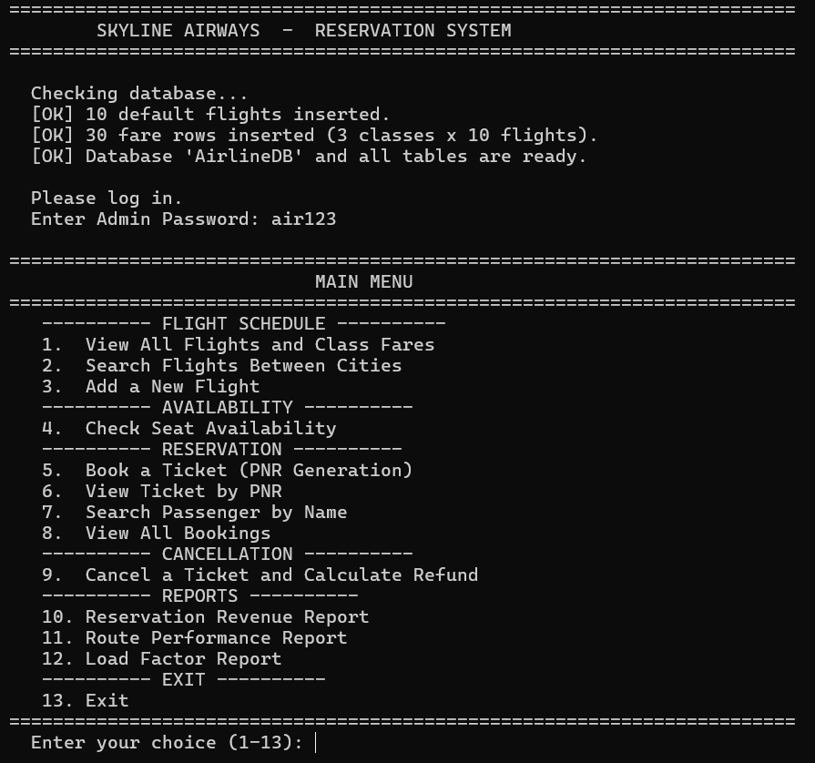Observation:
- On the first run the program automatically created the database AirlineDB and 4 tables (Flights, Fares, Bookings, Passengers).
- It inserted 10 flights and 30 fare rows (3 classes × 10 flights).
- On the second run the "inserted" messages did not appear because the SELECT COUNT(*) checks returned non-zero values. This proves the data is stored permanently in the database.

10.2 View All Flights (Option 1)
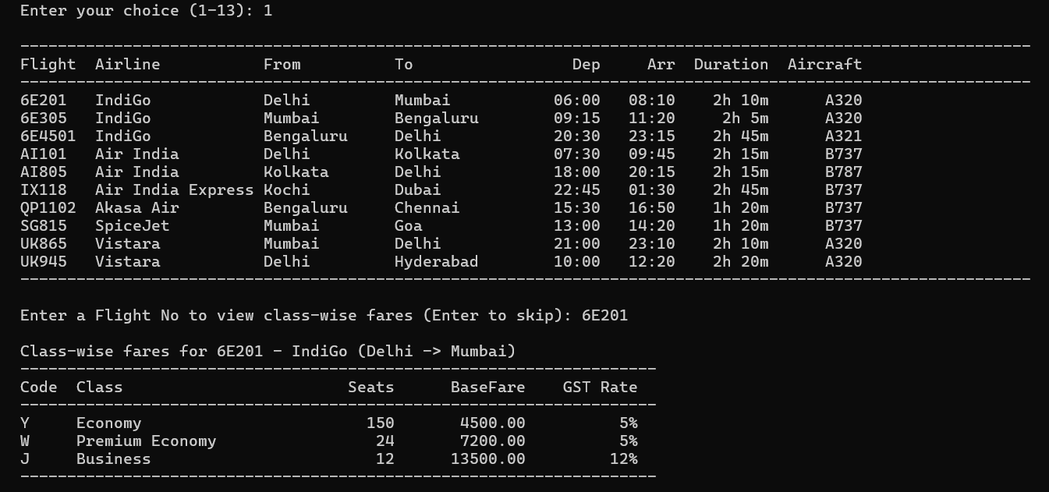Observation:
- The airline operates ______ flights across ______ distinct routes.
- The flight with the longest duration is __________________ at ______.
- For Flight ______ (route ______ → ______):
Code | Class | Seats | Base Fare | GST Rate
Y | Economy | 150 | Rs. ______ | 5%
W | Premium Economy | 24 | Rs. ______ | 5%
J | Business | 12 | Rs. ______ | 12%
- Note: The Business class fare is exactly 3× the Economy fare because of the multiplier rule.

10.3 Search Flights Between Cities (Option 2)
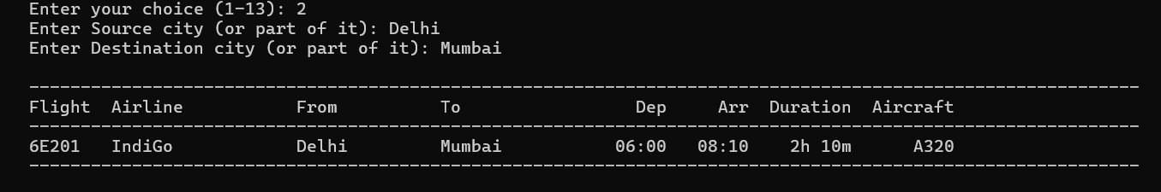Observation:
- Searching for flights from __________ to __________ returned ______ flight(s).
- The LIKE %...% operator allowed me to enter only part of the city name — for example, just "Del" matched "Delhi".

10.4 Add a New Flight (Option 3)
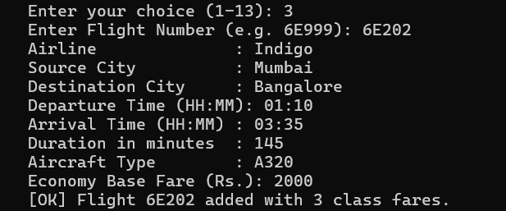
Observation:
- I added a new flight with number ______ between __________ and __________.
- The base Economy fare of Rs. ______ automatically generated the Premium Economy and Business fares using the multiplier rules — the user did not need to enter them.
- This is a good example of how business rules can be encoded into a program to reduce manual data entry.

10.5 Check Seat Availability (Option 4)
Screenshot to insert: The availability table.
Observation:
Code | Class | Total | Booked | Available | Base Fare | With GST
Y | Economy | 150 | ______ | ______ | Rs. ______ | Rs. ______
W | Premium Economy | 24 | ______ | ______ | Rs. ______ | Rs. ______
J | Business | 12 | ______ | ______ | Rs. ______ | Rs. ______
- Important observation: The Booked column was calculated live using SELECT COUNT(*) joined on Bookings and Passengers. No BookedSeats column is stored in the database — this avoids stale data.
- When I entered a date that was today, the program rejected it because the journey must be at least 1 day in advance.
- When I entered a date more than 120 days ahead, the program also rejected it.

10.6 Book a Ticket (Option 5) — PNR Generation
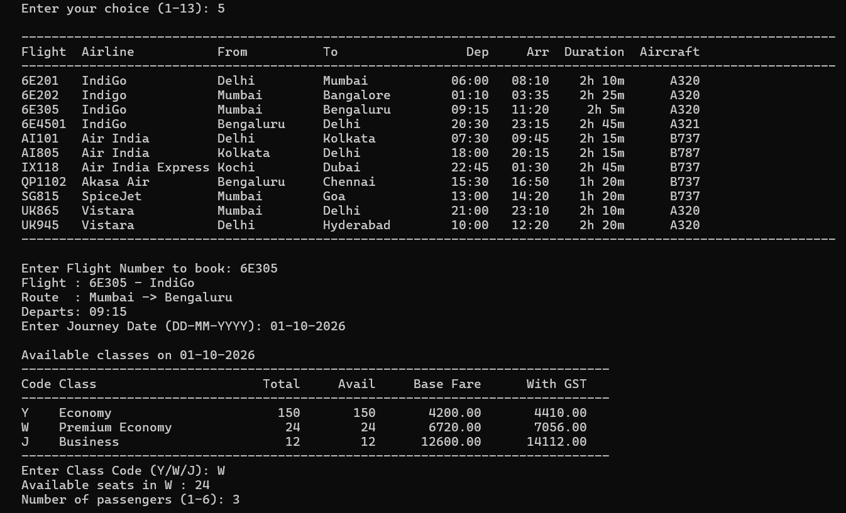
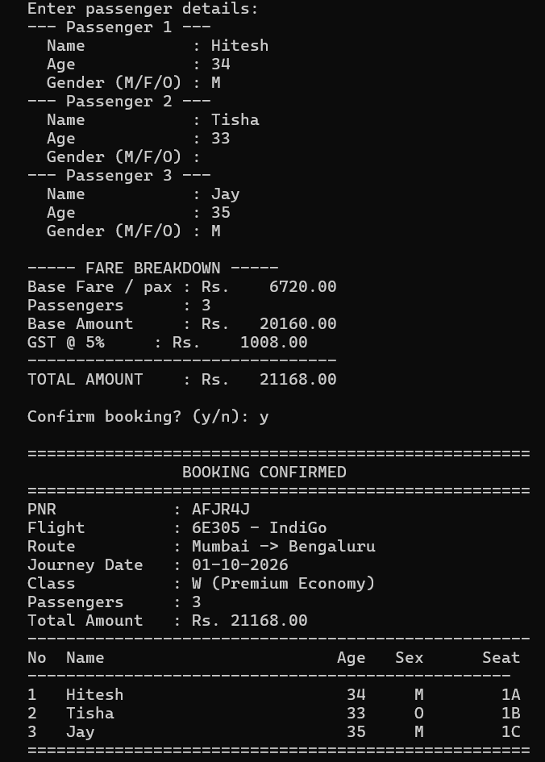
Observation:
- I booked Flight ______, Class ______ for ______ passenger(s) on ______.
- The PNR generated was ______ — a 6-character alphanumeric code starting with a letter.
- PNR generation: the program generated the PNR using random.choice(string.ascii_uppercase) for the first character and random.choices(string.ascii_uppercase + string.digits, k=5) for the remaining five. It then checked for uniqueness with SELECT PNR FROM Bookings WHERE PNR = %s — guaranteeing the primary key is never violated.
- Seat allotment: the program automatically allotted the seats:
Passenger | Age | Gender | Seat Allotted
______ | ______ | ______ | ______
______ | ______ | ______ | ______
______ | ______ | ______ | ______
- Fare calculation:
Item | Value
Base Fare per passenger | Rs. ______
Base Amount (Fare × Passengers) | Rs. ______
GST @ 5% or 12% | Rs. ______
Total Amount | Rs. ______
- Important observation: I booked an Economy (Y) ticket and confirmed that 5% GST was added. Then I booked a Business (J) ticket and observed 12% GST. This matches the tax rule coded into the CLASS_GST dictionary.

10.7 Seat Allotment without Clash — Second Booking
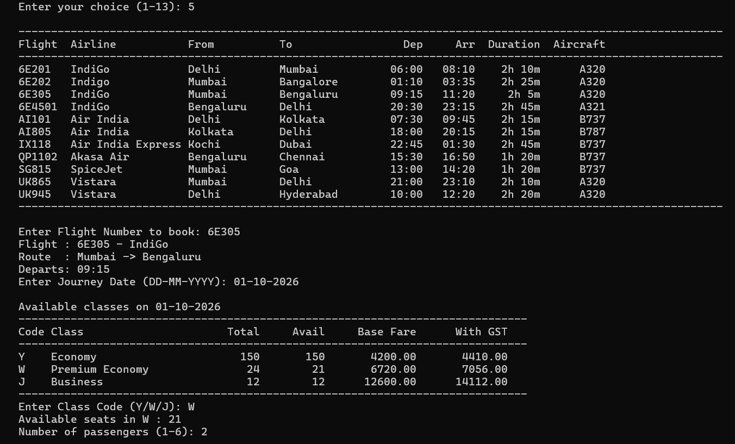
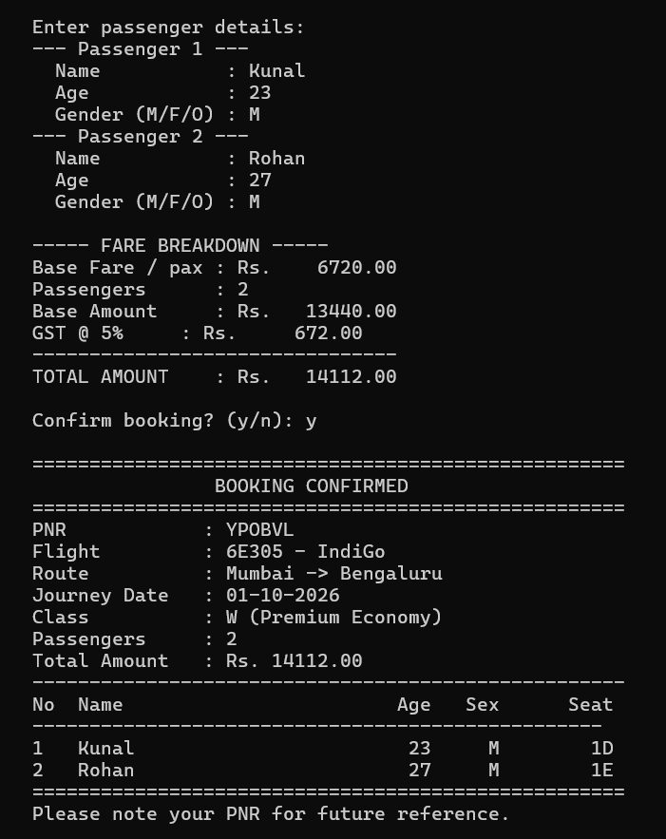

Observation:
- After the first booking of ______ passengers with seat numbers ______, ______ the second booking of ______ passenger(s) received seat numbers ______ — no clash occurred.
- This was made possible by the get_free_seats() function which:
  - Reads all currently used seat numbers for that flight+class+date.
  - Generates the full list of possible seats using seats_for_class().
  - Returns the first N seats not in the used set.

10.8 View Ticket by PNR (Option 6)
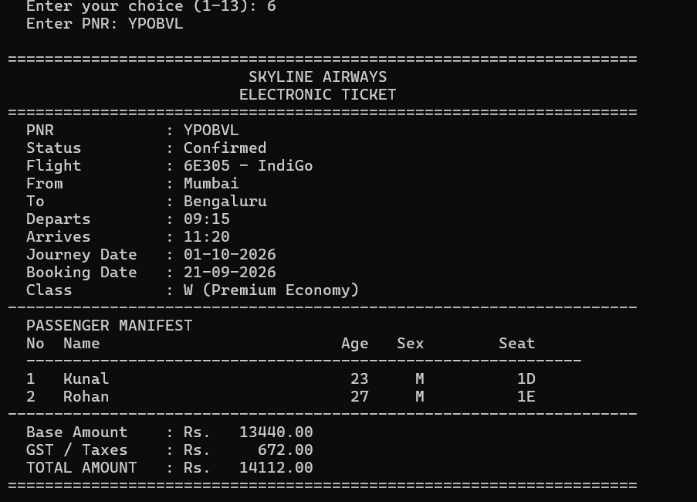

Observation:
- The e-ticket displayed all passenger names, ages, genders and seat numbers.
- The booking was retrieved using a JOIN between Bookings and Flights for the flight details, and a separate query on Passengers for the passenger manifest.
- The output layout resembled a real airline e-ticket.

10.9 Search Passenger by Name (Option 7)
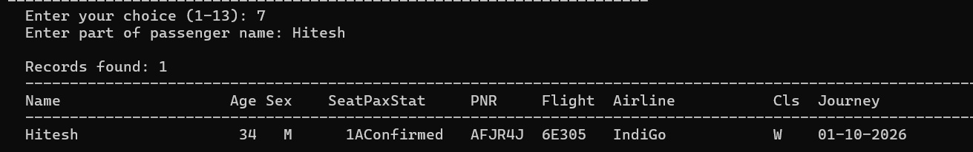Observation:
- Searching for part of a name returned ______ passenger record(s).
- The search used a 3-table JOIN — Passengers ⟗ Bookings ⟗ Flights — because the airline name is stored in the Flights table, not in Passengers.

10.10 Cancel a Ticket (Option 9) — Refund Calculation
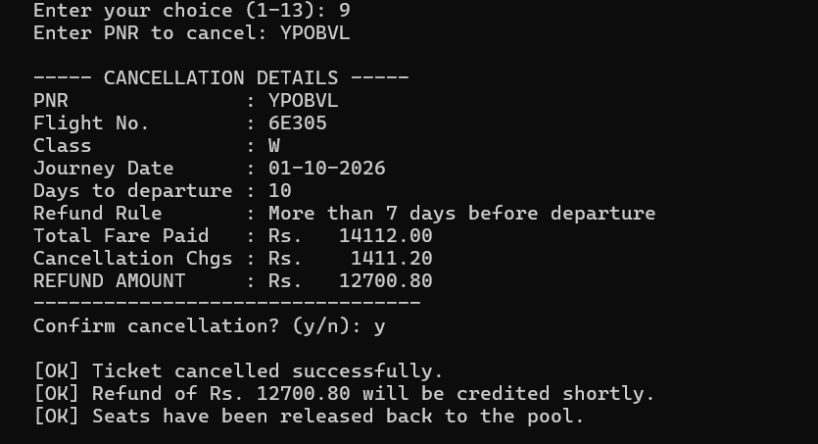Observation:
Item | Value
PNR Cancelled | ______
Journey Date | ______
Days to Departure | ______
Rule Applied | ______
Total Fare Paid | Rs. ______
Cancellation Charges | Rs. ______
Refund Amount | Rs. ______
- The refund was calculated automatically by comparing the journey date with today's date using (jdate - today).days.
- Important: The program applied the correct rule:
  - More than 7 days → 90% refund
  - 2 to 7 days → 75% refund
  - 24 to 48 hours → 50% refund
  - Less than 24 hours → 25% refund
  - After departure → No refund
- After cancellation, the booking status changed to Cancelled, all passengers were marked as Cancelled, and the seats became immediately available again — I verified this by checking availability (Option 4) for the same flight and date.

10.11 View All Bookings (Option 8)
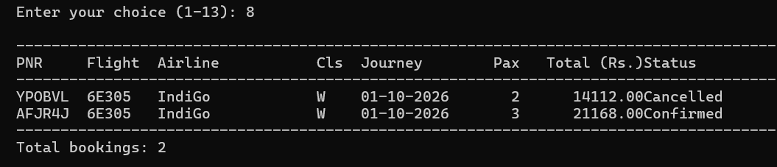Observation:
- The list showed both Confirmed and Cancelled bookings side by side.
- The ORDER BY BookingDate DESC, PNR DESC clause ensured the most recent bookings appeared first.

10.12 Revenue Report (Option 10)
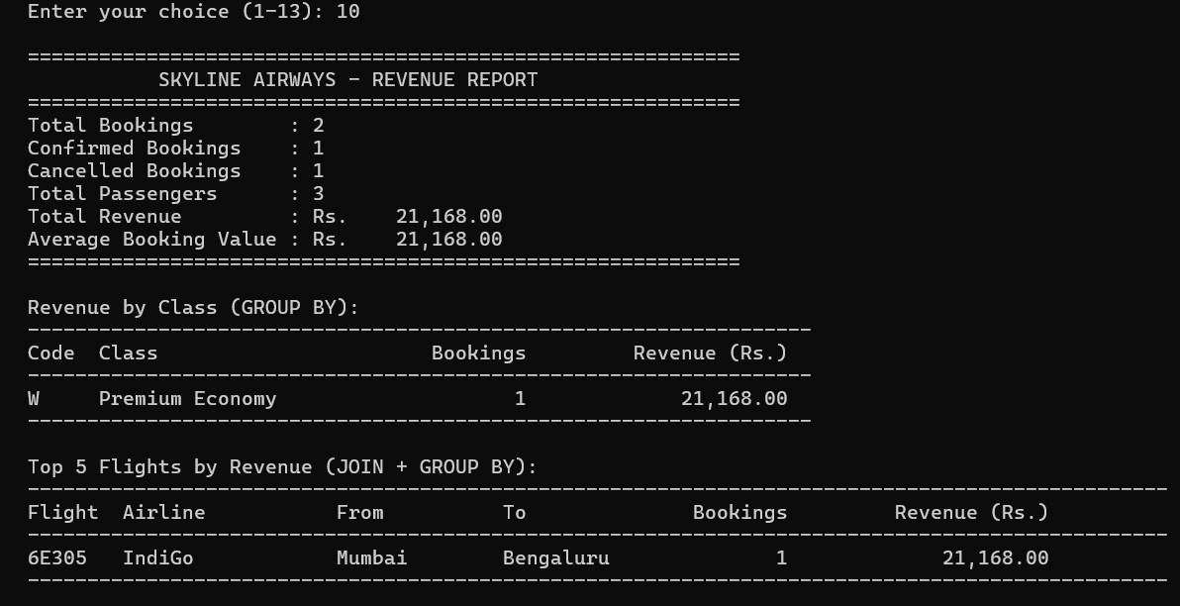Observation:
Metric | Value
Total Bookings | ______
Confirmed Bookings | ______
Cancelled Bookings | ______
Total Passengers | ______
Total Revenue | Rs. ______
Average Booking Value | Rs. ______
Revenue by Class:
Code | Class | Bookings | Revenue
______ | ______ | ______ | Rs. ______
______ | ______ | ______ | Rs. ______
Top 5 Flights by Revenue:
Flight | Airline | From | To | Bookings | Revenue
______ | ______ | ______ | ______ | ______ | Rs. ______
- Conclusion: The revenue-by-class table was produced using GROUP BY ClassCode with SUM(TotalAmount) and COUNT(*). The top-flights table used a JOIN followed by GROUP BY with ORDER BY SUM(...) DESC LIMIT 5. The WHERE Status='Confirmed' condition ensured that cancelled bookings were excluded from revenue.

10.13 Route Performance Report (Option 11)
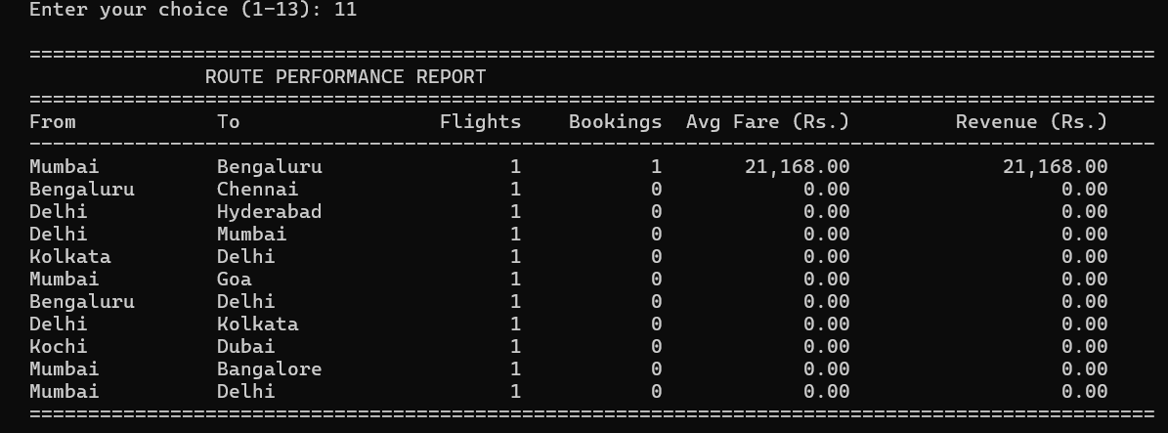Observation:
- The route with the highest revenue was __________ → __________ with Rs. ______.
- The route with the highest average fare was __________ → __________ at Rs. ______ per booking.
- The query used a LEFT JOIN between Flights and Bookings so that routes with no bookings still appeared with Rs. 0.00 revenue.
- Conclusion: This report tells the airline which routes to expand and which to review — the same analysis used by real airlines when planning their schedules.

10.14 Load Factor Report (Option 12)
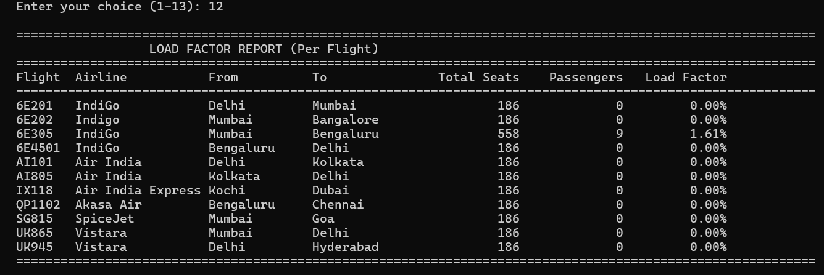Observation:
- The flight with the highest load factor was __________________ at ______ %.
- The flight with the lowest load factor was __________________ at ______ %.
- Conclusion: Load factor — the percentage of seats filled — is the single most important metric in the airline industry. A flight with a low load factor is losing money; a flight with a high load factor may need a larger aircraft or additional frequency. This report demonstrates the real business value of the entire system.

11. CONCLUSION AND FUTURE SCOPE
Conclusion
In this project I successfully developed a complete, database-driven Airline Reservation System using Python and MySQL. Through this project I learnt and applied:
- Python–MySQL Connectivity — using mysql.connector.connect(), cursor(), execute(), executemany(), fetchone(), fetchall(), commit() and rollback().
- Relational database design — creating four linked tables using a composite primary key in Fares and foreign keys in Fares.FlightNo, Bookings.FlightNo and Passengers.PNR.
- Automatic schema initialisation — using CREATE DATABASE IF NOT EXISTS and CREATE TABLE IF NOT EXISTS so the program needs no manual SQL setup.
- PNR generation — generating a unique 6-character alphanumeric PNR with random and string, and checking uniqueness against the database.
- Dynamic seat availability — computing available seats live by joining Passengers and Bookings — no BookedSeats column stored.
- Individual seat allotment — finding the first free seat numbers using a Python set and a seat-map generator, so passengers never clash.
- Class-based fare multipliers — one base Economy fare per flight generates all other class fares using multipliers — a real-world example of derived data.
- Conditional GST — 5% on Economy/Premium Economy and 12% on Business/First — matching Indian aviation tax rules.
- The datetime module — computing days remaining for the refund rule with (journey - today).days.
- Aggregate functions and grouping — generating business reports with COUNT(), SUM(), AVG(), LEFT JOIN and GROUP BY, and using IFNULL() to safely handle NULLs.
The project demonstrated the full power of a relational database: data is structured, relationships are enforced, complex reports run in a single SQL statement, and everything runs fast even as the volume of bookings grows.
Future Scope
- Graphical User Interface (GUI) using Tkinter so the reservation clerk can click buttons.
- Online Booking Portal with Flask/Django so customers can book from home.
- Waiting List and RAC — when a class is full, passengers could be added to a waiting list.
- Multi-city / Multi-leg Itinerary — allow a passenger to book a journey with connecting flights.
- Frequent Flyer Program — a separate table to track miles and loyalty tiers.
- Seat Map Display — show the actual aircraft layout with occupied/vacant seats highlighted.
- Boarding Pass Generation — a printed PDF using reportlab.
- Web Check-in — allow passengers to check in online and print their boarding pass.
- Delay and Cancellation Alerts — send SMS/email through smtplib.
- Dynamic Pricing — increase fares as the flight date approaches or as seats fill up (like real airlines).
- Dashboard with Charts — use matplotlib to visualise revenue, load factors and route performance over time.

12. TROUBLESHOOTING
12.1 Database Connection Errors
If you see:
text
Database Connection Error: 1045 (28000): Access denied for user 'root'@'localhost' (using password: YES)
follow these steps:
- Ensure MySQL is running — start the MySQL service in XAMPP.
- Test credentials from command line: mysql -u root -p.
- Create a dedicated user (recommended):
sql
CREATE USER 'airline_user'@'localhost' IDENTIFIED BY 'your_password';
GRANT ALL PRIVILEGES ON *.* TO 'airline_user'@'localhost';
FLUSH PRIVILEGES;
Then set DB_USER = "airline_user" and DB_PASSWORD = "your_password".
- Change authentication plugin (MySQL 8.0+ only):
sql
ALTER USER 'airline_user'@'localhost'
IDENTIFIED WITH mysql_native_password BY 'your_password';
FLUSH PRIVILEGES;
- Install / upgrade the connector: pip install --upgrade mysql-connector-python.
12.2 Common Errors
Error | Reason | Solution
Unknown database 'AirlineDB' | Database dropped | Run the script again — it recreates the database automatically
Table 'AirlineDB.Bookings' doesn't exist | Table dropped | Run the script again — CREATE TABLE IF NOT EXISTS recreates it
Not all parameters were used in the SQL statement | More values passed than placeholders | This project's Flights INSERT has 8 placeholders and 8 values and Fares INSERT has 5 placeholders and 5 values — verified consistent
Cannot add or update a child row: a foreign key constraint fails | Booking a flight that does not exist | Add the flight first (Option 3) or use an existing flight number
Data too long for column 'PNR' | Extremely unlikely — PNRs are always 6 characters | Not applicable
Duplicate entry '...' for key 'PRIMARY' | Extremely rare — PNR regenerated in a loop | Retry — a new PNR will be generated
Incorrect date value | Wrong date format | Always use DD-MM-YYYY
Cannot delete or update a parent row when deleting a flight | Booking rows still reference the flight | Not applicable — this project does not delete flights

13. BIBLIOGRAPHY
- Websites:
  - MySQL Connector/Python Documentation (dev.mysql.com/doc/connector-python)
  - Python Official Documentation — datetime, random, string (docs.python.org)
  - W3Schools — SQL Tutorial (www.w3schools.com/sql)
  - GeeksforGeeks (www.geeksforgeeks.org)
  - Stack Overflow (www.stackoverflow.com)
- Study Material:
  - NCERT Informatics Practices Textbook for Class XII
  - Sumita Arora, Informatics Practices with Python, Dhanpat Rai & Co.
- Reference Manual:
  - MySQL 8.0 Reference Manual (dev.mysql.com/doc)

